ASIA REGIONAL SANITATION & HYGIENE PRACTITIONERS WORKSHOP
31 JANUARY – 2 FEBRUARY 2012. DHAKA, BANGLADESH

WORLD VISION MYANMAR PHOTO ESSAY
SEARCHING FOR BETTER WASH RESULTS FOR FLOOD-PRONE AREAS

Abstract: During the rainy season many people who live in flood-prone areas like Nwew Ni Chaung village in Thabaung Township in the Ayeyarwady Delta area, experience great difficulties with sanitation. Although most people accept this as a normal part of their way of life, the government and development organizations want to help improve the situation. World Vision Myanmar has attempted to help improve people’s lives through material and technical support but sometimes we did not sufficiently take into account existing local skills and knowledge. As a large international development organization with complex operating systems, field workers sometimes find themselves with insufficient time to pay proper attention to understanding the complexities and realities of communities and their needs and aspirations. Failing to do this often leads to poor results. Reflecting on what we do and openly learning from our mistakes is an important way of improving our practice.
Keywords: sanitation, hygiene, sustainability, floods
Author-Photographer: May Zin Thaw, Sanitation & Hygiene Specialist, World Vision Myanmar
Contact details: May Zin Thaw | Sanitation & Hygiene Specialist | World Vision Myanmar | 16 Shin Saw Pu Road, Ahlone Township, Yangon | Tel. + (951) 525191, 510148, 511265, 510113, Ext. 4103 | Fax: + (951) 527502 | Mobile Phone: 09 7316 5422 | Email: may_zin_thaw@wvi.org
Acknowledgements: The author-photographer extends her thanks to World Vision Myanmar and the organizers of the Asia Regional Sanitation & Hygiene Practitioners Workshop for the opportunity of sharing this photo-essay. Thanks and appreciation is also extended to all of those who played a part in making this work possible, especially the people who appear in the photos.
Searching for Better WASH Results for Flood-Prone Areas
Nwew Ni Chaung is a village of 93 households with 511 residents in Thabaung Township in the Ayayarwaddy Delta area of Myanmar. The government and international organizations like UNICEF, Save the Children and World Vision have been supporting WASH projects in the Township for many years. Normal annual flooding in Nwew Ni Chaung results in the water-level rising 6 to 8 feet above the ground in the rainy season. Since the late 1990’s many shallow tube wells in the Township have been found to be contaminated with naturally occurring arsenic.

Scene 1
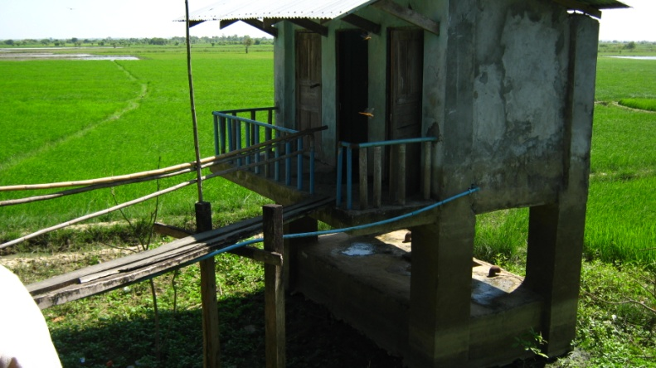
Water level reaches here in the rainy season.
Construction of students’ toilets for Nwe Ni Chaung Village Primary School was supported by World Vision Myanmar. However, safety of usage is an issue as the flood water level rises above the toilet floor in the rainy season and the bridge connecting the classrooms with the toilets is not safe - even for adults!
Scene 2
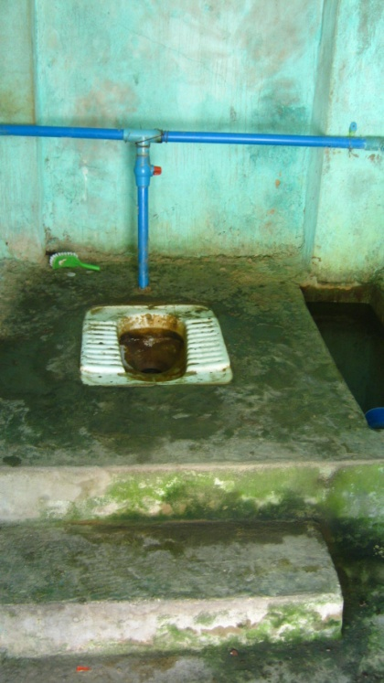
Over the course of time the condition of the toilets has seriously deteriorated – partly due to misuse and partly due to lack cleaning and maintenance. The toilets for students are filthy, smelly and disgusting. By contrast, the toilets for teachers are maintained in clean and fully functioning condition - kept locked for teachers and VIPs only.

Scene 3
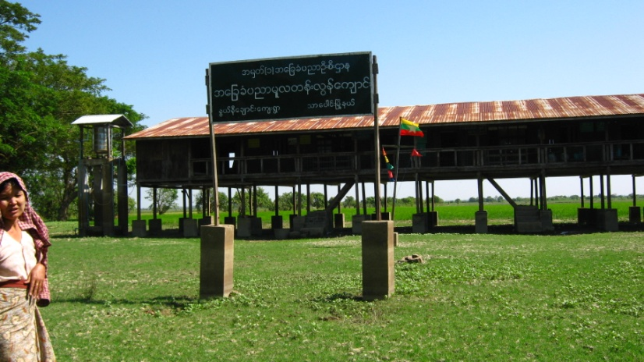
There is a nice elevated water storage tank for the school - but where is the safe drinking water for the students?
Scene 4
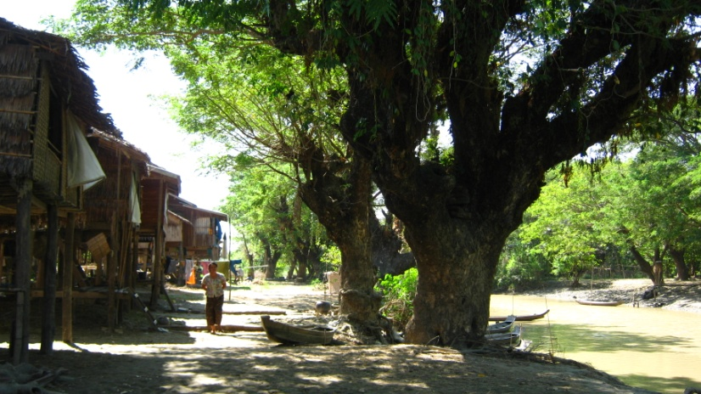
Most people still depend on water from the nearby creek for drinking and domestic purposes.

Scene 5
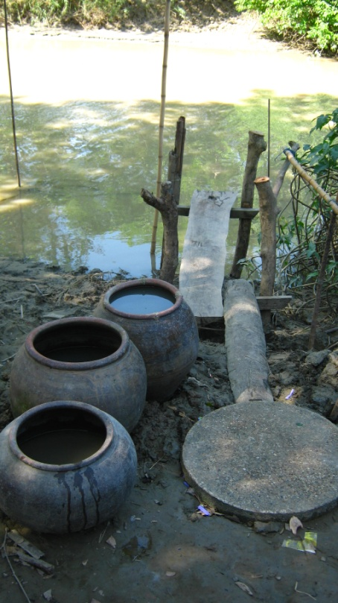
Water storage jars are kept nearby the creek. Although some villagers boil their drinking water many children can be observed still drinking water directly from the storage jars.
Scene 6
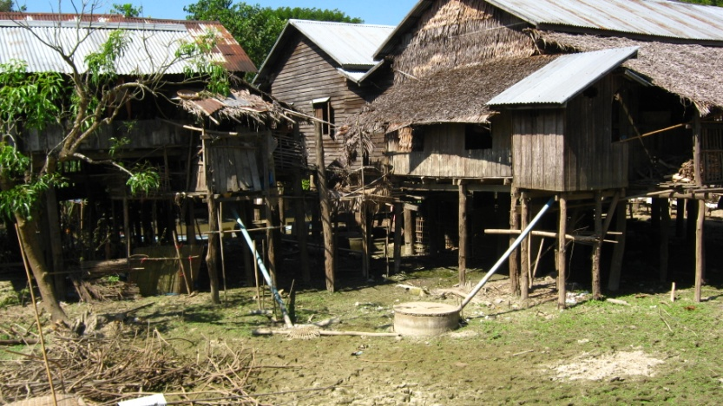
One of the villagers told us he rebuilds his family latrine every year because of the annual floods. He said that in rainy season most of the villagers remove the pipe that connects their toilet to the soak-pit and they defecate directly from the platform into the water. In such situations, what can we do for sustainable sanitation and hygiene? Should we keep promoting to people “Use sanitary toilets and wash your hands with water and soap”? Or can we offer some alternative sanitation solutions for use in the flood season?
We know what the issues are but we are still searching for practical, affordable and sustainable solutions that work
Please share with us any suitable evidence-based solutions
THANK YOU

