Dhaka, Bangladesh, 31 January -2 February 2012

Asia Regional Sanitation and Hygiene

Practitioners Workshop

6B Approach for toilet promotion

Rajendra Shrestha [Nepal]

“Toilet construction is beyond the reach of poor people because it is expensive.” This is general perception of people and most promoters when it comes to sanitation promotion among the poor. Consequently many people favor some subsidies for poor people. Superficially the argument is not wrong, considering that the cost of a simple pour flush toilet is about $300 in context of Nepal. But there are toilets which cost less than $100 and these are safe enough. The main difference in cost of these toilets is due to the cost of superstructure, which varies from cemented brick/block to bush/bamboo structures. The sub-structure (up to the pan level) remains the same, thus ensuring the toilets hygienically separate excreta from human contact and meet the criteria for improved sanitation as defined by the Joint Monitoring Programme. Thus the escalation in costs-- discouraging poor people from having a toilet—comes from the superstructure. In this context, the 6B approach has been initiated to ensure that improved sanitation is affordable to all. This approach encourages people to have a toilet as per their financial status and enhances capacity to utilize locally available materials. Six B promotes toilet superstructures made of Bag, Bush, Bamboo, Brick, Block or Boulder. This approach makes toilet promotion easier and empowers people to make informed choices regarding their toilet facilities. The promotion of these low-cost toilets also has challenges as the toilets aren’t as robust and will require frequent maintenance. But as the houses of the poor are also generally made of these materials it is easy to convince poor people to start with these toilets and upgrade the superstructure later as and when necessary. In conclusion, 6B approach provides socially acceptable, economically viable and technically appropriate options for toilet construction to people without compromising health impact.

Context

Sanitation promotion was started in Nepal from 1980s with the United Nations declaration of the International Decade of Drinking Water Supply and Sanitation. However, the major effort on sanitation started in the early 90s. In 1990, the national sanitation coverage in Nepal was 6% of the population and that increased to 43% in 2010. During the span of 20 years 37% additional sanitation coverage has been achieved. This implies that 100% toilet coverage with the declaration of an open defecation free country for Nepal is possible only in the coming 32 years. But Nepal has a national goal to provide toilets for all by the end of 2017. Needless to say, toilet promotion must be accelerated without any delay. On the other hand, drinking water supply coverage increased to 80% of the population by the end of 2010. This shows the wide gap between sanitation and water supply coverage. The smaller achievement in sanitation compared to water supply is due to implementation approaches as well as to the low priority given to sanitation.

Currently, the practice is to promote toilets having permanent superstructures which are called permanent toilets. Equally, there is common understanding among people that a toilet having a permanent superstructure is the good or safe toilet. In fact people should be encouraged to have safe toilets, which is possible simply by improving the pits and providing a pan with water seal trap. The superstructure of the toilet can be constructed according to the owner’s financial means. This is one of the major causes for slow toilet promotion. Because of the current approach, numbers of households can be found in country where the toilet is made of permanent, expensive materials while the house itself is temporary or made of bush. This is an unseen factor that is obstructing toilet promotion in poor communities. Most of the people cannot have such toilets because of the cost high. More subsidy arrangements also retard the toilet construction. Because of the large subsidy for a toilet, people, both the poor and even the rich, will not build toilets but will wait for a subsidy. Eventually the tendency of having toilet not for use but because of the subsidy will result in expensive but unused toilets.

People's participation during the implementation should not be targeted to achieving project outputs only. The mere presence of people during project implementation is not enough as well. Toilet promotion, to be successful, requires harmonization of project and community. Community participation in decision-making processes and their strong sense of ownership towards toilets will ensure sustainability. Kind and cash contribution of people will not be enough for ownership. Indeed the opportunity to people to choose toilet options among technological and financial verities ensures financially affordability and social acceptability.

Environment and Public Health Organization (ENPHO) is implementing a four year SWASHTHA Project (Strengthening Water, Air, Sanitation and Hygiene Treasuring Health Project) from January 2009 together with Practical Action Nepal and the Nepal Municipal Association under the financial support of EU and UN Habitat. SWASHTHA is a community-based project led by the local municipality. It focuses on improving the health and well being of the urban and peri-urban poor settlements of Bharatpur, Butwal, Gularia, and Tikapur municipalities. Among these four municipalities Tikapur and Gulariya are municipalities in the west part of the country established in same time, have similar nature and development status. This paper shares the learning from these two municipalities.

The project has envisaged that a demand-driven and community harmonization approach would result in a major shift in traditional sanitation promotion, where high subsidy is becoming a norm. The overall objective of the action is to contribute to the sustainable improvement of health and well being of vulnerable populations, particularly women and children residing in urban and peri-urban poor clusters.

6B Approach

In this context, the 6B approach has been initiated to ensure that improved sanitation is affordable to all. This approach encourages people to have a toilet which they can afford and enhances the capacity to use locally available materials for the superstructure. Six B refers to toilet superstructures made of Bag, Bush, Bamboo, Brick, Block and Boulder. As the houses of the poor are also generally made of these materials (bush/bamboo/bag), it is easy to convince the poor people to start with these toilets and upgrade the superstructure later as and when necessary using brick/block/boulder.

The overall objective of 6B approach is to promote financially affordable and environmentally or hygienically safe toilets in community. Its main features are:

- To encourage people to have toilet according to their financial status.
- To enhance capacity to utilize locally available materials properly.
- To motivate people to have low cost but safe toilets and upgrade as per their capability.
- To promote toilets in community with no subsidy or low subsidy.

6B Promotion

The 6B toilet is promoted in five phases:
- Preparatory phase
- Awareness and Ignition Phase
- Demand and Selection phase
- Implementation phase
- Follow-up phase

In the preparatory phase, project clusters were selected by implementing partners together with the local political and municipal authorities through series of field visits, FGD and meetings.

In the awareness and ignition phase, local tools and materials were used such including street/drama, folk songs, wall painting. CLTS (Community Led Total Sanitation). Documentary shows, demonstrations, mass rally, campaigns were organized on the occasion of national and international days.

In the demand and selection phase, the 6B approaches were introduced and different types toilets were explained leading to household selection in focus group discussions in the Tole (clusters). This was done through intensive discussion and motivation. Comparison of investment costs between different types of toilets, criteria for improved sanitation were shared with people. People were encouraged to construct a toilet as per their financial status. People were provided with training on using locally available materials properly. There were also made aware about the challenges of frequent maintenance of low-cost toilets.

For the implementation, the project management committee (PMC) decided to provide only the Pan (1 nos.), Pipe (2 meter) and Cement (1 bag) or Pan (1 nos.), Pipe (1 meter) and Ring (3 rings of 30 cm width with a cover) to each household for the construction of improved pit toilets. The household was entirely responsible for completion of toilet. During the implementation, one day orientation was provided to local mason on the proper construction of toilet especially on the leveling of the pan, maintaining the pipe and toilet floor slope. People were also provided training on construction of good superstructures using locally available materials. Frequent supervision was undertaken by a field technician to ensure the proper construction of toilets. After 8 months (in 2009) of baseline survey, planning and awareness campaign, people started to build toilets and about 750 toilets were constructed during 2010. As toilet promotion becomes tougher, slowly at the tail period of promotion a new strategy was developed with the support of the municipality. People who have toilets were honored with Sanitation Cards, a kind of certificate for having toilet. The Sanitation Card or its copy was made mandatory to attach as a supporting document during the process of application for any kind of service from municipality. It was used as local triggering tool that creates pressure to build, use and keep clean the toilet.

Follow up on technical aspects was done during construction/implementation. Use and cleanliness of toilets was monitored after construction. People were honored and praised for adopting 6B options and keeping toilets clean during the follow up.

The 6B is four year project started from January 2009. There are altogether 4 field- based project staff comprising the project coordinator-1, field coordinator-2 and field technician-1 for implementation. Local change agents like local WATSAN volunteers, local youth trained on water and sanitation, school child club, female community health volunteers, local culture groups were mobilized for the promotion of project activities at the grass root level. The project manager, central staff, is responsible reporting and management of project.

Achievement

The major achievement of the approach is that the community was enabled and convinced to use locally available materials for toilet construction instead of waiting for permanent toilets. After this successful experience in toilet promotion, the municipalities reduced their subsidy from NRs. 17,000 to 3,000 (from US$217 to US$38). In the same way, Gulariya municipality launched a similar program named toilets for poor. Implementation was started from 2009 and altogether 1192 toilets (not including toilet promotion by the municipality itself) have been completed by the end of September 2011 and are being used. Among these 1192 toilets, 50% have bush superstructures, 1% is made of bamboo, 10% of bag, 14% of the superstructures is brick and 25% are made of block. In addition, it has been noticed that households have started to upgrade the superstructures beginning in 2011.

Finding/Learning

The overall finding about this approach is that safe toilets can be promoted with no or low subsidy. Indeed toilet promotion can be easier if people were made aware properly about their facilities and encouraged and trained to use locally available material for toilet construction.

Challenges

The main challenge of this approach is that promotion of low cost superstructures is not easy and the superstructures will require frequent maintenance. The data shows that more than half the toilets have been constructed with low-cost superstructures which are not free from the chances of degradation in the coming days. Regular monitoring should be conducted by the local stakeholder (Municipality, TLOs). Another challenge is proper construction of toilet. As people were not able to afford a good mason and in many cases the house owners build toilet themselves, there are high chances and occurrence of defective fixing of pan, trap, pipe and its level. Toilet promotion with low subsidy is obviously again challenge. People generally want to have more financial support to have toilet.

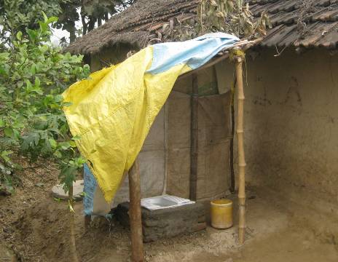 |  | 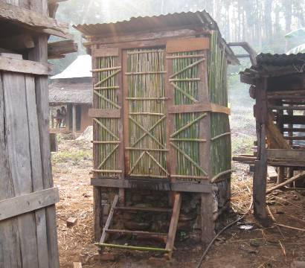
Photograph 2. Toilet with bag superstructure |  | Photograph 2. Toilet with bamboo superstructure
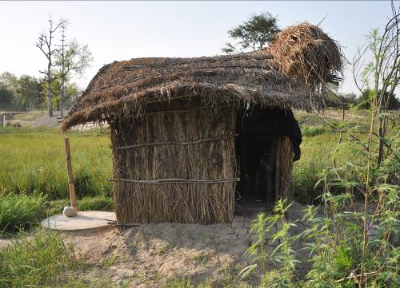 |  | 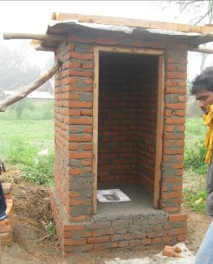
Photograph 3. Toilet with bush superstructure |  | Photograph 4. Toilet with brick superstructure
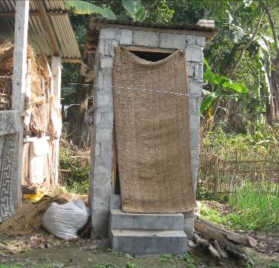 |  | 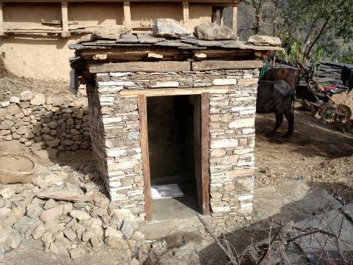
Photograph 5. Toilet with block superstructure |  | Photograph 6. Toilet with boulder superstructure

Acknowledgements
I would like to extend thanks to my colleagues Prashanna, Sulochana, Dharma, Ash Kumar, Sirjana, Basu, Sushil from ENPHO and Binay, Shirish from Practical Action Nepal. At the last but not least I like to express thanks to all project Partners and municipalities.

References

NMIP/DWSS (2010). A Survey Report on Nation-Wide Coverage and Functionality Status
of Water Supply and Sanitation. Kathmandu

MPPW (2009). Urban Water Supply and Sanitation Policy. Kathmandu

Keywords
Sanitation promotion, 6B approach, low-cost toilets, poor

Contact details

Name of Principal Author : Shrestha Rajendra
Address : Environment and Public Health organization (ENPHO), Kathmandu, Nepal
Tel: +977-1-4493188
Fax: +977-1-4491376
Email: rajendra.shrestha@enpho.org
www: enpho.org

