 | 27th WEDC Conference Lusaka, Zambia, 2001  People and systems for water, sanitation and health | 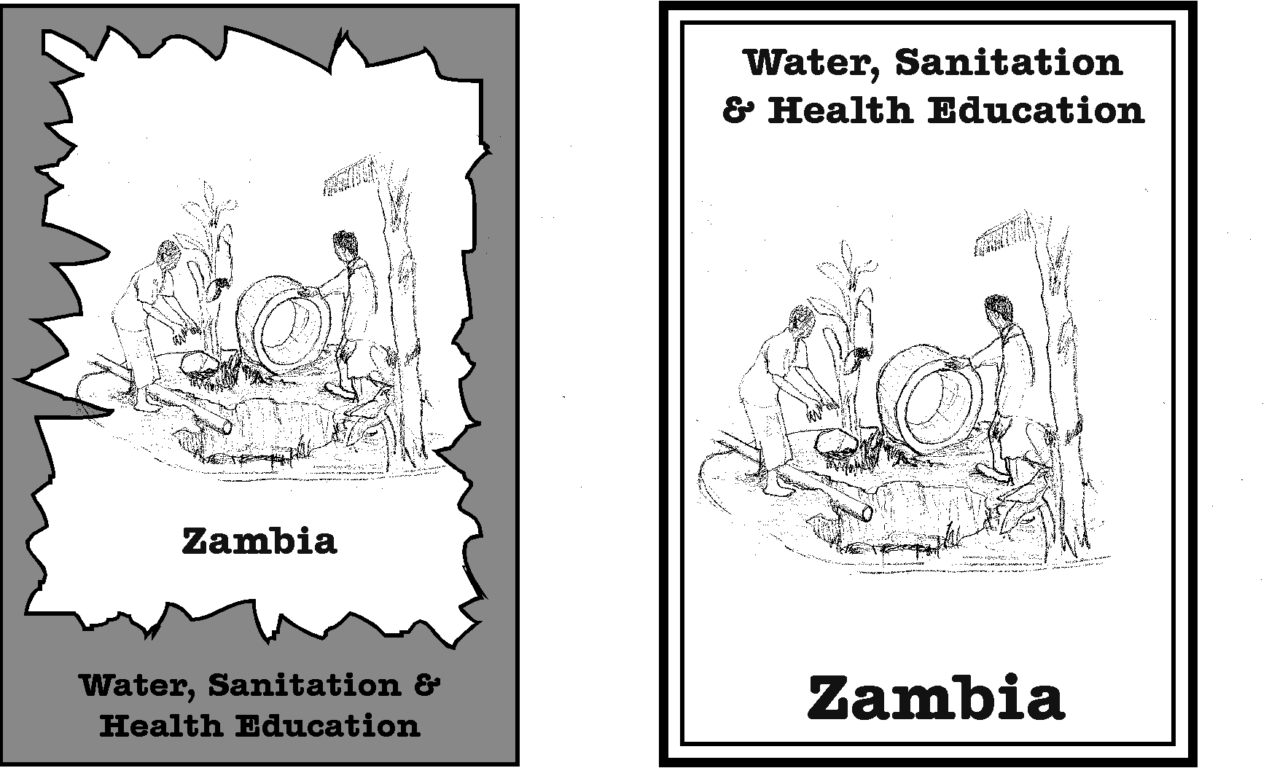

Summary report
of
Workshop on livelihoods, water resources and WATSAN

Facilitated by:
Patrick Moriarty, IRC International Water and Sanitation Centre (moriarty@irc.nl);
John Butterworth, Natural Resources Institute (j.a.butterworth@gre.ac.uk)
Brian Reed, WEDC (b.j.reed@lboro.ac.uk)

27th WEDC Conference Lusaka, Zambia, 2001

People and systems for water, sanitation and health

Message from the workshop on livelihoods, water resources and WATSAN

On 24 August 2001, following a series of papers and discussions on these issues at the 27th WEDC conference in Lusaka, a group of multi-disciplinary WATSAN professionals from 13 countries met to discuss the current role of the WATSAN sector in water resources management and the key water resource issues affecting the sector. This statement is a preliminary output from these discussions, and a network of interested people and organizations has been established to address the challenges arising.

Water is finite, and as populations and demands for water (particularly for productive purposes) grow there is increasing competition for and sometimes conflict over water. Increasingly, competition for scare water resources is impacting domestic water supplies for urban, peri-urban and rural communities. Commonly the poorest and most vulnerable communities lose out, and one reason that at a local level competition does not always become outright conflict is that these people are too weak to effectively demand their rights.

The quantity of water needed for the WATSAN sector is relatively small but crucial (volume does not indicate importance). Unfortunately, the limited quantity needed has led to equally limited involvement by the sector in water resources management fora, increasingly resulting in the failure of sources and supplies.

A key principle is proposed:
All people have a right to affordable water for sustainable livelihoods

To achieve this principle the WATSAN sector, through its members, should:

- Become an actor in Integrated Water Resources Management (IWRM)
Only by active participation in national, regional and local level IWRM for a can the WATSAN sector ensure that the rights of the poor and marginalised to adequate water for domestic and productive uses are safeguarded.

- Change its mission from one of provision of domestic water and sanitation to one of provision of water for sustainable livelihoods
The right to a basic level of access should not be constrained by definitions of use, standards or quantities. It is recognized that the past focus on basic (domestic) needs and supply norms has led to failure to provide the quantities of water that urban, peri-urban and rural communities actually require and can productively use. This has particularly impacted on women and the poor.

- There is an urgent need – largely unmet - to broaden the focus of WATSAN institutions, programmes and projects to support peoples’ total livelihood needs (not just health and hygiene related aspects).
- Service delivery must be determined by peoples’ current and future needs for domestic and productive needs; economic activities, social requirements; willingness and ability to pay; and resource availability (labour, land, water etc)
- WATSAN provision must evolve to achieve the flexibility necessary to respond to changing populations and patterns of water use.
- The WATSAN sector must work with those from other sectors, to provide holistic, people and livelihood centred development.

Table of contents
Message from the workshop on livelihoods, water resources and WATSAN 2
Table of contents 4
Summary report 5
Introduction 5
Methodology 5
Results 5
Notes from breakout groups 5
Group 1 – policy and reality 5
Group 2 – WATSAN and livelihoods 5
Group 3 – WATSAN in WRM 5

Summary report

Introduction
On 24 August 2001, following a series of papers and discussions on these issues at the 27th WEDC conference in Lusaka, a group of multi-disciplinary WATSAN professionals from 13 countries met to discuss the current role of the WATSAN sector in water resources management and the key water resource issues affecting the sector. The workshop led to the development of an advocacy message, and a the beginnings of a network of interested people and organizations was established to address the challenges arising.

This summary report includes:
- the message included at the start of this report – this was the main output from the workshop
- notes from the three workshop groups: policy and reality, WATSAN and livelihoods, and WATSAN in WRM
- a list of workshop participants

Workshop participants and other interested individuals and organisations are invited to comment on the message arising from the workshop, and/or in joining the network.

Methodology
The workshop was divided into three phases.
- an initial plenary introduction to aims and objectives
- break out groups to discuss three key issues
- plenary round up

The three key issues to be discussed had been circulated during the conference and are based on what the organisers felt to the key themes emerging in the sector. They were as follows:

- Group 1 – policy and reality
Increasing conflict over water resources is putting access to domestic water supply at risk. Despite international agreement as to the pre-eminence of domestic water resources over other competing uses, the reality is that un-controlled development of water for irrigation and whole-sale pollution from industrial uses threaten drinking water resources in many parts of the world.

- Group 2 – WATSAN and livelihoods
The more commonly accepted definition of domestic water as being that required for drinking, cooking and other strictly household activities (of the order of 25 l/person/day), makes no allowance for the other, small scale productive uses to which water is put. Uses that frequently play a key role in the livelihoods of women and the poor.
- Group 3 – WATSAN in Integrated Water Resource Management
Assuming that water resource issues should be dealt with by 'water resource managers' has been shown to be an illusion. Without a champion to defend their rights to access an equitable share of water for both domestic and small scale productive uses, the poor will inevitably loose out to the more organised voices of large scale ‘commercial’ users. The WATSAN sector must engage positively and proactively in the debate on water resource management and take on the role of champion of the rights of women and the poor.

The groups discussed the issues using a framework of:
- Issues
- Definitions
- Principles
- Actions and research priorities
- Targets for advocacy

The reports of the breakout groups are annexed to this summary report.

Following the group discussion a plenary session was arranged in which the feedback from the groups was brought together to form the substance of the workshop message.

Results
The main output of the workshop was the message on WATSAN, water resources and rural livelihoods.

It was agreed by all present that the issues raised are crucial, both for the wellbeing of the people whom the sector serves, and for the future of the sector itself.

However, it was also agreed that such a short workshop could only scratch the surface in starting to identify a coherent set of priorities and activities to address these issues. In particular given the absence from the conference of non WATSAN professionals. The failure to engage more with other sectors was raised as one of the single greatest obstacles to a more effective realisation of the potential of water to improve peoples lives.

The main activity suggested by the participants was therefore to continue the work of developing a network of individuals and organisations with an interest in the issues, from both within and outside the WATSAN sector, and to use this network initially as a sounding board for developing a fuller set of ideas and proposals for activities.

Notes from breakout groups

Group 1 – policy and reality
Increasing conflict over water resources is putting access to domestic water supply at risk. Despite international agreement as to the pre-eminence of domestic water resources over other competing uses, the reality is that un-controlled development of water for irrigation and whole-sale pollution from industrial uses threaten drinking water resources in many parts of the world.

Issues
- There was agreement that there competition for water resources is indeed growing, and that this does negatively affect domestic water requirements. Competition happens at local, regional, national, and international levels and must be dealt with differently at all of them.
- Conflict is often too strong a word to use for what is really competition. Conflict and water wars ,for example in the middle east, get global attention but are not representative of most competition over water resources. Competition without open conflict, in which weaker people are disempowered and defeated, forced to move away rather than fight, are more typical.
- Is water domestic water recognised as being pre-eminent in resource allocation? This is not clear
- Domestic water is recognised in Dublin but not clear that it is supreme
- A right based approach is a more fundamental principle but has yet to receive international backing
- What are the figures quoted so widely as per-capita supply targets? Are they design figures or aspirational targets? Per capita supply should be driven by considerations of costs/benefits/sources, not by national or regional design figures.
- There is a need to address as separate issues a right to basic water (however defined) and then rights to excess water. What are the limits and how are they arrived at? Should it be a question of social and economic efficiency?
- Should legal frameworks be based on a land rights (riparian) approach or public ownership – the examples of Kenya, where the nationalisation of Groundwater is on the agenda was given.
- Policy and legal frameworks are not enough, without effective enforcement and regulation. There is plenty of pollution from controlled and regulated systems e.g. sewage works. The case of leading to problems with water hyacinth in Zambia was given

Group 2 – WATSAN and livelihoods
The more commonly accepted definition of domestic water as being that required for drinking, cooking and other strictly household activities (of the order of 25 l/person/day), makes no allowance for the other, small scale productive uses to which water is put. Uses that frequently play a key role in the livelihoods of women and the poor.

Issues
- Finite resource and increasing demand. Conflict resolution
- Water as an economic good
- Water based activities as women’s work
- Need for water-based income generating activities to promote sustainability
- Sector has a blind spot towards productive water use
- Conjunctive water use (multiple sources)
- Need for water supplies designed to meet/ promote water-based activities
- Need to find out more about livelihoods of people (health and hygiene, distance, economic activities, land tenure as limiting water use)
- Domestic water particularly suited to accessing the poorest, which has important equity implications
- Water and sanitation sector is weak in integration with other sectors (although this is a two way issue with other sectors also failing realise the importance and potential of domestic water supplies)
- Lack of vision and failure to meet real demand
- Addressing the economic and other livelihood impacts leads to ability and willingness to pay

Definitions
- Water in livelihoods – all the roles of water to ensure social, economic, spiritual, health, well-being
- Domestic water supply – systems design should allow for growth, and change in use

Principles
- Water is a requirement for an economic livelihood
- WATSAN project designs should have flexibility to react to livelihoods and changes in needs
- WATSAN projects should be assessed on their impact on livelihoods (costs and benefits)
- WATSAN projects should provide support for economic activities e.g. business plans, access to credit, markets

Actions and research priorities
- Reorientation of sector professionals
- Tools to support communities in making productive use of water (e.g. exposure visits, training, guidelines)
- Tools and capacity to enable local Govt and NGOs to support communities
- Need case studies to document and information exchange
- Advocacy to donors e.g. UNICEF, World Bank
- Advocate in non technical language
- Writing manuals, courses, textbooks, web, radio, reports

Target
- Donors
- Private sector
- National governments
- Professional organisations
- International
- National – government
- Implementing agencies
- Communities/ consumers
- Other sectors
- Use different language/ media for different levels and target groups

Group 3 – WATSAN in WRM
Assuming that water resource issues should be dealt with by 'water resource managers' has been shown to be an illusion. Without a champion to defend their rights to access an equitable share of water for both domestic and small scale productive uses, the poor will inevitably loose out to the more organised voices of large scale ‘commercial’ users. The WATSAN sector must engage positively and proactively in the debate on water resource management and take on the role of champion of the rights of women and the poor.

Issues
- There is a general need for an improved understanding of both available water resources and user requirements (including livelihoods).
- Prioritisation of water use
- WRM is often not a WATSAN priority. Why?
  - lack of knowledge
  - other priorities relating to system sustainability (investment, O&M etc)
  - resources not be available
  - costs/ challenges
  - emphasis on supply not management
- Importance of environment/ biodiversity e.g. South Africa where more effort is expended on the environmental reserve than human needs)
- Scale – IWRM takes place at many levels (catchment, basin), while the strengths of the WATSAN sector are primarily at the local level
- Split between urban/ peri-urban (very technical focus) and rural approaches (which come out of urban and not rural development approaches). Rural often fragmented.
- Sanitation and high water levels/ fissured aquifers
- Rising populations, movement to marginal areas
- Climate change

Examples
India – irrigation & RWS
India – peri-urban industry and pollution
Palestine – Palestinian Water Authority taking over traditional systems
Somalia – cattle and d/s impacts; upstream use in Ethiopia

Principles
- Water is finite
- Water has many uses/ users who have different strengths
- Sustainability/ equity/ efficiency
- Water as an economic good/ but also rights/ social good
- Rights to affordable water for livelihoods within available resources available (land as well as water etc), balancing social and economic efficiency

- People have right to affordable water for sustainable livelihoods for all, with following caveats: resource availability (land water etc), balancing economic efficiency
- This can only be achieved if WATSAN sector becomes more actively involved in IWRM (at all levels, rural/ urban).

Discussion
- Didn’t discuss local water management e.g. reserve and groundwater
- Key point in discussion – need to be carefully of reality, sector will not do everything (e.g. large scale irrigation), but have to look at it even if you don’t necessarily manage it, question of scale
Workshop participants

Jospeh Adeleghan (Government)  PO Box 19626  University Post Office  Ibadan  Nigeria  Email: adelegan@skannet.com | Tom Armstrong (Consultant)  JB Drilling  Box 12540  Nakuru  Kenya  Email: tomtom@net2000ke.com
K.A. Asante (Government)  Water Research Institute (CSIR)  PO Box 38  Achimota  Ghana  Email: wri@ghana.com | A. Bos (IHE)  PO box 3015  2601 DA  Delft  Netherlands  Email: jjb@ihe.nl
Eberhard Braune (Geohydrology)  Dept of Water Affairs & Forestry  Private Bag X 313  Pretoria 0001  South Africa  Email: waa@dwaf.pwv.gov.za | P. Buttenga  Victoria Pumps Ltd  PO box 620  Kampala  Uganda  Email: vpl@infocom.co.ug
John Butterworth (NRI)  Natural Resources Institute  Central Avenue  Chatham Maritime  Chatham  Kent. ME4 4TB  United Kingdom  Email: j.a.butterworth@gre.ac.uk | Edward Bwengye (Unicef)  Unicef Uganda  Box 7047  Kampala  Uganda  Email: ebwengye@hotmail.com  Or ebwengye@unicef.org
Samuel Gbuyiro (Government)  Federal Dept of Meteorology PMB  1215 Oshodi  Lagos  Nigeria  Email: samuel_gbuyiro@yahoo.com | N. Griffiden (MEDAIR)  MEDAIR Uganda  PO Box 33333  Kampala  Uganda  Email: medair-kotido@atge.automail.com
Chris Jayakaran (Consultant)  Japan Techno Lusaka Office, Zambia  10 North Road  Cooketown  Bangalore  India  Email: Chris@coppernet.zm | Ch Langenhamp (EU)  EC Somalia Unit  Box 30475  Nairobi  Kenya  Email: christoph.langenhamp@delken.cec.eu.int
M. McCartney (CEH)  CEH  Wallingford  Oxon  OX10 8BB  United Kingdom  Email: mcc@ceh.ac.uk | M.A. Matjuda (DWAF)  DWAF  P/Bag x 9504  Pietersburg 0700  South Africa
C. Mazusam (DWAF)  DWAF  P/Bag x 313  Pretoria 0001  South Africa  Email: ven@dwaf.gov.za | Kgopotso Mokgope (AWARD)  Private Bag x 483  Acornhoek  1360  South Africa  Email: kgopotso@award.org.za
B. Mphane (DWAF)  DWAF  P/Bag x 313  Pretoria 0001  South Africa  Email: mphane@dwaf.gov.za | H. Mulonda (UNZA)  UNZA  School of Medicine  PBN Dept.  Box 50110  Lusaka  Zambia
Edgar C. Mulwanda (Evelyn Hone College)  Evelyn Hone College  PO Box 30029  Lusaka  Zambia  Email: chi_Alpha_hone@yahoo.com | Tommy Mumbo (Media)  Box 33611  Africa Today Magazine Lusaka  Lusaka  Zambia  (Tel: ++ 222414)
Ernest Ngirevela (Consultant)  PO box 32794  Lusaka  Zambia | Chewe Orbie (Student)  Evelyn Hone College  Box 30029  Lusaka  Zambia  Email: cheweorb@yahoo.co.uk
N.L. Ramathoka (DWAF)  DWAF  P/Bag x9506  Pietersburg 0700  South Africa  Email: amandap@dwaf.ptg.pwv.gov.za | Brian Reed (WEDC)  WEDC  Loughborough University  Loughborough  United Kingdom  Email: b.j.reed@lboro.ac.uk
K. Sami (CGS)  CGS  P/Bag x 112  Pretoria 0001  South Africa  Email: sami@geoscience.org | David Scarpa  Bethlehem University  Palestine  Email: dscarpa@bethlehem.edu
F.S. Sianga (WWSC Ltd)  WWSC Ltd  PO Box 910445  Mongu  Zambia  Email: wwsco@coppernet.zm | Frank Simpson (UW Earth Sciences)  University of Windsor Earth Sciences  401 Sunset Avenue  Windsor  Ontario  Canada N9B 3P4  Email: franks@uwindsor.ca
Julian Solomon (AWARD)  P/Bag x483  Acornhoek 1360  South Africa  Emai: julian@award.org.za | Thomas Sorensen
Graie Waako (Dev’t Organisation)  SMV  PO Box 8339  Kampala  Uganda | Sanjay Wijeseketra (Government)  Dept of Water Affairs & Forestry  P/Bag x 313  Pretoria 0001  South Africa  E-mail: VDF@DWAF.GOV.ZA

