HYGIENE & SANITATION IMPROVEMENT PROJECT IN DAKRONG DISTRICT
FINAL EVALUATION STUDY

Final Report

June 2009

Tim McGrath
Dao Ngoc Nga
Le Thi Chau Dung

ABBREVIATIONS

CPC Commune People’s Committee
DPC District People’s Committee
DVCL Double vault composting latrine
GoV Government of Vietnam
IDE International Development Enterprises
IEC Information, Educations and Communication
INGO International NGO
M&E Monitoring and Evaluation
NTP RWSS National Target Programme for Rural Water Supply and Sanitation
O&M Operations and Maintenance
P135 II National Programme for Socio-economic Development Program for Extremely Difficult Communes in Ethnic Minority and Mountainous 2006 - 2010
PPC Provincial People’s Committee
PRA Participatory Rural Appraisal
PMC Preventive Medicine Centre
RWSS Rural Water Supply and Sanitation
SEDP Socio-economic Development Plan
TOR Terms of Reference
VBSP Vietnam Bank for Social Policies
VND Vietnam Dong (unit of currency in Vietnam)
WES Water Supply and Environment Sanitation
WU Women’s Union

Table of contents

Executive Summary

- Introduction ……………………………………………..…………….....11
- Background…………………………………………………….…...........11
- Methodology………………………………………………………...……13
- Findings from the Household Survey and Fieldwork………….....14
- Evaluation Components………………………………………………..23
- Conclusions, Lessons Learnt and Recommendations……….….40

Annex 1: Terms of Reference…………………………………………….…...47
Annex 2: Revised Framework for the Evaluation………………….…..….56
Annex 3: List of Locations and People Visited…………………..………..60
Annex 4: List of Households and Organisations Interviewed………...63
Annex 5: Summary Points from Qualitative Fieldwork……………….…66

Executive Summary

From February 2006, with the financial assistance of Oxfam Hong Kong, IDE Vietnam developed a replicable approach that improved sanitation conditions and increased latrine coverage in an upland area of Viet Nam. The Hygiene and Sanitation Improvement Project targeted 4 communes in Dakrong District, a mountainous region in Quang Tri Province, The project area included 1,479 families and about 65% of these households lived below the poverty line, making rural sanitation a significant development challenge.
The final evaluation assessed the outcomes of the project according to targets for the three components and an evaluation framework with seven issues: effectiveness, efficiency, impact, sustainability, relevance and appropriateness, coverage and targeting and coordination. A quantitative survey was conducted of 150 households and complemented with qualitative work in Dakrong district, five communes, and many villages and households.
The consultant team evaluated the Project very highly in terms of a practical model for sustainable hygiene and sanitation improvement. The project was successful in reaching the target of 25% of the total number of households or 400 latrines/1479 households to purchase new hygienic latrines over three years. In March 2009, the household coverage had exceeded this target with 32% of households with hygienic latrines. However, access to hygienic sanitation for poor households was high compared to other areas but under 30%. While the IDE approach had not specifically targeted poor households, improving access to hygienic sanitation is a key national priority and Millennium Development goal. Poor households identified that the lack of information and access to credit options, and lack of suitable saving options were main constraints. With a more flexible approach, IDE could have increased coverage to more poor households.
The project also had the target to reach an additional 2,000 households who lived outside the project area. It was not possible to accurately assess the number of outside households who had been influenced by the Project. However, district leaders said that they were developing plans to utilize the project’s social marketing approach in all communes in the district. Inter-commune cross-learning visits were also conducted and many households from non-project communes constructed the Project’s low-cost sanitation. The project also influenced other donor/INGO projects carrying out low-cost sanitation in the district, for example the Finnish Rural Development Project and the Save the Children project. However, these projects tended to use IDE’s low-cost technology but were unwilling to adopt the social marketing approach.
The project was successful in using communication and awareness raising in changing the attitude and behaviour of local people. Outreach of hygiene behavior change was planned at 100% of households in the project area. All respondents in the small group discussions reported that every day they carry out the hygiene learnt in meetings, such as hand washing and proper latrine use. Survey results supported this finding. However, some poor households commented that they were often not included in demonstrations and follow-up activities, such as visits by promoters. Additional efforts for the inclusion of the poor in activities were required.
Promoters were identified as the vital link in communicating key messages about latrines, hygiene behavior and masons to the community. Their involvement was critical to facilitate and organize activities in the market chain.
In general, IDE had produced IEC leaflets and posters that were well designed and relevant to the culture nuances of the Kinh, Van Kieu and Paco ethnic minority groups in the four communes. The key messages were delivered mainly through well–designed and practical pictures, which were easily understandable by local people.
Twelve masons were trained on latrine construction by the Hygiene and Sanitation Improvement Project in Dakrong District. So far, nearly 80% of latrines in the four communes were built by these masons. Nearly 95% of households were satisfied with the quality of the masons’ work. Masons interviewed said that they receive income of 120,000VND/day when building a house and a negotiated rate of 80,000 VND/day when they built a latrine. The masons said that constructing latrines was less income but much more personally fulfilling. They enjoyed helping people and would continue to operate in the market.
The lessons learnt from the Hygiene and Sanitation Improvement Project provided important inputs into the development of a replicable approach to improve sanitation conditions and increased latrine coverage in upland areas of Viet Nam. The following key conclusions and recommendations outline these lessons and ways to improve the IDE approach so that it could be better utilized in other areas and by the national development programme, such as NTP RWSS and P 135 II. Pro-poor targeting is a main priority in these programmes and IDE needs to consider ways to incorporate pro-poor targeting in its approach.
Additional and more detailed lessons learnt, conclusions and recommendations are provided in section 6 of this report.
Key Conclusions
Institutional Issues
- At the start of the Project, meetings were carried out with provincial People’s Committee and Department of Health. There was only limited follow-up with provincial level. During Project closure workshops, provincial leaders assessed that the IDE approach was practical and had the potential for use in other districts and communes. Developing provincial linkages and arrangements during the course of the project would have improved the opportunities for replication.
- The DPC and IDE agreed that there was no need for parallel implementing structures such as the district steering committee or formal commune implementation committees. Government officials are busy and less formal arrangements would be more practical. However, IDE was needed to continue providing technical assistance.
- Cross-learning activities created opportunities to expand the project approach and low-cost technology to other areas.
- Sharing experiences with donor / other INGO projects was conducted. Projects adopted the low-cost technology but they were unwilling to adopt the social marketing approach.
- The mason network could be improved by training masons so they could carry out household visits themselves. Presently, promoters carry out household visits but masons have a financial incentive to develop the market
- The mason network was weak in developing the building materials market and providing access to building materials. It is in their interest to develop this market.
- Coordination of access to building materials with hygiene behavior change activities could help develop the low-cost sanitation market.
- The selection process for potential masons could have been better designed to stimulate interest in the sector, and select people most motivated to participate in the latrine construction training programme.
Planning Issues
- IDE has integrated project planning into the socio-economic planning process as much as practical
- IDE has developed an effective reporting and M&E system through the government’s health protection centre network. The M&E system provided reliable data and information on the status and progress of local investment in sanitation and identified emerging problems. However, the system was not integrated into the government RWSS monitoring system recently approved by the Standing Office of the NTP II. Integration into the NTP M&E system could improve the sustainability of the system.
Financial Issues
- Information flows about accessing low-interest loans for sanitation, such as from the Social Policy Bank, were not developed to village and household levels.
- There was a lack of information sharing in communes and villagers about options to access credit for sanitation.
- In the villages, there was reliance on a limited number of credit and savings options.
Technical Issues
- The communication tools (such as IEC materials, household meetings and training events) and the process to carry out the tools was practical and effective. However, the development of promoters’ network was a most successful and efficient way to communicate key messages about the latrines, hygiene and masons to the community. Promoters also provided or facilitated or organized the links in the market chain. Promoters were also local officials and could carry on Project activities after the completion of the Project unlike contracted outsiders. This helped integrate the Project approach into local administrative procedures and planning, and so promote sustainability.
- The present IEC materials are good quality but require small improvements
- The selection process of villagers for training as masons could be improved to enhance sustainability. Women were not encouraged to join the network. Masons constructed good quality latrines but their service coverage in local areas was limited.
- Targets were exceeded but IDE and partners were slow in developing a timely response to the lack of building material suppliers. Improving this link in the market would help to increase coverage more quickly.
Capacity Development Issues
- The capacity of personnel providing Preventative Health Services at district, commune and village levels was significantly enhanced.
- There has been effective impact on the capacity of key people at commune level including village promoters, masons and commune leaders and officials.
- The exit strategy needs to include additional activities so that promoters will be regularly updated with information and new promoters trained after the completion of the Project.
Project Implementation Process
- The Project principle of leaving the provision of sanitation to the very poor and extremely disadvantaged to the GoV social security safety net needs to be reassessed.
Key Recommendations
Institutional Issues
- IDE should develop institutional arrangements and linkages at provincial, district, commune and village levels and ensure clear information channels, so that Project results and the social marketing approach are regularly shared with decision-makers at all levels, especially provincial level.
- IDE should interact and support the Provincial Steering Committee for NTP RWSS II, which could organize cross-learning activities with other districts, commune and communities and information sharing with other donor/INGO projects. The role of the Provincial committee is to coordinate all activities in the WES sector and could integrate the social marketing approach into a sector approach.
- Project implementation should continue through the GoV administrative system. IDE should focus on the provision of technical assistance such as capacity development, community awareness and M&E.
- To develop access to building materials, with the support of IDE, the mason network should develop a range of options. For example, a commune could be divided into regions and one or two households in each region encouraged to develop building supply businesses; the mason network could develop a business relationship with a building supplier in the district and negotiate a short-term credit facility; and masons could function as an agent in the village where households submitted deposits with the mason until sufficient money was saved to purchase the building materials.
- To improve the sustainability of the mason network, the selection process for masons should be improved. For example, IDE could carry out an initial visit to villages and assess the number and quality of local masons. During the visit, IDE would ensure that the community was aware of the opportunities for women to join the network. IDE and partners could carry out a campaign in villages explaining the low-cost sanitation, hygiene behaviour change and the role of masons. A competition should be conducted and local people motivated to answer a list of twenty questions related to the role of masons and the market. Women would be encouraged to enter the competition. During the process, local people would ask questions and increase their awareness about campaign issues. The winners of the competition would participate in the latrine construction training programme.
Planning and M&E Issues
- The M&E system developed by IDE should be integrated into the government monitoring system.
Financial Issues
- IDE should cooperate with local authorities and develop information channels about access to low-interest credit for the community, especially the poor. Low interest credit for hygienic sanitation is provided by the Social Policy Bank as part of the Decision 62 programme.
- IDE should cooperate with local authorities and develop information channels about other financial sources for hygienic sanitation such as P 135 II, P 134, NTP RWSS and 61 Poorest Districts Programme.
- IDE should promote a more flexible and broader range of credit and savings options so that the poor and vulnerable groups can access sanitation. The village needs to be the focus of these options. People have closer relationships with each other, affected by each others’ decisions and the level of trust is higher. In one village, people and organizations could be identified who could hold savings from poor households, for example, the village leader, masons, promoters, health centre personnel and households with local prestige ‘uy tin’.
Technical Issues
- IEC materials should be printed on one side of the paper so they can be glued in convenient places and provide constant reminders.
Capacity Development Issues
- The Project should cooperate with local authorities to include in the exit strategy a coaching plan for promoters. Local authorities should organize activities so that promoters will be regularly updated and new promoters trained.
- The district and commune health centres carried out general training sessions which included all local stakeholders. IDE and partners should develop local capacity so that quality meetings will be specifically focused at households and small groups.
- The mason network should receive capacity development so they can directly visit households and explain the advantages and costs of low-cost sanitation.
Project Implementation Process
A two stage implementation process would help target the poor and very poor. More research would be required and a detailed roadmap developed, however, the two stages could include the following:
- The first stage would be similar to the present process carried out by IDE and local partners (with the inclusion of the recommendations above). Some households would become mentors of households during stage two.
- The second stage would continue to promote sanitation for all villagers but focus on the poor and very poor. Special IEC materials for the poor and men may be needed, information about the range of savings and credit options will be disseminated. If IDE is unable to carry out this stage, an INGO/NGO or pCERWASS should be considered to take responsibility for the specific pro-poor targeting.

- INTRODUCTION
The Hygiene and Sanitation Improvement Project in Dakrong District aimed to develop a replicable model for sustainable hygiene and sanitation improvement in poor upland areas of Vietnam. The Project used a 3-prong strategy that included rural marketing, social marketing, and private sector capacity building. IDE’s approach was innovative with a focus on market and private sector development. There were special challenges in the implementation of this approach in Vietnam.
The purpose of this final evaluation was to access the results of project interventions and the IDE approach, identify lessons learnt and recommend ways to improve the approach so that it could be better utilized by the national development program, such as by NTP RWSS and P 135 II.
This final evaluation of the Project was conducted in March 2009 by a team of independent consultants including:
- Dr. Tim McGrath, Independent Consultant (Team Leader)
- Ms. Dao Ngoc Nga, Independent Consultant (Social Assessment )
- Ms. Le Thi Chau Dung, Independent Consultant (Statistical and Technical Analysis)
OHK and IDE provided the consultant team important information about lessons learnt and practical ways to improve technology design(s) suitable for the upland areas, as well as recommendations on how to scale up IDE’s market-based approaches to other areas where the sanitation market was weak. The consultant team was very thankful for the frankness of IDE and OHK personnel who provided candid comments on Project processes and results, and indicated practical changes that would improve the impact of similar interventions in other areas and ways to improve sustainability. The consultant team evaluates the Project very highly in terms of a practical model for sustainable hygiene and sanitation improvement, none-the-less, the consultant team has recommendations to improve the replicability of the Project’s activities and process, especially in the area of improving access to sanitation for the poor, vulnerable and disadvantaged.
This report provides an outline of the Project, explains methods, presents findings and analysis from the household survey and fieldwork, and provides conclusions and recommendations.
- BACKGROUND
  - Project Summary
In February 2006, with the financial assistance of Oxfam Hong Kong, IDE Vietnam was given an opportunity to develop a replicable approach that improved sanitation condition and increased latrine coverage over a three-year period (from February 2006 to March 2009) in the upland areas of Viet Nam. The Hygiene and Sanitation Improvement Project targeted 4 communes in Dakrong District, Quang Tri Province, with 1,479 families. Using the present MoLISA poverty line nearly over half of these households live below the poverty line and the majority of the population were ethnic minority, making increasing the coverage of rural sanitation a significant development challenge.
Project goal:
Develop a replicable model for sustainable hygiene and sanitation improvement in poor upland areas of Vietnam by adopting strategies of rural marketing, social marketing, and private sector capacity which are shown successful in lowland areas.
  - Project objectives
Objective 1: Access to Hygienic Latrines: This Project expects rural marketing and private sector capacity building to have motivated an additional 400 households, or 27% of the total households in the targeted areas, to purchase new hygienic latrines after three years
Objective2: Hygiene Behaviour Change: At the end of three years, these interventions are expected to have reached 100% or 1,479 households in the Project areas and motivated at least one behaviour change (hand-washing and/or proper latrine use) for 65% (or 960 households) of those who have been exposed to social marketing campaign. In addition, the social marketing campaign is expected to reach an additional 2,000 households who live outside of the Project areas.
Objective 3: Development of Local Private Sector Network: This Project will build capacity for local masons to meet local demand for latrine construction. A local network of about 10-12 masons in the Project areas is developed after 3 years to continue to provide latrine and other construction projects and services.
IDE’s efforts were mainly focused on the following activities:
- Research and development for appropriate sanitation technology
- Capacity building for the local private sector network (training local masons)
- Partnerships with local community leaders
- Develop a marketing framework and implementation plan to induce demand for household latrines. The plan also included a comprehensive communication and promotion campaign to encourage the adoption of hygienic practices (primarily hand-washing and latrine hygiene maintenance).

3. METHODOLOGY

The final evaluation assessed the outcomes of the project according to targets for the three components and an evaluation framework with seven issues: effectiveness, efficiency, impact, sustainability, relevance and appropriateness, coverage and targeting and coordination. Reliable data and information collected from fieldwork and from IDE and OHK was used to evaluate and measure the impact of the Project.

The consultant team collected data and information in the following ways:
- In consultation with main stakeholders, the consultant team reviewed and revised the issues and definitions in the proposed framework for the evaluation.
- Carried out a desk review of Project documents including Project data and reports
- Reviewed national and provincial policy documents and other relevant materials
- Reviewed the Project M&E framework, and materials such as resources used for Hygiene Behaviour Change
- Conducted consultations and in-depth discussions with OHK and IDE Project staff in Hanoi and Quang Tri
- Conducted a quantitative survey of 150 households in the four Project communes that included households who had built hygienic latrines in the Project area and households who had decided not to build latrines in the Project area. Surveyed households also participated in the baseline and mid-term surveys, and comparisons were carried out.
- Utilised qualitative tools to collect information. These tools included structured and semi-structured interviews with different groups including the following:
  - Interviews with households in different areas of the communes
  - Focus groups discussions with the poor, EMs and Kinh, women and children (each group had a maximum of 10 people)
  - Meetings with masons (trained by the Project and not trained by the Project).
  - Discussions with commune implementation committees and commune health centre personnel
  - Discussions with Project commune and village promoters
  - Meetings with the district steering committee and the district health protection centre
The consultant team analysed the findings from the desk review, quantitative survey, and qualitative assessment and prepared a draft report for distribution to stakeholders for comment. The report was translated into Vietnamese. The report was shared with Oxfam and IDE and stakeholders at provincial, district, commune and village levels. Conclusions and recommendations were presented at a workshop in Dakrong and feedback was incorporated into this final evaluation report.

- FINDINGS FROM THE HOUSEHOLD SURVEY AND FIELDWORK

A survey of 149 households was conducted in March 2009. 32% of these households were Kinh, 66% were Van Kieu ethnic minority and 1.3% were Pako ethnic minority. Interviewees included 43% women and 57% men. The average household size was 5.5 persons and the mean number of children per household was 2.2. The poverty level was 24% using the new MoLISA poverty line. Data from the survey was complemented with information from fieldwork using qualitative tools such as small group discussions and in-depth interviews. Most households derive their main income from agriculture (87%) and 35% of households derive income from animal husbandry.
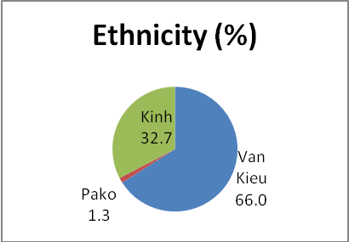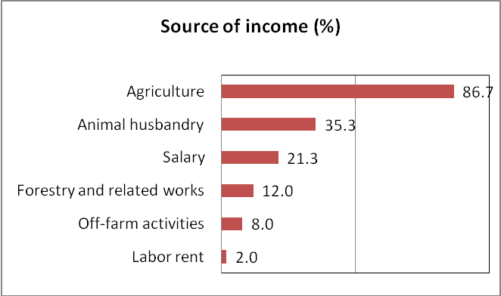
Component 1 Objective: Access to Hygienic Latrines
Performance assessment:
The Hygiene and Sanitation Improvement Project in Dakrong District was successful in reaching the target of 25% of the total number of households or 400 latrines/1479 households to purchase new hygienic latrines over three years. In March 2009, the household coverage had exceeded the target with 32% of households with hygienic latrines. However, improving coverage to poor households was less effective and less than 30% of households who invested in latrines were poor.
Demonstration latrines are a valuable tool in improving leverage and persuading people to invest in latrines. However, the Project target of 48 demonstration latrines was not reached and only 35 were constructed. The majority of these demonstration latrines were not constructed in poor villages, which was cited by some poor households as one reason they had not the incentive to invest in the latrines. They commented that they were not familiar and did not gain the experience with the latrines. Additional efforts for the inclusion of the poor in activities were required.
The network of local promoters was effectively established and Project targets achieved. At commune level 22 promoters were trained and 66 village level promoters were trained.
The Project also had the target to reach an additional 2,000 households who lived outside the Project area. It was not possible to assess the number of outside households who had been influenced by the Project. However, district leaders said that they were developing plans to utilize the project’s social marketing approach in all communes in the district. The Project also influenced other donor/INGO projects carrying out low-cost sanitation in the district, for example the Finnish Rural Development Project and the Save the Children Project. These projects used the low-cost technologies developed by IDE but were unwilling to adopt IDE’s social marketing approach. In addition, a group of villages from neighbouring Dakrong commune, outside the Project area, had visited project sites and over 20 households had constructed latrines promoted by the IDE Project.
The performance and success of increased coverage of latrines varied widely across Project communes and villages. Key factors affecting performance were poverty status in villages, access to building materials, the commitment and pro-activeness of key implementations such as the commune implementing committee and village leaders, and the awareness of local people.
Nearly all participants in the focus group discussions with latrine owners acknowledged that the latrines promoted by the Project were practical, good technical design and affordable. Technical construction was simple and local people could easily learn and apply latrine maintenance. There were a few complaints about the quality or disadvantages of the latrines but most issues concentrated on the problem of water availability for the latrines.
In 2009, more than 65% of the surveyed households reported using their household latrine for defecation and 4% used their neighbours’ latrines. In June 2006, below 40% of households were using latrines. This was a significant increase in a relatively short period of time and reflects the effect of the hygiene behavior change programme. Other donor and INGO projects in the communes had not provided IEC.
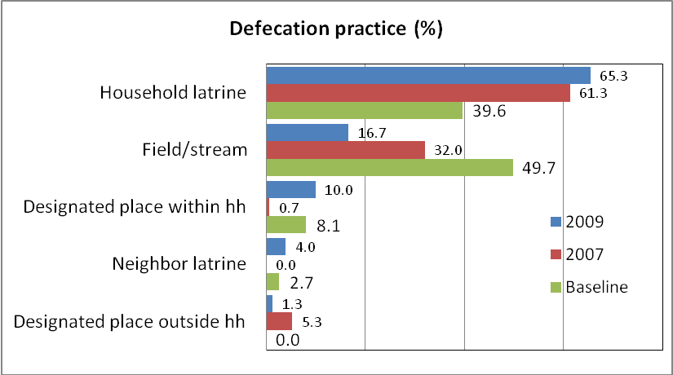
Assessment of the IDE Approach
There was good evidence that the market based approach promoted by the Project was appropriate for a poor mountainous district with a majority population of ethnic minority groups. The Project carried out an incremental approach to communicate information and technology options, which ensured the absorption by villagers. This approach was practical given the difficulties of local people including the poverty status, poor infrastructure (road, water supply access and lack of construction material)
Key project interventions included education, communication and advertisement campaigns. Interventions were directed to the key target groups including households on the demand side and a group of masons on the supply side. Meetings of villagers were conducted by village health staff to communicate key information about the Project and hygienic sanitation.
The Project utilized local government administrative structures and did not create a parallel implementation structure. Staff from the health service at district, commune and village levels (promoters) implemented most Project activities. This helped build capacity in the Project area and the sustainability of Project approaches and processes. However, one challenge was village promoters often paid more attention to households with the potential to invest in latrines, which were the better off households or local leaders and civil servants. The lack of pro-poor targeting was one negative impact of the programme.
The Project approach was to develop the demand side and supply side of the market. However, there was only a limited focus on strengthening institutional arrangements in the different government agencies carrying out rural water supply and sanitation activities and help develop an enabling environment for social marketing and market development. As a result, some departments and agencies carrying out sanitation activities did not have knowledge or understand the IDE approach. Donor/INGO projects had different partners as implementing agencies, for example the Department of Agriculture and Rural Development and Department of Planning, and these implementing agencies had little understanding of the IDE approach. Lack of an effective coordination mechanism exacerbated this problem.
This also impacted on the IDE Project implementation in some cases. For example, in one commune IDE promoted the purchase of pour flush latrines by local people. In contrast, the Finnish Project subsidized different types of latrines (45 latrines were fully subsided in Huc Nghi commune in 2008 and another 40 latrines were to be supplied in Huong Nghiep commune during 2009). This sent conflicting messages to the community, and resulted in some households deciding not to invest in latrines and wait until they received a subsidy.
Component 2 Objective: Hygiene Behavior Change
Performance of hygiene practice
The Hygiene and Sanitation Improvement Project in Dakrong District was successful in using communication and awareness raising in changing the attitude and behaviour of local people. Outreach of hygiene behavior change was planned at 100% of households in the Project area. All respondents in the small group discussions reported that every day they carried out the hygiene practices learnt in meetings organized by the Project, such as hand washing and proper latrine use. From 2007 to 2009 there was a significant increase in people washing their hands because they believed it was good for their health, which reflected the positive impact from the hygiene behaviour change programme.
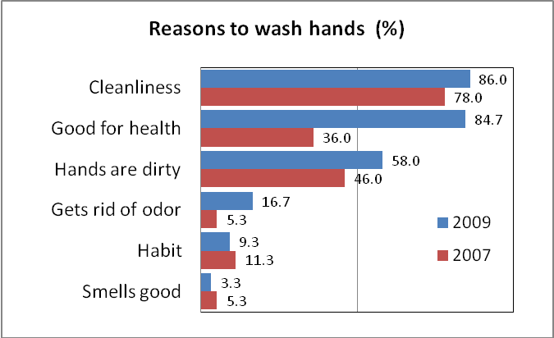
Household Meetings
Household meetings were an effective method for delivering IEC activities and encourage households to construct latrine and practice hand washing. The Project achieved its target in outreaching to men and women in the four communes. Fifty potential customer meetings were organized with men in the four communes with 1,404 participants, and 42 health education meetings were organized for women with 1,260 participants.
The four communes had different ways to deliver IEC activities. In Mo O and Trieu Nguyen, separate household meetings were conducted for latrine and hygiene and organized with a small group of households. In Huong Hiep and Huc Nghi communes, latrine and hygiene messages were integrated into regular village meetings or meetings of the Women’s or Youth Union. 209 meetings were organized in this way and reached 5,487 people. However, the fieldwork identified that separate meetings on each topic were more effective.
There was good evidence that the men, women, poor and ethnic minority households, children, and old people participated in IDE hygiene behavior change activities (See Annex 5). During discussions, all groups had shown interest, concerns, understanding of the usefulness of latrines, their motivations to purchase latrine, and the advantages of the IDE approach. From the survey results, there was a remarkable increase in the knowledge about hygienic latrines. Over 80% of households reported the latrine should have no odour, look clean and have a roof. This was a significant increase since the 2007 survey and indicated households’ rising expectations about the characteristics of a hygienic latrine.

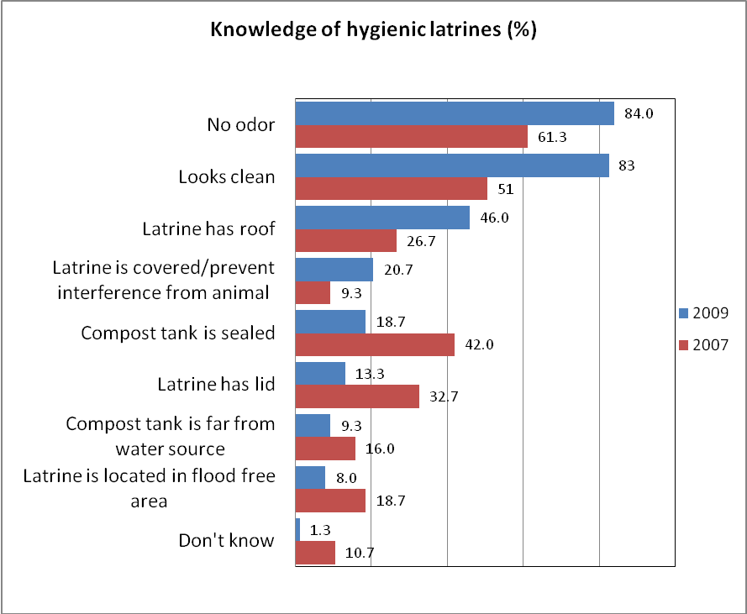
Training Events
The Project provided training courses for target groups: masons, promoters and villagers. Participants of courses who were interviewed said that the training events were appropriate and relevant. In some cases, villagers could not remember clearly all the content, but most villagers had absorbed the key messages from the training course. More women could remember and repeat messages than men. The changed attitude and openness of women in discussion on sometimes sensitive topics about hygiene was a positive impact from the Project.
Training of local promoters at village level was more effective at village level than commune and district levels. There were 8 training meetings between June 2006 and March 2009 held for village promoters and 161 participants (122% of Project target) and 1 training meeting for commune and district which represented 31% of the target.
Recall of the content of the community meetings was one method to help assess the quality of promotion campaign. From the qualitative fieldwork, nearly 93% of villagers said that they attended promotional meetings on hygiene. The survey results indicated significant differences between 2009 and 2007. In 2009, over 20% less people could recall the content of promotional meetings including topics on latrine models, impact on health caused by feces and nearly 10% less people could recall about disease transmission routes. Follow-up activities by promoters and masons may have ensured that key messages were better absorbed by villagers.
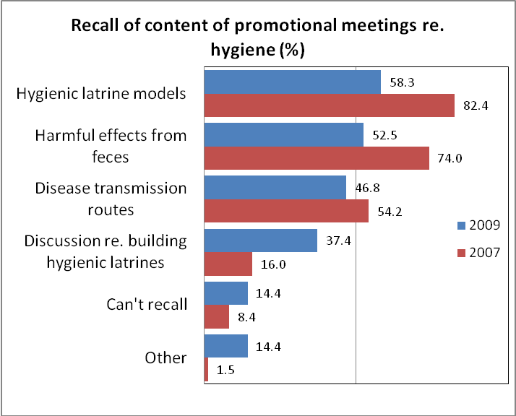
IEC materials
In general, leaflet and posters were well designed and relevant to culture nuances of the Van Kieu and Paco ethnic minority groups. IDE had allocated resources and significant effort to ensure the ethnic minority groups could access the information. The key messages were delivered mainly through well–designed pictures and were easily understandable for local people.
Most Project targets were achieved including 2,000 leaflets and 500 posters delivered to communes, villages and households. Key messages broadcast on TV achieved only 40% of the Project target.
Flyers were used to follow up on household and community meetings. Recall on latrine models was lower in 2009 than in 2007, which was similar to the finding from the survey regarding recall on content on promotional meetings. Reasons for this finding include a lack of follow-up activities after meetings and the distribution of flyers and the Project focus had shifted to the construction of latrines after the promotional meetings and distribution of flyers in 2007. A key point is the M&E system should have identified this problem when it emerged and IDE and partners taken actions to improve the absorption of the information.

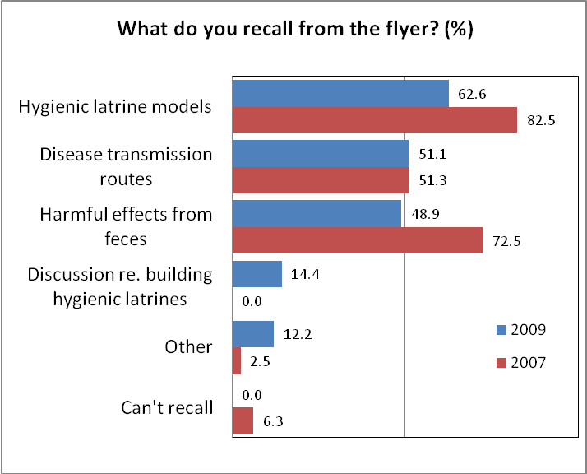

Component 3 Objective: Development of Local Private Sector Network
Twelve masons were trained on latrine construction by the Hygiene and Sanitation Improvement Project in Dakrong District. So far, nearly 80% of latrines in the four communes were built by these masons. The Project was also successful in developing modalities for private construction suppliers to trade with masons and villagers. However, these modalities should have been developed sooner. Some opportunities to increase coverage were missed because of the lack of coordination of the behavior change programme and local availability of building materials. Some households were motivated to invest in latrines but at the time it was too difficult to purchase the materials for construction.
Presently, six masons were also the construction material supplier. This was a good development as it resolves the key issue of material supply for the long-term and helps sustainability. It also helps motivate households to invest as they do not need to worry about the transportation of building materials.
From the qualitative fieldwork, villagers assessed that all masons trained by the Project provided good quality services. Some masons had been invited to construct latrines in non–project commune, such as Dakrong commune. Villagers were satisfied with the quality of work and the attitude of the masons during the delivery of services.
The network of masons could be further developed. Presently, masons work independently. Masons deliver services upon the request of households on a contract or by arrangement with the Project coordinator (the health official in commune clinic). Very few masons act as promoters in encouraging households to build latrine. Less than 10% of households found about latrines through communicating with masons. It may have been more effective if the network of masons was strengthened and more pro-active in social marketing, experience sharing, and household visiting.
In comparisons from 2009 and 2007, there was little difference in the satisfaction of households with the work of masons. Nearly 95% of households were satisfied and less than 5% had problems. The good quality work carried out by masons indicates relevant and practical training was provided to the masons by the Project and masons apply this training in their work. The high level of satisfaction will also help to develop the market as more people will be confident that the masons can be trusted to provide latrines which will service households for the long-term. As a result more people will invest.
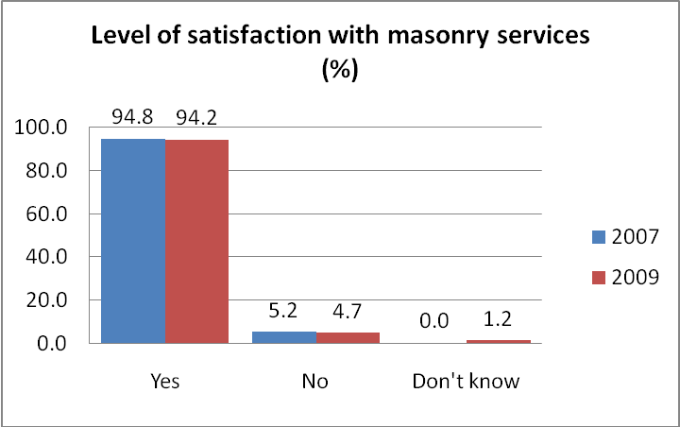
In 2007 and 2009, local authorities were the most popular way to access information about masons. In 2009, 11% of household found out about masons through relatives and 18% through neighbours. This means that after Project completion, most households will be able to access masons through local sources of information, which will help ensure the sustainability of the IDE approach.
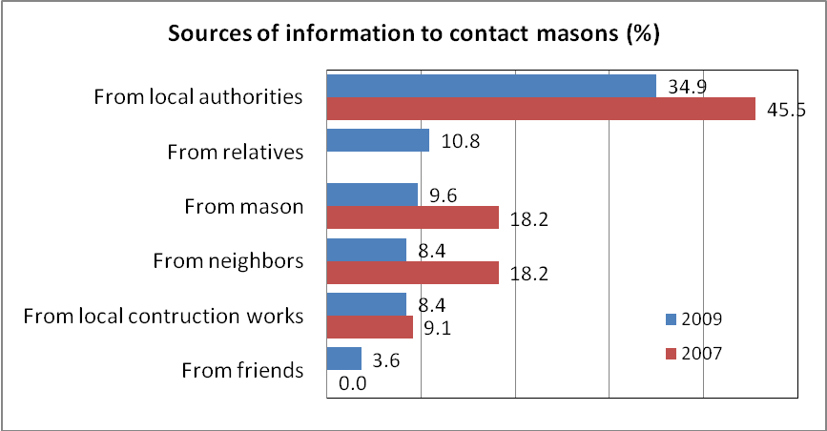

Masons interviewed said that they received income of 120,000VND/day when building a house and a negotiated income of 80,000 VND/day when they built a latrine. The masons said that constructing latrines was less income for them but much more personally fulfilling. They enjoyed helping people and would continue working in the hygienic sanitation market. In 2008 and 2009, 45% of survey respondents said Project trained masons constructed their latrines. However, only 83 households responded to this question. Findings from the qualitative fieldwork, IDE and local statistics indicated that Project trained masons constructed about 80% of latrines in the Project area. This finding was more representative of the local situation. Some interviewed households confirmed that to save money they dug the pit for the tank and helped the mason during construction. All households said they did not have the capacity to construct the latrine themselves and needed to contract the mason. The survey result below indicated that over 20% of households constructed latrines. This most likely refers to households with the labour and capacity to help the mason during construction.

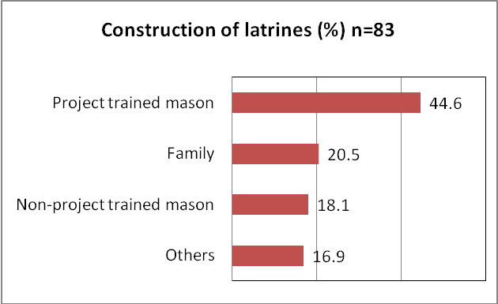

- EVALUATION COMPONENTS

  - Effectiveness
The Hygiene and Sanitation Improvement Project in Dakrong District has achieved its main outcomes. The total number of latrines built between September 2006 and February was 434, well exceeding the project’s target of 400 latrines. Compared to baseline data, the overall rate of latrine coverage has increased 32% in the Project area, while the Project target was 27% coverage increase.
There was good evidence that the Project contributed substantially to improving the confidence of local partners at district and commune levels and the community in the social marketing approach. During interviews, leaders, civil servants and local people confirmed that they had limited confidence in the success of the approach at the beginning of the Project. Their past experience involved the provision of subsidies as the main delivery and targeting mechanism. An unforeseen and positive result of the Project was practical results from interventions helped change the perspectives of leaders, civil servants and the community. Presently they were strong advocates of social marketing and the IDE approach.
Another unforeseen result was the influence that other donor/INGO projects had in the Project area. These projects provided subsidies for poor households for the provision of latrines and this had a negative impact on the up-take of the social marketing and market based approaches.
There had been active participation from the district Health Protection Centre and its network at commune and village levels, the Women’s Union, Farmer’s Union and People’s Committees. Committee meetings were held every month and informal meetings quickly arranged when an issue emerged that required an immediate response.
No financial analysis or assessment of costs was conducted during the assignment. However, for all procurements and service costs proper procedures were followed.
The hygiene behavior change campaigns had a positive effect in the villages. During the three year implementation period, 50 meetings for men with 1,404 participants and 42 meetings for women with 1,203 participants were conducted. Over 1000 household visits had been made by village promoters.
Since the baseline survey, the effect of hygiene behavior change campaigns has been impressive. In 2009, most households knew hygienic sanitary latrine designs: Pour-Flush (suilabh) (87.3%), Septic tank (77.3%). However, as indicated above, the number of households who could recall information about the associated hygiene aspects had significantly reduced in 2009. A balance of information on hardware and hygiene using the communication tools during project implementation should have been delivered to households.
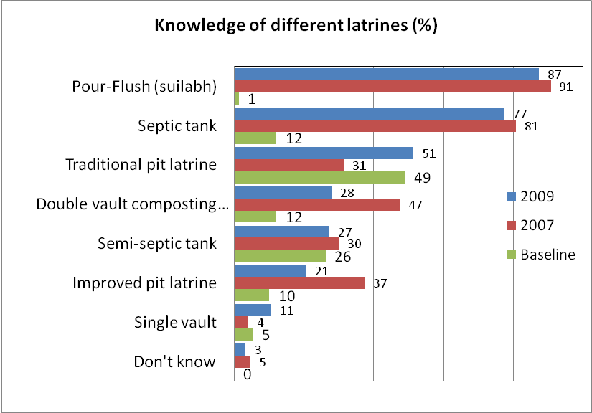
During fieldwork, respondents who had not constructed latrines said that the hygiene campaigns motivated them to construct latrines but there were three main constraints: not enough money; limited water access to use pour flush latrines; and waiting to build a new house and latrine together. Interviewees were committed to build latrines and willing to borrow funds if loans were available. Most interviewees from poor households (women and men) confirmed their willingness and stated that they would be able to repay the debt (600,000 VND to 1,000,000VND) over a period of two years (see Annex 5).
The quantitative survey showed three main reasons for lack of household planning to build latrines including waiting for subsidy, considered that it was not yet necessary, and it was more convenient to go to the toilet outside. There is still a need for awareness raising and examining different strategies to reach to this group. It also reflects the remnants of a reliance on government subsidies. The present subsidies for latrines provided by other projects exacerbated this problem. Better coordination by the provincial and district steering committees for RWSS was required so that the sector developed in a consistent and efficient way and resolved problems like this.
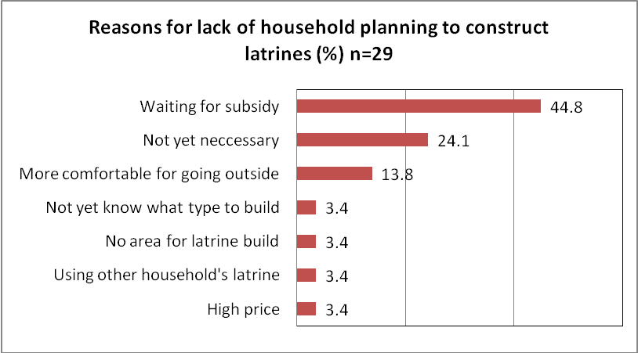
The Project designed simple and practical formats to record and monitor the outcome of household meetings and household visits. However the information from the system was not used effectively to identify emerging problems and challenges. Sometimes this resulted in delays in construction and implementation of activities as solutions to problems were negotiated.
Nearly all households were satisfied with the quality of construction by the masons trained by the Project and masons not-trained by the Project. As a result, households had the confidence in the local masons to recommend them to friends. This word of mouth method was the most practical and sustainable way to develop the local market for hygienic latrines.
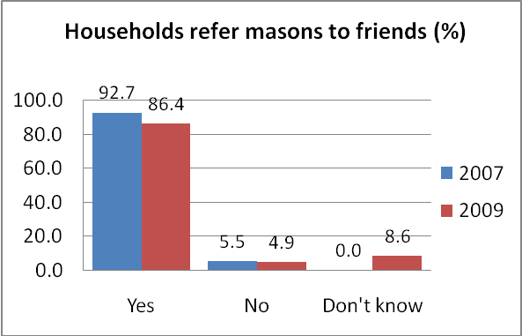

  - Efficiency
All Project activities were implemented according to the Project schedule. Fund transfers had been undertaken in a timely manner and the financial management system was considered by Project partners as flexible and no major problems were encountered. Project resources and executed expenditures were adequate for the achieved results
Project resources and executed expenditures leveraged increased household investment in sanitation. Results of the baseline survey indicated that there was no expenditure on sanitation. Respondents in the household survey conducted in 2009 said that they invested 1.3% of total expenditure into latrine construction and 2.7% of total expenditure as a second priority. Many households are poor or near poor and developing their awareness and confidence to invest in hygienic sanitation was a challenge. The allocation of 1.3% of annual expenditure was a significant increase in a short period of time and indicates an impressive result from the behavior change campaign, the practical low-cost technology options suitable for local conditions, and the good quality service provided by the masons.

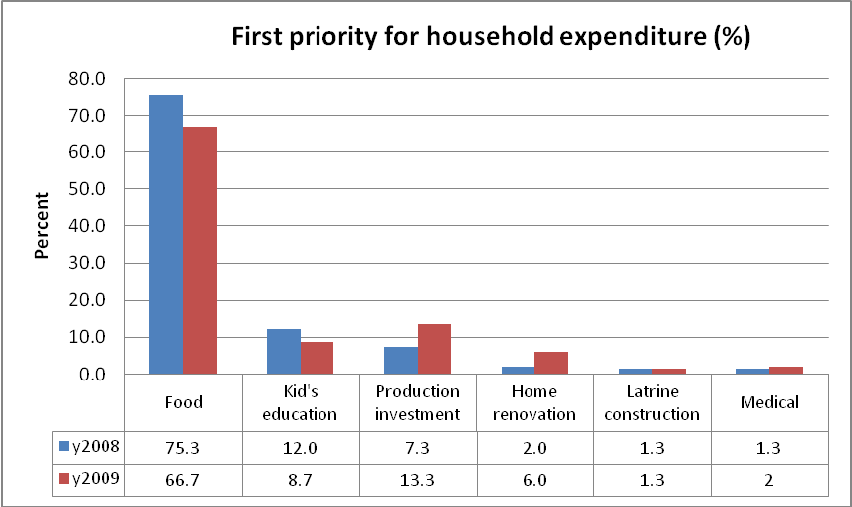

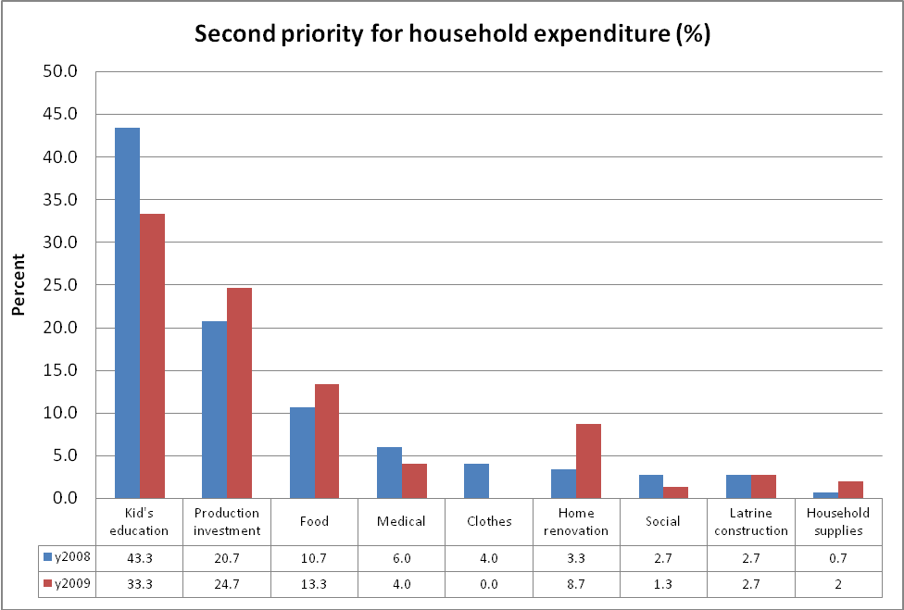

Villagers who borrow funds to construct latrines mainly borrowed from the Bank for Social Policy, which provided low-interest loans for clean water supply and sanitation. Relatives and friends were also important sources of credit. However, only 28 interviewees responded to this question during the survey and the qualitative fieldwork indicated that most poor and non-poor households did not have information about credit sources for hygienic sanitation and did not know how to access this information.

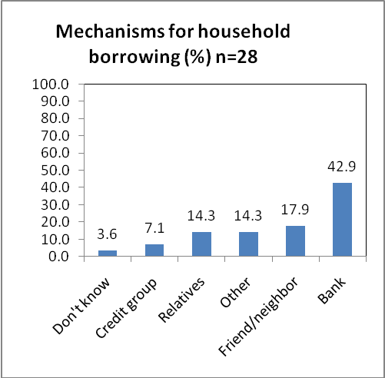
An annual Project implementation plan was prepared by the District Steering Committee in consultation with Project staff, IDE staff and commune leaders and civil servants. The annual implementation plan included action plans for each commune and activity plans for each district implementation agency. The commune action plans provided specific targets for latrines and number of hygiene behaviour change activities for the year. Commune implementation committees developed strategic plans to carry out the activities and allocate target to villages. These plans were developed in conjunction with the preparation of the annual socio-economic development plans.
  - Impact
Impact on hygiene and sanitation
An important Project impact was improved hygiene and sanitation conditions in all households in the Project sites. Hygienic practices were institutionalized in most households. Hygienic use of latrines was a key indicator during the evaluation of “culture village” awards. This national award programme was managed by the government and mass associations to promote better public health and safety, protect the ecology and environment and improve local awareness about public places and assets. The award increased the prestige “uy tin” of the village and villagers and the village accesses increased resources for activities such as operations and maintenance of public areas and rubbish bins. The use of hygienic latrines has improved the health security for all members in households, especially for women and children. Women and children were no longer worried about rain and bad weather which caused inconvenience in the past.
During the three year Project implementation period, the awareness and behaviour of villagers had changed. Before the Project, there were no hygienic latrines in the community. Villagers were accustomed with open defecation. Presently, the advantages of using latrines were openly discussed. People understood the disadvantages of open defecation, and reduced social acceptance had also placed pressure on villagers to change behaviour and invest in household latrines.
Results from the household survey showed significant improvement from the baseline survey to the present about reasons people build latrines. In 2009, 92% of interviewees were well aware that cleanliness was important and a main incentive to build a latrine. This increase reflected the impact of the hygiene behaviour change programme and the effectiveness of the communication strategies used by promoters to motivate households to invest in latrines.

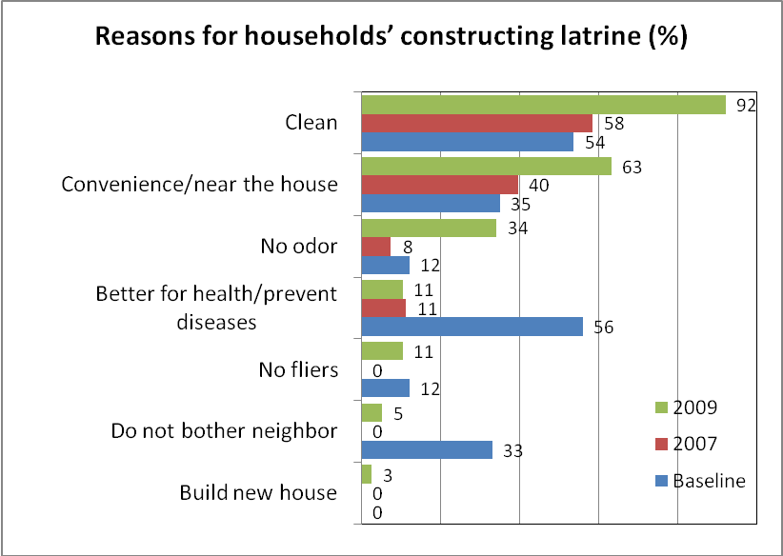

A cleaner environment was acknowledged by interviewees as an important impact. In commune Mo O and Trieu Nguyen communes, villagers and commune leaders and civil servants confirmed a cleaner environment in public places such as schools, health stations, market places and the main roads to villages.
District statistics were not reviewed but during interviews leaders and civil servants from the District Preventive Healthcare Centre and commune and village health stations said that the incidence of diseases such as diarrhea, cold and malaria had significantly decreased as a result of the hygiene behaviour change campaigns.
Hygiene behaviour change campaigns included direct communication in community meetings, interpersonal visits and meetings, awareness campaigns via the mass media, provincial sponsored TV news items, commune and village loudspeaker systems, public banners, and village contests and community public events. Almost all interviewees could speak in detail on gained knowledge about hygiene, and confirmed they applied the knowledge in their daily lives (See Annex 5). However, as indicated above, they could not recall specific details from the different communication tools.

The Project had been successful in introducing the market based approach. This was impressive. The approach had been applied in lowland areas but Dakrong was a poor mountainous district lacking infrastructure and a majority of ethnic minority groups, which posed particular challenges. IDE was effective in developing materials and processes to respond to the needs of the ethnic minority groups.
Local people were familiar with subsided services. Paying for access to hygienic sanitation was new and “strange” for local people at the beginning of the Project. However, the Project was successful in persuading people that purchasing latrines was practical and sustainable. Some interviewees indicated that they preferred to pay for building their latrine because they could supervise the building process and ensure the quality of construction. In this way the latrine was more durable. For subsidized latrines, they did not have this control.
In 2009, over 70% of respondents in the survey self-funded their latrines and under 30% received full or partial subsidy for latrines. Over 60% of households received a full subsidy and 40% a partial subsidy. The high level of self-funded investment reflected confidence in the market based approach promoted by IDE. Most of these households were better off households. The IDE approach did not include an explicit pro-poor targeting objective.

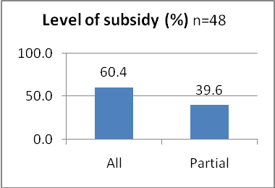
The introduction and institutionalization of the market based approach was a transitional process. Awareness and confidence building activities were focused on the community and over time people changed their hygiene behaviour. Other donor and INGO projects that provided grants for latrines complicated the process.
In addition, the consultant team visited a non-project commune and found that the delivery of hygienic sanitation including latrines and IEC was inconsistent.

Unwillingness to pay for latrine purchase in non–project commune
In our commune, there were no latrines until last year when the Finnish Project granted 20 household latrines. All villagers often open defecated. Recipients of latrine contributed nothing except labour to carry the building materials and dig the holes. This year, another INGO project came to the commune with support for household latrines but only double-vault dry latrines were provided. Some households did not want to receive the latrine because this type of latrine was smelly. But we were not permitted to change to other types of latrines. You see, even households that could receive a latrine as a grant do not want it. I am sure that if we encourage them to pay to purchase the materials and build latrines, they will never pay.
Interview with Chairwoman of Women Union, and health staff in Dak Krong commune.

Deciding to build a latrine was a long process for many households, especially the poor. The process often required consideration and calculation of cost and effects, and prioritizing the household’s needs and demands (See Annex5). Restructuring household expenditure to include investment in a latrine often required negotiation between wife and husband, and between children and parents. Most interviewees said that they saved for a long time to build the latrine. During this time, there had been emergencies that had delayed the latrine investment.
All respondents in the 2009 household survey reported that to build a latrine their families reduced home expenditure on home appliances. Under 20% of interviewees reduced spending on food and less than 5% reduced spending on education. Food and education remained main priorities for household expenditure. Only 3% of surveyed households reduced expenditure on clothes.

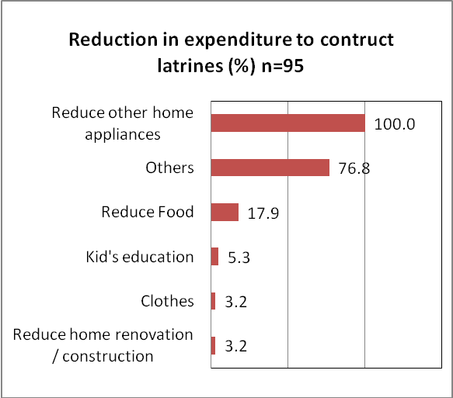

Gender impacts
Gender issues were mainstreamed in many Project activities. In some communes, the implementing committee employed Women’s Union members as promoters and used their network to disseminate hygiene behaviour change messages. Messages were delivered to women. Many households took a long time to decide to build a latrine and save the money. Women were often the key person with persistence and commitment to latrine construction. Women often restructured household expenditure to manage the savings for the latrine investment. This was a positive impact and increased the capacity of women in household’s priority management and affirmed the role and position of women in the household and community.

With commitment – poor households can save money for latrines
I am the first person in my family who raised the idea to build a latrine. I attended a meeting in the village where the official from district health centre introduced the advantages of latrine use. I realized that hygienic latrines were very useful for my family as I have 3 children. My husband did not agree in the beginning, and I had to find the solution to persuade him. When he agreed, we started saving. I saved 30,000 VND per month. I could have saved faster if my husband didn’t go to drink beer with friends so often. It took me about a year to save the 400,000 VND. To save this amount I cut down expenditure of daily food and persuaded my husband to reduce drinking with friends. We still have a debt of 200,000 VND and we are saving to repay the debt. I am happy that I could save and invest to improve our living facilities. My children are happy also.
Interview of poor women in Mo o commune
From the survey, about half of the interviewed households reported family discussion was the main method to decide to invest and the design of the latrine construction. About 30% of men made the decision to invest and the design of the latrines, while about 20% of women made these decisions.
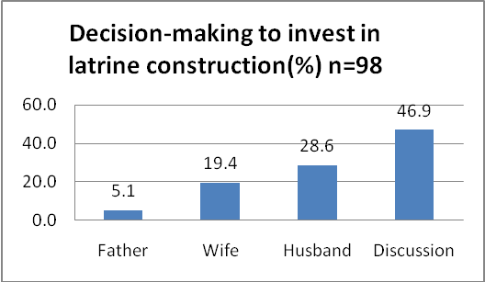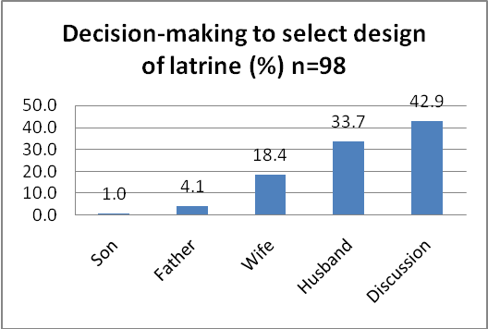

In many cases, women often raised the demand and were proactive in household discussions about latrine construction. In some households, where decisions were often made by the husband, women could not persuade their husband to invest in latrines. However, in most cases, women strengthened their role in household decision making and the household decided to construct a latrine. Women also had better recall on the content of meetings and flyers and used this knowledge to improve the health and well-being of their families. However, both men and women had knowledge about the different types and cost of latrines.
Impact on market
A main Project focus was the development of the market for hygienic latrines. A reliable and experienced group of masons was established in each commune. Local people considered the masons provided good quality services. However, the Project had not developed or promoted a system of options for supply of building materials. In at least two Project communes, there were no suppliers of building material. For example, in Huc Nghi commune (about 40 km away from the district town), the market arrangement for building materials was weak. During three years, more than 40 latrines had been built. Project staff and commune health staff were the key persons in building material supply including price and transportations. One result was a very high price for latrines, nearly 900,000 VND / household, while the price in Mo O and Huong Nghiep communes (near the district town) was 600,000 VND. Weak building material markets, high transportation costs and poor market arrangements in some areas were key factors that undermined the market based approach.
Over half the households surveyed selected a latrine priced between 301 thousand to 1.5 million VND, 21.8% selected price between 1.5 million VND to 3 million VND and 14.9% with a higher price. Compared to mid-term evaluation survey, more people selected latrines with a higher price.
The majority of constructed latrines were priced between 301 thousand to 1.5 million VND. This reflected the low average income of villagers and the high rate of poverty. However, both poor and non-poor households had invested in latrines over 300,000 VND, which indicated that poor households were convinced in the advantages of the hygienic latrines even though it was a significant expense for them.

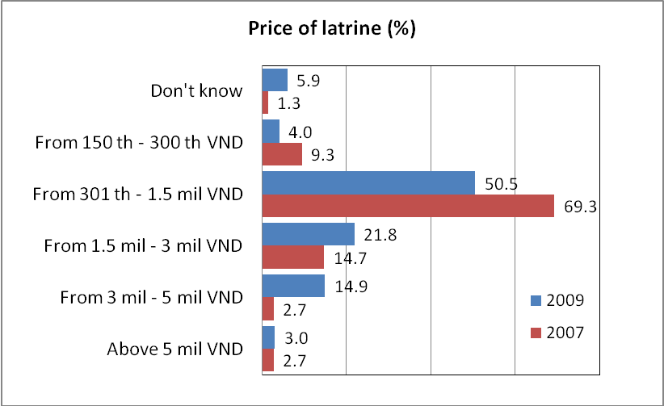

  - Sustainability

The Project used existing government structures for implementing most activities, such as promoters were often village health officials or women’s union, and local village masons to provide services. This approach helped improve the sustainability of Project interventions and approach.
Promoters received an allowance for 20,000 VND/month from the Project. This was not much but interviewed promoters said the work was personally fulfilling and they liked to help people because the work had a practical result. District level partners received an allowance to 100,000 VND/month. They were clearly motivated by the practical results of the Project, which could be used by the district for future WES planning.
Village promoters were the key persons driving the Project. They were well trained by the Project to carry out social marketing activities. All interviewed promoters confirmed that they would continue to carry out social marketing activities after the Project finished. They considered the work fulfilling, increased their local prestige and was practical. However, the Project has not yet developed additional activities to support the promoters in the exit strategy. Project staff should cooperate with local authorities to develop a coaching plan for promoters, to regularly update promoters and train new promoters after the completion of the project.
District and commune leaders and civil servants and village leaders were involved in the administration of the Project. These people were committed to the Project approach and it will be their political will that ensures activities and approaches introduced by the Project were continued after Project completion.
Commune People’s Committee included Project planning and activities into the working agenda of the commune socio-economic development plan, the main management tool in each commune. This was a good indication that the Project was integrating into government systems and sustainable.
Subsidies from government and donor/INGO projects impacted on the sustainability of the Project approach. Local people kept in mind that they ‘should be’ and ‘will be’ supported by the government or donor projects. Some households preferred to wait for this support than working and saving for the purchase of the latrine (See Annex 5).
From the results from three Project surveys, the number of households who were very satisfied with the investment in latrines increased by 300%. In 2009, very few households were dissatisfied with their investment compared to the baseline survey.

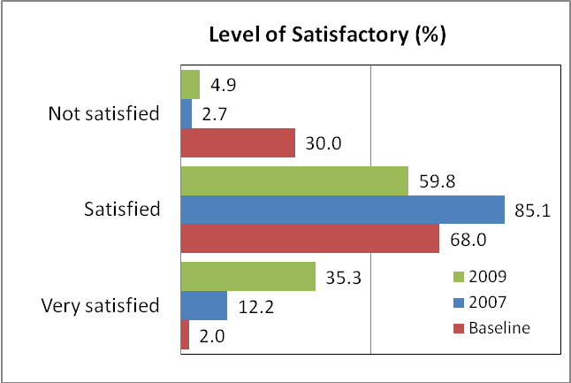

In the 2009 survey, respondents liked their latrine because it was clean 89.2%, provided privacy 55.9%, and was convenient 52%. This was one long-term result from the hygiene behaviour change campaign.

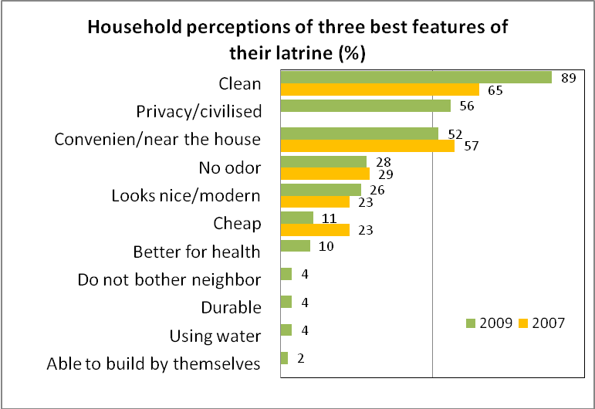

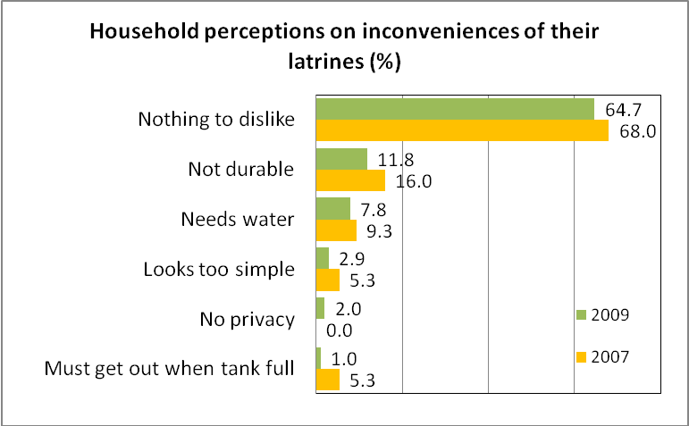

From the 2009 survey, over 92% considered the latrine was easy to maintain and only 8% considered the latrine was not easy to maintain. 36.7% of surveyed households reported they composted in the latrine tank and made a new latrine tank when it was full, and 21% of households hired people to remove the waste. However 19.3% people reported that they do not know how to maintain their latrines. This is quite high and IDE and partners need to organise activities so that all households understood and carried out maintenance of their latrine. This will extend the use life of the latrine and reduce repair costs.
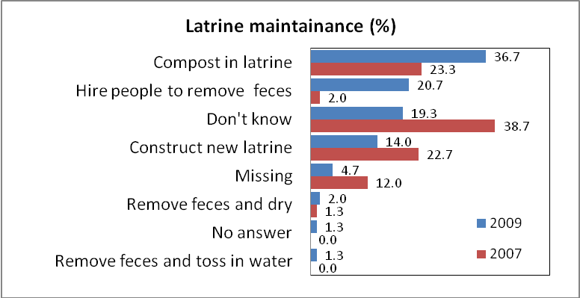
Project activities had influenced the awareness and knowledge of villagers about low-cost sanitation and hygiene. Over 32% of households have invested in latrines already. Many households have committed to build a latrine in the future. From the 2009, 81% of respondents intended to build a latrine. Reviewing the previous two surveys, there was a trend where more interviewees reported the intention to build a latrine. From the 2009 survey, the number of households who committed to build a latrine next year for sure increased substantially reflecting results of social marketing.

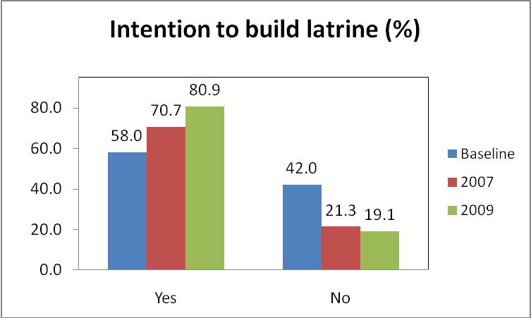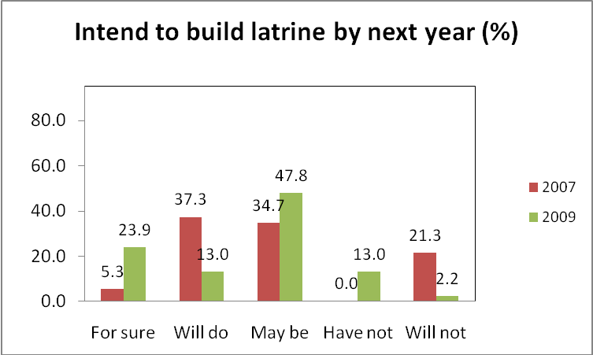

  - Relevance & Appropriateness

Relevance of policy environment
The Project approach and activities accord with the National Strategy for Rural Water Supply and Sanitation and are relevant to national and provincial policies. These policies promote improving access to clean water, household latrines, and hygiene and sanitation. In recent years, national results towards sanitation coverage targets have not been achieved and significantly lagged behind clean water coverage. By 2010 the national target is 70% of rural households own hygienic latrines. The Hygiene and Sanitation Improvement Project in Dakrong district provided a practical and sustainable model for effectively increasing sanitation coverage in rural regions, and especially for ethnic minority groups and poor areas. The model has been successful in the following ways:
- Rural households, including the poor and ethnic minority households in remote and extreme socio-economic disadvantage could manage to save and build a latrine using their own resources
- Technical options (type of latrine) are appropriate and durable and price is low-cost and reasonable
- Interventions are based at community level. Local authorities manage the implementation process and are proactive in developing ways to effectively carry out the social marketing approach.
Technical options proposed by Project have been widely accepted by local villagers. In 2009, most surveyed households were aware of hygienic sanitary latrine designs.
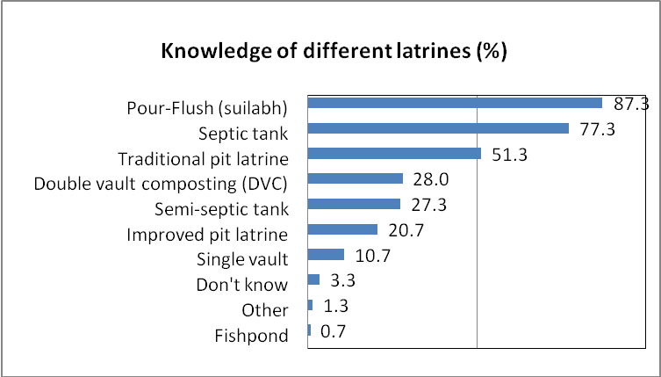

In 2009, the septic tank and pour-flush were understood by most households as the best hygienic latrine.
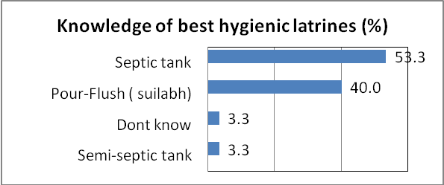
The delivered knowledge about different latrines was used during the selection of latrines. As a result most households invested in septic and pour-flush latrines. This was a significant change since the baseline survey and indicated the absorption of information from the hygiene behavior change campaign.

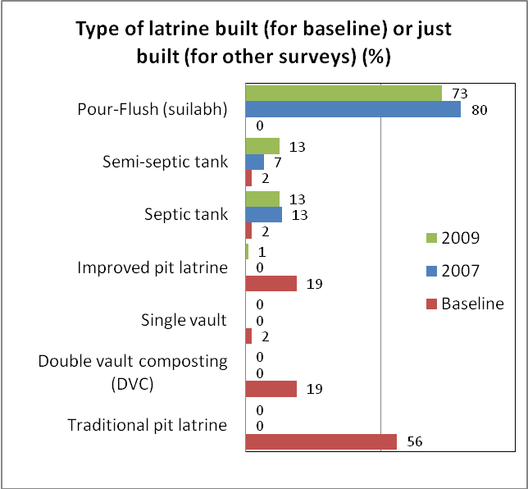

In recent years, nearly all households were satisfied with masonry service, which indicates the relevance of training provided to masons and the level of service in the market place.

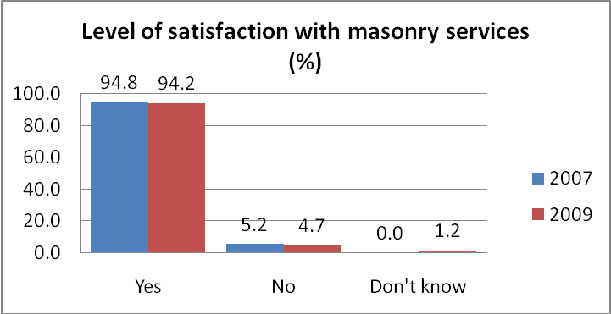

  - Coverage & Targeting
The Project did not explicitly aim to reach and increase the coverage of latrines in poor households. However, pro-poor targeting was a key priority of OHK, the GoV and a Millennium Development Goal. So far, only a limited number of poor households had built latrines. From June 2006 to March 2009, of the 434 households that constructed latrines 139 households were poor. This is less than 30% of total Project coverage.

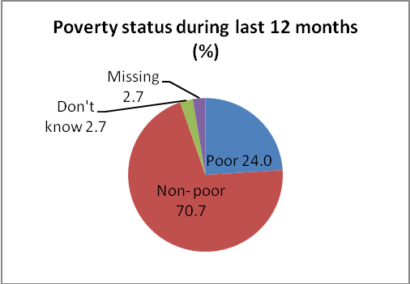

The Project lacked a specific pro-poor targeting mechanism and guideline. The baseline study had a focus on poverty issues but the Project had not designed a plan that prioritized the inclusion of the poor in activities. During the three year implementation of the Project there were the following issues:
- No specific activities targeted to poor groups vs. non- poor groups
- Promoters often delivered more intensive encouragement and promotion to “potential households” which were often non–poor households in the village.
- Project planning was structured from village to district level. Annually, each commune was given targets to achieve. The target often ranged between 5-15 latrines for each village. Reaching this target became the aim of promoters rather than reaching out to poor households. All interviewed promoters confirmed that there were no specific activities tailored for poor and vulnerable groups.
- There was only limited effort provided by promoters and local leaders and civil servants to provide information about access to low-interest credit or relevant methods of saving for the poor and disadvantaged households. In the three visited Project communes, the saving and credit scheme was successful in Mo O commune only. In Mo O commune, households saved about 2/3 of the total cost of latrines (400,000 VND) and were able to buy building materials on credit with the guarantee of the commune health staff. This was very important for poor households to access low-cost sanitation because it takes a long time to save enough money and there are many demands on their scarce resources.
- Increasing coverage to poor households will be difficult. Many of these households are in extreme poverty. They do not have regular income and about 25% of poor households live in remote villages and have no cash income for about 3-4 months during the rainy season. Saving to build a latrine is quite difficult for them.
  - Coordination
There was good coordination vertically and horizontally in the Project implementation structure. From June 2006 to March 2009, the district steering committee met seven times and there were 122 commune steering committee meetings during the same period.
The key implementing partner was the district Health Protection Centre and commune Health Centre. At village level, the promoters carried out Project activities in the community and with households. The promoters held a permanent position and received an allowance from the budget for health care. There were good linkages and information sharing from village to district level. However, this linkage and information sharing did not extend to provincial level.
Technical assistance delivered by IDE to the Project site was prompt and technical demands from Project sites were quickly responded and solutions developed. IDE staff regularly visited the Project site and worked together with local staff in organizing Project activities and events.
The Project Steering Committee was chaired by the deputy chairman of the DPC. However, there was limited coordination with other projects carrying out sanitation activities. As a result, there was limited experience sharing and lessons learnt with other programmes and projects. This hindered the replication of the social marketing approach in other communes in the same district and with other projects and programmes. As a consequence, in some communes, there were different financial mechanisms to promote low-cost sanitation which sent confusing messages to local people.
IDE successfully developed the capacity of key partners at district and commune levels to manage activities using the IDE approach. Through consultations, the DPC, CPCs and IDE acknowledged that there was no need for dedicated formal committees to manage the implementation of the project. Implementation could be carried out through the local government administrative structure and systems. Meetings of key stakeholders at district and commune levels could be arranged when needed. However, partners said IDE should continue to provide technical assistance.

- CONCLUSIONS, LESSONS LEARNT AND RECOMMENDATIONS

The lessons learnt from the Hygiene and Sanitation Improvement Project provided important inputs into the development of a replicable approach to improve sanitation conditions and increased latrine coverage in upland areas of Viet Nam. The following conclusions and recommendations outline these lessons and ways to improve the IDE approach so that it could be better utilized in other areas and by the national development programme, such as by NTP RWSS and P 135 II.

- Conclusions and Lessons Learnt
Institutional Issues
- At the start of the project, meetings were carried out with provincial People’s Committee and Department of Health were carried out. During project closure, provincial leaders assessed that the IDE approach was practical and had the potential for use in other districts and communes. Developing provincial linkages and arrangements during the course of the project would have improved the opportunities for replication.
- IDE has not developed linkages with the Provincial Steering Committee for NTP RWSS II, which would promote the integration of IDE approaches and technology in all RWSS activities in the province.
- The DPC and IDE agreed that there was no need for parallel implementing structures such as the district steering committee or formal commune implementation committees. Government officials are busy and less formal arrangements would be more practical. Meetings could be organized on a needs basis. However, IDE was needed to continue providing technical assistance.
- Cross-learning activities created opportunities to expand the Project approach and technology to other areas, for example, neigbouring Dakrong commune visited the Project area and 20 households constructed latrines using IDE low-cost technology.
- Sharing experiences with other donor/INGO projects was conducted but they did not adopt the IDE approach. Other projects identified that the Hygiene and Sanitation Improvement Project had practical and low-cost sanitation technology but where unwilling to change their financial delivery mechanism and use the social marketing approach.
- The mason network could be improved by training masons so they could carry out household visits themselves and provide information directly to households regarding the advantages of hygienic latrines and at the same time explain the costs. Presently, promoters carry out household visits but masons have a financial incentive to develop the market.
- The mason network was weak in developing the building materials market and providing access to building materials. It is in their interest to develop this market.
- Coordination of access to building materials with hygiene behavior change activities could help develop the low-cost sanitation market.
- The selection process for potential masons could have been better designed to stimulate interest in the sector, and select people most motivated to participate in the latrine construction training programme.
Planning Issues
- IDE has integrated project planning into the socio-economic planning process as much as practical
- IDE has developed an effective reporting and M&E system through the government’s health protection centre network. The M&E system provided reliable data and information on the status and progress of local investment in sanitation and identified emerging problems. However, the system was not integrated into the government RWSS monitoring system recently approved by the Standing Office of the NTP II. Integration into the NTP M&E system could improve the sustainability of the system.
Financial Issues
- Information flows about accessing low-interest loans for sanitation were not developed to village and household levels. This had a significant impact on opportunities for the poor and vulnerable groups to access low-cost hygienic sanitation.
- There was a lack of information sharing in villagers about options to access credit for sanitation, for example 4 million VND through the Bank for Social Policy as part of support from Decision 62.
- In the villages, there was reliance on a limited number of credit and savings options, which limits access to sanitation for the poor and vulnerable groups. Some options had limited feasibility, for example, poor households depositing funds with a mason from a different commune or village.
Technical Issues
- The communication tools (such as IEC materials, household meetings and training events) and the process to carry out the tools was practical and effective. However, the development of promoters was a most successful and efficient way to communicate key messages about the latrines, hygiene and masons to the community. Promoters also provided or facilitated or organized the links in the market chain. Promoters were also local officials and could carry on Project activities after the completion of the Project unlike contracted outsiders. This helped integrate the Project approach into local administrative procedures and planning and so promote sustainability.
- The present IEC materials are good quality but small improvements would ensure they are beneficial for the long-term and provide regular reminders for people.
- The selection process of villagers for training as masons could be improved to enhance sustainability. Women were not encouraged to join the network. Masons constructed good quality latrines but their service coverage in local areas was limited. Three masons or builders labourers from each commune were selected for training. This selection method did not ensure that the masons could cover all villages and would commit to supporting the Project in the medium and long-term.
- It was not planned but women were the main beneficiaries of IEC and community awareness activities. However, decisions about investment in sanitation will mostly involve husband and wife. Husbands were not as involved as women in accessing information about latrines, which sometimes delayed decision-making.
- Targets were exceeded but IDE and partners were slow in developing a response to the lack of building material suppliers, which in some areas had an impact on the cost of materials and reduced the effect of the hygiene behaviour change campaigns. People were motivated by the campaigns but without timely access to building materials some households delayed construction or used their funds on other expenditure. It was also more difficult to increase leverage and persuade people to invest in sanitation.
- There was a lack of follow-up to training for households and masons on latrine maintenance. The result was some households did not know how to maintain their latrines.
Capacity Development Issues
- The capacity of personnel providing Preventative Health Services at district, commune and village levels was significantly enhanced.
- There has been effective impact on the capacity of key people at commune level including village promoters, masons and commune leaders and officials.
- The exit strategy needs to include additional activities so that promoters will be regularly updated with information and new promoters trained after the completion of the Project.
Project Implementation Process
- The Project principle of leaving the provision of sanitation to the very poor and extremely disadvantaged to the GoV social security safety net needs to be reassessed. There are many poor and very poor households that do not benefit from the national target programmes.

- Recommendations
Based on these conclusions and lessons learnt the consultant team developed the following recommendations to improve the replicability of the IDE approach.
Institutional Issues
- IDE should develop institutional arrangements and linkages at provincial, district, commune and village levels and ensure clear information channels, so that Project results and the social marketing approach are regularly shared with decision-makers at all levels, especially provincial level.
- IDE should interact and support the Provincial Steering Committee for NTP RWSS II, which could organize cross-learning activities with other districts, commune and communities and information sharing with other donor/INGO projects. Donor/INGOs are often committed to their own specific approach and disbursement mechanism, which is difficult to change. The role of the Provincial committee is to coordinate all activities in the WES sector and could integrate the social marketing approach into a sector approach.
- Project implementation should be through the GoV administrative system. The role of IDE would focus on the provision of technical assistance such as capacity development, community awareness and M&E.
- To develop access to building materials, with the support of IDE, the mason network should develop a range of options. For example, a commune could be divided into regions and one or two households in each region encouraged to develop building supply businesses; the network could develop a business relationship with a building supplier in the district and negotiate a short-term credit facility; and masons could function as an agent where households submitted deposits with the mason until sufficient money was saved to purchase the building materials.
- To improve the sustainability of the mason network, the selection process for masons should be improved. For example, IDE could carry out an initial visit to villages and assess the number and quality of local masons. During the visit, IDE would ensure that the community was aware of the opportunities for women to join the network. IDE and partners could carry out a campaign in villages explaining the low-cost sanitation, hygiene behaviour change and the role of masons. A competition should be conducted and local people motivated to answer a list of twenty questions related to the role of masons and the market. Women would be encouraged to enter the competition. During the process, local people would ask questions and increase their awareness about campaign issues. The winners of the competition would participate in the latrine construction training programme.
Planning and M&E Issues
- The M&E system developed by IDE should be integrated into the government monitoring system.
Financial Issues
- IDE should cooperate with local authorities and develop information channels about access to low-interest credit for the community, especially the poor. Low interest credit for hygienic sanitation is provided by the Social Policy Bank as part of the Decision 62 programme.
- IDE should cooperate with local authorities and develop information channels about other financial sources for hygienic sanitation such as P 135 II, P 134, NTP RWSS and 61 Poorest Districts Programme.
- IDE should promote a more flexible and broader range of credit and savings options so that the poor and vulnerable groups can access sanitation. The village needs to be the focus of these options. People have closer relationships with each other, affected by each others’ decisions and the level of trust is higher. In one village, people and organizations could be identified who could hold savings from poor households, for example, the village leader, masons, promoters, health centre personnel and households with local prestige ‘uy tin’.
Technical Issues
- IEC materials should be printed on one side of the paper so they can be glued in convenient places and provide constant reminders.
- Special activities should be designed and conducted to increase the awareness of men about sanitation.
- IDE and partners to provide follow-up to training on latrine maintenance and information to households about latrine maintenance and provide guidance to households carry out this maintenance.
Capacity Development Issues
- The Project should cooperate with local authorities to include in the exit strategy a coaching plan for promoters. Local authorities should organize activities so that promoters will be regularly updated and new promoters trained.
- The district and commune health centres carried out general training sessions which included all local stakeholders. IDE and partners should develop local capacity so that quality meetings will be specifically focused at households and small groups.
- The mason network should receive additional capacity development so they can directly visit households and explain the advantages and costs of low-cost sanitation.
Project Implementation Process
A two stage implementation process would help target the poor and very poor. More research would be required and a detailed roadmap developed, however, the two stages could include the following:
- The first stage would be similar to the present process carried out by IDE and local partners (with the inclusion of the recommendations above). Some households would become mentors of households in stage two.
- The second stage would continue to promote sanitation for all villagers but focus on the poor and very poor. Special IEC materials for the poor and men may be needed, information about savings and credit options will be disseminated. If IDE is unable to carry out this stage, an INGO/NGO or pCERWASS should be considered to take responsibility for the specific pro-poor targeting.

ANNEX 1: Terms of reference

 | House #6, ngo 161, Thai Ha, Dong Da, Ha Noi  Tel: (84 43) 514 7800  Fax: (84 43) 514 7802  Email: info@idevn.org

TERMS OF REFERENCE
HYGIENE & SANITATION IMPROVEMENT PROJECT IN DAKRONG DISTRICT FINAL EVALUATION STUDY

C O N T E N T S

- BACKGROUND
- SCOPE OF WORK & EVALUATION CRITERIA
- TIME FRAME & CONDITIONS
- EVALUATION TEAM
- HOW TO APPLY

BACKGROUND
In February 2006, with the financial assistance of Oxfam Hong Kong, IDE Vietnam was given an opportunity to develop a replicable approach that improves sanitation condition and increases latrine coverage over a three-year period (from February 2006 to March 2009) in the upland areas of Viet Nam. The project targeted 4 communes in Da Krong District, Quang Tri Province, with 1,479 families. About 65% of these households live below the poverty line, making rural sanitation is a significant development challenge.

The overarching project goal is to develop a replicable model for sustainable hygiene and sanitation improvement in poor upland areas of Vietnam. The project plans to achieve this by adopting a 3-prong strategy that includes rural marketing, social marketing, and private sector capacity building, which has been proven successful in the lowland areas of Vietnam.
The project objectives are:
- Improving access to hygienic latrines: This project expects rural marketing and private sector capacity building activities to motivate an additional 400 households, or 27% of the total households in the targeted areas, to purchase new hygienic latrines with their own investments after three years.
- Improving sanitation and hygienic behaviours: At the end of three years, our health messages are expected to reach 100% or 1,479 households in the project areas and motivate at least one behaviour change (proper hand-washing techniques and/or proper latrine use). And 65% (or 960 households) of those who have been exposed to social marketing campaign. In addition, the social marketing campaign is expected to reach an additional 2,000 households who live outside the project areas.
- Developing a local private sector network: This project will train local masons on latrine construction techniques and other essential skills to meet the local demand for latrine construction. After 3 years, a local network of 10 -12 masons in the project areas is expected to be fully operational and continues to exist even after the project ceases.

IDE’s efforts have been mainly focused on the following activities:
- Research and development for appropriate sanitation technology
- Capacity building for the local private sector network (training local masons)
- Partnerships with local community leaders
- Develop a marketing framework and implementation plan to induce demand for household latrines. The plan also includes a comprehensive communication and promotion campaign to encourage the adoption of hygienic practices (primarily hand-washing and latrine hygiene maintenance).

The project entered the implementation phase in early September 2006. Prior to this, project resources were devoted to project preparation including technology research and development and marketing campaign design. After … months of project implementation, the project has achieved encouraging results: ….hygienic latrines were built with 100% household investment. The total sanitation coverage increased by …% , from ….% to ….%. Among the households that purchased latrines, …..% are defined as poor, ….% are ethnic minorities.
SCOPE OF WORK & EVALUATION CRITERIA

The final evaluation will assess the results and outcomes of the project as defined by OHK. The selected evaluation criteria are listed below:

CRITERIA | DEFINITION
- Effectiveness | This criterion will measure whether the implementation of the planned activities has achieved the expected results and if these results contributed to achieve the specific objective. Therefore, it will be also taken into consideration if the activities were implemented according to the schedule of activities and if this schedule was appropriate.
- Efficiency | This criterion will analyze whether:  - The planned resources (both human and financial) were adequate for the implementation of the project.  - Project resources and executed expenditures were adequate for the achieved results.  - How project resources and executed expenditures are compared to the household investment.
- Impact | This criterion will measure:  - How the implementation of the project has contributed to the achievement of the general objective.  - The impact of each component of the communication campaign, including:  - Household’s decision making process on what kind of latrine to build and how to build it. This includes not only how the decision has been made but also the negotiation process within the family, recoginising gender power relation, e.g. who make the decision over latrine design and investment in latrine construction; why do they choose to invest in latrine e.g. for family health or social pressure/standard etc.; how that decision affects family income distribution in general e.g. what cost has been cut for latrine investment, who get affected from cost cutting…  - Household’s knowledge of hygiene practices (hand washing and hygienic latrine maintenance) and relationship between hygiene and health, including households that have not built a latrine but have improved hygiene habits and households who had a hygienic latrine but were not using it in a hygienic way. Gender disaggregated data need to be collected e.g. who (men, women, elders, boys and girls) in the household have better or less knowledge of hygiene practices  - Application of hygiene knowledge (hand washing/ latrine hygiene maintenance) – same disaggregated data as above. It is necessary to differentiate hygiene practices (e.g. hand wash, use of latrine) and responsibilities (e.g. cleaning/latrine hygiene maintenance). The consultants shall also select a control group from other communes in the same district to compare the results with the project communes.  - The capacity and need of the masons providing sanitation services in the project area, both in terms of market promotion and technical ability to provide the range of sanitation products promoted by the project, analysing the differences between masons who participated in project training and those who did not.  - Unanticipated impacts (positive or negative) happening during the course of project implementation.
- Sustainability | This criterion will measure:  - Level of participation of the beneficiaries (women and men) in the different project stages. Do the beneficiaries have taken hold of the results of the project (awareness campaign)? Level of participation of the trained masons, have they been involved in the project as expected? Level of participation of the local stakeholders (transferability).  - Do the masons/beneficiaries have enough capacity (managerial and economic) to keep working with the achieved results of the project once the financial support is finished?  - Has the project introduced new technologies for the beneficiaries? If so, are these technologies suitable for the needs and requirements of the beneficiaries (particularly women) ? Can beneficiaries (poor families, female headed households) maintain latrines with their own resources? How is the households maintaining the latrine: how is the family responsibility shared? How is each member of the family using the latrine? Is there any difference among them?  - Can poor families and female headed households afford this kind of latrine without project subsidy?
- Relevance & Appropriateness | This criterion will measure the relevance of the project itself:  - Do the objectives and results adequate for the given context? Does the project answer the real problems/needs? Therefore, have been these problems properly identified?  - Relevance for future programmes. Recommendations and lessons learnt oriented to future similar interventions should be included.  - Did the project target the right people? Households (according to selection criteria) – Masons - 3 responsible at village/commune level  - Level of satisfaction of the households with the products and services provided by the masons and project
- Coverage & Targeting | This criterion will measure:  - Do the beneficiaries fulfil the criteria established in the project proposal? Why not poorer areas?
- Coordination | This criterion will measure:  - Assessment of OHK/IDE/ District steering committee roles in the project cycle.  - Coordination with other organisations working in the area/context (not overlapping).
8. Others | Additionally it is also required to analyse other factors that might have some influence on the project:  • Supporting policies  • Institutional capacity (CPM, IDE at the different levels)  • Socio-cultural issues  • Gender approach (family roles on hygiene and latrine usage and maintenance)  • Technological issues (technology adaptation)  • Environmental issues  • Economic and financial issues  It’s required to look at statistics throughout the Province in order to compare trends on coverage over the last 3 years, and not just in the control sites and  reference to the baseline survey or the social mapping to see what changes have occurred

Aside from these criteria, IDE will also provide recommendations for improving technology design(s) suitable for the upland areas, as well as recommendations on how to scale up IDE’s market-based approaches to other mountainous areas where the sanitation market is weak.
EVALUATION TEAM & TIME FRAME
To ensure the objectivity of the evaluation study, an external evaluator is required to lead and conduct all the essential tasks. The remaining tasks shall be performed by IDE staff with the participation and supervision from OHK. The assignment is scheduled for the period from December 2008 to February 2009.
Tasks |  | Person Responsible | Proposed Due Date
Research plan for both quantitative and qualitative components |  | External evaluator | February 2009
Quantitative component
 | Questionnaire design & development | External evaluator | February 2009
 | Training manual for data collection | External evaluator | February 2009
 | Training for data collectors | External evaluator  IDE | February 2009
 | Data collection | External evaluator  Local collaborators, IDE  OHK staff | February 2009
 | Data entry | External evaluator | February 2009
 | Data analysis | External evaluator | March 2009
 | Report write- up for quantitative component | External evaluator | March 2009
Qualitative component
 | Develop discussion guidelines for focus group | External evaluator | February 2009
 | Review discussion guidelines | External evaluator | February 2009
 | Gather information through focus group and in depth interview with key informants | External evaluator  Local collaborators  IDE  OHK staff | February 2009
 | Draft report on qualitative component | External evaluator | March 2009
Report write-up on the evaluation  (for both components) |  | External evaluator | March 2009
Present the findings at a District level workshop with some Provincial level presence as well as the Watsan WG and other National channels. |  | External evaluator

- REPORTING

A final report at the end of the evaluation shall be sent to IDE and OHK via electronic mail. Before finalizing the report, a decent draft will be sent to IDE and OHK for feedback. One report is required for both the quantitative and qualitative components with attached appendixes of raw and analyzed data. The final report should be written in both English and Vietnamese. The document should be no longer than 50 pages, it should include an executive summary of no more than 5 pages.

A contract between the evaluator and the IDE will be signed before starting any activity and after receiving the complete proposal from the evaluator.
- EVALUATION TEAM
External evaluator must have strong working experience in the rural communities with an understanding about the activities, strategy, local culture and management.
External evaluator should have a minimum of a Bachelor or Master Degree in Public Health, Program Management Economics, or in another relevant field.
Fluency in written and spoken English is imperative for consultants, as well as good computer and team working skills.
External evaluator must provide all the equipment and materials needed for the implementation of their job.
- HOW TO APPLY

Please send your application to the following contacts:

- Ms. Nghiem Thi Duc, email: ntduc@idevn.org , idewatsan@gmail.com – Tel: (84 43) 514 7800- cell phone: 0914 403 008
- Mr. Nguyen Dong, email: ndong@idevn.org – Tel: (84 05103) 859 746-
cell phone: 0914 014 131
- Ms. Hoang Thu Trang, email: tranght@ohk.org.vn – Tel: (84 43) 9454406-Ext:110 – Cell phone: 0983 534 233

ANNEX 2: Revised Framework for the evaluation
A framework for the evaluation was drafted and seven issues were identified: effectiveness, efficiency, impact, sustainability, relevance and appropriateness, coverage and targeting and coordination. This framework was revised and key questions and issues were drafted for each issue.

Issues | Key Questions/Issues
- Effectiveness | This criterion will measure whether the implementation of the planned activities has achieved the expected results and if these results contributed to achieve the specific objective. Therefore, it will be also taken into consideration if the activities were implemented according to the schedule of activities and if this schedule was appropriate.  What were the unforeseen effects of the project? How quickly were they identified and a response developed?  Was the M&E system effective in identifying positive and negative trends? How quick was the response?
- Efficiency | This criterion will analyze whether:  - The planned resources (both human and financial) were adequate for the implementation of the project.  - Project resources and executed expenditures were adequate for the achieved results.  - How project resources and executed expenditures are compared to the household investment?  - Were the human, financial and material resources used in the most efficient way?
- Impact | This criterion will measure:  - How has the implementation of the project contributed to the achievement of the general objective?  - The impact of each component of the communication campaign, including:  - Household’s decision making process on what kind of latrine to build and how to build it. This includes not only how the decision has been made but also the negotiation process within the family, recoginising gender power relation, e.g. who make the decision over latrine design and investment in latrine construction; why do they choose to invest in latrine e.g. for family health or social pressure/standard etc.; how that decision affects family income distribution in general e.g. what cost has been cut for latrine investment, who get affected from cost cutting…  - Household’s knowledge of hygiene practices (hand washing and hygienic latrine maintenance) and relationship between hygiene and health, including households that have not built a latrine but have improved hygiene habits and households who had a hygienic latrine but were not using it in a hygienic way. Gender disaggregated data need to be collected e.g. who (men, women, elders, boys and girls) in the household have better or less knowledge of hygiene practices  - Application of hygiene knowledge (hand washing/ latrine hygiene maintenance) – same disaggregated data as above. It is necessary to differentiate hygiene practices (e.g. hand wash, use of latrine) and responsibilities (e.g. cleaning/latrine hygiene maintenance). The consultants shall also select a control group from other communes in the same district to compare the results with the project communes.  - The capacity and need of the masons providing sanitation services in the project area, both in terms of market promotion and technical ability to provide the range of sanitation products promoted by the project, analysing the differences between masons who participated in project training and those who did not.  - Unanticipated impacts (positive or negative) happening during the course of project implementation.
- Sustainability | This criterion will measure:  - Level of participation of the beneficiaries (women and men) in the different project stages. Do the beneficiaries have taken hold of the results of the project (awareness campaign)? Level of participation of the trained masons, have they been involved in the project as expected? Level of participation of the local stakeholders (transferability).  - Do the masons/beneficiaries have enough capacity (managerial and economic) to keep working with the achieved results of the project once the financial support is finished?  - Has the project introduced new technologies for the beneficiaries? If so, are these technologies suitable for the needs and requirements of the beneficiaries (particularly women) ? Can beneficiaries (poor families, female headed households) maintain latrines with their own resources? How is the households maintaining the latrine: how is the family responsibility shared? How is each member of the family using the latrine? Is there any difference among them?  - Can poor families and female headed households afford this kind of latrine without project subsidy?  - Is there an exit strategy and has it been effectively communicated to all stakeholders?  - Has the awarenesss and capacity of leaders and civil servants in government and village leaders been developed?  - How well are the project outcomes integrated into commune and village planning processes?  - Were there effective information flows to all stakeholders?  - Was the planning and implementation of activities inclusive of all groups in the community?  - Is there an effective O&M strategy?  - Will the new technologies be used when the project is completed?  - Were cross-learning activities conducted?
- Relevance & Appropriateness | This criterion will measure the relevance of the project itself:  - What were the needs and demands of the people and did were the objectives and results adequate for the given context? Were the key problems properly identified?  - Was the project approach appropriate?  - Did the project target the right people? Households (according to selection criteria) – Masons - 3 responsible at village/commune level  - What was the level of satisfaction of the households with the products and services provided by the masons and project?
- Coverage & Targeting | This criterion will measure:  - Did the beneficiaries fulfil the criteria established in the project proposal? Why not poorer areas?  - To what extent did project activities reach vulnerable groups?  - Were there any groups excluded from the planning and implementation of project activities?  - Did the project reach its coverage target?
- Coordination | This criterion will measure:  - Assessment of OHK/IDE/ District steering committee roles in the project cycle.  - Coordination with other organisations working in the area/context (not overlapping).  - Is there an information sharing mechanism? Is it effective?  - Was there effective M&E and reporting systems?  - How was the quality of date collected?  - What challenges were faced by the management structure and how were they resolved?
8. Others | Additionally it is also required to analyse other factors that might have some influence on the project:  • Institutional capacity (CPM, IDE at the different levels)  • Gender approach (family roles on hygiene and latrine usage and maintenance)  • Environmental issues  It’s required to look at statistics throughout the Province in order to compare trends on coverage over the last 3 years, and not just in the control sites and (Oxfam and IDE to provide)  Reference to the baseline survey or the social mapping to see what changes have occurred (Oxfam and IDE to provide)

ANNEX 3: List of Locations and Persons Interviewed

Location | Persons and Position
Project District Steering Committee | Mr. Quyen – Deputy Chairman of People Committee of District/ Head of steering committee  Mr. Hien – Director of district preventive health centre
Steering Committee of Mo o Commune | Ho van Tham – chairman of CPC  Hoang thi Thuy – head of health station  Ho thi Hong, chairwoman of women union
Steering Committee of Huong Nghiep commune | Nguyen van Hieu – Chairman of CPC/ steering committee  Ho van Phay, deputy head of commune health station  Ho thi Huong, Chairwoman of women union  Ho Van Ninh – Chairman of farmer union
Steering Committee of Huc nghi commune | Mr. Toan – head of health station
Promoters in Mo o commune | Hoang thi Thuy, head of commune health station  Nguyen thi My Thanh, health staff of commune  Ho thi lam  Nguyen thi Chay  Ho thi Vinh  Ho thi Lien  Ho van Khuyen  Ho van Ho
In – depth interviews | Ho thi Lien, promoter, head of Phu Thieng village  Ho thi Thoa, household with success
Group of trained masons: | Ho Van Phuc – Mo o commune  Ho Van Nghi  Ho Van Nhien
Group of Un- trained massons: | Ho Van Lai  Ho Van Mien  Ho Van Chiu  Ho van Nghiep
List of interviewed households- Mo o commune | Ho thi Ban  Ho van Noi  Ho van Chien  Duong thi Dong  Ho van Trung  Ho Thi Hoa  Ho thi Ram  Ho thi Ninh
List of interviewed households - Huc Nghi commune | Ho Van Cuu  Ho thi Hue  Ho thi Lien  Ho thi He  Ho thi Thu  Ho thi La  Ho van Lien
List of interviewed households - Huong Nghiep commune | Ho thi Hieu  Ho thi Me  Ho thi Thai  Ho thi Mau  Ho thi Hung  Ho thi Tich
List of interviewed households - Dakrong commune (non-project) | Ho van Man  Ho Van Tien  Ho van Tieu  Ho van Thu  Pa Hien

List of Visited Locations
Commune | Village
Mo o Commune | Phu Thieng village  Ke lan village
Huong Nghiep commune | Phu an village  Ruong village
Huc Nghi commune | Huc nghi village  Ai ro village
Dakrong commune | Ca lu village

ANNEX 4: List of Households and Organisations Interviewed

  - HH interview:
- 01 group of the poor beneficiaries which built latrine (both men and women)
- 01 group of the poor non-beneficiaries which didn’t build latrine (both men and women)

- 01 group of non-poor beneficiaries which built latrine (both men and women)
- 01 group of poor non-beneficiaries which didn’t build latrine (both men and women)

- 01 group of female beneficiaries which built (poor and non-poor)
- 01 group of female non-beneficiaries which didn’t build latrine (poor and non-poor)

- 01 group of poor non beneficiaries which built latrine subsided from other development programs (both men and women)
- 01 group of poor non beneficiaries which didn’t build latrine (both men and women)

  - Mason interview: 3 groups (3-4 persons per group)
- 01 group of trained masons (function well)
- 01 group of trained masons (function not well)
- 01 group of untrained masons

- Local promoter interview groups (including village leader, women’s union and health worker): 2 groups
- 01 group of collaborators/village promoter in group discussions (function well) 1
- 01 group of collaborators/village promoter in group discussions (function not well)

Table of Interviews in Communes

 | Commune 1-successful implementation in project area | Commune 2- not successful implementation in project area | Commune 3-project area | Commune 4 (non project area) | Total
Commune steering committee (CSC) | 1 | 1 |  | 1 | 3
Local promoter interview groups | 1 | 1 |  |  | 2
Group of the non-poor beneficiaries which built latrine (both men and women) | 1 | 1 |  | 1 | 5
Group of the poor non-beneficiaries which didn’t build latrine (both men and women) | 1 | 1
Group of the poor beneficiaries which built latrine (both men and women) | 1 | 1 | 1 |  | 3
group of poor non-beneficiaries which didn’t build latrine (both men and women) | 1 | 1 |  |  | 2
group of female beneficiaries which built (poor and non-poor) |  |  | 1 |  | 1
group of female non-beneficiaries which didn’t build latrine (poor and non-poor) |  |  | I |  | 1
group of trained masons (function well) | I |  |  |  | 1
group of trained masons (not function well) |  | I |  |  | 1
group of un-trained masons |  |  | I |  | 1
group of poor non beneficiaries which built latrine subsided from other development programs (both men and women) |  |  | I |  | 1
group of poor non beneficiaries which didn’t build latrine (both men and women) |  |  | I |  | 1
Promoters | 1 | 1 |  |  | 2
household in-depth interview | 2 | 2 |  |  | 4
household in-depth interview: non-beneficiaries (built latrine) | I | 1 |  | 1 | 3
household in-depth interview: non-beneficiaries (don’t built latrine) | I | 1 |  | 1 | 3

Annex 5: Summary Points from Qualitative Fieldwork
Issue | The poor villagers | Non poor villagers | Poor women
Key reasons for not building latrine. | Have not enough saving money,  Do not have effective saving mechanism put in place for poor villagers  Limited awareness on the benefits of latrines  Lack of water source  In more remote villages, all villagers are poor and less educated, only 1 demonstration latrine built in village is not enough for all villagers to learn and replicate | Do not have effective saving mechanism  Building latrine is not the upper priority of households (men often make decision on investment, but not be aware on the necessity of latrine  Lack of water source  Waiting for building house first, then build latrine | Have no cash income for saving  Many of women spend long time on working in crop on the field and stay there long time during the season, less access to information  Poor women are often in case of many dependents, children or sickness.
Have you attended village meeting/ discussion or any project activities relating to construction of latrine? | All interviewed poor villagers have confirmed that they have participated several meeting where they have discussed on construction of latrines, the way to build the latrine, and why they need to build it  In some villages, the were meetings held specifically for discussion on construction of latrines, in other villages, the content of construction of latrine is combined in the meeting on the health issues, or general village meeting | All interviewed non poor villagers have confirmed the participation in village meetings or discussion on construction of latrines, the way to build the latrine, and why they need to build it | Poor women also attended the meetings of project. In most of the cases, they do not remember what the meetings are about or held by whom, for what project...
Who attended such events (household head, men or women...) | Both men and women, poor and non poor, household heads.  For the villages, if project uses women union to facilitate households to build latrine, the information and promotion is delivered via the channel of women union, only women attended the meetings. | No difference between the poor and non poor villagers in access and participation of village meetings | No difference between the poor and non poor villagers in access and participation of village meetings
Have you been visited by promoters? Masons? | Some of poor villagers have been visited by promoter, but only one time.  But discussion with promoter on construction of latrine is often in market place, during the work on crop field. | Only “potential” households were frequently visited by promoters.  Some households feel uncomfortable when promoter visits more than one time to discuss only on the construction latrine. | Few poor women headed households have been visited by promoter
If there is a credit fund, are you willing to get loan to build latrine? | Willing to get loan for building latrine up to 600,000 dong and can be able to return the loan within a year. | Willing to get loan for building latrine up to 1,000,000 dong and can be able to return the loan within a year.  Willing to join the saving group with a safe of 20,000 dong or 30,000 dong per month for building latrine | Willing to get loan for building latrine up to 600,000 dong and can be able to return the loan within a year
Some of poor households have built latrine, have you ever discussed with them on how they could be able to do it? | Yes, there was discussion with the poor who could build latrine. Even have made a try to use latrine. The key issue for the poor is lack of cash and do not know how to save money effectively | A number of households that have built latrine have been voluntary promoters by encouraging their neighbors to build and speak out about the benefits of latrine | Yes, poor women with small children are specifically keen on discussion, but find it hard to be able to save money
If you have intention to build latrine, do you know how to save money? | Yes, all have confirmed the intention to build latrine, but do not know how to save money.  Some of poor seek for assistance or grant on building latrine | Yes, some of non poor concerned on the access to water source | Yes, all have confirmed the intention to build latrine, but do not know how to save money.
How are you aware about the benefits of using latrines? From what sources? | Yes, from many source, but mainly from village meetings and the information provided by health staff | Yes, from many source, but mainly from village meetings and the information provided by health staff.  Some of non poor have learnt information from Television, or going out and discussion with friends, relatives who live in town. | Yes, from many source, but mainly from village meetings and the information provided by health staff

These communes are: Mo O, Trieu Nguyen, Huong Hiep and Huc Nghi
These communes are: Mo O, Trieu Nguyen, Huong Hiep and Huc Nghi
See Annex 2 for revised framework
The consultant team provided training to the people who carried out the survey to ensure quality and continuity.
Please see Annex 4 for a detailed list of interviews
Dakrong district receives support from the national programme for the 61 poorest districts
Final progress report of project, 2009.
These communes are: Mo O, Trieu Nguyen, Huong Hiep, Huc Nghi

