Dhaka, Bangladesh, 31 January -2 February 2012

Asia Regional Sanitation and Hygiene

Practitioners Workshop

Up scaling Rural Sanitation in
Pakistan Post-2010 Flood Areas

A. M. Irfan Saeed Alrai, B. Imran Yusuf Shami, [Pakistan]

In the aftermath of the unprecedented flooding in 2010 that devastated large areas of the country and directly affected over 20 million people, the incidence of water, sanitation and hygiene related diseases, including acute diarrhea, among the affected population was a major concern. In Pakistan, diarrhoea is the leading cause of mortality for children under 5 with 116,000 children perishing each year. The gap between the real progress and the MDG target for sanitation increased because floods washed away the gains made in the sanitation sector in rural areas. This paper presents the practical experience of developing and implementing a new rural sanitation programme in a post-flood situation with the objective to scale up the Pakistan Approach to Total Sanitation and to reach out to an estimated 7.6 million flood-affected people in 34 districts of Pakistan to safeguard and protect their health from water-borne diseases. The programme uses “triggering” as an entry point and puts a larger focus on behavioral change for sanitation and hygiene. The Program takes into account the integrated total sanitation model seeking to undertake a series of measures aiming at ensuring raising awareness through appropriate means of communication, attaining and sustaining an open defecation free status, promoting the use of secondary barriers and 100 % safe management of excreta through end of pipe treatment options. The programme was conceived on the premise that a market for sanitation goods and services must be operative to meet the increase demand for sanitation improvements resulting from behavioral change campaign.

Context

Open defecation is quite common, especially in rural areas of Pakistan with more than 48 million defecating in open. With a sanitation MDG target of extending improved sanitation facilities to 64% of population by 2015, Pakistan appears to be lagging far behind. The gap between progress and the MDG target for sanitation has further increased because the floods of 2010 washed away the earlier gains made in the sanitation sector in rural areas. In Pakistan, diarrhoea is the leading cause of mortality for children under 5 (PDHS 2007-08) where 116,013 children under the age of 5 die due to diarrhoea each year, translating into the loss of life of 13 Pakistani children per hour (PDHS 2007-08). Children also suffer disproportionately from sickness also due to diarrheal disease with almost 25 million cases reported annually (PSLM 2006-07)

Introduction

In the aftermath of the unprecedented flooding of 2010 that devastated large areas of Pakistan and directly affected over 20 million people, the incidence of water, sanitation and hygiene-related diseases, including acute diarrhea, among the affected population remained alarming. The epidemiological updates of the Ministry of Health and WHO shows that acute diarrhea, acute respiratory infections, skin diseases and suspected malaria remain the leading causes for which people seek health care in the flood affected districts. The total reported cases of acute diarrhea in the initial three months of 2011 were more than 700,000
In August 2010, UNICEF and Ministry of Environment arranged a meeting of important sector stakeholders to discuss the post-flood situation and the need to scale up the early recovery efforts to reach out to a maximum number of people in the flood-affected areas to safeguard and protect their health from water borne diseases. There was an agreement that efforts for achieving total sanitation should start from the beginning of early recovery phase to harness a spirit of building back better and these should not be confined only to achieving open defecation status by the communities. A holistic vision of sanitation was developed through an “Integrated Total Sanitation” model as provided in Pakistan Approach to Total Sanitation (Table 1).

Table 1. Key Elements of Integrated Total Sanitation Model (PATS)
Demand Creation Interventions | Supply Side Interventions | Hygiene Promotion Interventions | Drainage and Wastewater Treatment Interventions
IEC Campaigns, Community sensitization through CLTS, SLTS and marketing of hand washing etc | Creation of sanitation marts and supply chain mechanisms, training of masons, construction of demo latrines for technical solutions, trainings of sanitation entrepreneurs and incentivizing outcomes | IEC material on active health and hygiene key massages, behaviour change communications, usage of mass media campaign and IEC campaigns promoting low-cost appropriate and informed sanitation solutions etc | 100 % drainage with community participation with the aim to minimize exposure to human excreta and wastewater management

Programme Formulation & Components

The Phase I of the Early Recovery Programme to Up Scale Rural sanitation was conceived by UNICEF in September 2010. The programme seeks to achieve and sustain an open defecation free environment both in rural and urban areas with clear emphasis on behavior change and social mobilization to increase demand for sanitation. Sanitation demand is created through the application of Participatory Rural Appraisal (PRA) tools and using Community Led Total Sanitation (CLTS) tools. It focuses on respect, dignity and pride as motivations rather than the conventional shock, shame and disgust methodology. The program also promotes the use of safe, hygiene latrines and motivates improved hygiene behaviors through launching Information, Education & Communications (IEC) campaigns. The programme set up markets for sanitation goods and services, that is, trained masons, demonstration latrines to show case low cost options, availability of entrepreneurs, inexpensive and local materials for latrines, and so on. These markets must be operative to meet the increased demand for sanitation improvements resulting from the behavioral change campaign. It was felt that without such markets, triggering and other behavioral change interventions would not deliver intended results.

The programme also includes a pilot project for attaining 100% drainage & wastewater treatment in selected villages. A partnership has already been forged with the government to implement this component. The pilot project aims to provide 100% drainage from the house to the disposal point with active community participation. Constructed wetland is one option being considered to treat wastewater collected through the drainage system. The reuse of waste water and the probable income generation out of wetland will also be looked into to help sustain the whole sanitation system.

The programme also envisages intensive involvement of communities (men, women and children) at the center of planning process for collective action, behavior change, application of triggers, follow ups, certification, and institutionalization of behavior change process. A cascade model has been adapted whereby the implementing partners hire social organizers and train them as Master Trainers who in turn train a dedicated cadre of volunteers and field level functionaries (community resource persons/ community activators) to trigger communities to stop open defecation and improve their sanitation and hygiene status. There are four components of the programme as illustrated in Figure 1. These include i) Institutional linkages and capacity building, ii) campaigning for improved hygiene behavior, iii) Attaining total sanitation, and iv) Monitoring, evaluation & learning.

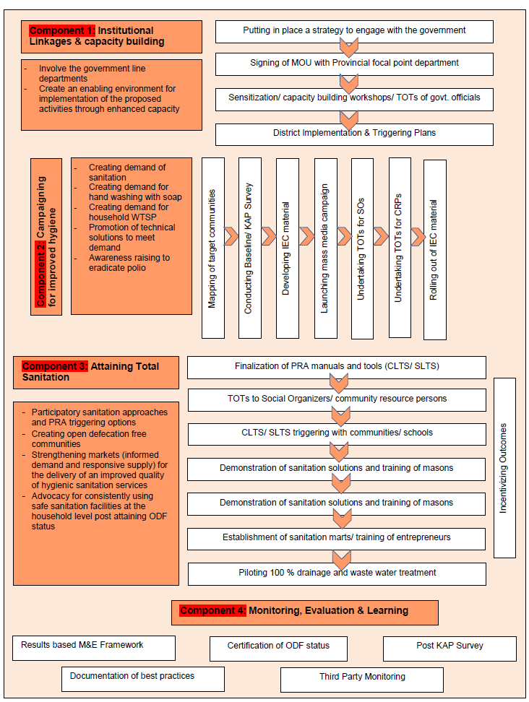

Figure 1. Components under the ER Scaling up of Rural Sanitation Programme

Phased Approach

UNICEF is following a phased approach in implementing the programme. UNICEF and Plan International, in October 2010, entered into partnership agreement to implement the Early Recovery Program on Rural Sanitation for four flood affected districts with a target population of 0.7 million. Later on, three additional stages were conceived with the total target population of approximately 7.6 million people in 34 flood affected districts (Table 2). Out of 7.6 million, the programme aims to target 3.5 million in both the flood and polio-affected areas in 17 districts. There are now about ten partner organizations who are involved in the implementation of this programme. This includes UN agencies, international non-governmental organizations and local organizations having strong focus on community empowerment and development.

Table 2. Target Population
Stages | Provinces/ Regions | Districts | Population to be served | Households | Villages
1 | KP, Punjab | 4 | 700,000 | 100,000 | 1000
2 | Punjab | 2 | 1,090,000 | 155,714 | 1557
3 | KP, Sindh, GB, AJK | 19 | 2,350,000 | 335,714 | 3357
4 | Punjab, Sindh, KP, Balochistan | 17 | 3,500,000 | 500,000 | 5000
Total | 6 | 34 | 7,640,000 | 1,091,428 | 10,914

A peer review of Phase I took place in July 2011 which highlighted many important issues. Based on this review, the following major changes have been made in the programme design:

- A partnership with WaterAid has been made to work as an external monitor
- A system of knowledge management has been devised for identifying, capturing, documenting and disseminating the programme learning’s, good practices and innovations

- A strategy is being worked out to reward schools through provision of WASH facilities in those villages where ODF status has been achieved and the village communities including school children who have worked to achieve the open defecation free status. For the school to be eligible it must have a functional WASH Club. Rewards have also been provided for the households/communities who have constructed simple pit latrines, stopped open defecation and would like to attain higher step on the sanitation ladder. In addition, rewards are available for providing WASH facilities in schools.

- Similarly, community resource persons will be compensated through results-based rewards, instead of a fixed salaries. This is based on the idea that there are many verifiable indicators and the community resource person shall be paid a certain percentage against each attained indicator, and shall be paid a lump sum amount of the balance on the certification of ODF status.

- A detailed strategy is being set up so that government institutions have a greater role. A detailed strategy for having a greater role of the government institutions is being prepared based on the following:
- Ensuring an agreement with key government departments at the provincial level
- Ensuring designation of government focal points at the district level and engaging with the focal points at continuous basis
- Ensuring sharing of tangible outcomes and results of the program with the district/ provincial government authorities
- Ensuring involvement of the government authorities in ODF verification and certification process
- Engaging with both PHED and LGDs for including the rural sanitation up-scaling schemes in their Annual Development Programs (ADPs)
- The provision of separate CLTS triggering sessions have been made with the schools to mobilize the school children as activists and the agents of change. The triggering is done with the children in schools and they are made aware of the harm of open defecation and the ways to make and use toilets in their homes

Conclusion

This initiative is now emerging as a major development story in Pakistan and the results are beyond expectations. The response of the communities has been very receptive to this triggering approach, which has encouraged UNICEF to take this programme to scale There are now more than 300 villages which have been declared ODF with more than 500,000 people living in ODF environment. . The results of the strategy have been beyond our expectations and the communities have been very receptive, encouraging us to take this to scale to reach out to 7.00million population.

In order to achieve ODF related targets, we do not have to necessarily focus on triggers based on “shock, shame and disgust”. The triggers which help communities realize their self-respect, dignity and pride we hope will lead to sustainable behaviour change. Strong mobilization along with effective coordination and collaboration between stakeholders including government, communities and CSO's is required. CLTS is no doubt an entry point to attain ODF, but a persistent approach needs to be undertaken with the communities after they have attained the ODF status with the functional involvement of the local government institutions to keep improving their status on the sanitation and hygiene ladders. Interpersonal communication matters. Once communities are provided with proper knowledge and skills this can help them in bringing about the required change in their lives. Children's are the best change agents and should play a central part in any behaviour change campaign. Mass media, including various means of communication, can play a key role in achieving and sustaining the desired behaviour change. From the point of view of scaling up of rural sanitation in flood-affected villages, major issues relating to the sustainability could be addressed through a dedicated cadre of volunteers and field level functionaries belonging to those villages. The program supports these volunteers as Community Resource Persons (CRPs). In order to ensure greater reach out to women, 50 % women CRPs are being employed, where possible.

Positioning and empowering women and children as community leaders, hygiene promoters and sanitation activists is critical not only in terms of consolidating the long term development gains, but also in making the sanitation and hygiene agenda truly inclusive and community led.

Acknowledgements
The authors would like to extend thanks to UNICEF, Plan International Pakistan, the Government of Pakistan, UN-Habitat, IRSP, PRSP, MuslimAid, Islamic Relief, WaterAid, AKRSP, NRSP, LPP and all other partners in the programme especially those communities who have undertaken this enormous task in the aftermath of the devastating floods and without whose help and commitment this program would not have been launched and taken to scale successfully

References

Ministry of Environment, Government of Pakistan (2011). “Pakistan Approach to Total Sanitation”

UNICEF Pakistan (2010). Early Recovery Scaling up of Rural Sanitation Programme (Phase I, II, III). (Programme Cooperation Agrrement) Islamabad, Pakistan

UN-Habitat Pakistan (2011). Early Recovery Programme on Rural Sanitation in Four Flood Affected Districts of Pakistan. (Mid Term Peer Review Workshop Report ; 8-9 July 2011), Islamabad, UN-Habitat

Key words: rural sanitation, community led, supply side, open defecation free

Contact details

M. Irfan Saeed Alrai  F-868, Satellite Town, Rawalpindi  Pakistan  Tel: +92-51-333-5127512  Fax: +92-51-209-7799  Email: misalrai@unicef.org | Imran Yusuf Shami  Address: House 668, Street 18, I-8/2, Islamabad  Pakistan  Tel: +92-300-9543045  Fax: +92-51-2609442  Email: imran.shami@plan-international.org

