The Process of LeaPPS

How to structure and organize district-based multi-stakeholder learning

Introduction to this document
In 2007, IRC International Water and Sanitation Centre, SNV Uganda and NETWAS Uganda partnered together to facilitate a multi-stakeholder learning process about hygiene and sanitation. The initiative is called LeaPPS: Learning for Practice and Policy on Household and School Sanitation and Hygiene. LeaPPS has four main elements: learning sessions, capacity building, action research, documentation & advocacy.
This document is about the pilot of LeaPPS in four districts in Uganda (2007-2009). The process was facilitated by IRC, NETWAS and SNV, but built on interest by local individuals and organisations in learning for improved sanitation and hygiene in households and schools in the selected districts. The purpose of this document is to provide a reference document for replication of LeaPPS and adaptation of the approach in other contexts. The document combines a description of steps, principles and methods with key lessons on facilitation.

Background and Objectives of LeaPPS

2.1 Why LeaPPS?
Improving access to sanitation and hygiene can make an integral contribution to improving health and well-being and reducing poverty. However, sanitation and hygiene are often not prioritised at district level. While sanitation coverage stood at 68% nationally in June 2009 up from 62% in FY 2007/08, there is substantial variation across districts, in Uganda, with some districts being stagnant or even declining in latrine coverage and facing recurrent outbreaks of faeces-related diseases including cholera.
In 2007, IRC, SNV and NETWAS Uganda partnered together to facilitate multi-stakeholder learning in four districts: Kyenjojo, Kamwenge, Arua and Koboko. In that year, the four (4) districts had latrine coverage standing at 75%, 69%, 57% and 50% respectively. It is useful to note that often these official figures do not represent the actual situation as there are always disparities in definitions and data between the national and districts levels.
LeaPPS started in March 2007 with assessments. The District is the key planning and monitoring level and so it was chosen as the entry level for this intervention. Buy-in from district stakeholders is crucial for ensuring participants come and are motivated to participate actively and apply the knowledge acquired in the learning sessions. Between 2007 and December 2009 eight learning sessions were held in each district. NETWAS, SNV and IRC jointly prepared and facilitated these sessions. Various district stakeholder groups participated in these sessions: technocrats from health, education and water departments, and from the chief administrative and planning office, Non Governmental Organisations (NGOs), politicians, administrative and health officials and politicians from two Sub-Counties in each district, and journalists representing the local media.
Reasons behind this initiative relate to the broader sector context and an analysis of the need for learning and sharing at district level to improve sanitation performance and hygiene practices in the selected districts.

The broader sector context:
At national level, there exists a rich package of government policies and legal framework regarding sanitation in general and School Sanitation in particular. However, the policies and guidelines are not widely disseminated and not well interpreted at lower levels.
- The Sanitation Memorandum of Understanding (MoU) – 2001, split up institutional responsibilities for sanitation between three different Ministries as follows:
- The Ministry of Water, Land and Environment would be responsible for planning investment in sewerage services and public facilities in towns and rural growth centres;
- The Ministry of Health would be responsible for household hygiene and sanitation; and
- The Ministry of Education and Sports for school latrine construction and hygiene education
However, the MoU has the following limitations:
- Mandates are not sufficiently clear. Key institutions like the Ministry of Local Governments (MoLG) and Ministry of Gender, Labour and Social Development (MoGLSD) are not mentioned.
- Responsibilities at district and lower local government levels are not clarified. Since prioritization for sanitation and hygiene at the local government level is largely dependent on the initiative of local government officials, and political leadership, this is an important limitation.
- Rural and urban issues are not distinguished.
- The sources of finance and funding mechanisms are not mentioned.
- The Kampala Declaration on Sanitation (KDS) – a national forum on sanitation was conducted in October 1997 and attended by four top leaders from each district: District Chairpersons, Resident District Commissioners, Chief Administrative Officers and Directors of District Health Services. The forum culminated in the KDS. The Declaration contains a 10-point strategy for action and committed all to take responsibility for sanitation improvement, both in households and schools. Sadly enough, this action program remained on paper.

Existing initiatives were analysed to identify gaps and possible linkages for supporting learning and innovation in sanitation and hygiene. The assessments identified the following weaknesses or gaps of existing initiatives:
- Existing platforms are focused on excreta related sanitation and hygiene, and did not address broader environmental sanitation issues.
- Existing platforms do not provide incentives for collective action, either between Ministries at the national level or between Ministries and Local Governments.
- District-based coordination mechanisms between the national and lower levels are still weak. There are coordinating bodies for sanitation and hygiene at National level (e.g. the National Sanitation Working Group) and District levels (The District Water and Sanitation Coordinating Committee – DWSCC). However, in most districts the DWSCC are not strong institutions. Some DWSCCs are not attended by key stakeholders such as education representatives, while they are responsible for school sanitation and hygiene.

Why learning platforms and LeaPPS learning sessions?
National level support structures from national level are often directive in nature and do not accommodate experiences from district and sub-district technocrats. Existing platforms often do not create space and right atmosphere to exchange and learn from local experiences.
The National Sanitation Working Group has done documentation of best practices e.g. “Documentation of Best Practices (BOPs) in Hygiene and Sanitation in the Districts of Uganda (WSP, December, 2006). However, these best practices have not been well disseminated for adoption, replication and scaling up.
National level policies, strategies and approaches/methodologies may not be based on the reality on the ground as there may not be an optimal flow of information on local experiences to the national level. The national guidelines, standards and manuals do not accommodate specific contextual conditions and may therefore lead to less successful interventions. However, technocrats may have had made progress locally or come across effective genuine community-based solutions that are not being shared with others or documented.
- The assessment highlighted a need for sharing and joint learning to improve performance and coordination at district and sub-county levels. A lot of knowledge and experience remains underutilised because it is not shared or documented.
For example:
- Positive or negative experiences and successes or failures in one district may not be known in a neighbouring district, possibly leading to ‘re-inventing the wheel’ or making the same mistakes.
- Communication on approaches, methodologies and solutions among technocrats within a district is very limited.
- Communication between sub-district and district levels about experiences and lessons may be hampered by hierarchical positions and directive attitudes of some district staff.
- Local NGOs and Community Based Organisations (CBOs) may apply methodologies leading to successes but they may not share these with the district technocrats, while district staff may not share with local NGOs their guidelines and manuals they receive from national level. This can lead to mismatches/ conflicting approaches and sometimes to duplication.

Capacity building is also an important aspect of performance improvement. The assessments found that capacity building through workshops and training is often very top-down. The content of the training has been decided at a higher level or by an external agency, while the topics and proposed direction may not respond to the specific demands and prevailing local contextual conditions.
Financial resources are also a limitation. The Ministry of Finance, Planning and Economic Development (MoFPED) has allocated a budget line for sanitation. However, there are no resources in the sanitation budget line to support the expansion of sanitation activities.

2.2 Objectives
The long term objective of LeaPPS is to support multi-stakeholder learning on household and school sanitation and hygiene in order to influence change in practice and policy towards sustainable performance improvement.
LeaPPS encouraged learning and sharing within and between various administrative levels. It also stimulated an atmosphere of partnership between local governments and civil society organizations. These elements were crucial for working towards the longer-term change objectives.
There are several challenges to improving sanitation and hygiene: limited budgets, limited support from politicians, and the fragmented institutional set-up: responsibilities and budgets for sanitation and hygiene are divided among departments that have other key priorities. To improve performance requires that different stakeholders prioritize sanitation and hygiene. It also means that they must agree on actions that help to coordinate and even harmonize approaches so that resources are used more efficiently and the results are more sustainable.

Specific objectives of LeaPPS were:
- To put sanitation and hygiene higher on the agenda of politicians and technocrats and to share promising approaches and useful messages.
- To agree on approaches and methodologies in improving household and school sanitation and hygiene
- To increase linkages between sanitation and hygiene activities and other development programmes (HIV/AIDS and accountability in particular)
- To enhance stakeholders’ capacities and knowledge for effective and sustainable sanitation and hygiene interventions.
- To improve coordination among all local stakeholders within an agreed coordination framework
- To improve communication across administrative levels and between NGO and LGs

To enhance harmonization, coordination and collaboration between technocrats, politicians and NGOs working on sanitation and hygiene, LeaPPS was linked to the District Water and Sanitation Coordinating Committee (DWSCC) and to the National Sanitation Working Group (NSWG).

Elements of LeaPPS learning process
The LeaPPS learning process has four elements:
- learning sessions
- capacity building
- action research, and
- documentation & advocacy

These elements are described in the following section. These elements are not separate, but work together. For instance, capacity building takes place in the learning sessions as a result of sharing of experiences and concepts, analysis of challenges and action planning. The sessions provide an opportunity to present solutions from other districts or other countries as well as from participants’ own experience. Action research provides an opportunity to test and promote new approaches, to raise awareness and to build people’s capacities.

3.1 The learning sessions
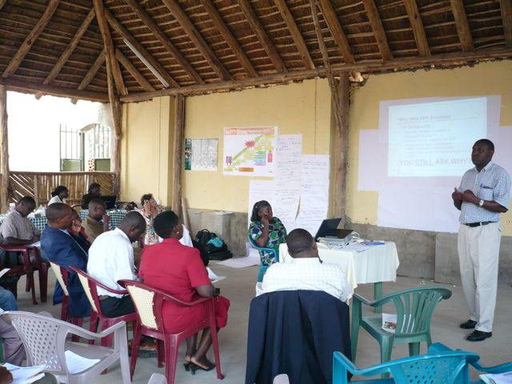
Between 2007 and 2009, eight multi-stakeholder learning sessions were held. The facilitation team developed the agenda for each session with inputs from participants. A preparatory meeting with the district water office is held before each session. This helps ensure that there is buy-in from the district and that the relevant people will attend.
Photo 1 Sharing & Learning in LeaPPS-Kamwenge (August 08)
In the sessions, participants’ interests and capacity building needs are addressed through presentations, group work, discussions and field visits. The facilitation team divides tasks beforehand so that presentations and case material can be prepared.
The team also must ensure that new concepts or methods are brought into the sessions (innovation). For example in the initial sessions participatory approaches, child-friendly teaching methods and the links between HIV/AIDS and sanitation and hygiene, innovative technologies such as Ecological Sanitation (EcoSan) were presented. Subjects that were discussed following specific requests from participants include social marketing, documenting best practices, effective bylaws and enforcement, the Improved Sanitation and Hygiene (ISH) Strategy, school sanitation and hygiene, and raising the profile of sanitation and hygiene.

The learning sessions aim to:
- Develop and test locally appropriate solutions and strategies to address these problems and incorporate various themes, such as resource mobilization, political prioritization, field-based hygiene promotion methods and approaches, etc (these issues were identified during the inception mission and were raised during following sessions).
- Present, analyse and discuss relevant concepts and approaches (from within and outside the district) to address problems jointly identified
- Stimulate hands-on learning through field visits and action research in selected sub-counties
- Follow-up and document LeaPPS sessions and lessons learned
- Identify key issues that need follow up by the District Water and Sanitation Coordinating Committee (for instance to scale up a successful approach, methodology or technology)

Each learning session lasts 1.5 days and includes a field visit. An important part of the sessions is reporting on progress and activities since the previous session. This provides an opportunity for joint analysis of challenges and learning needs. It also provides a way to critically review challenges and link them with good practices or innovative approaches and concepts that have been applied successfully elsewhere.
Action planning at the end of each session aims to ensure that the learning session does not remain a talk-shop, but leads to results and further learning and sharing.

3.2 Capacity building and follow up
Learning sessions are a very useful tool for the initial stages in capacity building, since the participants can identify themselves where their capacity gaps are. In between the learning sessions, follow up is needed to address in more detail the identified learning needs and interests. An important lesson from the pilot is that a ‘learning’ initiative should link up with organisations that can provide information and communication materials, technical backstopping, funding and/or training programmes. This helps support stakeholders to put what they have learned into practice. The learning platform provides the forum for feedback and sharing of practical experiences.
Capacity building activities in the pilot phase have included training by SNV, NETWAS and others. For example, PARUDA, a local faith-based NGO provided training on participatory tools. The TSU provided a PHAST training. Action research and documentation are also tools for capacity building and will be discussed in the following paragraphs.

3.3 Action research
Participatory action research brings in innovation, testing, reflection and action into the learning process. It provides data and tangible results and can motivate stakeholders to take further action. NETWAS secured funding from Simavi for Action Research about low-cost EcoSan and other innovations in selected households and schools. Local NGOs worked closely with stakeholders at sub-county level to implement the research. In the first six months (August 2008 to January 2009) the focus was on implementation of software components. The hardware component of the research was implemented only after capacity building and sensitization had started.
Action research requires specific skills of the local NGOs involved (as they are usually implementation oriented) and needs proper and intensive guidance, monitoring and documentation.

3.4 Documentation
Each learning session is documented and the reports are shared with participants. The facilitation team tried to have the reports ready within two weeks of the learning session. This proved difficult, but is vital to ensure that participants can report back to their peers and superiors and that they keep the momentum on agreed action points. The reports should not only provide an account of the agenda points, but also some of the discussions and should capture challenges, achievements and agreements. In 2009, the facilitation team captured the main elements and lessons learned in the session in a newsletter format as that would be more accessible and attractive to read and could be easily shared with superiors and peers.
Besides LeaPPS reports, various short documents and materials aim to support learning. These are information sheets on specific topics and case studies. For example there is an information sheet providing practical guidance on building Ecosan-composting toilet called arborloo or tree-latrine and fossa alterna or double composting latrine, and case studies describing the involvement of community members and children through health clubs in communities and schools.
There has been a strong interest expressed by both NGOs and local governments to improve their documenting skills. This is an area for further capacity development. One way we tried to support this during the learning sessions is to have participants share good practices in small workgroups, and then document the headlines of one selected good practice using a simple format. Participants were also taken through the process of how to document good cases for purposes of knowledge sharing. Guidelines for LeaPPS Case Documentation were developed and shared.

To encourage learning from each other, it is also important for facilitators to support the participants/learners to document and publish good cases, based on their own experiences in the field.

Conceptual roots and principles of LeaPPS
LeaPPS draws on multi-stakeholder processes called ‘Learning Alliances’. Learning Alliances are interlinked multi-stakeholder platforms. Learning Alliances aim at building relationships, sharing information and experiences and planning for solutions to common problems that cannot be solved by a single stakeholder. Each platform should bring together a range of stakeholders who capture diverse roles, interests, skills and experiences. If the alliance is representative of the institutional complexities and other realities of the system, then it is more likely that the actions and solutions agreed will be put into practice. Figure 2 illustrates how multi-stakeholder platforms at different administrative levels can help to break down barriers in communication and information sharing. LeaPPS platforms at district levels should influence stakeholders at sub-county and national level.
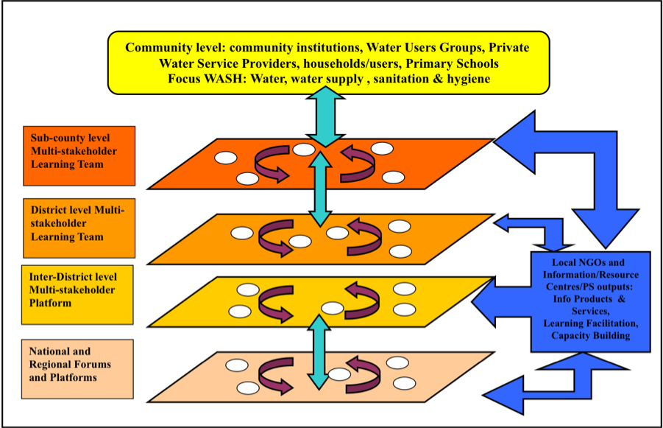
LeaPPS involves a wide range of stakeholders: water, health, education, community development, planning and finance officials, local NGOs and private sector stakeholders at district and sub-county levels, Councillors, donor agencies and INGOs active in the districts.
Figure 1: activities, outputs and outcomes
Ultimately, the Learning Alliance aims at improving how stakeholders work so that their interventions have greater impact and are better coordinated. Improvement of performance is the core of the learning. This also requires building linkages between different administrative levels: from community to national level. LeaPPS partners aims to link the initiative to existing structures for (technical) support and capacity building, for example the National Sanitation Working Group (NSWG) and the district Water and Sanitation Coordination Committees (DWSCC), see figure 1. Sub-County politicians and government staff working in Water Sanitation Health and Community development are also represented in the district learning platforms.
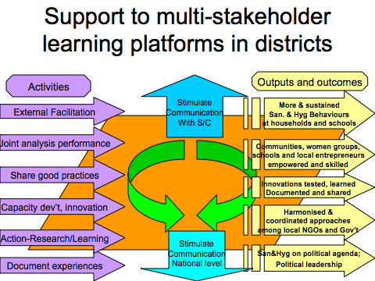
The activities, outputs and outcomes are visualized in figure 2. Externally facilitated learning session involve joint analysis and the sharing of good practices (activities on the left of the figure), should help stimulate communication with sub-counties and with national level and contribute to improved and sustained hygiene behaviours (outputs on the right of the figure).
Figure 2: breaking down communication and information barriers

Phases in the learning process
Between 2007 and 2009, LeaPPS was facilitated by SNV, IRC and NETWAS. The three main phases: inception, development and consolidation are described in the following section.
Phase 1: Inception phase
To understand the current status, challenges and opportunities it is important to speak to knowledgeable people from government and non government organisations. Relevant documents such as sector performance reports, relevant documents relating to policy priorities (e.g. PEAP and PRDP), publications of development programmes, workshop reports will also provide important information.

The inception phase should:
- Map out existing learning practices, processes and mechanisms in household and school sanitation as well as identify constraints to institutional and individual learning and information sharing at district and sub district level.
- Assess interest, feasibility and acceptability of learning and sharing concepts and processes at district and sub-county level.
- Develop a realistic framework for future district and sub-county-based learning with the institutional/ organisational realities and factors for success, and identify opportunities and constraints.
- Initiate a Learning Alliance with strategic and planning workshops.

The initial meetings and workshops in this phase are instrumental in developing the way forward. In the first LeaPPS, we discussed the lack of coordination and possible solution. One of the suggested actions was to strengthen the DWSCC through appointing a focal point to report the issues selected by the platform and table in the DWSCC meetings. In most cases, this focal person is the DWO.
During the initial workshops the key objectives are to:
a) Jointly identify commonalities and analyze the current situation – problems perceptions, roles and gaps–and collaboratively define what the various stakeholders want to change and what is needed to create this change.
b) Agree on a common vision – what various stakeholders want to achieve and then process steps, opportunities and constraints to achieving the vision.
In each district, a vision and process were jointly designed. An example of this process and identified steps is found in figure 3 and explained in the next section.

Figure 4 Arua process map

Phase 2: Establishing the learning process
In the next phases the learning process was given shape through regular learning sessions (on average 3 per year) as well as follow-up capacity support. To ensure LeaPPS was linked to district coordinating and planning structures, the learning session outcomes were shared with platforms such as DWSCC. The DWSCC structure was extended to include NGOs and Councillors to ensure broad based buy in of all stakeholders concerned with sanitation and hygiene. An initiative like LeaPPS should not stand on it’s own but be integrated into other structures and programmes. Within this pilot of LeaPPS, the team reported regularly to the National Sanitation Working Group (NSWG) and the district Water and Sanitation Coordination Committees (DWSCC).

Phase 3: Consolidating lessons learned in the pilot phase and agree on the way forward
After a two-year pilot and 6 learning sessions in the four districts it was time to revisit the initial joint vision and plan and discuss sustainability of such a learning process. This would involve also steps to mainstreaming and financing LeaPPS in ministries and UWASNET, and perhaps further involvement of TSU staff.

Phase 4: Ensuring sustainability/ follow up: Integrating the learning process into local planning cycles/ structures
Initially the process is externally facilitated, however, ultimately, the aim is for learning to be mainstreamed and budgeted for by local stakeholders. This will ensure sustainability and requires true ownership.
In 2009, various learning sessions and meetings invited district and sub-county stakeholders to think about how they would like to sustain and replicate lessons and results from LeaPPS. Ways to co-finance learning sessions, how to increase the focus on sanitation and hygiene within the DWSCCs and exploring opportunities to link sanitation and hygiene improvement to other programmes (like NAADS) all need to be explored. Building on results and interest generated in the pilot phase, IRC, SNV and NETWAS are now looking to local stakeholders to see how they would like to move forward.

Lessons on facilitation, some insights on involvement and commitment
In the following section, we present some of the lessons on facilitating an initiative like LeaPPS and reflections on how it could be done better. The important principles of LeaPPS are highlighted below.
Key principles of LeaPPS:
- participatory action research
- involvement of stakeholders from different levels
- building on existing structures
- make use of multiple/ diverse perspectives
- focus on learning for change

6.1 Creating a safe learning environment
For people to learn, they need the confidence to acknowledge failures or mistakes and to tolerate ambiguities. An important task of the facilitators is therefore the creation of a safe learning environment. Provide encouragement for people to learn, acknowledge shortcomings and share their insights. The tone of the learning sessions should be collaborative, respectful of various perspectives and contributions and encourage listening.
One practical way to help create a safer learning environment (especially at the beginning, when trust may be low) is to organize subgroups for discussion or group work. Group people together who have similar levels of power or experience. This can help people to open up.
It is also important to acknowledge and encourage different opinions and views. For this, we can use exercises in dialoguing or assigning particular people in certain roles in group discussions (e.g. being the critical observer, pathfinder etc) doing role plays in communication etc.
As facilitators it is important to encourage the exchange of different perspectives and to reduce the load of information coming from the ‘experts’ (either us as facilitators or certain participants who have a certain level of authority on the group). Instead of a dialogue between one participant and the presenter/ facilitator, we should stimulate participants to discuss, think for themselves, reflect on the applicability of what has been presented and encourage the use of the knowledge and experience readily available in the group.

6.2 Controlling platform versus visionary and creative network

A problem, which we were regularly confronted with as facilitators of the learning process, was dealing with the paradox of creating a good learning environment while at the same time addressing need to create a mechanism for change and action. During each session we agree on follow up and review progress in the following session. However, people may feel threatened if they have not implemented as according to the previous session or may feel exposed, particularly when there are power differences within the group or conflicts. For example Health Assistants and S/C Chiefs may feel unsure reporting in the presence of their bosses what has been done/ not done, NGOs may feel challenged by Government staff. As facilitators, we need to make sure the learning sessions do not get stuck in blaming and shaming, but rather stimulate dialogue and questioning how things are done and how to improve through the use more efficient and effective methodologies. This is a challenge. We noticed from the beginning the tendency of participants to shy away from telling what they did with the recommendations of the last sessions or to give desired positive answers. This attitude makes the discussions and outcome of sessions sometimes shallow and exhausts the energy of the facilitators trying to get more learning out of the sessions.
One way we tried to increase learning and honest reporting back is by encouraging reflection and analysis on the reasons behind a failure and understand constraints for better sector performance instead of blaming participants personally. We also always start with the successes/ things achieved before analyzing the failures.

6.3 Link with decision-making structures and platforms but do not become a decision-making body
The facilitators need to make sure that issues discussed in the platform are taken to the District Water and Sanitation Committees and followed up accordingly. In the LeaPPS pilot, we feel we were only partly successful in doing this despite SNV doing follow-up on this. There remains a lack of ownership for reporting back from LeaPPS to DWSCC as well as low priority and little time allotted to sanitation and hygiene on DWSCC agenda. This links to the following section: ownership.

6.4 Whose platform whose programme? The issue of ownership
As facilitators we often feel the need to be well prepared and organized and bring our own expertise in. At the same time, we need to be cautious that we do not fall into a didactic mode, acting as teachers in front of a classroom. As facilitators we often see ourselves and are seen to be the most knowledgeable about hygiene and sanitation. The learning process in LeaPPS therefore requires also a transformation within ourselves as facilitators.
Our aim in LeaPPS is to increase ownership of the process and the outcomes of the learning sessions. This implies that local stakeholders should become co-facilitators of the sessions, rather than recipients of knowledge. If we want to use local knowledge and reach increased commitment by LeaPPS stakeholders, we need to ‘hand over the talking stick’ and ask the right questions instead of giving the answers.
Sanitation and hygiene is a subject that is everybody’s responsibility and cuts across different departments. In addition, under decentralization, the districts and lower local governments all have roles to play in the promotion of sanitation and hygiene. Their efforts are supplemented by the work of development partners such as NGOs. As such key representatives of the different stakeholders, both at district and sub county levels were carefully selected to participate in the LeaPPS sessions. These ranged from relevant technocrats at districts and Sub County levels, to NGO staff, politicians as well as practitioners, both community and schools levels.
A focal person for LeaPPS was selected at district level in each district to ensure follow-up actions are implemented but also ensure adequate reporting is done at the district level through feedback during the DWSCC meetings. Participants to the learning sessions were invited through the Chief Administrative Officer’s office, not only to have this office informed about what was going on but also to give the invitations more weight and the participants the onus to attend and be held accountable. Ownership also relates to people attending and really participating in the sessions. There is a challenge of continuity of participation. Firstly, not all invited people, from Health and Education departments, HIV/ AIDS focal persons, Technical Support Unit (TSU), District Water Officer etc. show up. While some individuals participated in each session, others were delegated without adequate briefing. This influences the continuity in learning and limits effective follow up.
Participation of stakeholders in the sessions also varies. Timing of the sessions so that they do not clash with important district meetings, other workshops, holidays and other events is important. Sessions on Friday tend to be problematic and good timekeeping is essential to ensure that people who have to travel can still participate fully in the sessions.

As facilitators, we have learned that we can support participants taking ownership by:
- Setting of the agenda together with the key stakeholders in the platform. As a consequence there may be different agendas in the different districts (and sub-counties), which will require more preparation work by the facilitators.
- Focusing on local knowledge as the starting point for group and individual learning and stimulating participants to bring their own experiences into discussions (spontaneously, but also by invitation). Help them just enough to make this a success: give clear instructions and guidelines for contributions, go through and practice presentations.
- Practicing participatory reflection and action behaviours, which include flexibility, being supportive, sharing, abandoning preconceptions and being open to listen, watch and learn.

6.5 Tailoring the information so it is comprehensible and useful
Sometimes participants comment that we use difficult jargon, present power points with complicated graphics, are too fast and give too much information at once, refer to thick and boring text booklets for people without any reading culture, etc. In LeaPPS, we also made those mistakes and people might feel too shy to admit that they have not understood and we lose their interest.

We have tried to improve through:
- Combining a workshop setting hands on and practical learning by showing/doing, experimenting and testing in the Action Research
- Further follow-up on the list of fixed participants which will receive an invitation in order to have the same people every three months in the Learning platform
- Repeating information in following sessions to provide a refresher and prevent giving an overdose of new information in one session
- Limiting the number of items on the LeaPPS agenda to ensure there is enough time for reflection, discussion and analysis

Further reading and Links:
Water and Sanitation Resource Centre, Uganda: www.watsanuganda.watsan.net

LeaPPS reports and other documentation is available here:
IRC International Water and Sanitation Centre: www.irc.nl
A facilitation toolbox, resources on Learning Alliances and sector learning are available here:
SNV: www.snvworld.org

“Stakeholders” are defined as individuals, groups and organizations that have an interest in, influence over, or are affected by issues around household and school sanitation and hygiene practices and policies.
Ministry of Water and Environment, Water and Sanitation Sector Performance Report 2008, Uganda
Ministry of Water & Environment, Sector Performance Report 2009, Final Draft , Uganda
Ministry of Water and Environment, Joint Sector Review Report, 2007/08, Uganda
WSP, 2008; Chapter 2
TSU is the Technical Support Unit of Directorate of Water in the Min. of Water and Environment
PHAST is a methodology on Participatory Hygiene And Sanitation Transformation
Simavi is a Dutch NGO focusing on health improvement through water, sanitation and hygiene; www.simavi.nl;
The full series is available from http://www.watsanuganda.watsan.net/page/561 and http://www.irc.nl/page/44050
The Learning Alliance approach is derived from work on innovation systems and used as a way of putting innovations into practice (Verhagen et al., 2008): Verhagen, J.; Butterworth, J.; Morris, M. (2007) Learning alliances for integrated and sustainable innovations in urban water management.Waterlines, Volume 27, Number 2, April 2008 , Practical Action Publishing, pp. 116-124(9). IRC has applied Learning Alliances in several projects, including EMPOWERS, WASPA and SWITCH. More information is available on www.irc.nl

