**Contents**

1. Introduction
2. The context
3. Participant list
4. The method
5. The content
6. The Weggeman model
7. Conclusions
8. Way forward
9. Annexes

**1 Introduction**

In 2009 IEA and IRC staff came together twice to workshop, discuss and agree on a memorandum of understanding (MoU) between IEA (Institut International de l'Eau et de l'Assainissement, Rabat, Morocco, http://www.iea.ma) and IRC (International Water and Sanitation centre, The Hague, the Netherlands, www.irc.nl).

IRC has a well and international established name as WASH knowledge - or resource centre. In November 2009 IEA and IRC signed a MoU and one of the activities planned was a hands-on training workshop (learning by doing) on knowledge management. That workshop took place at IEA offices at Rabat on April 12-16. 2010.

This report describes what happened, what the result are and what is expected as follow up.

Group work and a participant facilitating

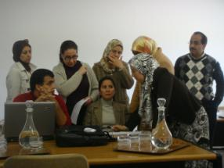 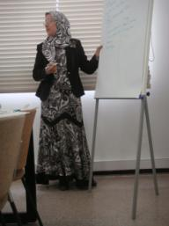

**2 The context**

IEA has the ambition to become a resource centre in the field of water and sanitation / hygiene (WASH). IEA has been created in 2008 and has as vision to operate as a resource centre at regional level (Middle East and North Africa or MENA, MAGREB region and Arab speaking countries). IEA has two departments: R&D and Training.

R&D is done on research for adapted solutions, sustainable and adaptable to environment in rapid change; partnership and networking and efficiency and applicability. In the field of training: technical, administrative and financial and managerial, and social. Per annum 22.000 training days are organised.

The IEA organisation chart

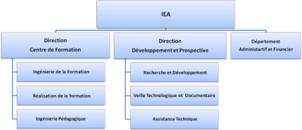

Next to the IEA functioning as resource centre IEA has the task to organise knowledge management within ONEP as a whole. ONEP has some 7000 staff and it is felt the information management and knowledge sharing can be improved.

**3 Participant list**

|  |  |  |
| --- | --- | --- |
| Smahane Fejry | Latifa Allach | Bouchra Nazih |
| Mehdi Tamtamaouy | Youssef Elmaadadi | Bouchra Naji |
| Samir Bensaid | Mohamed Laaouan | Hassan Chahid |
| Abderrafii Mardi | Mustapha Mahi | Omar Zmane |
| Mokhtar Jaait | Mahmoud Hafsi | Abderrahim Khadir |
| Samira Amrani | Mustapha Hajji |  |
| Salah Berhil | Mohamed ASSAFI |  |
| Laila Naji | Khadija Elaamri | Jaap Pels, IRC |

**4 The method**

IRC organised the knowledge management (KM) workshop using the theory of Weggeman as central model. The model comes with a KM scan to take inventory of the perceived situation by as much as staff as possible in respect to KM. The KM scan is a questionnaire. An example is given in chapter 6.

The learning by doing steps to take during the workshop are : 1) Scan the environment off IEA, 2) Mission, 3) Vision, 4) Goals – Objectives, 5) Knowledge value chain for objective A, B, C, 6) Details KM activities / processes personal level, 7) Details on organizational level (including the KM scan), 8) Details network level (IEA’s operating environment) and 10) detail activities on the level of ‘what, who, when’ given the ‘why’ stems from vision, mission and objective and the ‘how’ is operational. In the course of this report all steps will be addressed.

**5 The content**

An organisation operates in an environment. To get a better grasp, discuss and increase mutual understanding amongst participants, the first exercise the workshop participants worked on was to make a poster of IEA – ONEP in its operating environment and report back to the group in three minutes (the elevator pitch method).

Group work on IEA and its operating environment: group A, B, IRC, C (left + right) and D.

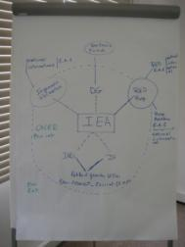 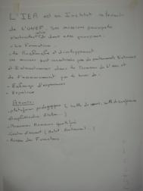 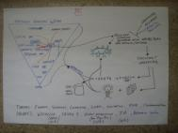

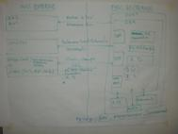 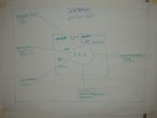 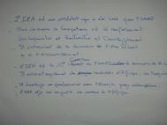

After understanding the IEA environment the participants focussed on the IEA vision and mission, again by means of group-work / discussion. The groups found out that this was not an easy and straight forward topic and assignment, but essential to generate a list of organisational objectives.

Results group work on mission, vision and objectives IEA

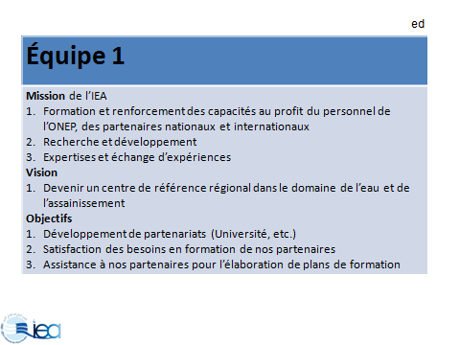 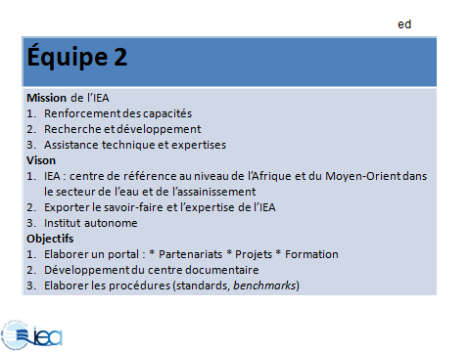

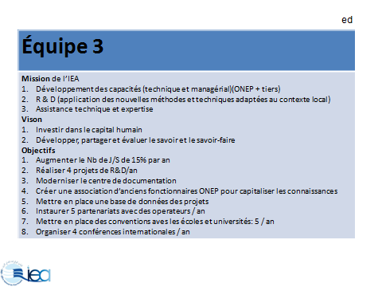 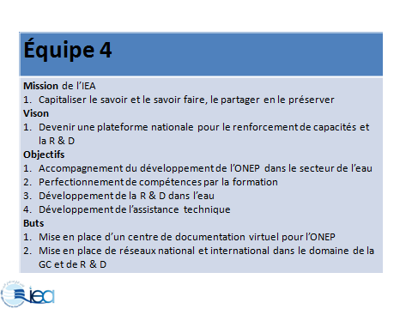

Again in groups participants choose one objective to experiment filling out the knowledge value chain. The Weggeman model used - as depicted below – states that an organisation will formulate objectives based on a mission and a vision (top left in the below picture). For every objective the knowledge value chain (bar in light blue) needs to be reflected on.

The Knowledge Value Chain

This exercise resulted in fierce discussions and confusion. After regrouping a side step to the ‘People, process and Technology’- model as show below – was made to better understand and make clear a KM plan is about an intervention on the processes within an organisation.

The PPT-model applied for IEA - ONEP



En passent, participants discussed objectives in terms of SMART (Specific, Measurable. Applicable, Realistic and Time bound) to ‘reality-test’ them. Also the objectives and plans were screened against the lessons learned by KM pioneers: 1) do we have enthusiastic champions?, 2) does the intervention build on existing core competence?, 3) does the plan address an urgent strategic imperative and 4) is there buy-inn from top-management?, and last, but not least, 5) are there early quick wins neutralise the nay-Sayers?

The group agreed the two plans they worked on: A) implementation of Alfresco-Share as underlying technology and central repository for IEA’s development as resource centre and B) to start with systematically capture lessons learned from activities by IEA. In the above picture they are pointed at by ‘Plan CG 1’ and ‘Plan CG 2’.

**6 The Weggeman model**

The underlying KM model used in the workshop is coined by Weggeman. The model is depicted below on the left. The top bar has been discussed above. To the left the organisational design variables – based on the 7S McKinsey. During the workshop we discussed then briefly. model (see for a detailed description of the 7S model <http://www.themanager.org/models/7S%20Model.htm>).

The right shows the result of a KM scan done at IRC. The lower values indicate where staff perceives KM as weak and thus that are the sports to target KM interventions on.

The Weggeman model and KM scan: the KM scan will point out where to plan KM interventions

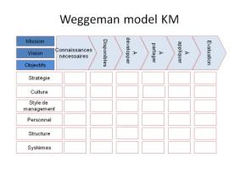 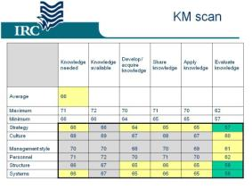

The KM scan as administered at IEA only had a few participants. To get a complete and thorough and to be trusted picture as much as possible staff has to take part in the KM scan. The emerging picture from the KM scan result below points at structures, systems and staff as ‘elements’ in IEA – ONEP to target KM interventions on. The application of knowledge is perceived as weakest element in the knowledge value chain. IEA’s KM plan 1 addresses a system and plan 2 a structure.

Results of the KM scan at IEA: 7 participants



**7 Conclusions**

It has been a typical KM workshop where participants enjoy the lecturing on Monday and discuss mission and vision. On Tuesday an appreciation grows on the difference between information (tangible) and knowledge (in people’s heads) accompanied with the confusion what to do.

On Wednesday participants do a lot of ‘brain-work’ because they have to plan a KM initiative based on an objective, which means coming up with processes that must be sustainable! The crux of the Weggeman model is that the knowledge value chain must be stepped through step by step and the further an organisation gets into the chain the better they perform.

On Thursday the group took ownership of the workshop and decided to work on two KM plans. The first is to install a system and train IEA staff in its use. From there other ONEP staff will be involved. The second plan (a combination of KM intervention; see slides in the annex) is to establish in IEA a procedure and tools / methods to capture lessons learned from all IEA activities.

From the Thursday and Friday group work participants realised KM is 5% inspiration and 95% transpiration. Especially the exercise to plan who has to do what when took time and realisation KM does not come overnight and needs entrepreneurial, open, pro-active teamwork to succeed.

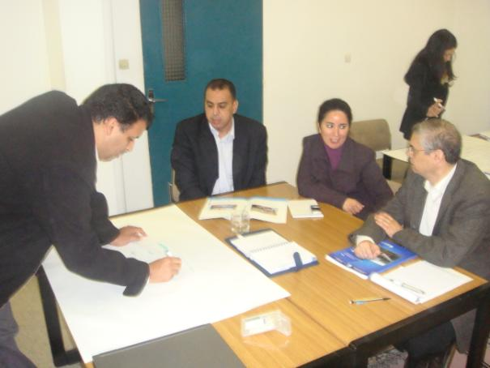

**8 Way forward**

The two developed KM plans are detailed enough to work with in the coming three months. In parallel with that IEA needs a KM plan which is renewed / updated on a yearly basis. The KM scan can support the KM planning because it can be used as baseline study and when administered again an indicator of success / improvement. It must be understood KM is far and foremost in organisations around managing circumstances for information to flow and knowledge to be shared. Thus KM in organisations is about organising sustainable processes. IEA – ONEP is in the fortunate situation of having a lot of IT installed already that can serve as communication back-bone for KM interventions.

The journey IEA wants to embark on – to become a respected resource centre in the MENA / MAGREB / Arab speaking region - is ambitious and will take three to five years in terms of knowledge management. IEA staff – the personal realm - will have to learn new skills, collect new experiences and build the entrepreneurial attitude; in short learn. IEA will have to improve its information management (KM plan 1) and experiment with knowledge sharing mechanisms (KM plan 2) to produce lessons learned / information and pro-actively show leadership in the sector.

The next steps in short:

* Execute KM plan 1
  + Install the system
  + Train all IEA staff in use
  + Plan ‘IEA learning & sharing’ sessions
  + Make a plan to involve non IEA ONEP staff
* Elaborate on KM plan 2
  + Experiment with / study process documentation (capitalisation)
  + Plan and entail ‘After action reviews’
  + Plan ‘IEA learning & sharing’ sessions
* Create a KM yearly plan
* Administer the KM scan IEA – ONEP wide

IRC, The Hague, April 29, 2010

**9 Annexes**

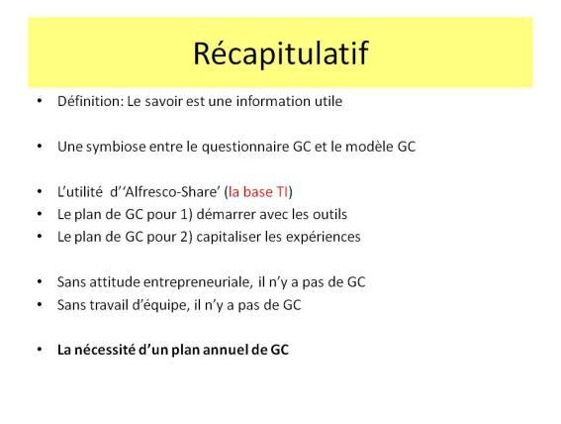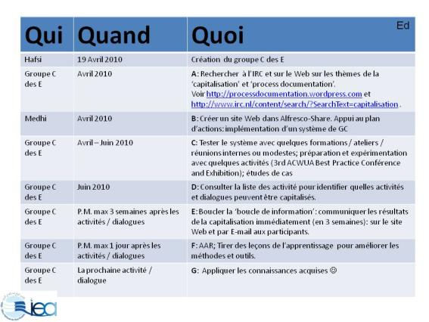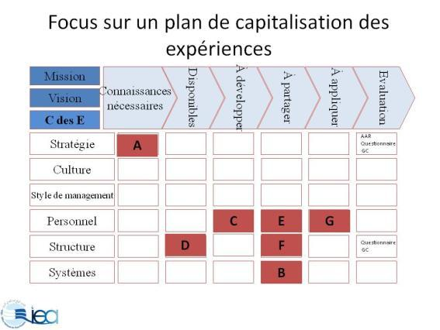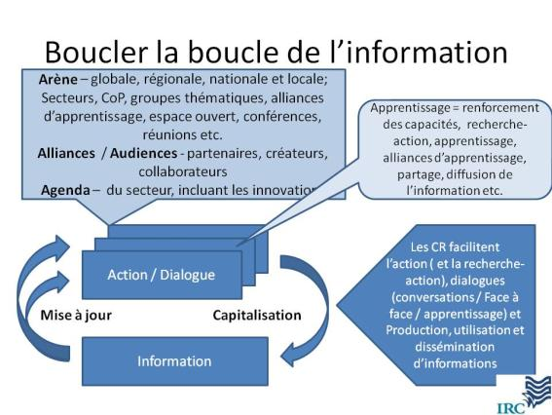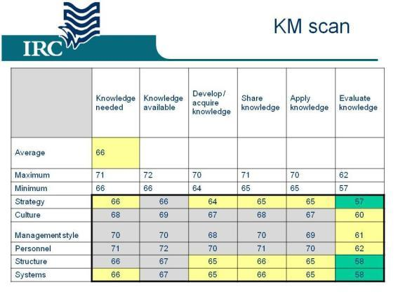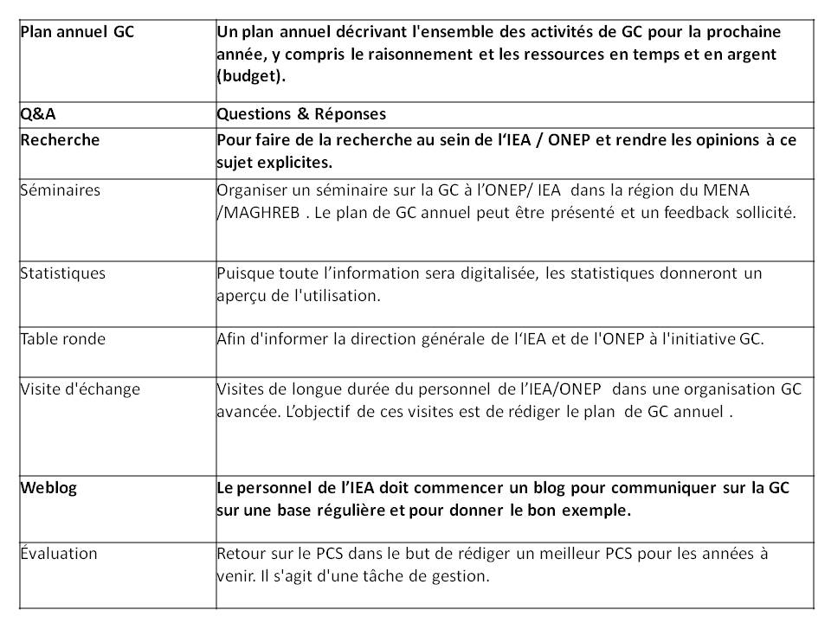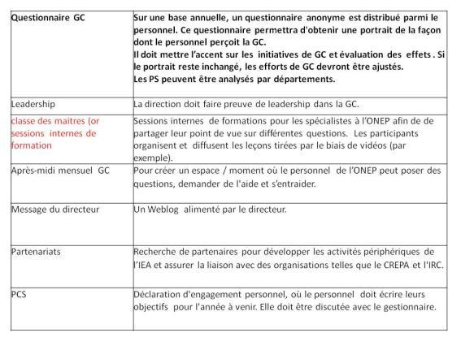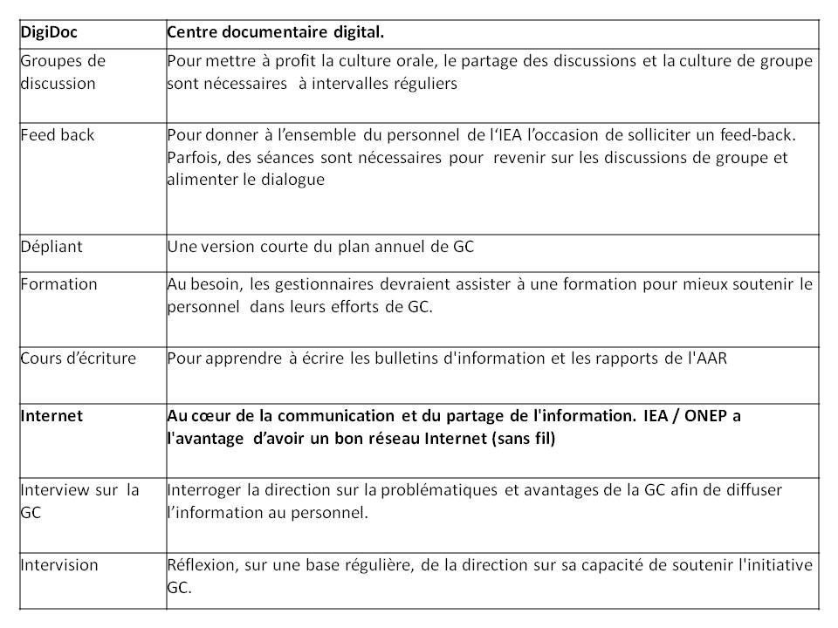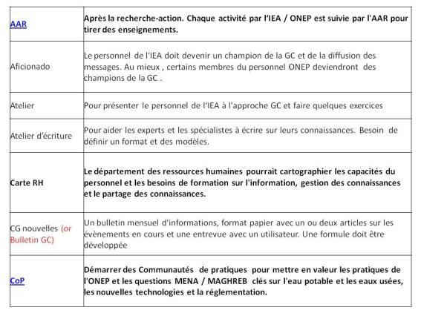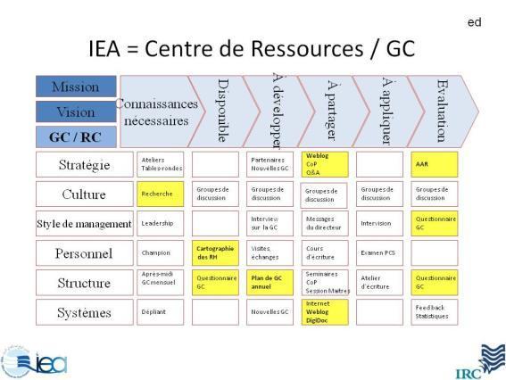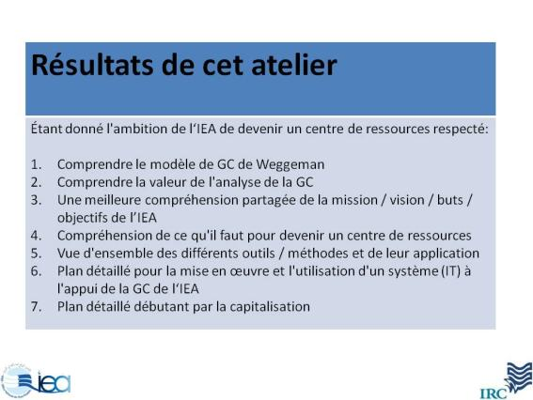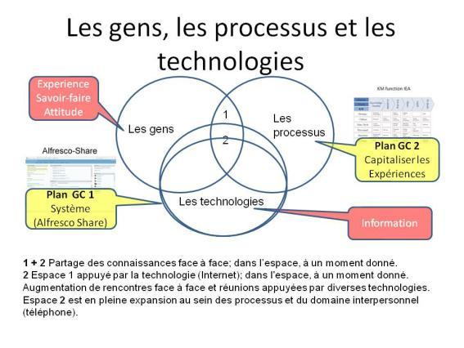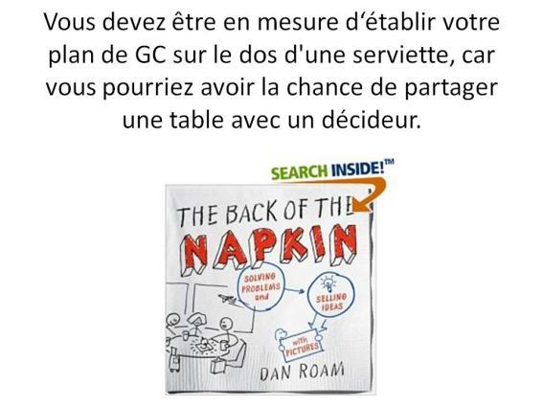

Final recap

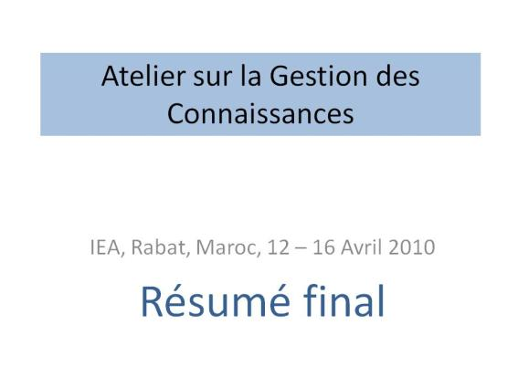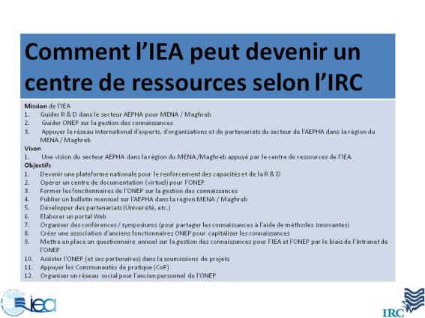

Plan CG 2

