Mexico’s Water and Wastewater Market

Strategic Review 2001-2003

Report produced for:

The Royal Netherlands Embassy in Mexico City

By:



Hanhausen & Doménech Consultores, S.C.

October , 2001

Table of Contents

Mexico’s Water and Wastewater Market 1
1. Executive Summary: 4
2. Economic/ Political/ Financial Issues: 6
2.1. Mexico’s Economic Performance and Trends. 6
2.2. Political Environment. 9
2.3. Financial Issues Impacting Mexico’s Water Sector. 10
3. Institutional and Regulatory Structure: 23
3.1. Institutional Structure: 23
3.2. Decentralization Process. 26
3.3. Legal and Regulatory Framework. 27
3.4. Enforcement and Trends 31
3.5. Main Government Programs. 33
4. Potable Water Market: 35
4.1. Overview, Coverage, Capacity and Technologies. 35
4.2. Pricing and Metering. 39
4.3. Schemes for Private Participation. 40
4.4. Needs and Investment Plans. 45
4.5. Priority Projects. 46
5. Wastewater and Sewage: 48
5.1. Overview, Coverage, Capacity and Technologies. 48
5.2. Pricing and Metering: 52
5.3. Schemes for Private Participation. 52
5.4. Needs and Investment Plans. 54
5.5. Priority Projects. 54
6. Services and Equipment: 55
6.1. Water Monitoring. 55
6.2. Industrial Wastewater Treatment. 56
APPENDICES: 58
APPENDIX A. Project Database: 58
APPENDIX B. In Country Contacts: 80
APPENDIX C. Major Local Players: 88

Mexico’s Summary Page

General:

Official Name: United Mexican States.

Language: Spanish.

Currency: Mexican Peso (equivalent to US$9.30 in October 2001).

Organization: 31 States and one Federal District.

Population (2000): 98 million inhabitants.

GDP (2000): US$ 570 billion.

GDP / Capita (2000): US$ 5,816.00

Government: Representative Federal Democratic Republic.

Executive Branch: The President is elected by direct and universal vote every six years. The President is also head of the State and Commander-in-chief of the army. He is forbidden to run for reelection. Current President Vicente Fox, was elected in July and took office in December 2000.

Legislative Branch: Formed by one Congress with 500 deputies who are elected every three years and one Senate with 128 members elected every six years, In both cases reelection is allowed for non-consecutive terms.

Judicial Branch: Supreme Court of Justice.

Water Service Coverage: (Latest official figures released for December 1999)

Potable Water: 87.4 % 13 million inhabitants lack of service.

Sewage: 73.1 % 23 million inhabitants lack of service.

Municipal wastewater treatment: 24.0 %

Industrial wastewater treatment: 28.0 %

Unaccounted water: 39.9 %

Low investment capacity by municipal water utilities.

Executive Summary:

- The Mexican economy has performed well over the last five years, under a stable economic environment and the highest growth in Latin America. Growth and price stability should continue over the following years, which will improve project finance conditions in Mexico.

- A new federal administration took office last December ending 71 years of dominance of a single political party and representing the beginning of a real democracy never seen before in Mexico for over a century. The new administration came with a strong mandate to change Mexico for the better. President Fox has defined environmental protection as a national security issue and is expected to deal with the challenge accordingly.

- Financing continues to be the key issue for environmental investments. Since there is simply not enough government funding to pay for the entire necessary water infrastructure, private participation will be strongly encouraged. For this to succeed, the government will continue its efforts to strengthen the institutional and financial structures of municipal water authorities, which are responsible for executing most water infrastructure.

- Mexico invests approximately US$1.4 billion per year in the water sector while the minimal yearly-required investment is estimated at US$ 1.6 billion. The lack of adequate investment over the past several years has created an important backlog of water investments. In order to increase water and sewer coverage to 97% of the population and wastewater treatment to 90% for the year 2025, Mexico would need to invest US$ 2.9 billion per year, and this can only be achieved if private capital is brought to the sector. Most local water utilities are not able to cover even their operational costs, creating a severe obstacle for water investment.

- The government is developing a new financial program called Fund for Infrastructure II (FINFRA II). This program will provide federal government funding to municipal water utilities that incorporate private participation in their operations. This program is the continuation of the Fund for Infrastructure (FINFRA) which succeded in atracting investment into new wastewater treatment plants. FINFRA invested federal monies as risk capital, lowering the amortization payments form the municipality to the concessionaire. FINFRA II is expected to boost private participation in the operation of municipal water systems and at the same time serve as a detonator for private investment in new infrastructure.

- As all federal financial support to the water sector (except investments in rural zones or priority projects) will only be approved if municipalities increase operational efficiency or incorporate private participation. Most opportunities will be sales of equipment and services for improving institutional, commercial, and financial capabilities of local utilities. Additionally, the largest projects will include those considered as priorities, which also will receive funding from multilateral and bilateral organizations as well as from the federal governemnt.

Best Prospects:

- Large internationally and federaly funded projects in Baja California, Mexico City and Guadalajara which offer approximately US$2 billion in diverse opportunities for services and equipment sales in the potable water, sewage and wastewater treatment sectors. The Baja California project is underway but the largest portions of the project will be tendered soon. The Mexico City and Guadalajara projects face political and technical problems that will delay their tenders for year 2002.

- Potable water, sewer and wastewater projects with financial support from FINFRA or from the North American Development Bank (NADBANK), represent the most solid projects. This not only because of the availability of financing but also the fast approval process they will have. Approximately 15 to 20 projects receive the supported of these organizations every year, totaling investments of over US$250 million.

- Mexico may develop a market for “private operators” in larger cities. These concessions would fuel a countrywide demand for a broad range of potable water, sewage and treatment services and equipment, including system rehabilitiation services and investment. The government is actively developing schemes to make private participation attractive to all parties involved, including municipal authorities and local utilities.

- The U.S. - Mexico border offers substantial opportunities for Build-Operate-Transfer (BOT) projects, as well as for equipment sales and services. These are a series of modest sized projects spread among approximately 30 border urban centers. These projects receive financial support from NADBANK and from U.S. environmental institutions.

- Equipment for operational efficiency, such as macro and micro water meters, billing and collection software, monitoring technologies, equipment for leak detection and repair, as well as services for enhancing water utility operations will see dynamic demand in the Mexican market in the following years.

Economic/ Political/ Financial Issues:

Mexico’s Economic Performance and Trends.

The Mexican economy achieved the highest economic growth of any Latin American country during the year 2000 reaching 6.9% growth amidst a continued downward trend in inflation, which closed the year at 8.96%. The economic outlook for the year 2001 remains positive albeit growth rate forecasts have been trending lower as result of the continued deceleration of the U.S. economy. Interrelation between the two economies continues to strengthen as pundits now indicate that the observed lower growth in Mexico is the result of the synchronization of the economic cycles in both economies.

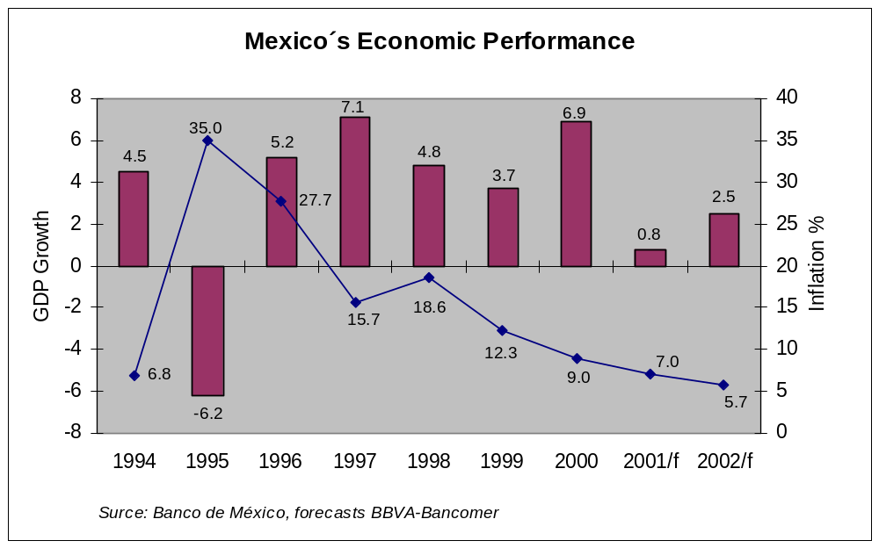
The Mexican economy grew at a rate of 1.9% during the first trimester and is expected to close the year with 1.1% growth. Inflation is expected to close the year at under 7%, while country risk has declined to about 300 basis points in the last semester, this contrasts with the country risks for Argentina and Brazil which continue growing.

Inflation during the first semester reached 2.11%, which was lower than that of the U.S. during the same period. On a positive note, the continued decline of the inflation rate and country risk premium have a positive impact on the internal rate of return for long term infrastructure projects like is the case for those in the water sector.

Mexico’s economy continues to present strong fundamentals that offer a positive outlook for long-term investments. Foreign exchange reserves are at a historic high of US$ 38.8 billion, with the exchange rate continuing to appreciate against the dollar in real terms supported by stable oil prices and continued inflows of foreign direct investment. FDI is expected to reach US$ 17.6 billion during 2001 and US$ 14.7 billion in 2002. As for the exchange rate, it is expected to close the year at $ 9.46 pesos per dollar. GDP growth is expected to reach 4.6% during 2002.

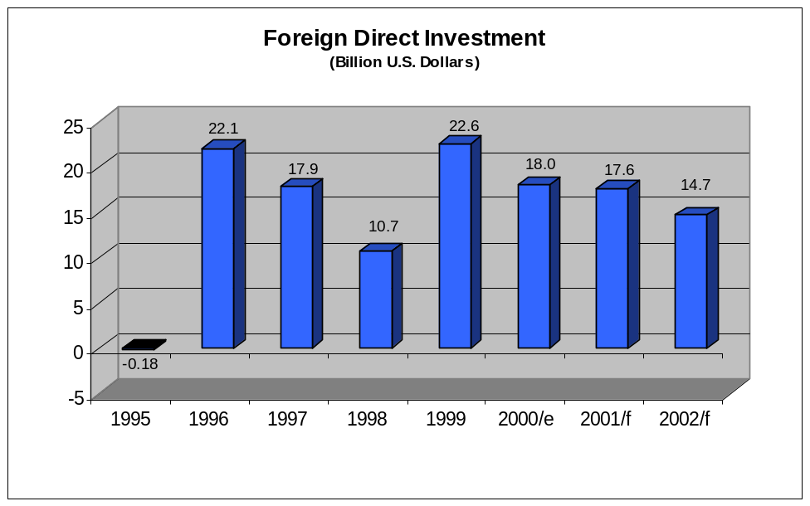

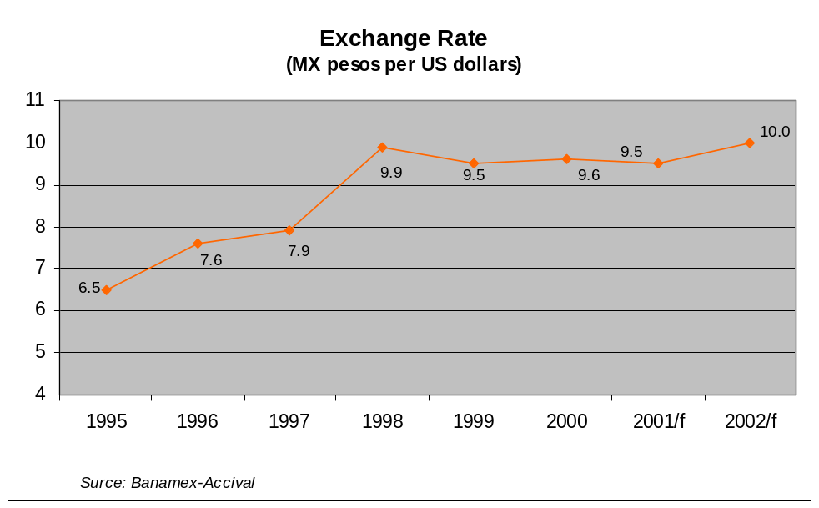

Macro-economic stability remains as one of the principal goals of the current administration. It is expected that a tax reform bill will pass through congress by the end of 2001. If this legislation is enacted it will allow for eliminating the public sector deficit which is currently estimated at 0.7% of GDP and will possibly allow Mexico to reach investment grade status. This will be another positive factor that will reduce the cost of financing projects in Mexico.

Increased economic stability will boost investment on infrastructure projects in Mexico, which have in the past been affected by economic imbalances. Among the principal factors that will support the development of this projects are: exchange rate stability, dramatic reductions on internal interest rates and most importantly, the population’s income is growing in real terms.

The Mexican government currently spends about $ 1.4 billion pesos per year on water sector infrastructure, but only a small fraction of between 22 to 27% of this expenditures are destined for the construction of new infrastructure. The vast majority of these resources are used for the most basic maintenance as it is estimated that an adequate maintenance of the existing infrastructure requires over $1.6 billion pesos per year. If the Mexican government were to increase the sector’s service coverage to its desired levels it will require expenditures of $ 2.4 billion pesos per year for the following 10 years.

Water availability in Mexico is becoming a major problem throughout the country, the government has emphasized that finding a solution to this issue is a key priority and has proposed plans incorporating a growing participation of the private sector on these investments. It is likely that because of the urgent nature of these projects, the Federal and local authorities will move forward to increase water rates and improve upon fee collection; these are the two fundamental steps for demonstrating the government’s commitment for fostering these investments.

Current economic stability plays well into the possibility for creating strong interest among private investors. But it is important to separate the underlying factors creating these investment opportunities. The economy’s strong growth seen in 2000 has been stalling and is expected to be much smaller this year, but infrastructure projects are driven by specific demand, which is strong in Mexico for water projects and more importantly by the long term prospect of economic stability that allows for the structuring of long term – affordable – financing for these projects.

Short-term growth prospects for the Mexican economy are almost independent issues to the development of water infrastructure. These projects are not dependent upon the country’s growth rates but upon its economic stability and the government’s commitment to support these investments. These projects are not conceived for satisfying potential future demand but for bringing the country up to date on the infrastructure it already needs for satisfying the needs of its 98 million inhabitants.

The major economic crisis of 1994 and its dramatic aftermath were caused by a series of factors that are not currently present with the exception of one: the real appreciation of the Peso against the US dollar. Government officials indicate that the current value of the exchange rate is determined by market forces and not by the central bank’s intervention. Because of this, the strength of the local currency is explained by the positive inflows of foreign direct investment and stable oil prices, which are a principal source of revenue for the Mexican government.

There is strong debate on whether the government should devalue its currency, but it has been clearly stated that the exchange rate is determined by market forces and because of this, we expect it will remain very stable for the following years. Pressures on the exchange rate from the trade balance are limited as Mexico’s trade deficit remains manageable and is expected to reach US$ 12.4 billion by the close of 2001, an amount easily financed by FDI flows. The growth rates of both imports and exports have declined from last year’s levels and are currently estimated at 6% for exports and 6.7% for imports. Export elasticity of the Mexican economy is much more dependent upon economic growth in the U.S. than on marginal exchange rate fluctuations.

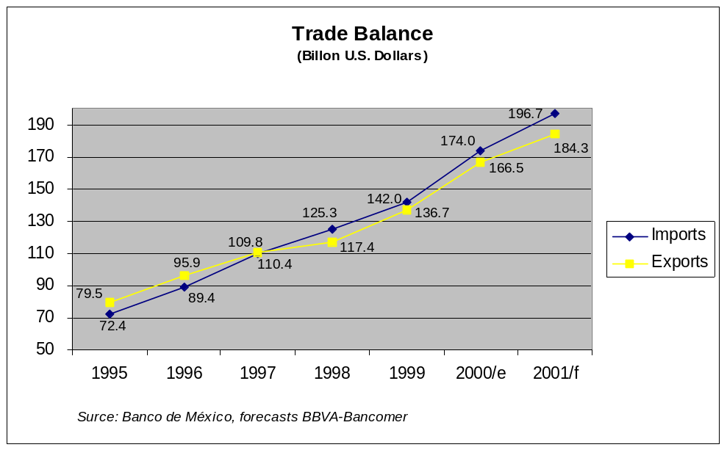

Basic Macroeconomic Forecasts of Major Banks

and Credit Rating Agencies.

 | GDP growth % |  |  | Inflation (%) |  |  | Unemployment %
Organization | 2000 | 2001F | 2002F | 2000 | 2001F | 2002F | 2000 | 2001F | 2002F
CAIE | 6.90 | 1.30 | 5.00 | 9.00 | 5.80 | 7.70 | na | na | Na
CIEMEX | 6.90 | 2.40 | 4.90 | 8.96 | 7.70 | 6.10 | 2.21 | 3.70 | 2.80
Bursametrica | 6.90 | 1.50 | 2.70 | 8.96 | 6.24 | 6.83 | 2.21 | 2.58 | 2.70
Merrill Lynch (as of 5/30) | 6.90 | 1.85 | 5.80 | 9.00 | 7.80 | 4.50 | na | na | na
Banamex | 6.90 | 2.30 | 4.70 | 9.00 | 6.30 | 5.20 | 2.20 | 2.40 | 2.30
Bancomer (as of 6/7) | 6.90 | 2.00 | na | 8.96 | 6.10 | na | na | na | na
Banxico Monthly Survey | na | 2.10 | 4.46 | na | 6.23 | 5.64 | na | na | na
Santander Investment | 6.90 | 2.30 | 4.20 | 9.00 | 7.30 | 6.00 | 2.20 | 2.30 | 2.20
Average | 6.90 | 1.97 | 4.54 | 8.98 | 6.68 | 6.00 | 2.21 | 2.75 | 2.50
Source: El Financiero, August 2001

Political Environment.

In Mexico there are eight political parties, but only three have real political power. The others are marginal players that join major parties forming coalitions for elections. Mexico’s political scenario was dominated by the party Partido Revolucionario Institucional (PRI) until the 2000 presidential elections, when Vicente Fox, a former Coca-Cola executive and governor of the State of Guanajuato, was elected president on July 2, 2000 ending 71 years of dominance of the Mexican presidency by the PRI. President Fox ran as the candidate for the coalition Alianza por el Cambio (Alliance for Change) formed by the National Action Party (PAN) and Mexico’s Green Environmental Party (PVEM).

At present the National Action Party (PAN) has the presidency and governs 12 states and over 50% of Mexico’s population. The Institutional Revolutionary Party (PRI) governs 15 states and is the single stongest minority in the federal congress. The Revolutionary Democratic Party (PRD) governs 4 states and Mexico City, where it also has control over the local congress.

The Fox administration plans to continue the process of economic liberalization in various sectors, including water, where it will promote decentralization and private participation in local water utilities. In order for projects to move forward, there is the need for coordination between municipal, state and federal officials. This requirement is the major cause for project delays. While the Federal government has prioritized privatization as the best option to solve the water sector challenge, states and municipalities prefer local government control.

During its presidential campaign, President Fox emphasized the importance of protecting Mexico’s environment and particularly controlling water pollution. He has refered to this specific issue as a national security priority. The Fox government has been in office for ten months, and it has presented its first far-reaching environmental program focused on protecting water and forest resources in Mexico. The National Crusade for Forests and Water program, presents the strategy the government will follw for cleaning Mexico’s surface waters and protecting its aquifers.

The Fox’s administration is expected to create favorable conditions for private investment in Mexico’s water sector. A strong signal in this direction is a recent proposal for increasing water prices to cover real cost and be able to finance the necessary infrastructure. This proposal has met strong objections from opposition parties and local governments. But the federal government is confident it will make progress in its proposals albeit slowly. Clear examples that this transition has begun, is the recent approval by the congress of Saltillo to create a joint public-private company to control the city’s water services and the creation of the Fund for Infrastructure II.

The Mexican government is developing a program to fund municipal water utilities that choose a scheme that incorporates private participation. Under this Fund for Infrastructure II (FINFRA II), the Federal government’s role will be to partially cover the investment needs of water utilities that allow some form of private participation in the operation of their systems. The more private participation involved, the more financing the utility receives. Details of this program are presented in chapter 2.3. of this report.

Financial Issues Impacting Mexico’s Water Sector.

Mexican federal legislation mandates that local governments are responsible for investing, operating and maintaining water infrastructure. However, as states, municipalities and local utilities have lacked the necessary resources for investing in new infrastructure, the federal government has been required to play an important role in this area.

In recent years, the federal government has promoted several decentralization programs that have received the support of multilateral agencies. This has helped to transfer water investment responsibilities to the local level. Although progress is slow and has not shown important results, it is expected that in the medium term, local investments will begin to gain momentum and substitute federal spending in the sector. The government is seeking to promote private participation, not only to bring in much needed capital investment but especially for increasing the efficiency of the services. An efficient system will generate the neccesary cash flow for project repayment.

Insufficient investments in the water sector over the past several years have created an important backlog of water projects. In order to increase water and sewer coverage to 97% of the population and wastewater treatment to 90% for the year 2025, Mexico will need to invest US$ 2.9 billion per year, and this can only be achieved if private capital is brought to the sector.

Water Investment scenarios for 2025
Concept | Current | Minimal | Desired
Irrigation hectares modernized | 0.8 million | 1.1 million | 5.8 million
Land with new irrigation infrastructure (Hectares) | N/A | 490,000 | 1 million
Losses in irrigation | 60% | 60% | 46%
Losses in urban systems | 44% | 44% | 24%
Potable water coverage | 87% | 87% | 97%
Sewer coverage | 73% | 73% | 97%
Percentage of wastewater treated | 24% | 50% | 90%
Water use volume (thousand million cubic meters) | 78 | 91 | 81
Yearly investment in the sector. (Billion US$) | 1.4 | 1.6 | 2.9
Source: CNA – Investment needs 2025.

It is important to note that of the US$1.4 billion invested in the water sector per year, only from US$300 to US$ 400 million go to new infrastructure while the rest is spent on operation and maintenance of existing systems. An adequate investment for new projects should reach between US$ 600 to US$ 800 million per year.

Domestic Financing:

Domestic financing for water infrastructure comes from a variety of federal, state and municipal resources. The National Water Commission (CNA), which channels federal resources to municipal and rural projects, and the National Public Works Bank (BANOBRAS) which provides financing, subordinated debt, and capital have been the dominant players. States, municipalities and local authorities have very limited financing capacity for new infrastructure. Additionally, the government owned development bank NAFIN, has also played a financing role for water infrastructure, but it’s role is mainly concentrated in providing financing to polluting industries and its participation has been limited.

The National Water Commission (CNA):

The CNA is a major source of financing for the sector. It administers the Programa de Agua Potable y Alcantarillado para Zonas Urbanas (APAZU – Potable Water and Sewage Collection Program in Urban Areas). APAZU has the dual goal of improving infrastructure while at the same time improving the institutional and commercial capabilities of local operating companies. The APAZU program allows states and municipalities to request financial assistance from the federal government for the improvement or construction of potable water, sewage and wastewater treatment infrastructure. To receive federal monies under this program, the states or municipalities have to sign an agreement whereby they commit to having their municipal water utilities become financially solid or at least “break even” on their operations under a period of no more than five years.

The main goals of the program are:

- Support municipalities and states in strengthening their water utilities as well as to increase service coverage.
- Gradually eliminate federal government subsidies for the construction of water infrastructure.
- Focus subsidies on improving the utilities’ physical, commercial and financial operations.

This program is available for cities with populations greater than 2,500 inhabitants while in smaller localities the CNA will continue to directly finance the development of infrastructure. The program provides the largest federal subsidies to the poorer municipalities.

States or municipalities entering this program have to provide the CNA with a schedule for the completion of the works as well as a plan demonstrating how the utility will become profitable in less than five years. These plans require authorization from the local congresses to ensure that if tariff increases are contemplated as part of the plan these will be approved.

The maximum federal government financial participation through the CNA in water projects is as follows:

For cities or localities with a population between 2,500 and 500,000 inhabitants:

FOR EFFICIENCY IMPROVEMENT
Poverty Index | Federal | State/Municipal
High | Up to 60% | 40%
Medium | Up to 48% | 52%
Low | Up to 42% | 58%

FOR POTABLE WATER
Poverty Index | Federal | State/Municipal
High | Up to 48% | 52%
Medium | Up to 30% | 70%
Low | Up to 18% | 82%

SEWAGE & WASTEWATER TREATMENT
Poverty Index | Federal | State/Municipal
All | Up to 42% | 58%

For cities with a population greater than 500,000 inhabitants:

Type of Work | Federal | State/Municipal
Efficiency Improvements | Up to 42% | 58%
Potable Water | Up to 18% | 82%
Sewer and WW treatment | Up to 42% | 58%

The program is creating an important market -at the local level- for efficiency-related equipment and services. These opportunities include equipment for metering, leak detection and control systems, equipment for detecting and assessing water sources, user registration services, and billing control software. Investments for potable water will be especially strong in Mexico City, Guadalajara and the northern border as well as in other large cities where APAZU is supporting municipal water utilities to increase efficiency. During 1999 CNA spent US$ 77.1 million under APAZU

The CNA also has direct spending authority, in addition to APAZU, targeted mainly at improving potable water capabilities. In 1999 CNA spent an additional US$ 85 million for development of water infrastructure in rural areas and for special projects.

The National Public Works Bank (BANOBRAS):

BANOBRAS is another major financial player in Mexico’s water sector. It is the principal conduit for infrastructure-related loans, World Bank, the Interamerican Development Bank (IDB) and the Japan International Cooperation Agency (JICA). Banobras, in addition to disbursing these loans, has established a series of financial instruments to provide financing to municipal water projects. The most important is called The Infrastructure Investment Fund (FINFRA).

FINFRA

This BANOBRAS managed fund has been an important support for infrastructure project development especially in water. FINFRA offers equity for Build-Operate-Transfer (BOT) or concession projects, reducing the investment risk to the concessionaire.

FINFRA provides subordinated capital for up to 40% of the total investment cost of the project, and venture capital for up to 35%. FINFRA can also combine subordinated and risk capital and finance up to 49% of the total investment. FINFRA can also combine both instruments with other BANOBRAS credits for up to 66.6% of the total project cost.

FINFRA also provides technical assistance and advices the municipalities on how to structure viable water projects, defining their adequate size and structure. Because of this, projects with FINFRA participation have lower risk than other municipal BOT projects. So far and after five years in operation, FINFRA has become a cathalist for private investment in wastewater treatment plants. For each dollar invested by FINFRA, private companies have invested two, and over 10% of all wastewater treated in Mexico is through plants built with FINFRA’s financial support.

Projects Financed with FINFRA Participation
(In thousand US$)

Project | FINFRA  Capital | CAN  Grant | Credit | Private | Total  Investment
WWTP (2) Cd. Obregón, Son. | 7,706.95 |  | 5,124.95 | 6,435.16 | 19,267.05
WWTP León, Gto. | 17,837.26 |  | 15,607.47 | 11,148.21 | 44,592.95
WWTP Tenorio, S.L.P. | 24,079.68 |  |  | 36,119.47 | 60,199.16
WWTP (2) Cd. Juárez Chih. | 13,047.47 | 6,523.79 | 4,892.74 | 8,154.74 | 32,618.74
WWTP (4) Puebla, Pue. | 25,674.63 |  | 31,244.95 | 19,696.74 | 76,616.32
WWTP Los Mochis, Sin. | 1,971.68 |  |  | 4,599.47 | 6,571.16
WWTP Culiacán, Sin. | 9,394.95 |  | 13,779.68 | 9,134.32 | 32,308.95
WWTP Torreón, Coah. | 6,316.00 | 2,041.05 | 5,432.11 | 9,144.63 | 20,892.74
WWTP G. Palacio, Dgo. | 2,697.68 | 924.42 | 2,454.11 | 3,903.47 | 9,055.37
WWTP Askareles, Edo. Mex. | 674.84 |  | 1,207.37 | 2,193.16 | 4,075.37
Sewr Tlanepantla, Edo. Mex. | 11,240.11 |  |  | 17,362.63 | 28,602.74
WWTP Tehuacán, Pue. | 2,517.26 |  | 1,636.32 | 3,776.00 | 6,293.26
Total | 123,158.53 | 9,489.26 | 81,379.68 | 131,668.00 | 341,093.79
Source: FINFRA.
Numbers converted to US$ at 2000 exchange rate of 9.5 pesos per dollar.
WWTP= Wastewater Treatment Plant Sewr= Sewer.

So far, FINFRA has played and important role in wastewater treatment but a limited role in potable water and sewer collection. These last areas demand much more resources than wastewater treatment and water is increasingly scarse in many regions. Because of this and FINFRA’s success in wastewater, the Mexican government through BANOBRAS is structuring a new program to increase private participation in this area. The new program called Fund for Infrastructure II (FINFRA II) will provide capital investment to municipalities, which opt for a private participation scheme in their water utilities. (See private participation schemes in Chapter 4.3. of this report).

FINFRA II:

FINFRA II has the objective of becoming an additional source of funds to support water utilities. These resources are dependant upon the autorities willingness to include private participation in their opperations. This idea is to support a process to make these utilities self-sufficient. FINFRA II is being created to promote the consolidation of municipal water utilities; promote operational efficiency; facilitate access to state of the art technologies; and promote environmental protection through sanitation projects, preferentially linked to wastewater re-use projects. FINFRA II is targeted to municipalities with over 50,000 inhabitants and will channel federal resources to:

- Increase efficiency of water utilities.
- Supply and installation of macro-metering.
- Supply and installation of micro-metering.
- Leak detection and control.
- Develop user registries.
- Billing and collection systems.
- Accounting systems.
- Information systems.

- Increase coverage:
- Drilling and equipment for new wells.
- Potabilization plants.
- Regulation tanks.
- Aqueducts.
- Construction and rehabilitation of sewer collection systems and wastewater treatment plants.

FINFRA II will fund up to 49% of the required investment, based on the achieved efficiency and private participation level. Any water utility in Mexico serving a population greater than 50,000 inhabitants will be eligible for FINFRA II funds, however these funds will be only provided as grant to utilities with an efficiency level of over 45%. Otherwise funds provided by FINFRA II will be considered credit until the utility exceeds a global efficiency level of 45%.

FINFRA II Funding for Efficiency Investments

Current level of Global Efficiency | Management Contracts or Mixed Public-Private Utility With Majority of Public Participation | Integrated Concession or Mixed Public-Private Utility With Majority of Private Participation
Current level of Global Efficiency | Funding Up to
Lower than 30% | 40% | 49%
30% to 40% | 30% | 40%
Higher than 40% | 25% | 30%
Source: BANOBRAS

FINFRA II will also provide funding for water, sewer and wastewater infrastructure. All Infrastructure projects will require a feasibility study with a social impact evaluation approved by BANOBRAS. These funds will have the same financial treatment and will be considered credit until the utility reaches a global efficiency level of 45% and only after this, funds will be considered grant without need for repayment.

FINFRA II Funding for Infrastructure

Type of Work | Management Contracts | Mixed Public-Private Utility With Majority of Public Participation | Integrated Concession or Mixed Public-Private Utility With Majority of Private Participation
Type of Work | Funding Up to
Water Supply | 20% | 25% | 30%
Sanitation | 30% | 40% | 49%
Source: BANOBRAS

FINFRA II is in a development stage and it is expected to begin operations by the end of 2001 with the first projects tendered in late 2002. (See priority cities for FINFRA in chapter 4.5. of this report)

Nacional Financiera: (NAFIN)

This government financial institution is a development bank whose purpose is to promote industrial development, specifically of medium and small size companies. Because of the link between industry and environmental issues, this bank has played a role on environmental project financing. Some industry related environmental projects have included wastewater treatment. NAFIN offers various financial services that range from direct credits, to providing funding to other private banking institutions for ear marked credits. It also offers credit enhancement and warrantee programs where NAFIN absorves up 70% of the credit risk in benefit of private banks.

NAFIN manages a program sponsored by the Japan Bank for International Cooperation (JBIC) where companies audited by federal authorities for environmental compliance and companies participating in the volunteer audit programs and which define an investment plan to mitigate pollution, are eligible for low interest credits from the Japanese bank. NAFIN also manages monies from the North America Environmental Fund (NAEF), whose objective is to invest in companies whose core business is environmental protection. Eligible companies include manufacturers of alternative power equipment, wastewater treatment plants, and recycling facilities. Under this program NAEF can invest up to US$ 3 million on a five-year horizon.

NAFIN also provides technical assistance and funding for feasibility studies, pilot projects, and the manufacturing of prototypes of environmental equipment through the European Community Investment Partners (ECIP). This program has the objective of supporting co-investment of Mexican and European investors of small and medium sized companies. The program provides:

- Financing for feasibility studies, pilot plants, and prototype manufacturing.
- Capital investment for joint companies.
- Financing for training technical and managerial personnel.

NAFIN has provided US$20 million to eleven companies under this program. Beneficiaries include companies in the areas of wastewater project construction and operation, plastics recycling, hospital waste treatment, energy savings, chemical residue treatment, and air conditioning systems for vehicles.

Local Water Utilities:

Mexican legislation gives responsibility for water investments to the local governments. Those have municipal or state owned water utilities are directly responsible for the service. Mexico has 345 local water utilities, which are plagued by insufficient metering; low efficiency levels; inadequate tariff structures and which also lack the technical and financial capacity to invest in new infrastructure.

The Mexican Government has undertaken several efforts to increase efficiency of these institutions, however this process is advancing at very slow pace due to political debates over increasing tariffs, an incipient water culture among Mexico’s population and a lack of investment capacity of local governments. The CNA estimates that less than 20% new water investments comes from locally generated revenues from tariff collection.

To increase the efficiency of local water utilities, the Mexican Government is working in two fronts:

- Increasing the efficiency of local public entities: The Mexican government has a program sponsored by the Interamerican Development Bank whose objective is to improve the financial management and collection structures of state and municipal governments. Although this program is not destined to water utilities only but to all municipal entities to support decentralization, the priority areas are: potable water, sewer and sanitation; basic infrastructure; urban equipment; paving and transportation; and institutional strengthening. This program has been an important source of technical assistance and funding to local utilities but implementation has been slow only reaching a few of the 345 utilities and providing limited assistance for capital expenditures.

- Promoting private participation in water utilities: Other than wastewater BOT’s, Mexico has only three water utilities with private participation in the cities of: Navojoa, Cancún and Aguascalientes. The experience of these “pilot projects” has been positive with coverage indexes and quality of service improving, but local authorities remain reluctant to give control of the water to private hands. As a new effort to increase private participation in water utilities the Mexican Government is structuring FINFRA II and assisting local governments in adapting local water laws that allow private participation.

The water utility at the northern city of Monterrey (3rd largest city in Mexico with a population of 3.5 million) shows it is possible for a Mexican water utility to be self sufficient and efficient. The utility Servicios de Agua y Drenaje de Monterrey (SADM), has achieved potable water and sewer coverage of 100% and wastewater treatment of 95% in Monterrey’s urban areas. It has decreased water losses from over 50% to about 30% and its goal is to reach 10% of unaccounted water by 2003. The utility if financially and operationally self-sufficient and has a tariff structure that promotes water savings by increasing –unitary- rates in relation to the volume of water being consumed. The opposite mecanism exists for those using treated water. The water utility has a B+ rating from Standars and Poors and has been able to raise funds from private lenders. This city serves as an example to other municipalities. However the conditions of Monterrey are special, as the city has a very strong industrial base and one of the lowest poverty indexes in Mexico.

In addition to Monterrey, there are few self-sufficient water utilities, like those in the states of Baja California, Quintana Roo, Puebla, Sinaloa and Aguascalientes. All the rest of the utilities do not cover their operational costs through revenue collection and require subsidies.

There is a strong need to raise water tariffs in most Mexican cities, to levels that would at least allow to cover operational costs, but since rising water tariffs is an unpopular political measure, most local governments are still refusing to do so. We expect tariffs to increase slowly as CNA and other federal government institutions will decrease their subsidies to the sector and local governments will have to opt for subsidizing their own utilities or making people pay for the service.

Mexican Banks:

Mexican banks faced severe problems following the 1994 economic crisis and the government was forced to absorve their bad loans to avoid a collapse of the banking and financial systems. Because of this, banks have become much more careful in their credit analysis, and see the water sector as particularly risky due to the long-term nature of the projects and low rates of return compared with other industrial or commercial activities. Although the Mexican economic situation has completely recovered from the 1994 crisis and Mexico might receive investment grade soon, Mexican banks are not likely to be a source of financing to the sector at least in the following two years.

International Financing:

Multilateral and Bilateral Financing:

The World Bank and the Interamercan Development Bank were major players in Mexico and important drivers in most major infrastructure projects and programs. These two agencies have decreased their support to the Mexican water sector and have substituted this support with programs aimed to assist the government in creating efficient decentralized entities. The following are the programs sponsored by these Multilateral Agencies active in Mexico:

The Program for Strengthening of States and Municipalities (FORTEM):

Under this program, BANOBRAS received from the International Development Bank (IDB), a credit line of US$ 400 million to support the decentralization efforts carried by the Mexican government. The objective of this program is to strengthening the financial condition and institutional capacity of State and Municipal governments, and at the same time promoting the modernization of local services through funding projects and public works with high social and economic impact in the municipalities.

The tenders for projects and contracts made under FORTEM are made following IDB’s guidelines, through international tenders and are open for participants of any IDB member country.

Although FORTEM is not limited to strengthening water authorities, and it covers a wide range of local institutions such as waste collection and disposal utilities, police, health, traffic, etc., the program states water utilities as one of its top priorities. FORTEM funds services destined to personnel training, technical assistance, project development, and feasibility studies. Equipment such as office equipment and software, monitoring equipment, vehicles, metering and collection systems, and billing technologies, as well as other water infrastructure, with the condition of a) to be of benefit strengthening the financial or institutional capacity of the utility and b) to have high social and economic impact.

Tenders of FORTEM funded services, equipment and projects are published in the Official Gazette of Mexico (Diario Oficial), as well as in IDB’s acquisition advice systems.

Natural Disaster Management Program:

Under this program, BANONBAS has a credit line of US$404.05 million from the World Bank to support prevention and response activities for natural disasters. The program is formed of three components: a) prevention activities, b) emergency recovery and reconstruction activities, and c) capacity building activities. The program was signed in December 2000 and investment is committed for three calendar years (years 2001-03).

In terms of geography and climate, Mexico is one of the most diverse countries in the world. It is susceptible to a wide range of natural disasters such as floods, droughts, volcanic eruptions, earthquakes, fires and tropical cyclones. These natural events can cause widespread loss of life and damage to the economic infrastructure because of the country's settlement patterns, construction practices and a lack of disaster response capacity.

The prevention component will finance analytical, design and policy-related studies and equipment aimed at reducing economic and human losses in the event of a natural disaster. Prevention activities will be executed through federal agencies (Including CNA) as part of their annual investment programs. The prevention component will not finance major public works.

The emergency recovery and emergency reconstruction activities component, will support emergency recovery and reconstruction activities financed through the National Fund for Disasters (FONDEN) and executed either through federal agencies or state and municipal agencies financed through state trusts. Only FONDEN-financed activities initiated within 15 days before and 180 days following the declaration of an emergency by the Secretariat of Internal Affairs (SEGOB) will be eligible for financing. Eligible emergency recovery and reconstruction expenditures include net-of-tax FONDEN expenditures for activities related to disaster recovery.

The component for capacity building activities will finance activities to strengthen capacity of federal entities, including CNA, to respond to natural disasters, manage social, cultural and environmental issues arising from natural disasters, and used for insurance and other risk transfer instruments. It is envisaged that this component will develop a framework to help sectoral implementing agencies identify priority prevention investments for inclusion in their annual programs.

The project is designed to help reduce human, economic and financial costs of natural disasters in Mexico by a) providing resources for rapid recovery following natural disasters within a fi-amework of sound budget management, and (b) reducing the likelihood that natural forces will result in loss of life and infrastructure damage by supporting policy and institutional reforms aimed at reducing vulnerability and risk and improving government capacity for analyzing natural disaster risk.

Companies interested in obtaining additional information of these programs should contact the IDB or World Bank respectively, or BANOBRAS through the following official:

Mr. Víctor Manuel González Molina
Underdirector of Credit Programs and Technical Assistance
Banco Nacional de Obras y Servicios Públicos, S.N.C. (BANOBRAS)
Calle Tecoyotitla No. 100,
Colonia Florida Delegación Alvaro Obregón
C.P. 01030 México, D.F.
Tel: (52-5) 723-6039; 723-6237
Fax: (52-5) 723-6000 Ext. 2154

The Fox government has not yet developed any water or environmental project that requires support from these two multilateral organizations, but according to the World Bank, a new program to fund municipal water utilities to increase their efficiency could be presented for approval. This project would involve technologies for detecting and fixing leaks in water networks, macro and micro metering, sewer cleaning vehicles, computers and software among other technologies. It would be similar to the FORTEM but channeled specifically to the water sector.

JBIC Sponsored Mega-Projects:

Another multilateral institution, which has been expanding their presence and support to Mexico’s water sector, is the Japan Bank for International Cooperation (JBIC). This bank, known previously as Overseas Economic Cooperation Fund (OECF) has been recently a major driver for Mexican water and wastewater projects. In 2000 JBIC provided a loan worth ¥22,148 million (Approximately US$ 200 million) to the Baja California State Water Supply and Sanitation Project, which involves over US$350 million in new water potabilization plants, sewer, wastewater treatment plants and water distribution networks for Baja California’s three most important cities. (See Baja California Stete Water Supply and Sanitation Project in Appendix 1 of this report).

JBIC has also offered financing to the Mexico City and Guadalajara mega-projects that involve investments of over US$700 million in water infrastructure. These projects have been under design and facing major political debates for the last three years but are considered as priority projects for Mexico’s federal government.

Bilateral Institutions:

In addition to the multilateral agencies, a bilateral institution created under NAFTA, The North American Development Bank (NADBANK) has been a major project detonator in Mexico’s northern zone. NADBANK provides long-term loans and loan guarantees for environmental projects within 100 kilometers of the U.S.-Mexico border. NADBank’s mission is to leverage private and public sector investment in environmental infrastructure projects in the border region. NADBANK must charge an interest rate of at least one- percent above U.S. Treasury rates for securities with comparable maturities and lends only in U.S. dollars. As with multilateral loans these funds are channeled through BANOBRAS, typically raising the cost of capital to municipalities.

NADBANK can lend only to projects certified by the Border Environmental Cooperation Commission (BECC), an institution also created under NAFTA where border projects are evaluated prior becoming NADBANK’s credit candidates.

NADBanks resources come mainly from the U.S. and Mexican governments. In addition, the EPA has provided funds to NADBANK for the construction of wastewater infrastructure. NADBANK and the BECC also operate different programs and funds for infrastructure development. The most important is the Project Development Assistance Program (PDAP), which provides funds for technical assistance in project preparation, and the Border Environmental Infrastructure Fund (BEIF) that provides grants to environmental projects.

The U.S. Environmental Protection Agency (EPA) provides most of the funds administered through the PDAP and the BEIF. This far, these funds have totaled over US$211 million.

BECC Approved Projects
City |  | Technical  Assistance  (US Dollars)  BECC | Project |  | Subsidies  From USA  (US Million)
 |  | Technical  Assistance  (US Dollars)  BECC | Type | Total Cost  (US Million) | Subsidies  From USA  (US Million)
Finished Construction
1 | Agua Prieta, SON | 69,049 | MW | 2.01 | -
2 | Matamoros, TAM | - | WW | 1.10 | -
3 | Puerto Peñazco, SON | 132,789 | MW | 2.25 | -
4 | Ensenada, B.C. | - | WW | 8.19 | -
Under Construction
5 | Cd. Acuña, COAH | 85,000 | WW | 80.35 | 16.73
6 | Cd. Juárez, CHIH | 77,664 | WW | 31.16 | 15.66
7 | Matamoros, TAM | 145,100 | MW | 12.98 | -
8 | Mexicali B.C. | 250,267 | WW | 57.36 | 20.62
9 | Naco, SON | 98,678 | PW / WW | 1.10 | 0.60
10 | Nogales, SON | 491,344 | PW | 39.00 | -
11 | Piedras Negras, COAH | 85,500 | WW | 57.42 | 8.40
12 | Tijuana, B.C. | 51,849 | WW | 19.52 | 18.50
Under Design
13 | Reg. 5 Manantiales, COAH | - | WW / MW | 17.50 | -
14 | Reynosa, TAM | - | WW | 83.40 | 33.50
15 | Sn. Luis Rio Colorado, SON | 495,000 | WW | 13.50 | 5.93
16 | Tecate, B.C. | 150,000 | PW / WW | 7.81 | 3.71
17 | Tijuana, B.C. (Ecoparque) | 38,704 | WW | 0.18 | -
 | TOTAL | 2,170,944 |  | 434.84 | 123.65
Source: BECC.
WW= Wastewater MW= Municipal Waste PW= Potable Water

Direct Investment & Equity:

The Mexican government has sought to attract private sector international financing and equity through concession programs, principally in the wastewater area. Private international financial institutions have only played a limited role in financing water infrastructure, and this has been done through balance sheet financing to the concessionaires while avoiding undertaking any project risk.

Private equity funds, especially form the United States are more aggressive than banks in financing Mexican water infrastructure, and their participation is more active in non-municipal projects such as PEMEX and industrial wastewater treatment and reuse projects.

Most water projects in Mexico have had to be financed through developer equity. These developers were for the most part major Mexican construction firms, but due to their weak financial conditions, these projects were taken over by international water companies which can rise financing for the development of their international projects through export credit agencies and private banks.

Institutional and Regulatory Structure:

Institutional Structure:

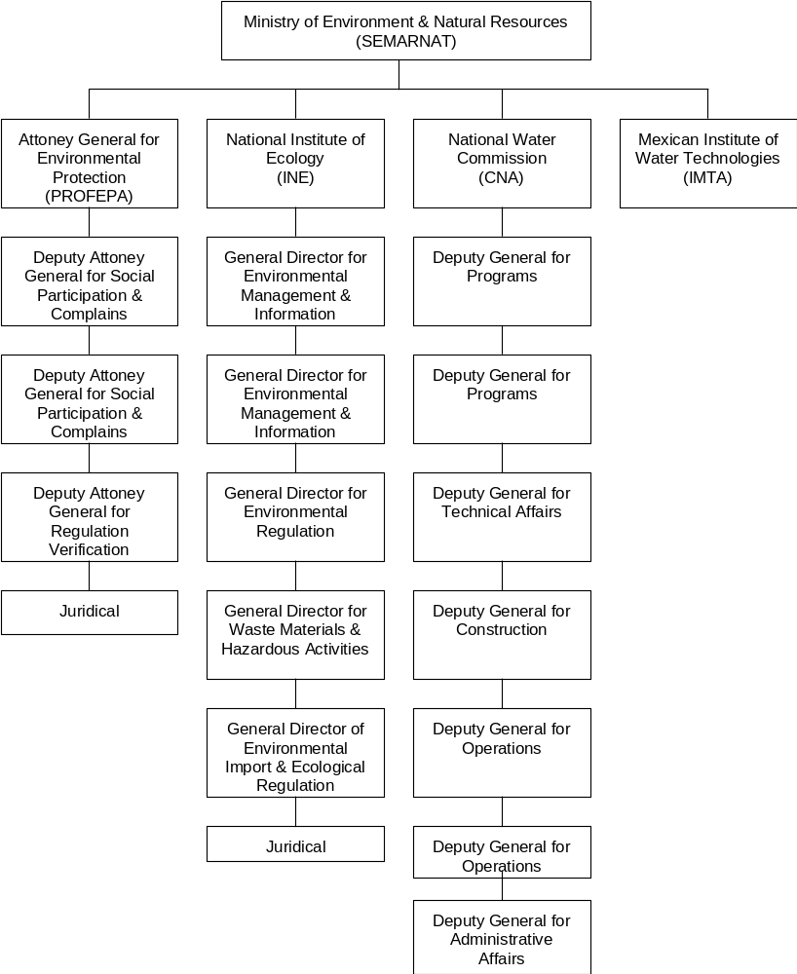

To understand the institutional structure of Mexico’s water sector, it is important to understand its legal structure:

According to the Mexican Constitution, all water resources are property of the federal government, and water use can only be achieved through federal government concessions. The Constitution places the responsibility for the regulation and provision of water services at the state and municipal levels. Thus, local governments have to obtain concessions from the federal government to use water and they are legally responsible for providing service to the population.

At the Federal Level, the water sector falls within the responsibilities of the Secretariat of the Environment and Natural Resources (SEMARNAT), but this agency only acts as a policy making and regulatory authority, and as a “holding” of Mexico’s water sector regulatory and enforcement agencies: The National Water Commission (CNA), the National Institute of Ecology (INE) and the Attorney General for Environmental Protection (PROFEPA) and the Mexican Institute for Water Technologies (IMTA).

The National Water Commission (CNA):

Founded in 1989, The National Water Commission is the main player of the Mexican water market. Its main functions include:

- Management and custody of all water resources, assigning and collecting water rights to users, including rights for polluted water discharges into water bodies.
- Overseeing compliance and enforcing the National Water Law, and other water related regulations. This includes assessing and collecting fees, fines and penalties for the violation of Federal environmental laws.
- Promote sustainable development and protect water bodies, which represent environmental risk.
- Overall planning of the sector.
- Build, operate and maintain water infrastructure belonging to the Federal Government.
- Provide technical and regulatory assistance to local water authorities and advice on project feasibility.
- Provide financial support to priority water projects and assist local governments in providing service to the poorer communities.

CNA is moving from being the main sponsor of water infrastructure projects, to a policy making and regulatory role and is increasingly passing infrastructure construction activities to local governments and local water utilities.

National Institute of the Environment (INE):

Traditionally the INE was the decentralized entity of Semarnat responsible for developing environmental standards. The Fox government is changing the role of this institute, and regulatory activities will now be at Secretariat level. The INE will be kept as a research center responsible for supporting SEMARNAT in the development of new regulations and in developing programs for a more efficient use of water resources.

Mexican Institute for Water Technology (IMTA):

IMTA is a technological research institute of the Mexican government responsible for technology development, certification of new technologies and research on the water and wastewater areas. Its most important and recent development is the creation of the Mexican Center for Water and Sanitation Training located near Mexico City. This center provides training to water utility employees and offers courses on new water technologies and development. The center has laboratories, conference rooms, a pilot wastewater treatment plant, underground water and sewer networks with leaks, a sludge treatment facility and other infrastructure to train personnel in increasing the efficiency of their systems. This center can contribute to further open and give exposure to Dutch water equipment and services technologies in Mexico, especially those which are new and that can be of benefit to Mexican water utilities.

Attorney General for Environmental Protection (PROFEPA):

The Office of the Attorney General for Environmental Protection (PROFEPA) is Mexico’s primary environmental enforcement agency. PROFEPA is organized into three areas: One oversees regulatory enforcement, one deals with community involvement and complaints and one oversees the voluntary industrial audit program. At the state level, PROFRPA has 32 local offices, one in each of Mexico’s 31 States and one in the Federal District. PROFEPA has the power to punish polluters with fines and even jail since in Mexico, company officials may be personally liable for damages caused to the environment by their companies. However PROFEPA’s enforcement strategies have focused more in solving environmental problems with violators through voluntary means, than through the imposition of fines or criminal penalties. For example, if a company’s operations have contaminated a water body, PROFEPA is likely to seek an agreement with the company to remedy the damage rather than to seek financial or criminal sanctions.

PROFEPA also manages the voluntary environmental audit program, which allows companies to avoid major penalties by committing to invest in complying with environmental standards. (See chapter 3.5 of this report for details of the program)

States and Municipalities:

Since by law, states and municipalities are responsible for providing local water and sewer services as well as wastewater treatment before its discharge to water bodies, these entities are the main source of projects, and the main clients for water and wastewater equipment and services. States and municipalities are empowered to set water tariffs, collect payments, defining local regulations and their enforcement within their systems. State and municipal governments have the final word on allowing private participation for the provision of water services, and in granting concessions to private companies. Most municipalities have decentralized water utilities (Organismos Operadores), which provide the service under the guidelines of the local authorities. Local governments have to pay water rights to the CNA as all water is property of the federal government. Because of the utilities inneficiency and low trariff rates, most have a high debt burden and are not able to pay these rights. The CNA estimates it is currently owed over US$ 6.5 billion that represent total revenues of all 354 water utilities for six years.
The CNA is considering writing-off these debts in exchange for the utilities’ comitment to incorporate private participation and establishing new tariffs that reflect operational and other service costs.

Decentralization Process.

The Mexican water sector embarked on a decentralization process during the last decade. Before this, the federal government carried on all water investments in Mexico, as local governments didn’t have the expertise or resources to invest and provide service to the population. With investments coming from the federal government, local authorities neglected the establishment of adequate tariff structures, metering and collection and created a notion among the users that the government will provide the service almost cost-free.

Since the early nineties, the trend of subsidizing new water investments in the water sector changed dramatically, and the federal government is decidedly reducing its financing for water infrastructure and is strongly promoting the efficiency of water utilities, so they can cover their operational and investment needs. Although this effort begun one decade ago, results are still small as water utilities continue having week financial structures and are yet to develop a long term plan to improve their operations and financial conditions.

The main problems faced by local water utilities are:

- Insufficient funds provided by the state / local governments to their water utilities and lack of political will to increase water tariffs.
- Obsolete infrastructure resulting in poor service quality, including low pressure in the network, sediments in water supplied, high water loses and service interruptions.
- Low service quality serves as excuse for the users not to pay their water bills.
- Frequent changes in water authorities interupt the development of long term modernization programs. (Water utility directors remain in their jobs and average of 1.8 years and are usually replaced by political apointees with no water sector experience).
- Regulations are critizized for not providing reasonable compliance periods. Water utilities consider existing deadlines as unrealistic and non-compliance rates are high.

The Fox administration will continue the decentralization process begun by the previous administrations. The goal is to have the CNA as a regulatory and planning entity and eliminate federal government spending in the provision of water services, which are the responsibility of states and municipalities. To do this without affecting the population it is necessary to first develop efficient and self-sufficient water utilities.

In order to gradually phase-out federal subsidies to local water utilities, a series of programs have been created which condition federal expenditures to efficiency improvements or the inclusion of private participation in the provision of the services.

The most important programs are:

- Program for Water Supply and Sanitation in Urban Zones (APAZU), which provides federal monies to municipal water utilities for infrastructure development, access to this funding requires a commitment to efficiency improvements. (See chapter 2.3.1. for a detailed description).

- The Program for Strengthening of States and Municipalities (FORTEM) aimed to create more professional local institutions and which has a US$400 million credit line from the Interamerican Development Bank. (See chapter 2.3.2 of this report for a detailed description).

- And the Fund for Infrastructure II (FINFRA II) that will provide necessary funds to upgrade those water utilities that adopt a private participation scheme. (See chapter 2.3.1. of this report for a detailed description).

Legal and Regulatory Framework.

Mexico’s water regulatory framework derives from two constitutional precepts:

- Article 27 establishes that water resources belong to the federal government and that individuals, companies and even municipal governments can only exploit these resources through a concession granted by the federal government.

- Article 115 of the Constitution places the responsibility for the administration and provision of water related services including potable water, sewage, and wastewater treatment services in the hands of municipal governments.

Because of this, water regulations are divided in federal and local regulations.

Federal Regulations:

- The National Water Law: Promulgated in 1992, this law interprets the provisions of article 27 of the Constitution. The law is divided in 11 chapters and regulates water management organization, structures for concession, water rights, protected zones, pollution prevention and control as well as penalties for violations.

- Federal Law for Water Rights: This law is modified every year to incorporate tariff increases reflecting the inflation rate and to define water availablitiy and protected areas. It sets the terms, conditions and pricing for water use in Mexico, including payments for exceeding pollution limits on water discharges.

- Regulation NOM-001-ECOL-1996: This is the most important regulation and the main driver for Mexico’s municipal wastewater market. The regulation sets forth the standards for municipal discharges into water bodies (i.e. rivers, lakes, sea, etc.). The standard sets different quality requirements based on three categories of receptor water bodies. Thus, municipalities face different standards based on where they discharge their wastewater. Compliance with this regulation will require, depending on each case, of advanced primary or secondary treatment. The regulation was issued in late 1996 and established compliance dates for 2000, 2005 and 2010 depending on the size of the municipality or urban area.

The basic parameters are the following:

Municipal Water Discharge Parameters set by NOM-001-ECOL-1996
Parameter | Type of Receptor Body
Parameter | A |  | B |  | C
Mg/l (except as specified) | D.A | M.A | D.A | M.A | D.A | M.A
Temperature | N.A | N.A | 40 | 40 | 40 | 40
Grease & Oil | 15 | 25 | 15 | 25 | 15 | 25
Floating Material | Ab | Ab | Ab | Ab | Ab | Ab
Sedimentary Solids | 1 | 2 | 1 | 2 | 1 | 2
Total Sus. Solids | 150 | 200 | 75 | 125 | 40 | 50
Bio. Ox. Demand | 150 | 200 | 75 | 150 | 30 | 60
Total Nitrogen | 40 | 60 | 40 | 60 | 15 | 25
Phosphorus | 20 | 30 | 20 | 30 | 15 | 25
Fecal Coloform (ml) | 2000/100 | 1000/100 | 2000/100 | 1000/100 | 2000/100 | 1000/100
Heavy Metals
Arsenic | 0.2 | 0.4 | 0.1 | 0.2 | 0.1 | 0.2
Cadmium | 0.2 | 0.4 | 0.1 | 0.2 | 0.1 | 0.2
Cyanide | 2.0 | 3.0 | 1.0 | 2.0 | 1.0 | 2.0
Copper | 4.0 | 6.0 | 4.0 | 6.0 | 4.0 | 6.0
Mercury | 0.01 | 0.02 | 0.01 | 0.01 | 0.01 | 0.01
Nickel | 2.0 | 4.0 | 2.0 | 4.0 | 2.0 | 4.0
Lead | 0.5 | 1.0 | 0.2 | 0.4 | 0.2 | 0.4
Zinc | 10.0 | 20.0 | 10.0 | 20.0 | 10.0 | 20.0
PH | 5/10 | 5/10 | 5/10 | 5/10 | 5/10 | 5/10
Source: NOM-001-ECOL-1996
D.A: Daily Average M.A: Monthly Average Ab: Absent
Receptor Body A is defined as: Rivers used for irrigation
Receptor Body B is defined as: Urban rivers, surface bodies used for irrigation
Receptor Body C is defined as: Rivers that protect aquatic life
Note: Above standards vary for coastal waters and direct discharges to agricultural land

Schedule for enforcement of NOM-001-ECOL-1996
Size of Municipality | Present Compliance Plan | Compliance Acheved | Number of Cities | Cities Complying
Larger than 50,000 | June 1,1997 | January 1, 2000 | 139 | 47
20,001-50,000 | Dec. 31,1998 | January 1,2005 | 181 | N/A
2,501-20,000 | Dec. 31, 1999 | January 1, 2010 | 2,266 | N/A
Source: NOM-001-ECOL-1996 and data of CNA.

The federal government through the CNA, is fining 92 municipalities for non-compliance with this regulation. A very low percentage of these rights and fines are being paid.

Non-Municipal Water Discharge Parameters set by NOM-001-ECOL-1996
Biological Oxygen Demand (Tons/day) | Total Suspended Solids (tons/day) | Present Plan | Compliance Acheved
Greater than 3 | Greater than 3 | June 1,1997 | January 1, 2000
1.2 to 3.0 | 1.2 to 3.0 | Dec. 31,1998 | January 1,2005
Less than 1.2 | Less than 1.2 | Dec. 31, 1999 | January 1, 2010
Source: NOM-001-ECOL-1996

In non-municipal discharges (industries discharging directly to water bodies) compliance is higher than for municipal discharges, and non-complying companies pay water discharge rights and penalties to the CNA, often spending more than what would be the cost of treating their water. Compliance with the NOM provides an additional incentive for wastewater investments since the regulation grants discounts on potable water rights to entities that install treatment facilities that exceed the set parameters. The discounts are defined according to the level of improvement over the legal limits and can represent savings on potable water costs ranging from 12 to 44 percent.

- Regulation NOM-002-ECOL-1997: sets the standards for discharges into municipal sewage systems, placing special emphasis on limiting pollutants that could damage municipal wastewater systems such as oils, copper, nickel and other heavy metals and chemicals. Its enforcement is responsibility of the municipalities.

Discharge Limits into Municipal Sewage Systems
Parameters  (mg/l, except when noted) | Monthly  Average | Daily  Average | Instantaneous
Greased Oils | 50 | 75 | 100
Sedimentary solids | 5 | 7.5 | 10
(milliliters per liter)
Total Arsenic | 0.5 | 0.75 | 1
Total Cadmium | 0.5 | 0.75 | 1
Total cyanide | 1 | 1.5 | 2
Total copper | 10 | 15 | 20
Chromium | 0.5 | 0.75 | 1
Total mercury | 0.01 | 0.015 | 0.02
Total nickel | 4 | 6 | 8
Total lead | 1 | 1.5 | 2
Total zinc | 6 | 9 | 12
Source: NOM-002-ECOL-1997

Enforcement of this regulation falls under the responsibility of the municipalities but only those that have already built wastewater treatment plants are serious on verifying industrial compliance within their systems, as illegal industrial discharges could seriously hamper the operation of municipal wastewater treatment plants.

- Regulation NOM-003-ECOL-1997: Sets the standards for wastewater treatment reuse in public services. It states the maximum limits for polluting agents. These limits vary depending if the reuse water will have direct or indirect contact with the population. Enforcement of NOM-003-ECOL-1997 is the responsibility of local governments within their cities or municipalities and of the federal government in federal areas.

Local Regulations:

Each state has its own water law that states how water services should be provided and how tariffs are structured and adjusted. These state laws also detail the level of private participation allowed in the provision of services and on the development of infrastructure.

State Water Laws, 1999

State | Date of Law | CNA | Considering CNA adoption | Tariffs set by | Service Cuts Allowed
Aguascalientes | 1996 |  | Yes | Local Authority | Yes
Baja California Norte | 1969 |  |  | Local Congress | Yes
Baja California Sur | 1990 |  |  | Local Authority | Yes
Campeche | 1992 |  |  | Local Authority | Yes
Coahuila | 1993 |  |  | Local Authority | Yes
Colima | 1997 |  | Yes | Local Authority | Yes
Chiapas | 1993 |  | Yes | Local Authority | No
Chihuahua | 1996 |  |  | Local Authority | No
Durango | 1991 |  | Yes | Local Congress | No
Guanajuato | 1991 |  | Yes | Local Authority | No
Guerrero | 1994 |  |  | Local Authority | Yes
Hidalgo | 1996 | Yes |  | Local Congress | No
Jalisco | 1981 |  |  | Local Congress | No
México | 1982 | Yes |  | Local Authority | No
Michoacán | 1994 |  |  | Local Congress | No
Morelos | 1995 |  |  | Local Congress | Yes
Nayarit | 1995 |  |  | Local Authority | Yes
Nuevo León | 1995 |  |  | Local Authority | No
Oaxaca | 1993 |  | Yes | Local Authority | Yes
Puebla | 1996 |  |  | Local Congress | Yes
Querétaro | 1992 |  | Yes | Local Authority | Yes
Quintana Roo | 1996 |  |  | Local Authority | Yes
San Luis Potosí | 1996 |  | Yes | Local Congress | Yes
Sinaloa | 1993 |  |  | Local Authority | Yes
Sonora | 1992 | Yes |  | Local Authority | Yes
Tabasco | 1982 |  |  | Local Congress | No
Tamaulipas | 1992 |  |  | State Governor | No
Tlaxcala | 1981 |  | N/A | N/A | N/A
Veracrúz | 1992 |  | Yes | Local Authority | No
Yucatán | 1992 |  |  | Local Congress | No
Zacatecas | 1994 |  |  | Local Authority | Yes
Source: CNA with data of State governments.
Local Authority = Management council of local water utility.

Most state water laws did not allow private participation or the suspension of water service to non-payers. In 1998 the CNA as part of its efforts to promote efficient water utilities, developed a Model State Water Law, which allows for private participation and sets a comprehensive tariff adjustment system based on the cost of water and reflects the impacts of inflation. To date, the states of Hidalgo, Mexico and Sonora have adopted the model law. In addition, nine states are in the process of seeking state congressional approval for the model water law. The CNA model law sets the creation of a state water commission, which would take control of water supply and sanitation services in the whole state, or would be responsible of overseeing all municipal water utilities within the State.

Enforcement and Trends

In general terms, the effectiveness of regulatory enforcement in Mexico’s water sector is very low with regard to public sector entities, and from low to moderate with regard to industry.

CNA is responsible for enforcing federal water regulations, charging water rights to municipalities or industries using water, property of the nation, and for charging rights to municipal or industrial discharges into water bodies. Currently 92 municipalities with a population greater than 50,000 inhabitants, equivalent to 66 percent, are violating the NOM-001-ECOL-1996 for not having wastewater treatment systems after the deadline set for early 2000. These municipalities are charged with water discharge rights, but less than five percent of those are actually paying these rights.

The lack of payment has resulted in a debt of US$ 6.5 billion, equivalent to the total revenue of all 354 water utilities for six years and thus unpayable. CNA, per request of the National Association of Water and Sanitation Companies (ANEAS), is discussing with other federal authorities on formally writing-off this debt and extending the deadline for municipal compliance for another two or three years. Private wastewater companies believe this would be a mistake since it wouldn’t resolve the non-payment issue, and would only promote that municipalities continue to discharge untreated water into Mexico’s rivers, lakes and underground water.

In theory, the CNA has the right to request to the Ministry of Treasury (SHCP) to take monies from the federal funds assigned to municipalities when these don’t pay their obligations. Politically however, this would be difficult since municipalities would have less to invest, so the CNA will continue to simply document these liabilities in its books while finding an alternative solution.

Industries discharging to federal water bodies are under greater pressure to comply than municipalities, since in this case it is more politically acceptable to impose fines. Industrial compliance with NOM-001-ECOL-1996 is estimated at between 75 to 80 percent, however in those industries missing compliance, CNA has had limited success in enforcing penalties. This limitation is largely attributed to lack of staff and industrial verification equipment.

In addition to CNA enforcement, Industries face additional enforcement pressure from PROFEPA, which has the authority to fine and even close facilities that are in non-compliance with federal environmental regulations. PROFEPA performed 7,600 inspection visits during 2000 and found minimal infractions in 75.5% of the cases. This figure is high but PROFEPA believes this will decrease following the pattern of grave infractions, which have decreased constantly since 1992.

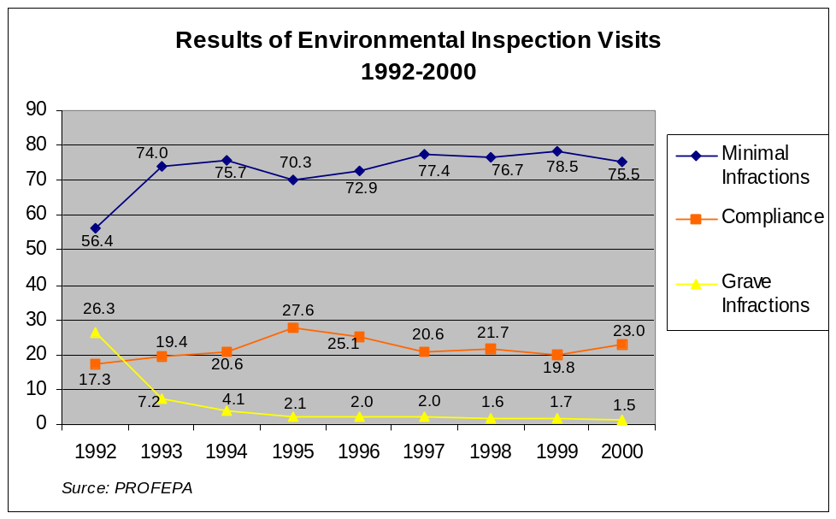

Enforcing regulation NOM-002-ECOL-1997 falls under the jurisdiction of the municipalities, as it relates to discharges into municipal sewer systems that are approximately 45 percent of all industrial effluents. Enforcing this regulation requires local monitoring equipment and enforcement staff. Municipalities have limited enforcement capacity and, in many cases, little political will to enforce regulations on major urban employers.

As municipalities are responsible for the quality of wastewater discharged into federal bodies, they have an incentive to ensure that industries are giving pre-treatment to their discharges. Otherwise industrial discharges could damage municipal wastewater treatment systems or in the cities where there is no treatment, water discharge rights would rise as result of industrial pollution. Enforcement is stronger in those municipalities complying with municipal wastewater treatment than in those discharging without treatment. It is expected that enforcement within municipalities will increase at the same pace than compliance with the municipal discharge regulation. A clear example of this trend is the increased enforcement that has resulted from the installation of wastewater treatment plants in the cities of Toluca, Ciudad Juárez and Monterrey among others. Also, the Mexico City Government is beginning the installation of a sewer-monitoring network in order to detect polluted discharges or hazardous waste dumping into the sewer. So far only one monitoring station has been tendered and it will be installed in late 2001. The monitoring network will consist of 18 stations (fixed and mobile), which will measure metals, oils, and other hazardous materials in the water.

Voluntary Environmental Audit Program

Under the voluntary environmental audit program, Mexican companies hire authorized consultants to perform complete inspections and assess their compliance with all environmental and safety regulations. Participation in the program is both voluntary and confidential and is closely supervised by PROFEPA. After the audits are completed, companies failing in some aspect of the regulatory framework develop an action or investment plan for complying with all regulations. This voluntary program allows companies to avoid penalties while implementing their compliance plans. After the compliance plan is completed, the company receives from PROFEPA a clean industry certificate and a commitment that it will not inspect the company for a two-year period, except in case of accident.

The goal of the program is to increase environmental compliance in a non-confrontational manner and also to allow companies to invest in needed technologies over time, thereby avoiding an undue financial burden.

Since the beginning of the program in 1992 through June 2001, a total of 1,807 companies applied and 1,783 concluded their environmental audits. To date, these have mostly been large industrial companies. A total of 1,339 action plans were signed and PROFEPA has granted 717 Clean Industry Certificates.

Results of the Environmental Audit Program
Type of Action | 1992-1994 | 1995 | 1996 | 1997 | 1998 | 1999 | 2000/01* | Total
Audits Started | 422 | 115 | 158 | 191 | 165 | 294 | 462 | 1,807
Audits Completed | 246 | 180 | 174 | 217 | 170 | 221 | 575 | 1,783
Action Plans Signed | 99 | 102 | 186 | 100 | 296 | 317 | 239 | 1,339
Clean Industry Certificates |  |  |  | 115 | 122 | 175 | 130 | 717
* Includes Information of 2000 and Jan-Jun 2001
Source: PROFEPA

As these audits almost always result in action plans requiring technology investments, the program is a strong generator of business opportunities for environmental companies.

Main Government Programs.

Since the presidential campaign, President Fox referred to the water problem in as a national security issue. President Fox took office on December 1, 2000 and one of the first programs launched by his government was for protecting Mexico’s water and forests. This program called National Crusade for Forests and Water is a general document which asseses the problem, and sets guidelines and defines many specific projects that will involve private investment, technologies and services.

From this document, the CNA developed its strategic guidelines for Mexico’s water sector, which will be implemented during the period 2001-2006. The guidelines and objectives are as follows:

- Promote Efficient Water Use in Agriculture:
- Increase water use efficiency in irrigation districts by the construction of irrigation infrastructure.
- Develop new zones for irrigated agriculture, especially in Mexico’s southeast region.
- Strengthening user organization.
- Promote the substitution of water from wells with treated water for non-vegetable agriculture.

- Promote Coverage and Quality of Water and Sanitation Services:
- Increase water coverage especially in rural zones lacking of service.
- Improve coverage and quality in the supply for potable water, sewer and sanitation services in urban areas.
- Promote wastewater treatment and substitution of first use water with treated water.
- Promote the efficiency of local water utilities.
- Develop alternative supply sources by the adoption of new technologies such as rainfall caption and water re-injection.

- Achieve Sustainable Management of Basins and Aquifers.
- Measure and publish volumes of water available and used in the different basins and aquifers serving as sources of water.
- Reduce extraction volumes until balance is achieved.
- Reduce water pollution by promoting treatment and remediation.
- Orient economic development to these zones with grater water availability.

- Promote Technical, Managerial and Financial Development of the Water Sector.
- Increase resources destined to the sector, specially those focused to create efficient and self-sufficient water utilities.
- Consolidate Federal involvement in the sector as regulatory and policy making while transferring operational and investment activities to the local authorities to achieve a better water management.
- Generate and transfer necessary technology.

- Promote Water Culture:
- Consolidate basin councils.
- Promote the National Crusade for Water and Forests.
- Create conscience among population on the economic and strategic value of water.

- Prevent Risks and Attend Effects of Natural Disasters and Droughts:
- Improve the meteorological alert systems.
- Develop master plans to prevent and attend natural disasters.
- Protect inhabitants of high-risk zones.

To implement those guidelines, the CNA will work with the Secretariats of the Environment, Economy and Agriculture, as well as with other institutions of the Federal Government. The main programs that will help CNA achieve its strategic goals are FINFRA, FINFRA II, FORTEM, The Disasters Management Program, explained in chapter 2.3 of this report, and the voluntary audit program explained in chapter 2.4 of this report.

Potable Water Market:

Overview, Coverage, Capacity and Technologies.

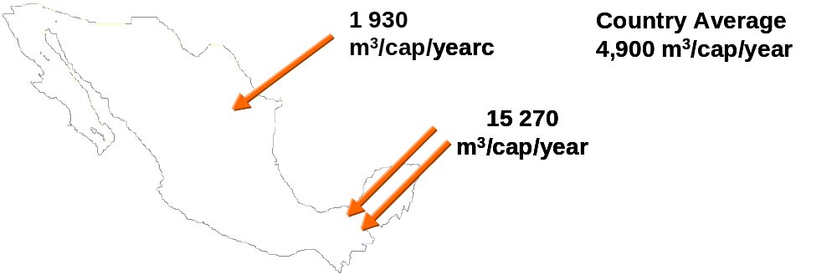
On a gross basis Mexico is rich in water resources, receiving about 4,900 m3 of water per inhabitant per year. At the same time there is a great disparity between where these resources are located and where they are needed. A great majority of water resources and rainfall occur in the southeastern portion of the country while the vast majority of the population (77%) resides in the central highlands and north of the country, thus water availability in the most populated regions averages 1,930 m3 per inhabitant per year. In addition to this situation, rainfall in the northern region occurs in four months of the year, having large drought periods.

This uneven distribution of the resource has caused water to be scarce in some areas, for example, in the arid northern regions of Mexico, surface water sources are non-existent and it is becoming increasingly difficult to find new underground sources.

Mexico consumes approximately 78 billion m3 of water per year, being 83% used for agriculture purposes, 12% for urban consumption and 5% for industrial use. Of the total urban consumption, 80% is used for household, 15% commercial and 5% industrial use.

70% of Mexico’s water used comes from superficial sources and the remaining 30% from underground aquifers. Underground water is of special importance for Mexico since it supplies 1/3 of the agricultural users, 2/3 of the population and 50% of the industry.

The CNA estimates that at least 100 of the 600 aquifers used in Mexico are overexploited and a number ranging from 50-100 were illegally tapped and are being used without any control. Approximately 50% of the volume of underground water used in Mexico comes from overexploited aquifers. This situation is one of the main drivers behind Mexico’s interest in promoting wastewater treatment and reuse, and for minimizing water losses in municipal systems.

Overexploited Aquifers
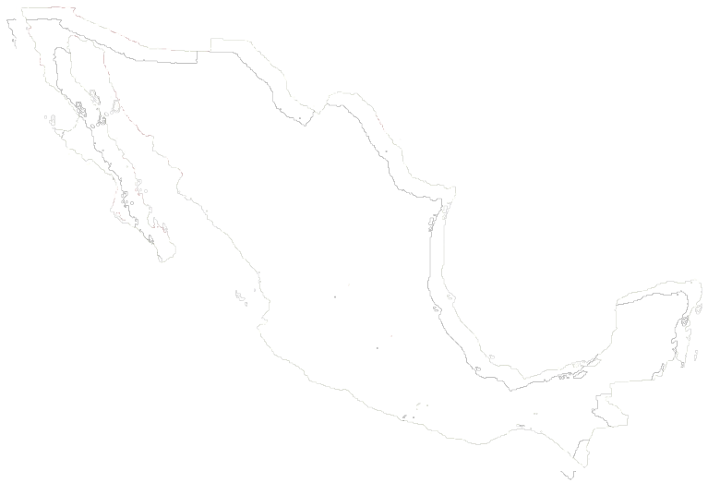

Global weather changes are also another important factor driving Mexico’s interest to protect its water resources. The phenomenon “El Niño” has increased its frequency over the last decade, and this phenomenon’s impact is; less rainfall and subsequantly less superficial water and less natural aquifer recharge. The frequency of hurricanes especially in Mexico’s southeast region and droughts in northern Mexico have also increased, causing damages estimated in over US$500 million per year.

Despite fundamental supply problems, Mexico has been able to supply an increasing percentage of its growing population with potable water. Mexico has increased the percentage of the population with access to potable water from 76.9% in 1995 to 87.4% in 2000. Coverage is much higher in urban areas than in rural areas as, 91.5% of urban residents have access to potable water while only 65.7% of rural residents enjoy such access. The Fox government has set a preliminary goal of increasing potable water coverage to 92% of the population. This will only be achieved if private participation in the provision of the services is achieved and if the federal government focuses its investment efforts in poorer communities.

According to SEMARNAT, the following cities face severe water supply problems:

- In the North border region: Ensenada, Mexicali, Tijuana, San Luis Río Colorado, Nogales, Ciudad Juárez, Ciudad Acuña, Piedras Negras, Nuevo Laredo, Reynosa, Río Bravo and Matamoros.

- Cities where economic development has caused water supply problems: Mexico City, Guadalajara, Monterrey, Puebla, León, Toluca, San Luis Potosí, Querétaro, Coatzacoalcos, Chihuahua, Carmen, Aguascalientes and Hermosillo.

- Cities where touristic development has caused water supply problems: Acapulco, Cancún, Playa del Carmen, Mazatlán, Manzanillo, Los Cabos and Ixtapa-Zihuatanejo.

- Cities with water quality problems: Zimapán, Torreón and Saltillo.

- Cities with conflicts for use of water with agricultural users: Culiacán and Los Mochis.

These cities will be considered as priority urban areas for development of water supply projects.

In 1999 Mexican potable water plants supplied consumers with 78.2 m3/s, which represented 25.2% of the national water supply estimated at 309.1 m3/s. A total of 66 plants with a capacity of 5.1 m3/s are out of operation due to lack of maintenance or obsolecense. Many of these plants are considered for rehabilitation.

The most used processes for water purification are conventional clarification, with 260 plants representing an equivalent of 70% of the total capacity, and direct filtration with 23 plants and 15% of the total purification capacity. An inventory of plants by State and Technology is as follows:

Potable Water Plants By State and Technology (1999)

 | No. of  Plants |  | Functioning Plants  (Lps) |  |  | Non Functioning  Plants
State | No. of  Plants | Type of Plant | No. | Capacity | Actual  Output | No. | Capacity
Aguascalientes | 1 | CC(1) | 1 | 18.0 | 10.0
Baja California N. | 19 | CC(15), CP(1), DF(3) | 19 | 8,684.0 | 5,896.5
Baja California Sur | 1 | DE(1) |  | 0.1 |  | 1 | 0.1
Campeche | 3 | S(1), CC(2) | 3 | 525.0 | 403.0
Coahuila | 3 | CC(3) | 3 | 1,100.0 | 1,000.0
Colima | N/A | N/A | N/A | N/A | N/A | N/A | N/A
Chiapas | 4 | CC(2), CP(2) | 3 | 2,500.0 | 1,910.0 | 1
Chihuahua | 4 | CC(3), CP(1) | 3 | 820.0 | 540.0 | 1 | 150.0
Distrito Federal | 4 | CC(2), DI(2) | 4 | 1,255.0 | 680.0
Durango | 12 | AC(2), MT(10) | 12 | 20.5 | 12.4
Guanajuato | 2 | CC(2) | 2 | 400.0 | 310.0
Guerrero | 12 | S(1), CC(5), CP(3), DF(1), SF(2) | 8 | 3,950.0 | 2,905.0 | 4 | 770.0
Hidalgo | 2 | CC(2) | 2 | 100.0 | 100.0
Jalisco | 17 | CC(16), CP(1) | 15 | 13,291.0 | 11,069.0 | 2 | 68.0
Estado de México | 6 | CC(4), CP(1), DI(1) | 4 | 19,825.0 | 15,725.0 | 2 | 15.0
Michoacán | 3 | CC(2), CP(1) | 2 | 1,328.0 | 1,200.0 | 1 | 8.0
Morelos | N/A | N/A | N/A | N/A | N/A | N/A | N/A
Nayarit | 3 | CC(1), CP(2) | 3 | 230.0 | 120.0
Nuevo León | 9 | CC(4), DF(3), SF(2) | 8 | 14,435.0 | 5,376.0 | 1 | 50.0
Oaxaca | 6 | CC(3), DI(2), DF(1) | 6 | 1,151.3 | 611.3
Puebla | 1 | CP(1) |  | 20.0 |  | 1 | 20.0
Querétaro | 2 | CC(2) | 2 | 24.0 | 25.0
Quintana Roo | 6 | S(6) | 4 | 1,290.0 | 760.0 | 2 | 260.0
San Luis Potosí | 9 | CC(3), CP(2), DF(3), MT(1) | 8 | 918.8 | 783.8 | 1 | 20.0
Sinaloa | 136 | CC(100), CP(7), DF(5), SF(24) | 119 | 5,680.0 | 5,300.0 | 17 | 242.0
Sonora | 31 | CC(30), DF(1) | 21 | 4,715.0 | 2,356.5 | 10 | 1,866.0
Tabasco | 19 | CC(15), CP(4) | 18 | 3,875.0 | 3,335.0 | 1 | 500.0
Tamaulipas | 53 | CC(33), CP(15), DF(5) | 42 | 12,966.0 | 9,815.0 | 11 | 396.0
Tlaxcala | N/A | N/A | N/A | N/A | N/A | N/A | N/A
Veracrúz | 11 | CC(10), DF(1) | 9 | 6,145.0 | 4,215.0 | 2 | 25.0
Yucatán | 11 | S(9), CP(2) | 3 | 4,745.0 | 3,700.0 | 8 | 745.0
Zacatecas | N/A | N/A | N/A | N/A | N/A | N/A | N/A
Total | 390 |  | 324 | 110,011.7 | 78,158.5 | 66 | 5,135.1
Source: CNA, 1999
KEY: MT = MEMBRANE TECHNOLOGY; S = WATER SOFTENING; AC = ACTIVATED CARBON; CC = COVENTIONAL CLARIFICATION; DE = DESALINIZATION; DI = DE-IRONING; DF= DIRECT FILTATION; SF = SLOW FILTRATION; CP = COMPLETE PURIFICATION

Pricing and Metering.

The latest official information available shows that 59% of the government spending in the water sector came from the Mexican federal government while cash flows generated by municipal utilities covered only 7% of the total investment in 1999.

Of all potable water produced in Mexico, 39.9% is unaccounted water – either lost through leaks, theft, or not metered –. From accounted water, 60% is billed to users with users paying about 65% of what they owe. This means that from the total water produced in Mexico, only 23.4% is paid for by the users.

In addition to low collection, water prices are highly subsidized to most customers and therefore cash flows generated by local utilities are insufficient to provide for adequately maintenaing or financing additional system investment. Most rates are scaled with cross subsidies from industrial and commercial sectors. This tariff structure subsidizes domestic use which is the largest urban consumer.

Tariff structures and prices are set at the local level, either by the local congress, by the water utility or by the state governor. The nature of billing varies radically from operator to operator, and some operations even charge a flat fee for unit of water consumed.

To exemplify water tariffs structures, in Mexico City the government structured a scale where users pay a fixed fee for the lower limit of the scale level and an additional fee for each m3 consumed over the lower limit. Mexico City has one of the highest tariffs in Mexico and larger consumers as well as non-residential users subsidize urban water consumption.

Water Prices for Mexico City

(In US Dollars)

Residential Use |  |  |  |  | Commercial and Industrial Use
Consumption in m3 |  | Tariff |  |  | Consumption in m3 |  | Tariff
Lower  Limit | Higher Limit | Fixed Fee | Fee for m3 over inferior limit |  | Lower limit | Higher Limit | Fixed Fee | Fee for m3 over inferior limit
- | 10.0 | 1.26 | 0 |  | 0 | 10.0 | 7.59 | 0
10.1 | 20.0 | 1.26 | 0.15 |  | 10.1 | 20.0 | 15.17 | 0
20.1 | 30.0 | 2.75 | 0.17 |  | 20.1 | 30.0 | 22.75 | 0
30.1 | 50.0 | 5.57 | 0.33 |  | 30.1 | 60.0 | 22.75 | 1.13
50.1 | 70.0 | 12.18 | 0.42 |  | 60.1 | 90.0 | 56.57 | 1.47
70.1 | 90.0 | 20.62 | 0.54 |  | 90.1 | 120.0 | 100.54 | 1.80
90.1 | 120.0 | 31.40 | 1.07 |  | 120.1 | 240.0 | 154.66 | 2.14
120.1 | 180.0 | 63.57 | 1.36 |  | 240.1 | 420.0 | 411.65 | 2.48
180.1 | 240.0 | 144.95 | 1.95 |  | 420.1 | 660.0 | 858.08 | 2.82
240.1 | 420.0 | 261.87 | 2.25 |  | 660.1 | 960.0 | 1,534.58 | 3.17
420.1 | 660.0 | 665.87 | 2.62 |  | 960.1 | 1,500.0 | 2,486.68 | 3.55
660.1 | 960.0 | 1,293.51 | 2.83 |  | 1,500.1 | and over | 4,406.14 | 3.65
960.1 | 1,500.0 | 2,141.24 | 3.25 |  | Source: Mexico City Government.  Tariffs converted using 9.1 pesos per US$ rate.
1,500.1 | and over | 3,896.50 | 3.46

Private participation in the water sector requires tariffs to reflect the real costs of providing the service. The low political will to increase tariffs is one of the main causes for low private participation in the provision of these services, however those cities which have opted for some private participation scheme, have benefited from realistic tariffs as they allow for increased coverage, efficiency, and have reduced subsidies to the sector.

President Fox mentioned that in order to maintain water supply levels and increase quality of the service, it is necessary to increase water tariffs an average of 50% on a national basis. This announcement caused anger among most local opposition governments who argued that is not responsibility of the President to set guidelines for how local governments manage their finances and that rising water tariffs would directly impact low income families.

Schemes for Private Participation.

Most potable water and sewage projects funded with government monies are contracted as public works projects. The key players in this segment include large Mexican construction firms mostly in partnership with international water groups and technology suppliers.

Private participation in the provision of water services is relatively new in Mexico, and at present only three cities (Aguascalients, Cancun and Navojoa) have concessioned their systems to private players. In addition two cities (Mexico City and Puebla) have signed agreements with private companies under management contracts, and the city of Saltillo, is in the process of selecting a private sector partner to form a mixed public-private water utility. In all cases where schemes for private participation have been selected, efficiency levels, quality of the service and coverage have increased over the national average.

Private participation in the provision of water services is expected to grow as states and municipalities seek efficiency gains to attract private capital while the federal government is conditioning resources to efficiency improvements or inclusion of private participation.

The following are the private participation schemes available in Mexico’s water sector.

Integrated Concessions:

Under this scheme, the government grants a concession title to a private operator for the operation of their entire water system, from water extraction and supply through the treatment of wastewater. The private company is in charge of financing all required infrastructure improvements and is usually required to meet certain water coverage goals. The private company is also in charge of billing customers and collecting these bills. Property of the water system can be passed to the concessionaire for the period of the concession.

The cities of Aguascalientes and Cancun have adopted integrated concessions. The concessions have suffered problems but in general terms they are considered successful. It is not clear that the integrated concession model will work in other cities, as both Cancun and Aguascalientes are somewhat unique in character. In Cancun, most water customers are luxury hotels and Aguascalientes enjoys one of the highest living standards in Mexico.

Currently the best prospects for other integrated concessions are in Mexican tourist cities where there could be strong revenue flows to support private investment. At the same time, local municipal authorities have been reluctant to give up control to private operators.

Mixed Public Private Company:

Under this scheme the municipal water authority and a private operator invest jointly in a new utility which will be in charge of providing water and sanitation services regularly under a concession scheme. The mixed company has the benefits of having public participation for representation in front of users and other authorities while the private operator brings efficiency and entrepreneurial vision. Under this scheme, the municipal water utility decides on the participation level of the private operator. This scheme is new for Mexico and currently the first mixed public-private utility in under bidding process for the selection of the private partner. This first experience is taking place in the northern city of Saltillo and attracted only two bidders. The tendering process established private participation in 49%, and the new company will have to increase potable water coverage from 80% to 97% of the population, reduce water losses from 50% to 25%, and increase metering and collection in a period of five years without modifying tariffs over inflation.

Management Contracts:

Another scheme involving private participation in the provision of water services is the management contract. Under a management contract, a private company is paid a fee for achieving certain benchmarks or improvements, such as receiving a set payment for each meter installed or each leak fixed. This arrangement has proven effective in Mexico City and Puebla. This approach has proven less controversial than integrated concessions since fees are paid to the local government and the government sets tariffs. This scheme involves less participation of the private companies but also less risk.

The most successful management contract has been the one in Mexico City, which has survived two government changes including a change in the party governing Mexico City. It has increased the metering, billing and collection indexes and has minimized water losses in the secondary distribution network. Management contracts are likely to be implemented in other large Mexican cities and represent important opportunities for firms with experience with water system management as well as for companies selling efficiency enhancing equipment, services or software.

Partial Concession:

Another scheme for private participation is similar to the integrated concession except that the operator does not have responsibility for wastewater treatment. Rather the private company is responsibility for providing potable water services as well as sewage collection and performs the billing and collection. The private operator has to accomplish an ambitious investment plan and establish an efficient collection system. The revenues obtained are first used to cover repayment of the required investment program and any excess goes to the municipality to finance wastewater treatment services. At present this scheme has not been used, but will be the most convenient for these cities which have concessioned their wastewater treatment plants as BOT’s and now select a new operator for the potable water and sewer components of the system.

Case Studies of Private Participation in Water Services:

Aguascalientes Integrated Concession:

The Aguascalientes Integrated concession was the first case of private participation in the Mexican water sector. The evolution of this concession offers some lessons that may be useful for gaining a better understanding of the sector and, in particular, of how to work with a municipal utility (Organismo Operador).

The process of private participation in Aguascalientes was initiated in 1989, when the state water utility of Aguascalientes, Comisión de Agua Potable y Alcantarillado – CAPA, requested that the Mexican construction firm ICA performed a series of studies related to sourcing additional potable water. Aguascalientes was running out of water due to the creation of a new development zone know as Pañuelas and no additional potable water sources were situated in close proximity to the city.

ICA formed an association with Compagnie Generale des Eaux and began to analyze the problem. ICA and Compagnie Generale des Eaux formed a joint venture and created the company OMSA (Operación y Mantenimiento de Sistemas de Agua, S.A. de C.V.) and a subsidiary called SAASA (Servicios de Agua de Aguascalientes, S.A. de C.V.).

The results of the studies performed by ICA and its partner showed that a lack of water was not the primary problem. The main problem was that the existing potable water network was inefficient and full of leaks, well connections were inadequate and over-exploitation of wells was resulting in geologic failures that caused great damage to the network. In addition, illegal hookups were very common and commercial services were inadequate. CAPA, originally created in 1984, suffered operational inefficiencies due to an inadequate budget. During the 1980´s the Mexican government was facing a severe economic crisis and reduce the funding available to public works.

SAASA proposed to fix the water problems in Aguascalientes via a service contract in which SAASA would be paid based on the personnel, equipment, and resources expended in the administration and the operation of the system. The main objectives were to improve the utility’s operational income, increase system efficiencies and rehabilitate the water sources (wells). The responsibility of paying for the works, however, remained in the hands of the state government, which in turn obtained financing through Banobras.

In 1991, the municipal water utility of Aguascalientes – Comisión de Agua Potable y Alcantarillado del Municipio de Aguascalientes – CAPAMA was created. After revising the progress of SAASA, CAPAMA renewed the contract and included additional functions such as operation of the potabilization plants, detection and repair of leaks, maintenance and reading of water meters and maintenance of sewage system among others.

At year-end 1992, SAASA was controlling the majority of the system and obtaining satisfactory results from the point of view of both the community and the municipal authority. Although progress made had been significant, the municipality was running short of money to pay SAASA and to build new infrastructure needed to meet the needs of the growing city. SAASA proposed to take over all water and sewage operation and finance needed investments via its own capital and revenues. The municipality analyzed SAASA´s proposal but, for political reasons (it was an electoral year), the concession was not awarded.

A new municipal government assumed power following the elections and after analyzing the problems of the water infrastructure, decide to grant SAASA a concession. Under the terms of the concession agreement, the concessionaire assumed the commercial risk and the liabilities and would operate the water system, making commitments to improve coverage and service quality.

On October 20th, 1993, the state government authorized the concession after modifying the state water law and the municipality granted the concession to SAASA in November 1,1993.

Although Political disputes between parties clouded the political environment from mid-1992 to October 1993, SAASA made considerable progress in the areas of coverage relation and service quality.

The concession agreement was initiated with low water prices. Every two months, however, the tariff was increased slightly, since the “starting tariff” was too low to cover all costs even with an efficient metering and billing system. This situation caused social discontent.

In December 1994, Mexico faced a severe economic crisis. The value of the peso decreased nearly 90 percent against the dollar, requiring SAASA to increase tariffs substantially from one month to the next to protect its investment. Tariff increases resulted in major social discontent.

In 1996, the municipal government changed again following elections. The new government attempted to cancel the concession contract and assume operation of the water system. Negotiations between the new municipal government and SAASA were problematic. The new government promised the public that it would lower water tariffs. Following negotiations between SAASA and the municipal government, tariffs were indexed to inflation and the concessionaire maintained control of the water system.

SAASA made the decision to publish water system progress and infrastructure improvements in local newspapers, enabling the company to win substantial public support. While several districts still lack water services, coverage now reaches nearly 100 percent and the system has a pressure of 1.2kg/cm2. Whereas only 74,000 users were registered and billed in 1994, 138,000 users are currently registered.

ICA reports that the Aguascalientes system is currently self-sufficient. The company does not view the Aguascalientes concession as a gold mine, but rather as a good long-term business.

Secrets to Success:

- ICA initiated long-term relationships with the municipal and state government prior to being hired.
- ICA formed a joint venture with a partner that had significant expertise in operations.
- SAASA undertook a series of studies to determine the costs involved in the proposal prior to presenting it to the municipality.
- SAASA accepted a low tariff level for a limited range of work initially.
- The process of obtaining an integrated concession was a process in which SAASA gradually assumed more and more of a management role over time. This allowed the company gradually to gain the confidence of the community and to survive a rocky political climate.

Mistakes Made:

- Liabilities of water utility that the state or municipal government should have assumed were included in the concession title.
- SAASA initiated the concession with a tariff that did not cover costs. Subsequent bimonthly increases caused social and political problems. A substantial initial increase combined with a publicity campaign that justifies that increase would have been more effective.
- The 1994 peso devaluation increased liabilities beyond tariff levels. The tariff should have been indexed to either inflation or the dollar under the initial concession contract.
- The autonomy of the concessionaire is limited since CAPAMA supervises the concessionaire. This creates bureaucracy and delays decisions. The municipal government should supervise the concession directly while respecting the autonomy of the concessionaire.

Mexico City Management Contracts:

In 1993, The Mexico City Water Commission awarded four “Service Provision Contacts” to four major water consortia to restore and operate the water networks of different areas in Mexico City. The municipal government opted to structure private participation in the form of service contracts rather than as concessions. The municipal government also decided to award four contracts rather than a single one for the entire city, in order to avoid a monopoly situation and to introduce competition through the ability to compare the performance of the various service providers.

The bid required that each bidder had experience in the operation of potable water system. Since Mexican firms did not have this experience, consortia were formed between the major Mexican construction firms and water operators from France and Great Britain.

Each contract was awarded for a 10-year period and was divided into the three phases outlined below. By the beginning of the third phase, 8 million Mexico City residents were serviced entirely by private sector operators.

Phase I:

- Conduct a census of all water users (completed).
- Install water meters (over 1,000,000 meters installed).
- Digitalize the network (completed).
- Service providers are paid a fee for each water meter installed.

Phase II: (Ongoing)

- Generate, distribute and collect invoices in conjunction with the city’s treasury and banks.
- Service providers are paid a fee for each invoice generated.

Phase III: (Began in June 1998, currently ongoing)

- Operate and maintain the secondary distribution network.
- For this service each company is paid a price per unit of water delivered. The Mexico City government assumes the collection risk. Companies have an incentive to reduce water losses and improve billing efficiency.
- Fix leaks. (714 kilometers of pipeline have been replaced and 1930 lps. have been recovered)
- Provide service to customers.
- Assist Mexico’s City Treasury by collecting bills.

Note: phase III Involves substantial investment.

Given the nature of the contracts, exact dollar figures are not available. Concessionaires place the collective value of the 10-year contracts at over US$ 1 billion.

In 1997, the first government election in Mexico City took place, and the Democratic Revolutionary Party (PRD) which was an opposition party yet to win a local election, won the election. The PRD analyzed the progress made by private operators, and despite its critisism – of private participation in public services- this government decided to continue working with the private companies. Today the City government being in hands of the same political party for a second term is evaluating the convenience of continuing working with the four companies or issuing a new tender in 2003. The Mexico City government is aware of the benefits private participation has bought, and are satisfied with their performance.

Needs and Investment Plans.

Mexico’s overall water sector goals through the year 2005 are as follows. Note that these are preliminary objectives that are being revised. The final objectives will be published in the National Development Plan for the Water Sector in early 2002.

- Increase potable water coverage to 92%.
- Promote the efficiency of local water utilities to achieve at least 50% of water billed and collected.
- Promote private investment and participation in the water sector.
- Promote efficient water use in agriculture.
- Substitute first-use water with treated water for industrial and agricultural uses.
- Protect overexploited aquifers by using re-injection technologies or substituting its use.

To achieve these goals, CNA will continue being an important source of funding for the water sector, but funds will be conditioned to efficiency improvements and to adopt tariffs which reflect the cost of providing water service. Through this and through the application of FINFRA II, CNA expects to reach its potable water coverage goal of 92% and increase water service billings to 50%.

CNA is developing a program, which provides incentives to high volume water users located in the northern and central regions of Mexico so they move their facilities to Mexico’s southeast region where water availability is not a problem and were wages are lower than in the more developed areas.

Promoting efficient water use in agriculture has been a problem since according to the Mexican constitution and other regulations, water used for agriculture is free. CNA has tried without success to change those regulations and considers it unfeasible to do so. Because of this, the CNA has structured a program where the Federal Government provides a 50% subsidy to all irrigation investments and agricultural infrastructure if water used comes from superficial sources and replaces the use of wells.

Other important potable water projects in the pipeline include the Baja California, Guadalajara and Mexico city mega projects, all assisted financially by the OECF/JICA, and the inclusion of private participation in Mexico’s most important water systems.

Priority Projects.

Municipal water investments in Mexico will be focused to four areas:

- Mega-projects: The Baja California, Guadalajara and Mexico City mega-projects are integrated public investment programs consisting of major potable water, sewage collection and treatment components. Their combined investment value is superior to US$2.0 billion. These are being undertaken with the support of OECF/JICA and involve private participation only in wastewater treatment being the remaining public works. The Baja California mega-project has started and the first works have been tendered while the Mexico City and Guadalajara projects are still facing political discussions and are expected to move forward in 2002 at the best. (For details of these three programs please refer to appendix A of this report).

- The U.S. Mexico Border: Mexico’s northern border has a special problematic for water supply. While the zone is arid and water resources are scarce, this zone is registering the highest population and economic growth indexes in the country. The Mexico-U.S. border will be focus of several water projects over the next 2-3 years. These will be smaller scale projects, but will demand a wide variety of equipment and service in all water sectors. Water supply problems in the northern region of Mexico are so severe that the adoption of desalinization technologies is being considered. Projects in the U.S.-Mexico border zone are eligible for financing from the North American Development Bank. This support makes the zone especially attractive for water investments.

- Efficiency Improvements: Fox’s government strategy is centered in improving the financial condition of local water utilities to reduce water losses, promote payment culture and allow local utilities to cover their operational costs. Efficiency improvement projects are found in almost every Mexican City with a population greater than 50,000. Those projects represent important opportunities for international companies.

- Promote Private Participation: As mentioned before, neither the Federal nor local governments have enough resources to cover the investments needed to increase all water indicators to the desired levels. Due to this, private participation is the most viable alternative to upgrade Mexico’s water sector. The Fox government is betting to FINFRA II (Described in chapter 2.3.1. of this report) as a tool to detonate private participation in Mexico’s water sector. BANOBRAS has identified 39 Cities as candidates for FINFRA II.

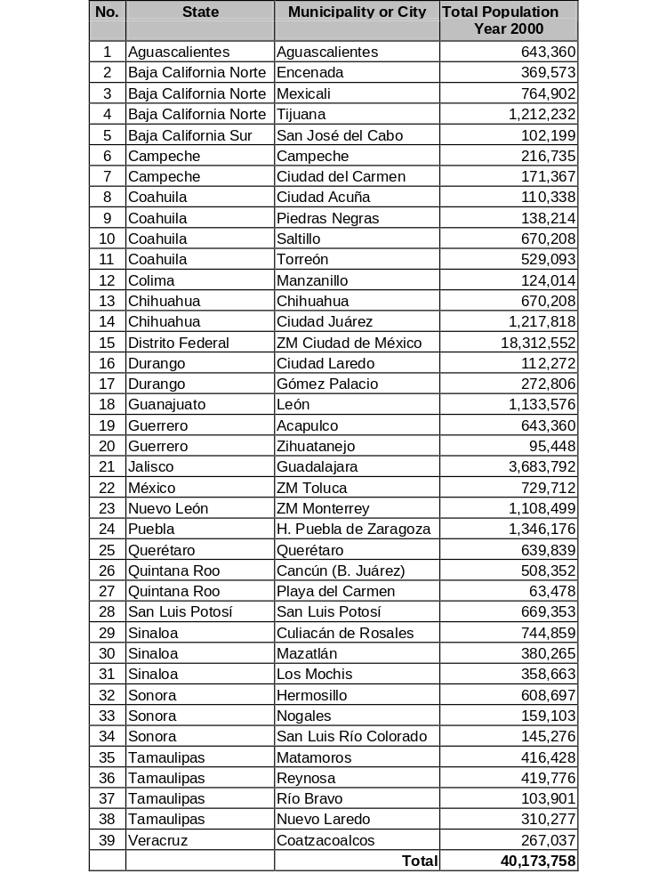
Cities Susceptible for FINFRA II
Source: Banobras.

Wastewater and Sewage:

Overview, Coverage, Capacity and Technologies.

Sewage collection coverage is lower than that of potable water, reaching approximately 73.1% at the end of 1999. Coverage follows a similar pattern as that of potable water, with coverage levels of 92.7% in cities with population greater than 50,000 inhabitants, 75.4% in medium sized cities, and 33% in rural areas or small towns.

Investments in sewage infrastructure average US$75 million per year, being the majority destined to larger cities.

Sewage Coverage

Year | Population  (Million) | With Service | Without Service | Increase | % Coverage
1990 | 83.5 | 51.2 | 32.3 | 1.7 | 61.3
1991 | 85.1 | 53.1 | 32.0 | 1.9 | 62.4
1992 | 86.7 | 55.3 | 31.4 | 2.2 | 63.8
1993 | 88.4 | 57.1 | 31.3 | 1.9 | 64.6
1994 | 90.0 | 59.1 | 30.9 | 1.9 | 65.7
1995 | 91.2 | 65.7 | 25.5 | 6.6 | 72.1
1996 | 92.7 | 67.2 | 25.6 | 1.5 | 72.4
1997 | 94.3 | 68.3 | 26.0 | 1.1 | 72.4
1998 | 95.8 | 69.4 | 26.4 | 1.1 | 72.4
1999 | 97.3 | 71.1 | 26.2 | 1.7 | 73.1
Source: CNA/ UPRPS/ Sistema Nacional de Información.

Sewage projects are spread among Mexico’s large and medium sized cities, and these are mainly civil works tendered in portions to several national construction firms. Cities installing wastewater treatment plants are including sewer connections as part of the tenders for the plants, so sewer systems are included in the BOT packages.

Mexico City has special problems with its sewer system. The city was build over a lake and underground soils are unstable. In addition, the extreme overexploitation of the underground aquifer combined with the weight of buildings has caused some areas of the city to sink over 50cms. per year, causing the sewage system to loose its steepness and outflow capacity. The City has lost over 30% of its original sewer capacity and this is causing floods during the rainfall season. The Mexico City government is undertaking with assistance of the CNA a project to rehabilitate its sewer. (See sewage and drainage project for Mexico City in Appendix A of this report.)

Although sewage collection accounts for approximately 185 m3/s, the country has wastewater treatment capacity of 67.5 m3/s at 1000 wastewater facilities. In practice, only 43.4 m3/s received treatment at the 777 plants in operation.

Wastewater Treatment Plants By State

State | Total  Plants | Functioning Plants  (Lps 1999) |  |  | Non-Functioning Plants
 | Total  Plants | No. | Capacity | Actual Output | No. | Capacity
Aguascalientes | 93 | 79 | 2,509.3 | 1,853.8 | 14 | 78.9
Baja California N. | 13 | 13 | 4,112.0 | 3,702.4
Baja California S. | 15 | 14 | 998.5 | 598.8 | 1 | 20.0
Campeche | 9 | 9 | 110.6 | 33.4
Coahuila | 15 | 8 | 1,423.5 | 812.0 | 7 | 239.5
Colima | 29 | 28 | 522.1 | 395.1 | 1 | 10.0
Chiapas | 13 | 6 | 457.2 | 86.0 | 7 | 234.0
Chihuahua | 34 | 27 | 1,539.5 | 745.2 | 7 | 38.5
Distrito Federal | 18 | 18 | 5,632.5 | 2,933.5
Durango | 57 | 53 | 3,272.0 | 2,059.4 | 4 | 33.4
Guanajuato | 19 | 12 | 1,491.0 | 892.0 | 7 | 369.0
Guerrero | 14 | 13 | 2,159.0 | 1,431.0 | 1 | 20.0
Hidalgo | 5 | 5 | 47.9 | 21.9
Jalisco | 71 | 51 | 3,291.7 | 1,747.6 | 20 | 949.7
Estado de México | 43 | 40 | 6,408.7 | 4,546.3 | 3 | 110.0
Michoacán | 16 | 10 | 1,905.0 | 930.0 | 6 | 465.0
Morelos | 27 | 16 | 1,527.9 | 994.2 | 11 | 361.0
Nayarit | 51 | 39 | 1,837.9 | 1,008.3 | 12 | 184.0
Nuevo León | 41 | 39 | 11,154.0 | 7,212.0 | 2 | 20.0
Oaxaca | 30 | 25 | 578.0 | 358.0 | 5 | 80.0
Puebla | 22 | 20 | 557.3 | 402.3 | 2 | 13.2
Querétaro | 45 | 32 | 899.5 | 314.4 | 13 | 144.0
Quintana Roo | 18 | 14 | 1,480.0 | 1,178.0 | 4 | 87.0
San Luis Potosí | 13 | 4 | 461.0 | 245.0 | 9 | 176.0
Sinaloa | 13 | 10 | 950.0 | 1,045.0 | 3 | 102.0
Sonora | 75 | 62 | 3,711.7 | 2,633.3 | 13 | 211.0
Tabasco | 32 | 16 | 1,137.2 | 404.0 | 16 | 570.2
Tamaulipas | 22 | 15 | 2,346.0 | 2,089.7 | 7 | 90.0
Tlaxcala | 33 | 20 | 864.2 | 477.2 | 13 | 87.0
Veracrúz | 76 | 57 | 3,552.0 | 735.9 | 19 | 1220.0
Yucatán | 9 | 9 | 344.5 | 339.3
Zacatecas | 29 | 13 | 265.7 | 171.6 | 16 | 75.0
National Total | 1000 | 777 | 67,547.4 | 42,396.6 | 223 | 5,988.4
Source: CNA, Data to December 1999

The CNA estimates that many of the 777 plants in operation are inefficiently run and offer minimal treatment, and not compalying with NOM-001-ECOL-1996. Wastewater treatment plants operated by private companies, and those built with NADBANK support in the northern border, exceed the standards set by the regulation for municipal discharges.

To comply with regulation NOM-001-ECOL-1996 a primary treatment plant would be enough for medium sized cities, while larger cities require the use of activated sludge, biological filters or other secondary treatment technologies. In Mexico the most common treatment plants are stabilization lagoons, however in capacity, activated sludge technology doubles the capacity of these plants.

Wastewater Treatment Plants By Process

Process | No. Plants | Capacity (Lps) | %
Activated Sludge | 212 | 30,571.3 | 45.3%
Stabilization Ponds | 491 | 14,441.9 | 21.4%
Aerated Lagoons | 12 | 5,201.5 | 7.7%
Biologic Filters | 31 | 3,899.9 | 5.8%
Dual | 4 | 3,330.0 | 4.9%
Advanced Primary | 5 | 3,090.0 | 4.6%
Oxidation Ditch | 27 | 1,793.0 | 2.7%
Anaerobic Reactors | 43 | 1,400.7 | 2.1%
Imhoff Tank | 58 | 1,017.0 | 1.5%
Primary | 6 | 1,005.0 | 1.5%
Biodisk | 10 | 754.0 | 1.1%
Anaerobic | 18 | 415.9 | 0.6%
Biological treatment | 15 | 224.0 | 0.3%
Other | 19 | 175.1 | 0.3%
Wetland | 15 | 100.3 | 0.1%
Enzimatoc Reactor | 14 | 65.8 | 0.1%
Chlorinated Tank | 20 | 62.1 | 0.1%
Source: CNA, Data to December 1999

Mexico’s municipal wastewater market is driven by regulation NOM-001-ECOL-1996 which at present is being met by only 33% (47 of 139) of the cities with a population greater than 50,000 inhabitants which had to comply by 2000. The CNA estimates that investments of over US$2.2 billion are needed to achieve compliance, out of which, close to US$ 1 billion would be required to bring Mexico City, Guadalajara and Baja California (3 Cities) into compliance. Bringing these cities to comply would represent treating 52% of the municipal wastewater generated, a much greater percentage than the current 24%.

The water utilities of Monterrey, Baja California, Aguascalientes, Cancun and Sinaloa have financial capabilities to build their own wastewater treatment facilities. Other cities lack the necessary revenues to even warrantee payment for treatment to private concessionaires. For this reason, only projects receiving financial support from multilateral or bilateral organizations such as NADBANK, or projects funded by CNA or FINFRA will move forward in upcoming years.

FINFRA Pipeline Projects

(In Million US$)

Project | FINFRA  Capital | Total  Investment
Aqueduct Conejos-Médanos Cd. Juárez Chih. | 8.22 | 20.54
Aqueduct Carneros II Saltillo Coah. | 5.54 | 13.85
WWTP Morelia Mich. | 5.54 | 13.85
WWTP Veracruz. Boca del Río y Medellín | 2.88 | 7.21
WWTP Tuxpan de Rodríguez Cano Ver. | 0.81 | 2.04
WWTP Saltillo Coah. | 7.62 | 19.03
WWTP Xalapa Ver. | - | -
WWTP Ciudad Valles S.L.P. | 0.92 | 2.31
Potable Water Supply Querétaro Qro. | N/A | 203.05
Total | 31.5 | 281.9
Source: BANOBRAS. Figures converted to US$ using 9.1 pesos per US$ rate.

The inadequate or no treatment to municipal discharges is the main cause of pollution in superficial waters. Of these, 19% are considered as very polluted, 54% polluted, 20% acceptable and only 7% of excellent quality

Superficial Water Pollution

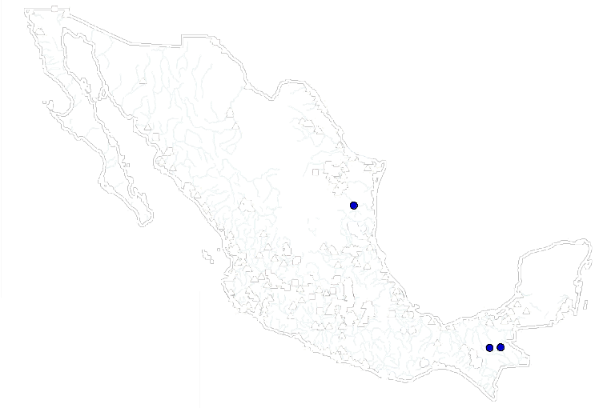

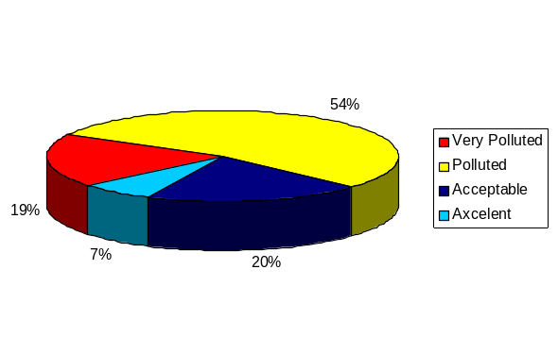

Pricing and Metering:

Mexican population is not currently charged for sewer collection. As this charge is in theory included in the potable water fees billed to the users. The same situation happens to municipal water treatment in the cities that have installed those systems.

Wastewater treatment tariffs charged by private operators to municipalities also vary depending on the structure of each concession or BOT arrangement. Projects financed by FINFRA and NADBANK usually follow the same methodology, being this based in three tariff components:

T1 = Amortization of the investment: Private company’s charge a fixed fee based in pesos/m3 of the total plant capacity. This component is paid by the utility for the amortization of the investment made by the private concessionaire. Projects receiving funds from FINFRA or NADBANK have lover T1 tariffs since this is only applied to the operator’s equity in the project.

T2 = Fixed operational costs: This fee is based also on the total capacity of the plant since the operator will have to cover fixed fees regardless the amount of water treated. This fee is usually applied to cover operational costs independent to the volume of water treated.

T3 = Variable operational costs: This fee is charged to the municipality, based on the volume effectively treated by the wastewater treatment plant on a certain period of time. This volume is based pesos/m3 effectively treated.

The final tariff structure is made of T1+T2+T3 = Tariff in pesos per m3. Tariffs vary depending on the technology used, the type of funding received by FINFRA or NADBANK, and the weather conditions of the area. Tariffs tendered by bidders have continuously decreased as more competition has entered the selection processes and financial risks are decreasing.

Schemes for Private Participation.

Private participation in wastewater treatment is takes place mostly in the following two forms:

- Wastewater treatment plants built by private companies and “sold” to the municipality as turnkey projects.
- Build, Operate, Transfer schemes (BOT’s) where the private company builds the plant and charges a tariff per m3 under the T1+T2+T3 tariff structure or a leasing and operational contract.

The first scheme is mainly used for wastewater treatment plants funded by a multilateral organization or by the federal and local governments. For example, the wastewater treatment plants to be built in Baja California with funding of the Japan Bank of International Cooperation (JBIC) will be tendered as turnkey projects.

The second scheme is the most commonly used in Mexico since it gives the local government the flexibility of having treatment and paying over time. This scheme has been very attractive for private players specially in those cases where NADBANK and FINFRA funding is included.

Private participation in Mexico’s wastewater market dates from the early 1990’s, when Mexico initiated an effort to encourage municipalities to meet their wastewater needs through the granting of concessions for the design, construction and operation of new wastewater infrastructure. While the authority for wastewater treatment resides at the local level, the federal government, principally through the CNA and BANOBRAS sought to encourage and support this program with both, technical and financial assistance.

Municipalities, as well as local and international bidders embraced the program. From 1992 to 1994 US$ 744 million, or 30 m3/s in wastewater project concessions were awarded to private concessionaires. The program was effective in awarding concessions, but poor in terms of following on the completion of the projects. The December 1994 crisis crashed the program leaving 34 awarded projects without the possibility of rising funds.

The following obstacles plagued the program:

- Unwillingness of local governments to raise tariffs and thus inability to finance the concessions.
- Lack of federal funds to support the communities.
- High financing costs or high premiums charged by concessionaires made projects no longer viable.
- Most plants were oversized and proposed costly technologies. Often plants were sized assuming the construction of sewage collection systems by the local utility and those were not built.
- Dominance of Mexican construction firms that lacked the experience of treating water and operating plants.
- Corruption in the tenders.
- 1994 Devaluation of the peso.

After the failure of the first concession program, many lessons were learned by the Federal and local governments, as well as by concessionaires who were not able to build their plants. Only those international companies which had experience and financial support were able to restructure their projects and go ahead with investments.

After the painful experiences of the concession program, wastewater treatment plant projects have decreases in number, but those which are tendered and built, now have learned their lessons and in the majority have been successful.

Currently BOT projects in Mexico require a detailed tariff impact study, and only those municipalities which accept to modify tariffs to reflect the cost of wastewater treatment receive funding from BANOBRAS.

The federal government is supporting projects by lowering the costs associated with the amortization of the investment (T1). In this way, municipalities are able to pay the concessionaires only for the available capacity and the volume of wastewater treated.
New investment schemes and reduced corruption by involving federal, state and local governments, as well as FINFRA or NADBANK has attracted a greater number of bidders, and has lowered the fees tendered in the concession processes.

The favorable economic conditions of Mexico, and the trend to index tariffs to inflation have also decreased capital costs for these projects. Indexing tarifs to inflation is also viewed as a good way to hedge the revenues against currency devaluations, which are currently unlikely.

Mexican construction firms are not participating in wastewater projects any more, or in the few cases they are is because they have the support of an international water company with experience in wastewater projects. This is explained because local construction firms are not able to raise financing as they almost disapeared as result of the 1994 crisis.

Needs and Investment Plans.

Although sewage collection and wastewater treatment are responsibilities of the local governments, the federal government is responsible for protecting Mexico’s environment and has established the following preliminary goals for the year 2005:

- Increase sewer coverage to 80%.
- Increase wastewater coverage to 50%.
- Place special emphasis in cleaning the most polluted basins.
- Implement and enforce the National Crusade for Water and Forests.
- Substitute first-use water with treated water when for agricultural and industrial use.

The strategies of the federal government for meeting these goals are in line with the strategies followed by the previous administration. The programs APAZU which provides monies for water infrastructure to municipalities committing to increase their efficiency, funds and technical assistance provided by FINFRA to wastewater projects and support to NADBANK activities will continue to be the main federal government support to the wastewater sector.

In addition the three so called Mega-projects, there are other important sewer and wastewater projects that if built, would rise municipal wastewater treatment to over 50%.

Priority Projects.

As according to the municipal wastewater regulation NOM-001-ECOL-1996 all municipalities with a population greater than 50,000 inhabitants had to comply with wastewater treatment for the year 2000 and currently only 47 from a total of 139 are in compliance, there are 92 municipalities which are being fined with water discharge rights by CNA.

The largest infractors are Mexico City, which includes one municipality from the federal district and 18 for the state of Mexico, The City of Guadalajara, formed by five municipalities, the cities of Ensenada, Tijuana and Mexicali in Baja California and which account for 9 municipalities. These three cities have received approval for JICA funding and their Mega-projects include bringing up wastewater treatment to over 90%.

The State of Veracruz is also another priority area, there the state government is working with Banobras to use FINFRA funds for bringing to complaince three of the most important cities: Boca del Rio, Tuxpan and Jalapa.

The northern border are is also considered a priority, since according to the environmental appendixes of the NAFTA, all Mexican border cities would have to comply with international wastewater regulations by 2000 and there are still many cities in the Mexican side of the border missing compliance. NADBANK is serving as an important driver for these investments.

All priority projects identified during the course of this study are described in Appendix A of this report.

Services and Equipment:

In addition to potable water, sewer and municipal wastewater infrastructure, Mexico offers important opportunities for equipment manufacturers and service providers in the areas of water monitoring systems, sewage cleaning units, industrial wastewater treatment as well as services such as tariff impact studies, and water quality analysis and assessment.

Water Monitoring.

For water monitoring equipment we identified two projects which represent important opportunities for suppliers of this type of equipment. The first is on a National level since the CNA is developing a laboratory network to meet the increased demand for improved water monitoring and testing. One of the functions of the laboratories will be to monitor drinking water supplies including surface waters, wells, and aquifers and to identify pollution sources. The second purpose of the new network will be to certify public and private laboratories under a program called Project for the Modernization of Water Management (PROMMA). The laboratory network program is being partially funded by World Bank loan No. 4050-ME and by the federal government. Important progress has been made in this project. CNA has completed its National Reference Laboratory in Mexico City and now is upgrading its network of thirteen laboratories out of which six will be equipped with BETEX systems. CNA will also procure mobile laboratories to provide coverage to cities where no permanent laboratories exist.

For more information on this project please contact:

National Water Commission (CNA)
Dr. Jesús García Cabrera
Manager for Laboratories and Monitoring Network
Tel: (525) 668-5997
Fax: (525) 595-3950

The second project identified is located in Mexico City, where the government has begun with the installation of a sewer monitoring network. Currently only one monitoring station was tendered and awarded to a French company who will install this first station before September 2001. The monitoring network will consist of 18 stations, 16 fixed and two mobile. The characteristics of each station will be defined in the tender documents but the main purpose of this network is to identify polluters discharging metals, oils, and other hazardous materials in the water.

For more information on this project, please contact:

Directorate for Water, Soil and Municipal Waste Projects
Dirección de Proyectos de Agua, Suelos y Residuos Municipales
Biol. Sergio Gasca Álvarez
Director
E-mail: sgasca@mail.dgpcc.gob.mx
Tel: (52) 5209-9903 ext. 6900 and 6910
Fax: (52) 5209-9903 ext. 6920

Industrial Wastewater Treatment.

The industrial wastewater market in Mexico also offers significant potential opportunities for Dutch equipment and service suppliers, not only because of the greater number of companies installing these systems, but also from third-party owned treatment and reuse facilities located in industrial parks and industrial zones.

Although industries have historically lagged behind in discharge regulation compliance, there are several factors that indicate this market is gaining momentum. First, the greater number of cities and municipalities installing municipal wastewater treatment systems, is and important driver to improve industrial verification activities at the local level, since many industrial discharges such as oils and metals, damage the bacteria of wastewater treatment plants and can be harmful to the municipal systems.

Second, the Federal Government has placed special emphasis in protecting Mexico’s water resources and has considered the problem as a national security issue. Enforcement activities carried by PROFEPA are expected to increase over the following years, and the government could even use the army to verify industries located in federal zones.

In third place, the government has made a tremendous effort and has invested important resources in bringing its industries comply. The national petroleum company PEMEX and the Federal Electricity Commission have been important players of the Volunteer Environmental Audit Program. With government owned companies complying, private industries have no excuse for missing compliance.

In addition to the factors mentioned above, exporter companies, which represent a growing percentage of the industrial base, can now be sanctioned under NAFTA for non-compliance.

While it is complex to assess the industrial wastewater market, and polluting companies do not easily reveal their projects, selling to industries seeking to comply is easier if local presence is established. We recommend Dutch companies entering this market, to establish an office in Mexico or work with a Mexican environmental company to access this market.

Industrial water use is estimated in 6 km3 per year. From the total water volume used by Industries, the CNA estimates 70% corresponds to industries sourcing water from wells or superficial water while only 30% use water from municipal systems.

Seven industrial sectors account for 86% of the water extracted by Industry, these sectors include: sugar, chemical, petroleum, petrochemical, cellulose and paper, iron and steel, textile and food and beverages.

Industries generate 6.2 million tons of biological oxygen demand (BDO) per year equivalent to three times the amount of BDO generated by the population.

APPENDICES:

APPENDIX A. Project Database:

Official Project Name: Baja California Water Supply and Sanitation
Mega Project

Client: State Water Commission of Baja California
(Comisión Estatal de Agua de Baja California)

General Description: In recent years the northwestern State of Baja California has experienced the fastest growth in the country, with an average growth rate superior to 8 percent per year. The Maquiladora program has attracted a great number of foreign companies, mainly from the U.S. creating a significant concentration of population. Water supply and sanitation infrastructure has lagged behind population growth and there is growing concern that this might create a bottleneck for economic development. In addition, untreated water has flowed to the neighboring Salton Lake and the Gulf of California, degrading the environment and thereby causing a bilateral problem with the United States.

This is an integrated project that includes several projects in the areas of potable water, sewage and wastewater treatment. The program covers four major cities of Baja California. The projects will be tendered in eight major packages as EPC or turnkey projects and several small works as EPC contracts.

Four packages correspond to Mexicali:
1. Rehabilitation and Construction of Potable Water Network: This project involves the construction of new potable water pipelines and rehabilitation works for the existing network.
2. Construction of sewage systems to feed the future wastewater treatment plant.
3. Rehabilitation of two existing potabilization plants with capacity of 1.1. and 2.2 m2/s respectively. Construction of four additional plants, one with a capacity to purify 700 lps and another three with capacities of less than 50 lps.
4. Rehabilitation of an existing anaerobic wastewater treatment plant with a capacity of 1.3 m2/s. Construction of a new wastewater treatment plant to treat 840lps with anaerobic lagoons system.

Three Packages correspond to Tijuana and Rosarito:
1. Potable water system, collectors and pumping stations to serve 20,000 inhabitants.
2. Construction of collectors and sewage to serve 20,000 inhabitants.
3. Four wastewater treatment plants with capacities of 340, 150, 100 and 75 lps with secondary biological treatment.

One package will be tendered for Ensenada and will include works in potable water and sewage, as well as the construction of one pumping station and a wastewater treatment plant for 100 lps.

Consulting services for the coordination of the tenders will also be contracted.

Type of Bid or Invitation
and When: Several projects to be tendered between 2001 and 2004. Most EPC projects, plants will be tendered as turnkey.

Project Status: The Japan Bank for International Cooperation signed the loan agreement with Banobras in March of 2000. The CNA also signed an agreement with the State for the provision of funds. Pre-investment studies are underway and the state and municipal water authorities are evaluating water reuse in most wastewater facilities. The state water commission released some small tenders for the first works in April 2001. In the last quarter the state water authority plans to bid most wastewater treatment plants, and at the beginning of 2002 the Ensenada package.

Estimated Investment
Amount: US$ 390 million

Source of Financing: US$ 201 million JBIC (25/7)
US$ 111 million CNA
US$ 78 million State of B.C. and possible NADBANK funding.

For more information
contact:

Name: Comisión Estatal de Agua de Baja California
Contact: Ing. Leonardo Caloca Gilda
Position: Underdirector of Implementation Unit
Tel: (52-6) 6-22-41-56
Fax: (52-6) 6-34-03-82
E-mail: Leonardo@telnor.net

Official Project Name: Mexico City Wastewater Mega-Project

Client: Trust fund formed by The National Water Commission (CNA), the Mexico City Government and the State of Mexico Government.

General Description: Mexico City currently generates approximately 35m3/s of wastewater, of which about 10 percent receive treatment. This project forms part of the overall Mexico City project and is designed to treat 100 percent of the wastewater from the city and surrounding areas in order to bring it in to compliance with environmental standards. In total, the project calls for the construction of approximately 50m3/s of treatment capacity through four major wastewater treatment facilities. The project will serve to reducing health risks and allowing for the safe diversion of water for irritation purposes, chiefly in the state of Hidalgo. The proposed advanced primary treatment would eliminate health risks and increase the variety of corps allowed in the irritation area.

For the tenders of the wastewater treatment plants, the commission will specify the quality and nature of the water to be treated, as well as the composition of the outflow. Bidders will propose technical approaches that meet these effluent standards. Current discussion about technologies might change this scheme, closing the opportunities to only a few advanced primary or secondary technologies.

Type of Bid or
Invitation and When: Turnkey construction and operation contracts. The project has suffered important delays due to political discussions between the three parties involved. The Mexico City government has achieved downsizing the project from an original capacity of 74.5 m3/s to 50 m3/s. Both governments, Mexico City and the State of Mexico are confident the project will be tendered in mid 2002. Bid will follow normal JICA procedures with separate technical and economic bid submissions.

Project Status: The project was originally planned to begin in 1998. It is fully funded by OECF/JICA from Japan and has suffered significant delays. The original project had called for the constructions of four plants with a total capacity of 74.5 m3/s. Following discussions between the Mexico City government and the CNA, the project was downsized to 50 m3/s. The project continues to face difficulties, and discussions on other aspects of the project continue, the most important of witch relate to plan location, sludge treatment strategies, and treatment technologies. The National Institute of the Environment (INE) is current working on a sludge regulation that would give certainty to the sludge issue. The technologies issue is currently under final negotiations and although the parties involved are confident this project will be tendered in early 2002, further delays could be presented.

Plants Capacities: Tecamac: 34 m³/s
Coyotepec: 10 m³/s
Conejos: 5 m³/s
Nextlalpan: .5 m³/s

Exact Site Location: The three plants will be located in the Valley of Mexico. The largest plant was originally planned to be installed in the old Texcoco Lake, but due to the soil instability now has been moved to Tecamac, 15 kilometers outside of the city.

Estimated Investment US $ 1.5 billion approximately
Amount:

Financing Sources: OECF/JICA -Japan (untied aid)
Mexico City and State of Mexico Governments.
National Water Commission.

Operation Period: The plant would be build as turnkey and after completion a service contract could be signed with a private operator.

Estimated Period of
Project Execution: 24 to 36 months.

Other contracts related: The Mexico City government is carrying rehabilitation works for the sewer and is installing a sewer monitoring network to identify polluters who discharge materials that could be harmful for the wastewater treatment plants. (See chapter 6.1 of this report).

For more information
Contact:
Name: Secretaria de Obras Publicas y Servicios
Address: Plaza de la Constitución 2, Col. Centro, 06068, México, D.F.
Contact: Ing. César Buenrostro Hernández
Position: Secretary of Public Works
Tel: (525) 512-8604
Fax: (525) 521-3529

Official Project Name: Mexico City Water Supply Expansion (Temascaltepec)

Client: The National Water Commission (CNA), Mexico City Government.

General Description: Mexico City and surrounding areas currently consume approximately 63.5 m³/s of water. Sixty seven percent, or 43 m³/s, comes from wells, which is literally causing the city to sink as much as 1 meter per year in certain areas. Six m³ (9.5%) comes from the valley of Lerma via a 60-kilometer aqueduct. A total of 13 m³ (20.5%) comes from the Cutzamala system, located 127 kilometers to the east. Finally, 1.5 m³ (2.3%) is drawing from the Rio Magdalena. The projects goal is to increase the supply of water in to the Cutzamala system by 5 m³/s. This project is a priority as it addresses the fundamental imbalance between the city’s water needs and its available but threatened supply. The Mexico City Metropolitan area faces growing water demand coupled with over-exploitation of the aquifer. This investment proposes to increase supply from external sources, thus reducing overexploitation of the aquifer and avoiding the severe consequences involved. Technical feasibility studies have concluded that construction of this aqueduct is the most efficient way to deliver additional water to the city.

Included in the project are:

Construction of a 52 meter by 185-meter dam across the Temascaltepec River.
A 3300-meter length of 2.4 meter diameter pipe to conduct water to the pumping station tank.
Construction of a pumping station with a 15 m/s capacity to raise the water 270 meters.
52 kilometers of above ground conveyance, including 5 Km of pressurized tubing.
Pumping station and potabilization plant expansions.

Type of Bid or
Invitation and when: All projects will be bid in accordance with IDB’s international standards and will be international tenders. The project has faced difficulties due to social opposition in the State of México to take water used for irrigation in the zone and transport it to Mexico City. Since the project is priority for the city and for the CNA, we expect it will move forward before the end of 2001.

Project Status: It is expected that Temascaltepec will be financed by the IDB. The CNA expects that the loan agreement will be signed in late 2001. Construction of some small works began in late 1998 with federal resources and portions of the system have been built and are not operational. The great majority of the works will be bid through 2002 and 2003.

Type of Works: All works will be tendered as turnkey projects or EPC contracts.

Exact Site Location: From the municipality of Temascaltepec and Valle de Bravo, which is approximately 125 kilometers east of Mexico City to the City.

Estimated Investment
Amount: The temascaltepec system has an estimate cost of
US$ 580 million.

Financing Sources: The CNA requested a loan to the IDB in late 1998, this loan was approved and afterwards cancelled since the project didn’t had social support. The Mexican Government and the Mexico City Government have been negotiating to relocate the farmers located in the area. Some progress has been made with the project opposition, and most of the affected communities have signed acceptance agreements, however CNA wants to ensure total social acceptance before requesting the loan again.

Amount of Time to
Prepare Bid Offer: The work will involve several EPC tenders.

Other Contracts Related: Since water deficit in Mexico City accounts for 3 m³/s and over 200,000 inhabitants lack of service, the local government will continue opening new wells to further exploit the aquifer while the Temascaltepec system is built. The Mexico City government has plans to open five new wells and build potabilization plants next to the wells. In addition the government has plans to rehabilitate a 500 lps potabilization plant and build a new one with a 250 lps. capacity. Other projects include to continue repairing leaks in the potable water system and the installation of pressure regulating valves.
For more information
Contact:

Name: Comisión Nacional de Agua (CNA)
Address: Insurgentes Sur 2140, Col. Ermita, 01070, México, D.F.
Contact: Ing. César Herrera Toledo
Position: General Underdirector of Programming
Tel: (52-5) 661-2840
Fax: (52-5) 481-4117
E-mail: cherrera@sgp.cna.gob.mx

Official Name Guadalajara Megaproject
of Project:

Client: Intermunicipal Water and Sanitation Service Utility of the Metropolitan Zone of Guagalajara (SIAPA) and National Water Commission (CNA)
(Sistema Intermunicipal de los Servicios de Agua Potable y Alcantarillado de la Zona Metropolitana de Guadalajara y Comisión Nacional del Agua)

General Description: Guadalajara is the second largest city in Mexico and requires an upgrade of its water systems. This city currently does not effectively treat its wastewater and is in need of new potable water sources. The Guadalajara project is one of the three so-called mega projects, along with Mexico City and Baja California. The city has 90 percent potable water coverage and 85 percent sewage collection coverage however its water utility is in bad financial condition due to high inefficiency indexes. Metropolitan Guadalajara sources water from the Chapala lake, which has decreased its level in disturbing levels in recent years. The city has high indexes of unaccounted water caused by lack of maintenenace to existent infrastructure and a high rate of illegal tabs. Guadalajara produces nearly 8 m³/s of wastewater, almost none of which is effectively treated. Given the growing demands on the city’s water system, new investments must be made rapidly to avoid shortages and mitigate health risks.

The City of Guadalajara made an integral investment plan which accounts for over US$320 million. Although works begun in 1999, only some of the works considered for efficiency improvements have been completed and are receiving financial support form the CNA. Larger infrastructure works are expected to begin in 2002 after receiving support from the IDB.

Type of Bid or
Invitation and When: The project involves several components related to efficiency improvements, water supply and sanitation. Tenders for efficiency improvements commenced in 1999 and are underway. Water Supply and Sanitation projects are expected to be bid in 2002 and 2003. The Original investment plan calls for the following:
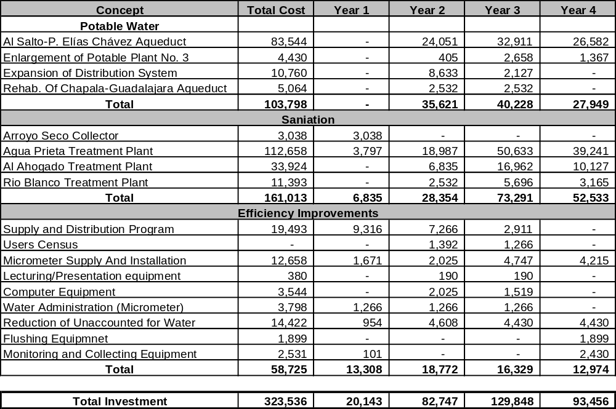

Project Status: The project has an authorized JICA-Japan loan. However before accepting the grant, CNA and the municipal utility are working on efficiency improvements to make the local utility financially solid and able to manage the loan.

The CNA, which acts as the project’s technical and financial advisor, is pushing the state government to go forward with the project, since according to NOM-001-ECOL-1996; the city must comply with wastewater treatment legislation by the year 2000.

Estimated Investment
Amount: US$ 323 million.

Financing Sources: OECF-Japan/Federal & State government

For more information
Contact:

Name: Sistema Intermunicipal de Agua Potable y Sanieamiento (SIAPA)
Contact: Ing. José Luis González Velasco.
Position: General Director
Tel: (52-3) 877-4272
Fax: (52-3) 877-4272

Official Project Name: Morelia Wastewater Treatment Plant

Client: Water utility for the city of Moreila in the state of Michoacan (Organismo Operador de Agua Potable, Alcantarillado y Saneamiento de Morelia).

General Descriptions: The project includes the construction of a wastewater treatment plant with a capacity of 1,300 lps. with anaerobic percolating filters technology. The project is supported by FINFRA and will consist in a 20-year BOT concession scheme.

Type of Bid or
Invitation and When: The current government has completed all necessary studies and applied for FINFRA funding, however there will be a change in government administration at the state and municipal levels in late 2001. It is expected that the tender process will be handled by the new administrations and is expected to take place at the end of the second quarter of 2002. The project will be open to foreign companies.

Project Status: The Morelia Utility has selected the site for the treatment plant and has produced the basic engineering for the plant as well as for the collector network and completed the tariff impact studies.

Exact Site Location: The plant will be located 8 kilometers to the east of the city of Morelia. Morelia is located in the state of Michoacan in the central- west region of Mexico and has approximately 900,000 inhabitants.

Estimated Investment US $ 13.85 million
Amount:

Financing Sources: FINFRA US $ 5.5 Million
The balance will be financed by the concessionaire.

Estimated Period for
Project Execution: 12-24 months

Other Contracts Related: An additional project that will be bid separately will consist in a 10 Km expansion of the sewage system. It is estimated this project will have a cost of US $ 5.5 Million.

For more information contact:

Name: Organismo Operador de Agua Potable, Alcantarillado y Saneamiento de Morelia (Water Utility for the City of Morelia)
Address: Av. Acueducto 1896, Col. Chapultepec Norte, C.P. 58260, Morelia, Michoacán, México.
Contact: Ing. Jaime Juárez
Position: Project manager
Tel: (52-43) 14-0024
Fax: (52-43) 14-1111
E-mail: jjuarez48@hotmail.com

Official Project Name: Xalapa Wastewater Treatment Plants.

Client: Municipal Water Utility of the City of Xalapa. (Comisión Municipal de Agua Potable y Saneamiento de la Ciudad de Xalapa.)

General Description: Xalapa is the third most important city of Veracruz with a population of 400,000 inhabitants. The city is currently discharging all its wastewater without treatment. The planned wastewater treatment plant will be divided in three modules. The first will treat 300 lps. on its first stage, and will be expanded until reaching 650-700 lps. Prior building the plant the municipal water utility will tender the collectors, one with a length of 16 kilometers and an estimate cost of US$4.5 million and the second with a length of 11 kilometers and an estimate cost of US$2.3 million. Tenders for the collectors are expected for late 2001. Montgomery Wattson is currently developing the executive project and related studies. As part of the study being developed by Montgomery Watson, water re-use is being evaluated for industrial purposes.

Type of Plant: Stabilization Lagoons

Capacity: Three modules, the first of 300 lps. and future modules will reach a 650 lps. capacity.

Type of Bid or Invitatión
and When: Public works – Collectors
20 year Concession – wastewater treatment plant
Date not defined yet. (Late 2002)

Project Status: At present the U.S. company Montgomery Watson is developing the executive project for the wastewater treatment plant and related infrastructure. This study will be delivered to the Water Utility in late 2001. After completing the executive project, the municipal utility will contract another private firm to conduct a tariff impact study. This study will be funded by FINFRA. The Utility believes this project will be ready for bidding in the second semester of 2002.

Exact Site Location: The plant will be located in the suburbs of Jalapa, the land for the plant is being transferred to the state.

Estimated Investment
Amount: The precise investment will be determined after completion of the executive project. The utility estimates the plant value in between US$13 to US$18 million.

Financing Sources: The Utility is working with FINFRA for the execution of the necessary studies, and it will request FINFRA risk capital for the construction of the wastewater treatment plant. The concessionaire will fund the remaining cost.

Operation Period: 20 year concession.

For more information contact:

Name: Comisión Municipal de Agua Potable y Suministro de la Ciudad de Jalapa
Address: Alfaro 5, C.P. 91000, Xalapa, Veracruz, México.
Contact: Ing. Luz María González Ramírez
Position: Technical Underdirector.
Tel: (52-28) 17-3453
Fax: (52-28) 17-3453

Official Project Name: Sanitation of Ciudad Valles, San Luis Potosí 2nd Stage

Client: Municipal water utility of Ciudad Valles, San Luis Potosí. (Dirección de Agua Potable, Alcantarillado y Saneamiento de Ciudad Valles, San Luis Potosí.)

Geneal Descriptions: The project involves the construction of three activated sludge wastewater treatment plants and the construction of collectors and pumping stations to connect the plants. The municipal water utility is evaluating the convenience of tendering each plant separately, if this decision is made, the first plant with a capacity a capacity to treat 100 lps, (Two modules of 50 lps).would be built in 2002, the second with a capacity of 50 lps in 2003 and the third with a similar capacity in 2004.

Type of Bid or Invitation
and When: The municipal water utility is deciding if the project will be made through one tender for the three wastewater treatment plants, or independent tenders for each. Tenders will be international and the first is expected for the first months of 2002. If the three plants are tendered together the tender could be delayed until late 2002.

Project Status: One year ago the utility approached FINFRA to request support for the basic engineering for the project, but due to the small scale and high costs charged by FINFRA, the municipality decided to perform those on their own. The studies are at final stage and the results are expected for September 2001. If the studies confirm expected costs and the utility decides to tender the plants separately, the first bid would take place the last quarter of 2001 to begin construction in the second quarter of 2002.

Exact Site Location: Ciudad Valles is located in the southern part of San Luis Potosí, 261 kilometers away from the State capital. The three plants will be located in the southern part of the city.

Estimated Investment
Amount: US$ 3,000,000.00

Financing Sources: The water utility will pay for the total cost of the project. They are requesting financing to the constructor during construction period and would pay after completion of the works. Other financing options such as APAZU are being analyzed.
Estimated Period of
Project Execution: Six months for each plant.

Amount of Time to
Prepare Bid Offer: From three to four months after tender is issued.

For more information
contact:

Name: Dirección de Agua Potable, Alcantarillado y Saneamiento de Ciudad Valles, San Luis Potosí.
Address: Carretera Valles-Mante, Km. 1.5, Col. Valles, C.P. 79020, Ciudad Valles, San Luis Potosí, México.
Contact: Ing. Raimundo Cano Tinajero.
Position: Technical underdirector
Tel: (52-138) 2-4726
Fax: (52-138) 2-2772
E-mail: dapa@terra.com.mx

Official Project Name: Improvements to the Wastewater Collection and
Treatment Services in Palomas, Coahuila.
Client: Municipal water utility of Palomas, Coahuila
(Junta Rural de Aguas y Saneamiento de Palomas, Chihuahua. (JRAS))

General Description: The goal of this project is to make improvements to the city’s wastewater collection and treatment services. This includes rehabilitating and expanding the current waste water collection system, as well as constructing a new small wastewater treatment plant of 34 lps consisting in an anaerobic lagoon, a facultative lagoon and a wetland. The project is divided in two phases, the first for the sewage collection and the second for the wastewater treatment plant. In addition this utility is carrying several actions to improve its operational efficiency.

Type of Bid or Invitatión
and When: The utility is in final negotiations to sign NADBANK’s credit, after signed it will define the precise bidding date. They estimate to sign the credit in August and to issue the tender in September or October 2001.

Project Status: All necessary studies for the project are completed and NADBANK has accepted to provide funding. The Utility has plans to begin construction before the end of 2001 and to do that, it would have to issue the bidding documents before October.

Exact Site Location: The city of Palomas is located to the northwest in the state of Chihuahua, México in the municipality of Asención. It shares a common border with the city of Columbus, New México. Palomas is located approximately 86 miles from the Ciudad Juárez, Chihuahua and El Paso, Texas.

Estimated Investment US $5.18 million
Amount:

Financing Source: (BEIF) Border Environment Infraestructure Fund:
Construction Assistance: US$1.76 million
Construction Management Assistance: $120,000
These funds will only be used for the first phase of the project.

NADBANK Loan:
$191,610 (to be signed)
These funds correspond to the first phase of the project. An additional loan for the second phase will be determined prior execution.

Institutional Development Cooperation Program:
Various institutional strengthening studies of the JRAS will be conducted. For instance, an update of the billing and collection system will be undertaken as well as studies examining the agency’s rate system and user registry.

Additional funds for the project will be made available via the National Water Commission (CNA) and the Junta Central de Agua y Saneamiento and JRAS.

Extimated Period of
Project Execution: Approximately 1 year 4 months.

Amount of Time to
Prepare Offers: 45 days.

For more information
contact:

Name: Junta Rural de Agua y Saneamiento de Palomas, Chihuahua.
Address: Av. Revolución e Internacional S/N, Zona Centro, C.P. 31830, Palomas, Chihuahua, México.
Contact: Mr. Antonio Palacios
Position: Project Manager
Tel: (52-166) 6-0105
Fax: (52-166) 6-0105

Official Project Name: Integral Sewage ant Treatment Project for Tuxpan,
Veracruz

Client: Tuxpan Municipal sewage and potable water commission.
(Comisión Municipal de Agua Potable y Saneamiento de Tuxpan.)

General Descriptions: The proposed project includes the construction of three wastewater treatment plants with a total capacity of 425 liters per second. The first two plants will have a capacity of 175 lps each and the third 75 lps. Construction of the collectors is currently taking place for the first 175 liters per second. It is contemplated that it will be a project under a 15 to 20 year BOT structure open to bidding by international companies.

Type of Plant: Aereation lagoons. But this type of plant might be changed depending on a final site selection.

Type of Bid or
Invitation and When: Site selection is underway and all necessary studies have been completed. The Utility estimates to bid the first plant in early 2002.

Project Status: The proposed project is conceived as an integral project to include a wastewater treatment plant as well as an expansion of the sewage system. The work currently being contemplated includes the construction of the collectors and other necessary infrastructure for collecting a larger sewage and rainfall volume. Work is also progressing regarding site selection for the wastewater treatment plant. No technical design has yet been proposed for this plant.

Exact Site Location: The specific site for the construction of the treatment plants has not been selected. It will be located in the area of the city of Tuxpan in the state of Veracruz. This state is located in Mexico’s gulf coast.

Estimated Investment US$ 2.04 million for the first plant.
Amount:

Financing Required FINFRA US$ 840,000
(if any):

Operation Period: 15 to 20 years

For more information
contact:

Name: Comisión Municipal de Agua Potable y Saneamiento de Tuxpan. (Municipal potable water and sewage commission).
Address: Miguel Lerdo de Tejada 42, Zona Centro, C.P. 92800, Tuxpan, Veracruz, México.
Contact: Ing. Guillermo Rivera Carrasco
Position: Managing Director
Tel: (52-783) 4-8367
Fax: (52-783) 4-0214

Official Project Name: Comprehensive Sewage and Efficiency Improvement Project (Piedras Negras)

Client: Potable Water and Sewage Commission for the State of Coahuila and Municipal Potable Water and Sewage System of Piedras Negras.
(Comisión Estatal de Aguas y Saneamiento de Coahuila and Sistema Municipal de Aguas y Saneamiento de Piedras Negras.)

General Descriptions: Piedras Negras is a bordering city located in Mexico’s north central region and with a population of 180,000 inhabitants. The comprehensive project egun with the construction of a 360 lps wastewater treatment plant currently under construction. The second stage will incorporate the construction, rehabilitation and expansion of the sewage system and pumping stations as well as several works for efficiency improvements. As a third stage, the project will incorporate the expansion of the existent plant form 360 to 720 lps. The date for this expansion will be determined once the sewer expansion is completed.

Type of Bid or
Invitation and When: It is estimated that the first tender will be released in October or November of 2001 for the sewer expansion. Several tenders will be made for efficiency improvements, including IT systems, water meters, user registry services, among other. All tenders will be open to foreign companies and projects will be tendered as turnkey of EPC contracts. In addition to the sewer expansion, there will be some complementary projects that will be bid in the following years.

Project Status: The first phase of the project consisting in the construction of the wastewater treatment plant has been completed. The following projects will consist in the expansion of the sewage infrastructure to increase the sewage volume into the WWTP and efficiency improvements.

Type of Plant: The wastewater treatment plant being built is based on an activated sludge treatment system.

Exact Site Location: Piedras Negras, is located on the Northeastern portion of the state of Coahuila, Mexico. This state borders the US.

Estimated Investment US $ 57.42 million (estimated)
Amount:

Financing Sources: Border Environmental Infrastructure Fund (BEIF)
Construction Assistance: US$ 8.40 million. This assistance will be applied to the construction budget for the sewage collection expansion projects.

NADB (North American Development Bank)
US$ 16.80 million.

Institutional Development Cooperation Program (IDP)
Institutional strengthening activities will be undertaken to improve the operation of SIMAS in order to make the utility self-sufficient.

For more information
contact:
Name: Comisión Estatal de Aguas y Saneamiento de Coahuila. (Potable water and sewage commission for the state of Coahuila)
Address: De la Fuente 433-A, Zona Centro, C.P. 25000, Saltillo, Coahuila, México.
Contact: Lic. Salomón Abedero López.
Position: Managing Director.
Tel: (52-84) 12-7069
Fax: (52-84) 14-0568
E-mail: ceas@prodigy.net.mx

Official Project Name: Wastewater Treatment Plant for the City of Saltillo

Client: Municipal potable water and sewage utility for Saltillo (Sistema Municipal de Agua y Saneamiento de Saltillo)

General Descriptions: Saltillo is the State capital of Coahuila, the city has a population of 750,000 inhabitants and an important industrial base. The wastewater treatment project is conceived in three stages. The first to be bid in September 2001 will consist on a wastewater treatment plant with a capacity to treat 1,200 lps. The technology will be a combination of activated sludge and biofilters. Additionally, this projects calls for the expansion of the sewage infrastructure. The following two phases will call for the construction of two additional wastewater treatment plants, each with a capacity of 400 lps. for which they have not defined bidding dates.

Type of Bid or
Invitation and When: The bidding documents are expected to be released in the month of September 2001. The project will be open to foreign companies and will consist on 20 year BOT scheme.

Project Status: They are in the process of finishing the conceptual engineering for the project, which will be ready in August 2001. They are also finishing the feasibility studies, the soil analysis and other information that will be presented to the bidders.

Exact Site Location: The plant will be located in between the municipalities of Ramos Arizpe and Saltillo, These are located in the state of Coahuila which limits to the north with the U.S. and east with Nuevo León.

Estimated Investment US $ 19.03 Million for the first plant.
Amount:

Financing Source: NADBANK US $ 6.9 Million.
Concessionaire the remaining.

For more information contact:
Name: Sistema Municipal de Agua y Saneamiento de Saltillo
(Municipal potable water and sewage utility for Saltillo)
Address: General Cepeda y de la fuente 433, Zona Centro, C.P. 25000, Saltillo, Coahuila, México
Contact: Ing. Gustavo Martínez
Position: Department for special projects
Tel: (52-84) 14-0455
Fax: (52-84) 14-9840

Official Project Name: Wastewater treatment plant for Boca del Rio and
Medellin, Veracruz

Client: Regional potable water and sewage commission of Boca del Rio (Comisión Regional de Agua y Saneamiento de Boca del Río.)

General Descriptions: The project contemplates the construction of a wastewater treatment plant with a total capacity of 1,200 lps. The construction will be divided in three 400 lps. stages. The project will also incorporate the construction of some collectors and the expansion of a portion of the sewage system. The wastewater treatment plant will use anaerobic process and will consist in oxidation lagoons.

Type of Bid or
Invitation and When: It is likely that the project will be bid under a BOT scheme open to international companies. As for the bid release dates, the sponsors are estimating those will be published before the end of 2001.

Project Status: They are about to finish the basic engineering project. They have received approval from Banobras and the CNA for financing and as soon the basin engineering is completed, a date for tender will be set.

Exact Site Location: The plant site is located at Puente Minero in the municipality of Medellin, in the state of Veracruz. This state is located in Mexico’s gulf coast.

Estimated Investment US $ 7.21 Million for the first stage.
Amount:

Financing Sources: FINFRA US $ 2.9 Million
CNA US $ 1.5 Million.

For more information contact:

Name: Comisión Regional de Agua y Saneamiento de Boca del Río
(Regional Potable water and sewage commission of Boca del Rio)
Address: Grijalva 76, Esq. Rafael Freine, Fraccionamiento Reforma, C.P. 91910, Boca del Río, Veracruz, México.
Contact: Arq. Francisco García Barradas
Position: Operations Manager
Tel: (52-29) 37-1672
Fax: (52-29) 37-1672
E-mail: sistemas@ver.megared.net.mx

APPENDIX B. In Country Contacts:

Mexican Government Contacts

Secretariat of the Environment and Natural Resources
Secretaría de Medio Ambiente y Recursos Naturales (SEMARNAT)

Office of the Secretary
Lic. Víctor Lichtinger, Secretario
Periférico Sur 4209, Fracc. Jardines en la Montaña, 14210, México, D.F.
E-mail: vlichtinger@semarnat.gob.mx
Tel: (52-5) 628-0606, 628-0602
Fax: (52-5) 628-0643

Undersecretariat of Planning and Environmental Policy
Subsecretaría de Planeación y Política Ambiental
Dr. Francisco Szekely
Periférico Sur 4209, Fracc. Jardines en la Montaña, 14210, México, D.F.
E-mail: fszekely@semarnat.gob.mx
Tel: (52-5) 628-0615
Fax: (52-5) 628-0618

General Directorate of Planning
Dirección General de Planeación
Lic. Roberto Cabral Bowling
E-mail: rcabral@semarnat.gob.mx
Tel: (52-5) 595-2561 ext. 22121

General Directorate for Regional Programs
Dirección General de Programas Regionales
M. en C. Carlos Toledo Manzur
E-mail: ctol@semarnat.gob.mx
Tel: (52-5) 628 07 49, 628 07 50 ext. 633

General Directorate for Education and Training towards Sustainable Development
Dirección General de Educación y Capacitación para el Desarrollo Sustentable
Dra Tiahoga Ruge Scheffer
E-mail: tiahoga@semarnat.gob.mx
Tel: (52-5) 658-3380

General Directorate for Statistics and Information
Dirección General de Estadística e Informática
Sr. Yosu Rodríguez Aldabe
E-mail: yosu@semarnat.gob.mx
Tel: (52-5) 628-0853, 54, ext. 2185

General Coordination for Decentralization
Coordinación General de Descentralización
Arq. Julio García Coll
E-mail: jgarcia@semarnat.gob.mx
Tel: (52-5) 628-0673, 628-0600 ext. 2195 10980

Undersecretariat of Management for Environmental Protection
Subsecretaría de Gestión para la Protección Ambiental
Biol. Raúl Enrique Arriaga Becerra
Periférico Sur 4209, Fracc. Jardines en la Montaña, 14210, México, D.F.
E-mail: rarraiga@semarnat.gob.mx
Tel: (52-5) 628-0623
Fax: (52-5) 628-0624 ext. 305

General Directorate for Forests
Dirección General Forestal
M. en C. Cuauhtémoc González Pacheco
E-mail: dgforestal@semarnat.gob.mx
Tel: (52-5) 554-5620 ext. 15505

General Directorate for Soil Conservation and Remediation
Dirección General de Restauración y Conservación de Suelos
Ing. Rafael Obregón Viloria
E-mail: robregon@semarnat.gob.mx
Tel: (52-5) 658-8974 ext. 15514

General Directorate for the National Reforestation Program
Dirección General del Programa Nacional de Reforestación
Biol. Vicente Arriaga Martínez
E-mail: varriaga@netmex.com
Tel: (52-5) 641-3301, 641-9101

General Directoate for Federal Sea and Land Zones
Dirección General de Zona Federal Marítimo Terrestre
Biol. Ricardo Juárez Palcios
Tel. (52-5) 524-8154, 524-8969

Undersecretariat for Promotion and Environmental Regulations
Subsecretaría de Fomento y Normatividad Ambiental
Lic. Cassio Luiselli Fernández
Periférico Sur 4209, Fracc. Jardines en la Montaña, 14210, México, D.F.
E-mail: Ksandoval@semarnat.gob.mx
Tel: (52-5) 628-0610, 628-0614
Fax: (52-5) 628-0656

National Institute of Ecology
Instituto Nacional de Ecología (INE)

Office of the Presidency
Dr. Exequiel Ezcurra, President
Av. Revolución 1425, Col. Tlacopac, 01040, México, D.F.
E-mail: eezcurra@ine.gob.mx
Tel: (52-5) 624-3400
Fax: (52-5) 624-3598

Environmental Impact and Zoning
Ordenamiento e Impacto Ambiental
Biol. Amado Ríos Valdéz, Director
Tel: (52-5) 624-3374
Fax: (52-5) 624-3368

Management and Environmental Information
Gestión e Información Ambiental
Dr. Adrián Fernández, Director
Tel: (52-5) 624-3456
Fax: (52-5) 624-3584

Enviromental Regulations
Regulación Ambiental
Lic. Dulce María Avila Martínez, Director
Tel: (52-5) 624-3491
Fax: (52-5) 624-3656

National Water Commission
Comisión Nacional del Agua (CNA)

General Director
Lic. Cristóbal Jaime Jáquez, General Director
Insurgentes Sur 2140, Col. Ermita San Angel, 01070, México, D.F.
E-mail: direcciong@sga.cna.gob.mx
Tel: (52-5) 481-4219, 481-4217
Fax: (52-5) 481-4218

Water Administration
Administración del Agua
Lic. Mario Alfonso Cantú Suárez, General Subdirector
Tel: (52-5) 661-0680
Fax: (52-5) 661-3590

Construction
Construcción
Ing. Próspero Antonio Ortega Moreno, General Subdirector
Tel: (52-5) 481-4260
Fax: (52-5) 481-4262

Operation
Operación
Ing. César Octavio Ramos Valdés, General Subdirector
Tel: (52-5) 661-3056
Fax: (52-5) 661-6429

Programing
Programación
Ing. César Herrera Toledo, General Subdirector
Insurgentes Sur 2140, Col. Ermita, 01070, México, D.F.
E-mail: cherrera@sgp.cna.gob.mx
Tel: (52-5) 661-2840
Fax: (52-5) 481-4117

General Attorney for Environmental Protection
Procuraduría Federal de Protección al Ambiente (PROFEPA)

General Attorney For Environmental Protection
Lic. José Campillo García, Procurador
Periférico Sur 5000, Col. Insurgentes Cuicuilco, 04530, México, D.F.
Tel: (52-5) 528-5417 and 528-5409
Fax: (52-5) 528-5432

Underattorney for Industrial Verification
Subprocurador de Verificación Industrial
Mr. Alfredo Fuad, Subprocurador
Tel: (52-5) 589-8550
Fax: (52-5) 589-4398

Underattorney for Environmental Audits
Subprocurador de Auditorías Ambientales
Dr. Luis Fernando Hernández, Subprocurador
Periférico Sur 5000, Col. Insurgentes Cuicuilco, 04530, México, D.F.
Tel: (52-5) 528-5478, 528-5475
Fax: (52-5) 528-5469

Underattorney for Natural Resources
Subprocurador de Recursos Naturales
Lic. Diana Ponce Nava, Subprocurador
Periférico Sur 5000, Col. Insurgentes Cuicuilco, 04530, México, D.F.
Tel: (52-5) 665-0757
Fax: (52-5) 666-9482

Mexico City Government

Secretary for the Environment
Dra. Claudia Sheinbaum Pardo, Secretaria
Plaza de la Constitución 2, Col. Centro, 06068, México, D.F.
Tel: (52-5) 521-3528
Fax: (52-5) 521-2688

General Directorate for Planning and Environmental Policy
Dirección General de Planeación y Política Ambiental
Ing. Guillermo Calderón Aguilera, General Director
Plaza de la Constitución 1, Col. Centro, 06068, México, D.F.
Tel: (52-5) 542-9311
Fax: (52-5) 522-6289

Directorate for Water, Soil and Municipal Waste Projects
Dirección de Proyectos de Agua, Suelos y Residuos Municipales
Biol. Sergio Gasca Álvarez
Director
E-mail: sgasca@mail.dgpcc.gob.mx
Tel: (52) 5209-9903 ext. 6900 and 6910
Fax: (52) 5209-9903 ext. 6920

Mexican Financial Institutions

Banco Nacional de Obras y Servicios Públicos (BANOBRAS)
Departamento de Organizaciones Internacionales
Lic. Ismael Díaz Aguilera, Gerente
Tecoyotitla 100, Col. Florida, 01030, México D.F.
Tel: (52-5) 723-6000 ext. 6268
Fax: (52-5) 723-6248

Banco Nacional de Comercio Exterior (BANCOMEXT)
Lic. José Luis Romero Hicks, General Director
Camino Santa Teresa 1679, Col. Jardines del Pedregal, 01900, México, D.F.
E.mail: dir_gral@bancomext.gob.mx
Tel: (52-5) 481-6012
Fax: (52-5) 652-9408

Nacional Financiera (NAFIN)
C.P. Mario Laborin Gómez, General Director
Insurgentes Sur 1971, 01020, México, D.F.
E-mail: mlaborin@nafin.gob.mx
Tel: (52-5) 5325-6000 ext. 6701
Fax: (52-5) 661-8418

Bilateral and Multilateral Development Institutions

North American Development Bank (NADBank)
Ing. Raúl Rodríguez Barocio, General Director
203 South St. Mary´s, Suite 300, San Antonio, TX 78205
Tel: (210) 231-8000
Fax: (210) 231-6232

Border Environment Cooperation Commission (BECC)
Mr. Gonzalo Bravo, Public Participation Officer
Blvd. Tomás Fernández 8069, Fracc. Parques, 32470, Cd. Juárez, Chih.
Tel: (52-16) 25-9160
Fax: (52-16) 25-6999

International Boundary and Water Commission (IBWC)
4171 N. Mesa, Suite C-130, El Paso TX 79902
Tel: (915) 534-6678
Fax: (915) 534-6680

The Wold Bank
Office of the U.S. Executive Director
Commerce Department Liaison
1818 H. Street, N.W. Washington, D.C. 20433
Tel: (202) 458-0120
Fax: (202) 477-2967

The World Bank/Mexico Mission
Mr. Ricardo Hernández, Especialista en Medio Ambiente
Insurgentes Sur, 1605, Col. San José Insurgentes, 03900, México, D.F.
Tel: (52-5) 480-4266
Fax: (52-5) 480-4222

Inter.-American Development Bank (IDB)
Commerce Department Liaison
1300 New York Avenue, N.W., Rm SE 228 Washington, D.C. 20577
Tel: (202) 623-3822
Fax: (202) 623-2039

Inter-American Development Bank/Mexico City Office
Mr. Rafael Negret, Especialista en Medio Ambiente
Horacio 1855, piso 6, Col. Los Morales, 11510, México, D.F.
Tel: (52-5) 580-2122
Fax: (52-5) 580-6083

Japan Overseas Economic Cooperation Fund (OECF)
1900 L Street, N.W., Suite 213, Washington, DC 20036
Tel: (202) 463-7492
Fax: (202) 463-7496

Industrial Chambers

Confederación de Cámaras Industriales (CONCAMIN)
Ing. Raúl Tornel Cruz, President
Santa Lucía 311, Col. Santa Cruz Acayucan, 02770, México, D.F.
E-mail: rtornel@tornel.com.mx
Tel: (52-5) 561-6111 Ext. 2901
Fax: (52-5) 561-2151

Cámara Nacional de la Industria de la Transformación (CANACINTRA)
Ing. Raúl Picard del Prado, President
Av. San Antonio 256, Col. Ampliación Nápoles, 03849, México, D.F.
E-mail: rpicard@canacintra.org.mx
Tel: (52-5) 563-5581
Fax: (52-5) 598-8044

COPARMEX
Ing. Jorge Epina Reyes, President
Insurgentes Sur 950, Col. Del Valle, 03100, México, D.F.
Tel: (52-5) 682-6063 ext. 267
Fax: (52-5) 536-1698

Cámara Regional de la Industria de la Transformación de Jalisco
Ing. José Simón Sánchez Santana, President
Bruselas 626, Col. Moderna, 44190, Guadalajara, Jalisco
Tel: (52-3) 810-5237
Fax: (52-3) 811-3350

Cámara de la Industria de la Transformación de Nuevo León
Ing. Sergio Gutiérrez Muguerza, President
Av. Fundidora 501, Col. Obrera, 64010, Monterrey, Nuevo León
Tel: (52-8) 369-0204
Fax: (52-8) 369-0210

American Chamber of Commerce of Mexico (AMCHAM)
Mr. Gary Deaton, International Trade Director
Lucerna 78, Col. Juárez, 06600, México, D.F.
Tel: (52-5) 705-4033
Fax: (52-5) 703-3908

Industrial Associations

Consejo Nacional de Industriales Ecologistas (CONIECO)
Ing. Carlos Sandoval, President
Gabriel Mancera 1121, Col. Del Valle, 03100, México, D.F.
Tel: (52-5) 559-5600
Fax: (52-5) 575-2337

Asociación Nacional de Importadores y Exportadores (ANIERM)
Lic. Humberto Simoneen Ardila, Executive VP
Monterrey 130-1, Col. Roma, 06700, México, D.F.
E-mail: anierm@anierm.org.mx
Tel: (52-5) 564-8618
Fax: (52-5) 584-5317

Federación Mexicana de Ingeniería Sanitaria y Ciencias Ambientales, A.C.
Dr. Blanca Jiménez Cisneros, President.
Calzada de Tlálpan 972, Col. Nativitas, 03500, México, D.F.
E-mail: fmisca@cmic.org
Tel: (52-5) 579-6723 Fax: (52-5) 579-5482

Private Institutes

Centros de Estudios del Sector Privado para el Desarrollo Sustentable (CESPEDES)
Mr. Gabriel Quadri de la Torre, General Director
Lancaster 15, Col. Juárez, 06600, México, D.F.
Tel: (52-5) 514-9300
Fax: (52-5) 514-0762

Instituto para la Protección Ambiental de Nuevo León, A.C.
Ing. Fernando Gutiérrez Moreno, Director
Av. Fundidora 501, Col. Obrera, Monterrey, Nuevo León
Tel: (52-8) 369-0252
Fax: (52-8) 369-0254

Institute of the Americas
Collen Morton, Vice President
10111, North Torrey Pines Road, La Jolla, CA 92037
Tel: (619) 453-5560
Fax: (619) 453-2165

APPENDIX C. Major Local Players:

Company Name: Aguas de Barcelona (AGBAR)

Nationality: Spanish

Business Description: Founded in 1867 and grown through acquisitions and internationalization, Aguas de Barcelona is one of the leading international water service providers. It provides water and sanitation services to over 10 million people in 620 localities around the world. In addition to providing water services, The Agbar Group offers services such as health care, technical inspection of vehicles, waste management, engineering and construction, telecom, and tax collection.

Role and Projects: Agbar has been one of the latest entrants to the Mexican market. The group intended to enter Mexico in the late 1990’s through the acquisition of the Cancun integrated concession, but its effort failed by not reaching the price requested by the broke construction firm GMD, concessionaire of Cancun at that time. Agbar is the only bidder left in the creation of a mixed public-private company to offer water services in Saltillo. The company has been involved in this process since its early stage and if awarded would be its first major project in Mexico.

Alliances: The company is currently working on its own through a representation office in Mexico. If awarded with the Saltillo water utility participation, the company could develop alliances with national construction or engineering firms.

Strategy: Agbar is interested in providing integrated water services more than being a wastewater operator. The company has good expectations in Mexico since the new government’s strategy is based on the inclusion of private players in the provision of water services.

Key Contact:

Name: Alberto Usobiaga Suinaga
Position: Representative for Mexico
Tel: (525) 5518-8409
Fax: (525) 5521-5374
E-mail: ausobiaga@agbar.com.mx

Company Name: Azurix

Nationality: United States of America

Business Description: Azurix was founded in 1998 as a subsidiary of the American Petroleum and Power company Enron. The first action made by Azuriz was acquiring Essex Water Plc, considered the most efficient water and wastewater utility of the United Kingdom. The company has grown its water business through acquisitions of International concessions and expanding its presence through private water utilities in the United States.

Role and Projects: On January 1999 Azurix bought 49.9% of the integrated concession of Cancun for US$13.5 million in cash and the assumption of US$ 25 million in financing and operational commitment. The Cancun concession is for 24 years and serves 383,000 people.
Later in 1999, Azurix paid US$22.5 million to acquire a 49% stake of Industrias del Agua (IASA), one of the four companies providing service in Mexico City. Included in this transaction was the purchase of a wastewater treatment plant in Matamoros and the technical company of IASA, SITEPSA. In May 1999, IASA through a joint venture with Fypasa won a tender for a 20 year BOT wastewater treatment plant in Torreon, with an estimated value of US$20 million, and on September 1999 Azurix made a joint venture with Fypasa for a 49% stake in a US$25 million wastewater treatment plant in León.

Alliances: Industrial del Agua S.A. de C.V. – Azurix (49%)
Fypasa ECOSYS III Plant – Azurix (49%)
Fypasa ECOAGUA - Industrias del Agua S.A. de C.V. (90%)

Strategy: After entering aggressively to the Mexican water market, and although Azurix had good results with its Mexican projects, the company went broke in early 2001. Operations of Azurix were taken by Azurix’s parent company Enron, who is evaluating its exit strategy from the water sector. Enron will likely sell its participation in its water projects in Mexico.

Key Contact:

Name: Ing. Enrique Aguilar Amilpa
Position: General Director SITEPSA
Tel: (525) 5237-3824
Fax: (525) 5237-3887
E-mail: eaguilar@azurix.com

Company Name: ONDEO-Degrémont

Nationality: French

Business Description: Ondeo-Degremont belongs to the French Suez group, which has 220,000 employees in 120 countries. Ondeo-Degremont has operations in 19 countries and 3,000 employees. The company builds water-treatment plants to purify water and treat wastewater around the world. Plants constructed by ONDEO-Degrémont provide 65 world capitals with drinking water, and the company has built wastewater-treatment plants for cities worldwide. Its industrial service plants treat wastewater for clients that include including paper and petrochemical manufacturers. ONDEO-Degrémont also makes a range of treatment equipment, from aerators to filters to biologic treatment reactors. The former Degrémont became ONDEO-Degrémont when parent Suez re-branded its water services operations in 2001.

Role and Projects: Ondeo-Degrémont has been very active in the construction and operation of municipal and industrial wastewater treatment plants in Mexico treating over 10 m3/s. Part of ONDEO’s success in Mexico comes from water reuse, which is a component included in all its projects. The following are Ondeo-Degrémont municipal projects in Mexico:

City/ State | Capacity | Reuse | Concession
Culiacán, Sinaloa | 1.7 m3/s | Agriculture | 18 years
Cd. Juárez, Chihuahua | 3.5 m3/s (2 plants) | Agriculture | 12 years
Puebla, Puebla | 3.6 m3/s | Agriculture | 15 years
Salina Cruz, Oaxaca | 324 m3/h | Petrochemical Complex | 12 years
Hermosillo, Sonora | 400 m3/h | Power plant | 12 years
San Luis Potosí | 1.1 m3/s | Power plant | 18 years

In addition to these municipal projects, Ondeo-Degrémont is very active in industrial wastewater treatment where it has built plants for international companies with operations in Mexico such as Smurfit, Dupont, BASF, Nestlé, and Danone, and for Mexican companies such as Cartonajes Estrella, CFE, Telmex and Pemex.

Alliances: Prior becoming part of Ondeo, Degremont de Mexico functioned as a sub-contractor for the Mexican construction companies Bufete Industrial and Tribasa and for Sumitomo on municipal wastewater projects. Currently Degremont is participating alone in most wastewater treatment tenders and sub-contracts Mexican construction companies for the civil works involved.

Strategy: Ondeo-Degremont is probably the most aggressive player in Mexico’s wastewater market and will be a very strong contender for the Mexico City wastewater treatment plants. The company has been limiting its efforts to wastewater, however in the near future Ondeo-Degrémont plans to begin offering solutions for potable water.

Key Contact:

Name: Ing. Patrice Keime
Position: General Director
Tel: (525) 5255-9000 ext. 9001
Fax: (525) 5260-1377
E-mail: Patrice.KEIME@ondeo-degremont.com.mx

Company Name: Bi-Water Mexicana

Nationality: English

Business Description: Biwater is a world leader in the international water industry. Its expertise lies in water and environmental engineering; packaged equipment, products and services; water systems ownership, investment and operations; water asset management; leisure; project and structured finance.

With its highly successful track record of working internationally, Biwater has built an enviable global reputation and has operated in over sixty countries.

During the past three decades Biwater has grown by expanding its own range of skills and expertise, by acquiring established companies within the water industry and by forming joint ventures with organizations that provide complementary services.

Role and Projects: The US$33 million Puerto Vallarta wastewater treatment plant in Mexico was constructed on a greenfield site for which Biwater, through a Mexican subsidiary company, raised the finance and carried out the design, construction, installation and commissioning. The concession, now operated by Cascal (a Nuon Biwater company) covers the operations and maintenance of the plant for 15 years. The plant, with a maximum capacity of 2,500 l/s, bettered all the designated performance criteria during its first year of operation. This is the only project Biwater has built in Mexico.

Alliances: N/A

Strategy: Bi-water had several problems with the Puerto Vallarte plant sicne the municipality considered it was oversized and refused to pay for capacity. After years of discussion the plant is operating efficiently.

Key Contact:

Name: Mr. Ronald Pealing
Position: Plant Manager
Tel: (5232) 210-965
Fax: (5232) 210-865

Company Name: Fypasa Construcciones

Nationality: Mexican

Business Description: Created in 1943, Fypasa considers itself as the largest Mexican wastewater company as larger players are foreign companies. Fypasa provides engineering, construction and procurement services for potable and wastewater systems. Altough Fypasa is a small company, it boasts an impressive set of potable water and wastewater projects across the country.

Role and Projects: Fypasa has won major concessions in Aguascalientes, Querétaro, Tampico, Toluca (2 plants) and León. Through these six plants the company treats over 3 m³/s of municipal effluents. The company is also active in Industrial water and wastewater projects, offering small plants with custom-made designs to meet client requirements.

Alliances: Fypasa established a joint-venture with the now inexistent construction company Grupo Mexicano de Desarrollo (GMD). When this Fypasa’s partner went broke, Azurix took over most of its operations and is its current partner in the León and Toluca plants.

Strategy: Fypasa is well positioned in both, the municipal and industrial water and wastewater markets. This company is an excellent candidate for alliances and Dutch equipment supplies as it offers custom-made solutions and uses equipment from different international manufacturers.

Key Contact:

Name: Ing. Francisco José Chozas Rizo
Position: General Director
Tel: (525) 688-0585, 688-7115
Fax: (525) 688-9469
E-mail: drgral@fypasa.com.mx

Company Name: Operación y Mantenimiento de Sistemas de Agua
OMSA
(Formed by VIVENDI and ICA)

Nationality: 51% Mexican 49% French

Business Description: Operación y Mantenimiento de Sistemas de Agua (OMSA) was formed by Mexico’s largest heavy construction company ICA and VIVENDI, formerly Compagnie Générale des Eaux in the early 1990’s. OMSA participates in the construction, designs, operation and maintenance of water systems and has had a limited participation in wastewater treatment.

ICA has a number of alliances other than VIVENDI, the Mexican construction giant is allied with Fluor Daniel for industrial construction projects. Through this venture ICA-Fluor Daniel builds large water supply, sewer systems and other major water works such as dams. OMSA is mainly the water-operating arm of ICA.

Role and Projects: OMSA has three water concessions in Mexico, The company operates the integrated concessions in Aguascalientes and Navojoa, and has one of the four service contracts for water in Mexico City. OMSA also won a concession for a municipal wastewater treatment plant in La Paz, Baja California Sur, but this project was not built.

Strategy: The ICA-VIVENDI partnership is currently the most important local water system operator in Mexico. The company is leaving wastewater concessions for VIVENDI’s subsidiary U.S. filter, and is focusing on integrated concessions and service contracts.

Key Contact:

Name: Ing. Manuel Salvoch Oncinis
Position: Executive Vice President
Name: Ing. Pedro González Martínez
Position: Director
Tel: (525) 272-9991
Fax: (525) 277-8387, 271-6801

Company Name: Desarrollo y Construcciones Urbanas, S.A. de C.V.

Nationality: Mexican

Business Description: Desarrollo y Construcciones Urbanas, S.A. de C.V. (Dycusa) is a general public works construction company based in Monterrey.

Role and Projects: Mostly limited to civil construction services including sewage collection systems, aqueduct construction and installation of tanks and pumping stations. Dycusa constructed the Monterrey wastewater treatment plant “Dulces Nombres”, the largest in the Country and the Cuchillo-Monterrey aqueduct.

Alliances: Dycusa sub-contracted design and operation of a 3m3/s wastewater facility in Monterrey to Burns and McDonald, although this is not a formal alliance both companies work and bid together for several water works in Mexico.

Strategy: Dycusa has preference for EPC and turnkey projects.

Key Contact:

Name: Ing. Juan Antonio Balli González
Position: General Director
Tel: (528) 358-4200
Fax: (528) 359-6655

Company Name: US Filter (Vivendi Water Systems Mexico)

Nationality: US (Subsidiary of French Vivendi)

Business Description: The Company participates in the potable water and wastewater treatment markets. Since its incorporation to Vivendi, this company has focused its efforts in small municipal wastewater treatment plants and industrial projects, leaving large municipal projects to the venture ICA-Vivendi, OMSA.

Role and Projects: The company won two municipal BOT projects in the state of Morelos and has also successfully done work with Chrysler, Pemex, Femsa (Coca Cola) among other companies. US Filter bought out Wheelabrator Clean Water’s interest in a water re-use facility in Lechería in the state of Mexico. Most recently U.S. Filter supplied the equipment for four small municipal wastewater treatment plants in Nuevo León.

Alliances: Being part of Vivendi, the company has a number of alliances with Mexican and International companies active in Mexico’s wastewater market. One of the key alliances is with the company Compañía Mexicana de Aguas, which operates three municipal wastewater treatment plants and sells re-use water to industry.

Strategy: U.S. filter is focused in small municipal projects and industrial projects.

Key Contact:

Name: Mr. Gonzalo Pique
Position: General Director
Tel: (525) 545-3700
Fax: (528) 531-7109

Company Name: Atlatec-Earthtec

Nationality: Mexican (Subsidiary of Earthtec since 2000)

Business Description: Atlatec is a Mexican company, originally founded by the Mexican chemical company Cydsa, which has revenues of US$700 million. In 2000, Earthec (a Tyco company) with sales of over US$1300 million acquired Atlatec. This company participates in industrial and municipal wastewater projects, including design, construction, financing and operation. Since it incorporation to Earthtec, the company begun offering integrated environmental solutions including air, waste, water and soils.

Role and Projects: Atlatec won a number of major projects including municipal wastewater treatment plants in Monterrey, Chihuahua, and Saltillo. In addition, Atlatec won four wastewater and re-use facilities which it has under concession with PEMEX in its refineries Cadereyta, Madero, Tula and Mina, and several industrial wastewater treatment plants for Vitro, Papelera Maldonado, the Federal Electricity Commission, Nestlé among other companies.

Alliances: None

Strategy: Atlatec’s market presence is strongest in Northern Mexico and the company is planning to diversify, offering other environmental services as well as focusing to projects in other regions of Mexico.

Key Contact:

Name: Ing. Rafael Forsek Rodríguez
Position: Comercial Director
Tel: (528) 158-2305
Fax: (528) 331-3758
E-mail: rforseck@cydsa.com
Company Name: Grupo Marhnos (Proagua)

Nationality: Mexican

Business Description: Marhnos is one of the top ten Mexican construction firms. The company is a general contractor often associated with general residential, commercial and industrial construction and development. Marhnos business mostly pertains to smaller scale civil works rather than major infrastructure projects. Grupo Marhnos formed a subsidiary named Grupo Proagua to pursue water projects. Proagua’s focus is on municipal potable water and sanitation projects.

Role and Projects: Grupo Marhnos won three wastewater projects, one in San Luis Potosí which is operating, one in Oaxaca that is under construction and one in Veracruz that is still to begin construction.

Alliances: Marhnos has no formal joint ventures with international companies, however this company established an alliance with the Canadian consulting engineering company SNC Lavalin, which provided working capital for Marhnos San Luis project.

Strategy: Marhnos is seeking financial partners for bidding into municipal wastewater concessions. Other than these the company will limit its efforts to finalize the construction of its existent concessions and on EPC contracts.

Key Contact:

Name: Dr. Juan Pedro Escobar Latapí
Position: General Director - PROAGUA
Tel: (52-48) 17-43-81
Fax: (52-48) 17-43-89
E-mail: jplatapi@proagua.com.mx
Company Name: Severn Trent

Nationality: United Kingdom

Business Description: Severn Trent is a leading provider of water supply and sanitation services in the United Kingdom. The company is active in all aspects of water business and maintains 200 water treatment stations and 1,013 sewage treatment works.

Role and Projects: Severn Trent has 49 percent ownership interest in Aguas de México, one of the four companies operating the Mexico City water system which is its main presence in the market. Severn trent also won a project to build and operate a small wastewater treatment plant at the Finsa Industrial park on the U.S. –Mexico border.

Alliances: Severn Trent has alliances with Azurix, (now Enron) and with Aguas de México.

Strategy: Severn Trent is interested in operation of water systems.

Key Contact:

Name: Ing. Michael Phillip Jones Taylor
Position: General Director
Tel: (525) 237-3800
Fax: (525) 237-3887

Company Name: Ionics

Nationality: U.S.

Business Description: Ionics is a global separations technology company involved in the manufacture and sales of membranes and related equipment for the purification, concentration, treatment and analysis of water and wastewater, in the supply of purified water, in water disinfection, and in water quality monitoring. Ionics has been a pioneer in purified water with its worldwide five-gallon brand Aqua Cool® Pure Bottled Water, as well a pioneer in privatization with Build, Own, and Operate (BOO) water facilities around the world.

Role and Projects: Ionics entered the Mexican market in 1999 and has successfully built two water purification facilities in Mexico City.

Alliances: Ionics is established in Mexico as a subsidiary of Ionics in the U.S. For civil works, the company works with recognized Mexican construction firms. Although Ionics manufactures membranes and ionization systems, all the mechanic and civil engineering works are subcontracted in Mexico.

Strategy: Ionics is trying to demonstrate that its state of the art technology is the best alternative for purifying water in Mexico. The good results proven by its two pilot plants are serving as example for other municipalities.

Key Contact:

Name: Ing. Mateo García Vázquez
Position: Sales Manager- Mexico
Tel: (525) 255-1637
Fax: (525) 255-4460
E-mail: mgarcia@ionics.com

Source: ANEAS.
CNA – Presentation “Overview of Mexico’s water Sector, June 2001.
CNA, data to December 1999.

