FINANCING THE WATER SECTOR IN THE NETHERLANDS:

A first analysis

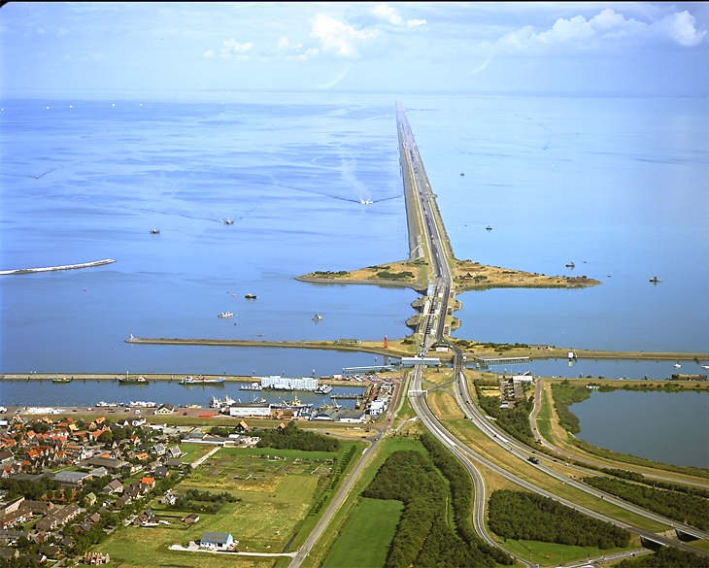
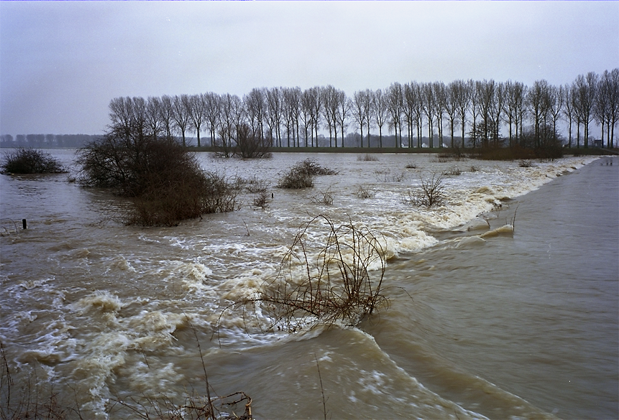
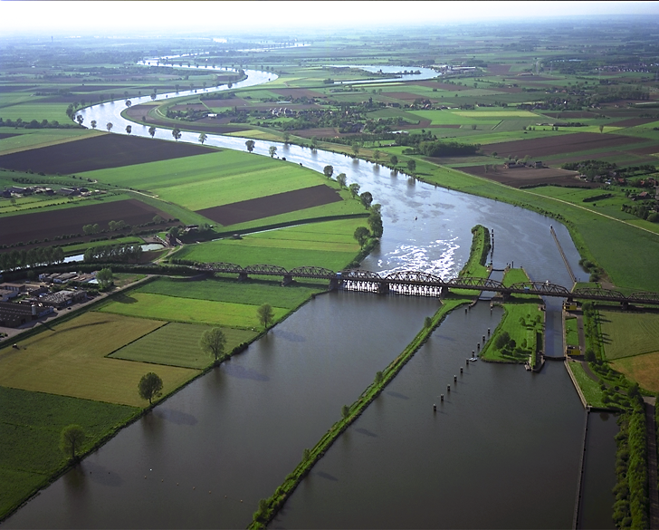
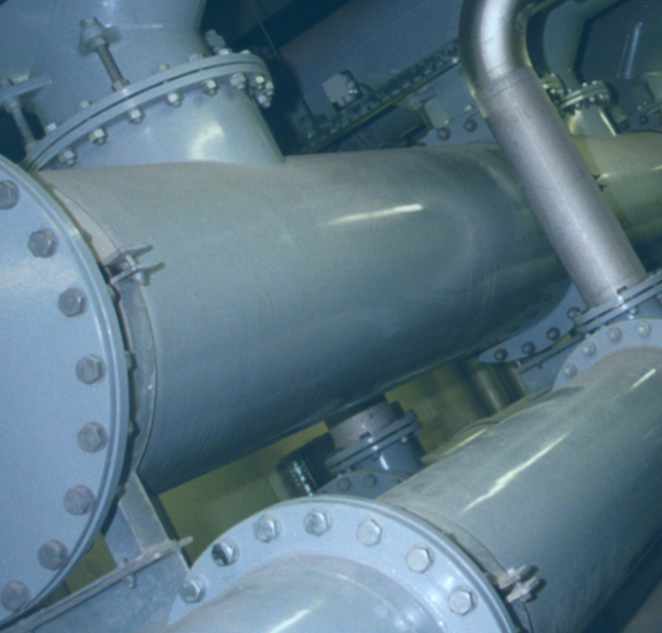
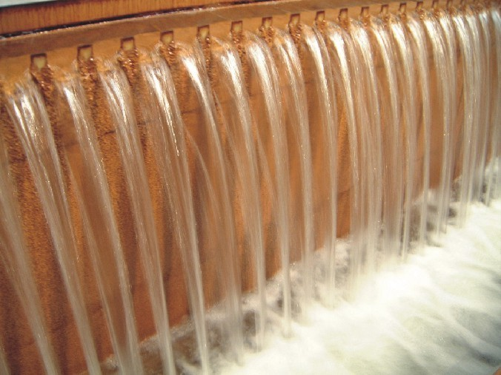
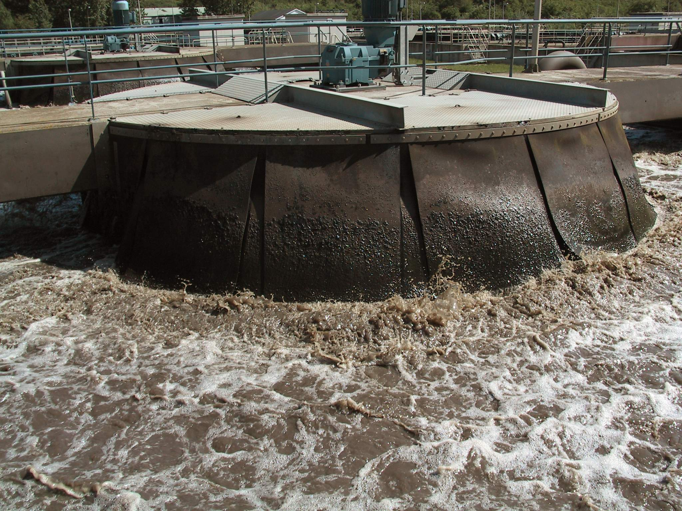

A paper invited by the Netherlands Water Partnership (NWP) to prepare for the Financing Water Infrastructure Panel in The Hague, on October 8-10, 2002

Netherlands Water Partnership, POBox 3015, 2601 DA Delft, The Netherlands
T: +31 15 2151728 F: +31 15 2151759 E: info@nwp.nl I: www.nwp.nl

FINANCING THE WATER SECTOR IN THE NETHERLANDS:

A FIRST ANALYSIS

A paper invited by the Netherlands Water Partnership (NWP) to prepare for the Financing Water Infrastructure Panel in The Hague, on October 8-10, 2002 (version 7-10-2)

Prof. dr. Meine Pieter van Dijk and drs. Klaas Schwartz Department of Management and Institutions, UNESCO-IHE Institute for Water Education, Delft, the Netherlands

Westvest 7
Pobox 3015
2601 DA Delft
The Netherlands
Tel. 31(0)152151779
E-mail mpd@ihe.nl and kls@ihe.nl
http:/www.ihe.nl

Table of contents

Introduction

The need for finance: Water management is an expensive business even in the Netherlands

The Water Sector in the Netherlands

Funding

Water Boards
- Background and tasks
- Developments

The financing of Water Boards
- Income of Water Boards
- Sources of capital for the Water Boards
- Private sector involvement

The Bank for the Water Boards in the Netherlands (NWB)

Water supply companies
- Background and tasks

Budgets
- Developments

Financing of water supply companies
- The income
- Sources of capital for the Water companies

Conclusions

References

Sheets

Notes
Introduction

The Dutch have a long tradition of managing water. Can any lessons be learnt from Dutch experience for the financing challenges facing the world’s water sector? In order to abstract lessons learnt it is first necessary to broadly examine the water sector in the Netherlands and in particular the main actors. Next we zoom in on the Dutch Water Boards and the Water supply companies. We will analyse the way the water sector is financed in the Netherlands, to be able to eventually answer the question whether there is a Dutch model of financing and whether this is a model for other countries as well.
The paper will deal separately with financing water supply and flood control, water quality management and wastewater collection and treatment. First the origin of the Water Boards and how they finance their activities and then the history of the water companies and their sources of revenue and capital will be described. Separate attention will be given to the Bank for the Water Boards in the Netherlands (NWB), before addressing the question whether there is a Dutch model for financing the water sector? Subsequently the question, not answered in this paper, but possibly relevant for the next World Water Forum, would be which elements of such a model could eventually be repeated elsewhere.

The need for finance: Water management is an expensive business, even in the Netherlands

The fact that water management is an expensive business can be illustrated by pointing to the experience in the Netherlands. Water control activities alone in this country cost 386 US$ per inhabitant in 1994. These total cost are made up of flood protection cost (16%), cost for water quantity control (19%) and for water quality control (65%).
The Netherlands are not the only country that needs to make substantial investments in the water sector and has to make high costs to keep its water control and supply activities going on. The Asian Development Bank estimated in 1996 that some US$ 200 billion will be needed annually over the next ten years to finance infrastructure investment in Asia alone, given increasingly urbanised populations and higher income levels. These needs can be translated in a demand for:
- new sources of finance
- new methods of channelling finance to projects and
- new financial instruments (using bonds, project finance, or issuing shares).

All of these may require a much greater involvement of the private sector on the one hand, but also more pro-active and innovative activities of the public sector on the other. Sometimes the financial institutions need to be developed and to get interested in lending for infrastructure. However, the existence of such intermediaries is not enough. On the demand side, the water utilities require in most cases reforms first, to make them creditworthy. If order has been put in their administration new forms of financing will become available. However, we will also have to ask the question to what extent this approach starting from the demand side and suggesting the development of institutions on the supply side can be financially and environmentally sustainable (Van Dijk, 2001).
The World Water Vision and the associated Framework for Action estimated during the World Water Forum held in The Hague in March 2000 that in the period 2000-2025 180 billion US$ per year would be necessary for the necessary water services in developing countries. This figure refers to new works alone and does not take into account the ongoing costs of maintenance, rehabilitation and replacement. Cosgrove and Rijberman, 2000) calculated the annual shortfall between demand and present resources for water in developing countries as about 100 billion US$! Now the question is how can this shortfall be financed, what are the different options? Even in the case of public ownership of the utility private sector involvement in financing this amount seems to be necessary and desirable as can be learned from the Dutch model. However, even private sector involvement will not solve all problems (Figueres, 2002)

Given the financial situation of many water utilities, Private Sector Participation (PSP) in the water sector is more likely in the future and hence requires more attention. Attracting private capital requires a different approach to water projects. These projects now have to convince financial people that it is worth putting their money into it. This requires an identification of the possible risks (Lindfield, 1998). The increasing role for the private sector institutions and the importance of Public Private Partnerships (PPP) does not mean the ownership of the Water Boards or companies has to be private. The question is rather: what is the relevance of the different types of public private partnerships in the water sector and who will participate in these PPPs.

The expectations are that a well designed and scaled facility, using the right technology, working in a proper institutional and policy context with private sources of capital and using some kind of cost recovery mechanism will probably be the most successful one. Let us now look at the experience with financing the water sector in the Netherlands.

The Water Sector in the Netherlands

For understandable reasons the water sector in every country is unique in many ways. The Netherlands forms no exception in this respect. The distribution of tasks and responsibilities in the water sector in the Netherlands is largely historically defined. History has resulted in a fragmentation of responsibilities over a multitude of actors as shown in table 1. Strategic and operational policy is formulated at four different levels of government involving no less than seven different institutions.
Responsibilities concerning water policy formulation are attributed to the European Union, the central government, the provincial government, the municipal government, the Water Boards, the Netherlands Waterworks Association (VEWIN), and the individual drinking water companies. Table 1 provides an overview of actors and responsibilities in the Dutch water sector.
Table 1: Overview of Responsibilities in the Dutch Water Sector

Organisation | Responsibility
European Union | - EU Directives (for example: Water Framework Directive (2000/60/EC), Urban Wastewater Treatment Directive (91/127/EEC), Drinking Water Directive (98/83/EC)
Central government | - Framework Acts and General Administrative Measures  - Strategic national policy  - Operational policy and management for the North Sea and national water systems  - General supervision over provinces, water boards and municipalities
Provinces | - Strategic groundwater and surface water policy  - Operational groundwater policy and management  - General supervision over Water Boards and municipalities.
VEWIN | - Draft ten-year plans every five years
Water boards | - Surface water management (quantity and quality), water control, management of inland waterways and some small inland roads
Municipalities | - Sewerage collection
Drinking water companies | - Production and distribution of drinking water  - Draft one-year plans
Source: Based on Perdok 1995, as cited in Mostert 1997

Funding

The total costs for water management in the Netherlands amount to € 5.67 billion per year (Ministry of Transport and Public Works 2000). More than half of this amount goes to water supply provision and water quality management. For this reason we shall specifically focus on the financing of Water Boards and water companies, who are responsible for these tasks.

Financing of water management activities derives from six sources (based on Perdok 1995):

- Central Government budget
- Water Board charge
- Pollution levy
- Groundwater taxes
- Drinking water charges
- Private project financing

The Water Boards collect the water board charges and pollution levy. The water supply companies collect the drinking water charges.

Water Boards

Background and tasks
Since the Middle Ages, when the first Dutch Water Boards were founded, the Water Boards have played a prominent role in the water sector in the Netherlands. At current, 53 Water Boards still operate in the Netherlands, down from 3,500 in 1850 and 2,500 in the late 1940s. The Water Boards, which are considered to be the oldest democratic institutions in the Netherlands, are so-called ‘functional government bodies’, the councils of which are elected by the stakeholders of the activities of the Water Boards (owners of real estate, wastewater dischargers, leaseholders and residents) (Perdok 1995). The Water Boards are supervised by the Provinces in which they operate, but through the process of scaling up this has become more complex. The provincial governments are responsible for defining the tasks of the Water Boards (Perdok 1995). The tasks of a Water Board can include (Water Boards Act 1992):
Figure 1: The Dutch Water Boards

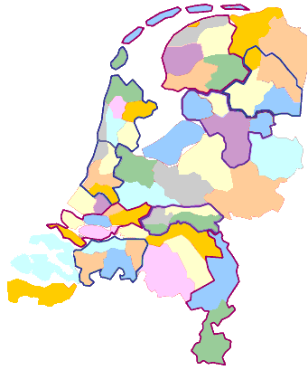
Source: http://www.uvw.nl

- Water control: providing protection against flooding by means of dunes, dykes and canals;
- Water quantity: managing the amount of water and ensuring that it is kept at the right level;
- Water quality: fighting water pollution and improving the quality of surface waters, treatment of urban waste water
- Additional related tasks, such as management of inland waterways and roads.

Not all Water Boards undertake all these tasks yet. Some Water Boards only concern themselves with the management of water quantity. Others are only responsible for managing water quality. The current reorganisation process will lead to 27 Water Boards in 2005, dealing with both water quality and quantity.

Budget
The entire budget of the water Boards is financed by two taxes which the Water Boards are authorised to levy. These are the Water Board charge and the pollution levy (Union of Water Boards 1997). The collection of these two taxes has led to an annual budget, which in 1999 amounted to approximately € 2.6 billion. Of this amount approximately 73 % is spent on operating costs and the other 27 % on investments. Of the operating costs close to 60 % of the budget is allocated for the task of managing water quality.
Table 2: Expenditure of Water Boards in 1999

Item of Expenditure | Amount (in million €)
Total Investments | 700
Total Operating Costs: | 1,900
- Water quality management | 1,108
- Water quantity management | 604
- Water control | 127
- Management of inland roads | 73
- Management of inland waterways | 5
Total Expenditure | 2,6000
Source: Union of Water Boards 2002

Developments
Under pressure of rising sea levels, an expected subsidence of the surface, climatological changes and increasing urbanisation, the future poses significant challenges for the Water Boards. The ground level is expected to sink between 2 and 60 cm over the next 50 years (Ministry of Transport and Public Works 2000). Meeting these challenges will be an expensive undertaking, costing an additional € 5 billion to € 10 billion over the next decades (Union of Water Boards 2002).
A second challenge comes from the European Union where in recent years legislation has been passed requiring stringent standards to wastewater treatment. The Urban Wastewater Treatment Directive has the purpose of protecting the environment from adverse effects of sewerage discharges and to ensure that all significant discharges are treated before being released into receiving waters. The Directive sets standards and dates by which those standards are to be met. Especially the removal of nitrogen will lead to big investments in the coming years.
Financing these additional investments is likely to follow the same ‘rules’ as have been implemented for many decades in the water sector in the Netherlands. If this is not sufficient additional funds will have to be made available.

The Financing of Water Boards

Two third of the budget of the Water Boards is collected by way of Water Board charges and pollution levies. This covers the recurrent costs for the Water Boards. The other one third was financed primarily through loans. In this section the Water Board charges and pollution levies are briefly reviewed and then the sources of capital for financing projects will be examined. Concerning financing three aspects need to be separated: the financial instruments, the necessary financial institutions and complementary policies creating an environment in which such a financial system can flourish.

Income of the Water Boards
The Water Boards finance their work entirely from two taxes: the Water Board charge and the pollution levy (Union of Water Boards 1997). The Water Board charge is based on the basic principle that interest (or benefit) in the activities leads to contributing financially to those activities (taxation) which in turn leads to representation in the Water Board council responsible for those activities. The more one benefits from the activities of the Water Board, the more one is taxed for those activities. Stakeholders’ categories are represented in the Water Boards council. In addition every polluter in the Netherlands pays according to the Surface Water Pollution Act. This structure has led to a vast decline of discharges to surface waters. At the same time Water Boards make use of these levies to finance their quality tasks.

The Water Board charge is used for expenditure in the area of water control, water quality and for maintaining the roads and waterways. The charge is levied on residents, owners and users (tenants) of land and property in the service area of a Water Board (Union of Water Boards 1997). The Water Board charge knows a limited number of tax categories, which are determined by law. Different tax categories know different tax bases (Spoek 1997) and one household can receive several invoices, if for example economic activities are carried out on the land or in the building:
- Residents. In practice each household pays a fixed amount.
- Owners of buildings. Owners of houses and/or commercial properties pay a charge pro rato the economic value of their property.
- Owners of greeneries. Owners of greeneries pay a charge in accordance with the economic value of their property.
- Owners of Land. Owners of land pay a charge pro rato the surface area of the land

According to the Surface Water Pollution Act charges are being levied in order to finance water quality management, including wastewater treatment. As such, the expenditure on water quality is covered completely through the pollution levy. The pollution levy is based on a ‘pollution unit’, which is equivalent to the amount of wastewater one person produces per year. In 1999, the average pollution levy was € 41.7 per ‘pollution unit’. A family on average pays for 3 pollution loads or € 125.2 per year (Union of Water Boards 2001). The amount levied per pollution load ranges between different Water Boards from almost € 50 to € 32. The difference in levy is closely linked to the costs for treating waste water. For industries tailor-made approaches are in operation. 80 % of the income generated by the pollution levy is spent on wastewater treatment. The remaining 20 % on other activities aimed at improving the quality of surface waters (Union of Water Boards 2001).

Sources of Capital for the Water Boards
Part of the total cost for water control activities are not included in the 386 $ per capita figure, which corresponds roughly to six billion €. These are the capital cost, which are partly financed through the financial market. Water Boards may lend money or allow private or (other) public participation in their projects (project finance). The importance of the latter options will also be studied, although of limited importance so far in the Netherlands. It is important for developing countries, where private sector involvement is often recommended as the solution for many problems (Van Dijk and Schulte Nordholt, 1994). We will deal with the major activities one by one: flood control and water system management and water quality management and waste water treatment.
In general, the most important financial instruments are loans, bonds, project finance and share issue or sales. In the case of Water Boards, being functional government bodies, the possibility of share issue or sales is out of the question, leaving loans, bond and private finance as potential possibilities. The Bank for the Water Boards (NWB) plays a prominent role in granting loans. Because of the presence of the NWB the Water Boards do not use bonds to finance their activities. The advent of private financing is a relatively new phenomenon for Dutch Water Boards.

Flood protection and water system management are primary conditions for life and hence usually not left to the private sector. Water management institutions need a financing mechanism in which taxing is directly related to the interest of stakeholders. There are three major sources of finance for water management: payments based on the profit principle (the user pays: implying cost recovery), or based on the polluter pays principles (the polluter pays levies to the competent water authority for the full charges, including investments, this is the reflection of the profit principle) or based on contributions from the general budget. The rule is if the individual charges cannot be made, then the concerned community members pay as per the polluter pays principle. Finally, only if both are not feasible, then the state provides the means. The costs of regional water management are expected to increase in the years to come, resulting in an increased burden of regular expenses per household. These expenses differed significantly between water Boards in 1999, ranging from 120 to 205 € per houshold.
Since traditional sources of finance are probably not enough for the future and certainly not for most developing countries, we will also pay attention to efforts to attract private sector finance.

The Water Boards also play an important role in water quality management. Two third of the amount needed for water management is financed through Water Board graded taxes, Water board pollution charges and Municipal sewerage charges. These concern mainly the recurrent cost. There are different sources of capital that can be tapped for wastewater treatment. The most important financial instruments are loans, bonds, project finance and share issue or sales. Corresponding legal forms are PPPs, Build Operate and Transfer (BOT), privatization or the creation of a special project vehicle.
Different forms of privatization can be distinguished, ranging from a complete divestiture to privatising only certain stages of the production process (Van Dijk and Schulte Nordholt, eds, 1994). Only certain functions, such as the management, may be privatised, or certain tasks could be contracted out to private partners. Finally, involvement of the private sector is also possible by using management or service contracts or through concessions. In this case the property is not transferred, but only the management. An early summary of experiences of involving the private sector in the supply of urban services, such as water supply and sewerage can be found in Roth (1989). An example of the later is the public private partnership for the water purification plant for the region The Hague, which will be discussed now.

Private Sector Involvement

In 2002, the Water Board Delfland awarded a Design-Build-Finance-Operate (BFO) contract to the Delfluent consortium for the construction and operation as one of Europe’s largest wastewater treatment plants which should be operational in 2008 (as well as upgrading an older treatment plant). The concession has a duration of 30 years. The decision to involve the private sector rested on the need to build a new treatment plant (in light of the need to meet European guidelines on urban wastewater discharge). The Water Board Delfand believes the DBFO scheme will at least provide efficiency gains of 10%.
With the awarding of the first DBFO contract private sector financing has made its entry into the Dutch water sector. At current, this is the first and only project of its kind. It remains to be seen to what extent private sector financing will grow over the coming decades. In light of the challenges facing the Dutch water sector, however, it is clear that it will definitely been seen and investigated as a viable option by many decision makers. The lessons so far are that the process takes more time than expected and that there will be a need to monitor the project to find out whether it achieves its goals.

The Bank for the Water Boards in the Netherlands (NWB)

The NWB was formed in 1954 and is the most prominent financial institution in the financing of activities undertaken by both the Water Boards and the water supply companies. The NWB, which is fully owned by the public sector was created as a response to the severe floods in 1953, the same that led to the construction of the Delta works. The Bank operates almost exclusively in the Netherlands and supplies services only to the public sector, providing long term funding to provinces, municipalities, Water Boards, water supply companies and environmental corporations.

The provision of long-term finance to the Water Boards continues to be a key area of NWB’s business. Historically this was an important task, in particular since many small Water Boards were not considered creditworthy at the time. Through guarantees provided by the Netherlands government they became eligible for credit and then they gradually improved their financial management.

The Bank also acts as treasurer for the Water Boards and provides them with a range of banking services. All business transacted is under state guarantee. The NWB is quite unique and can only compared with the role which the Bank of the Dutch Municipalities (BNG) for Dutch cities and towns (Van Dijk 2001). This bank is an example of a bond bank, which issues bonds on behalf of the municipalities, to lend the money on to municipalities.

Table 4: Balance of the NWB 1997-2001 in € million

 | 2001 | 2000 | 1999 | 1998 | 1997
Long-term loans and advances | 18,256 | 15,539 | 14,465 | 14,162 | 13,746
Capital base | 921 | 834 | 750 | 667 | 589
Total assets | 22,634 | 18,535 | 17,083 | 15,851 | 15,116

Source: http://www.nwb.nl

Water Supply Companies

Background and tasks
Since the beginning of water supply provision in the Netherlands in the 1850s the sector has evolved continuously. This evolution is illustrated by the various modes of organisation that have been dominant since the first water supply company started operating in 1853. From 1853-1920, water supply provision was largely a private enterprise in which privately owned companies provided potable water to customers. Partly because of these early ‘private’ beginnings the water supply sector has always had a history of full-cost recovery. In the period between 1921-1974, in which the importance of safe water supply was fully realised, the municipal public utilities became the predominant mode of water services delivery. From 1975 onwards the government-owned public limited company became the most prominent mode of organisation for supplying potable water. The prominence of the public water PLC resulted largely from government regulation, most notably the Drinking Water Supply Act and amendments to this Act in 1975, which promoted the “[a]malgamation of water utilities into larger vertically integrated units under the public water PLC format”, whilst “horizontal integration with other utilities and other institutional forms were discouraged” (Blokland et al. 2000). The number of water supply companies, who are only responsible for production and/or distribution of potable water, dropped from 210 in 1950 to 15 at the moment (VEWIN 2002).
Figure 2: The Dutch Water supply Companies

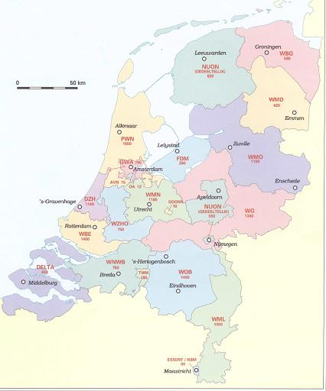
Source: H2O

The essence of the government-owned PLC is that the company is established and operates under company law whilst the shares of the company are in hands of national, regional or local government authorities. Generally, there is no legal or organisational difference between a publicly-owned and a privately-owned PLC apart from the government ownership of shares (Schwartz and Blokland 2002). The implication is financial transparency. This may not be enough, however, to guarantee economic efficiency. For that reasons the sector has implemented self-regulation in 1989 through annual performance comparison. The idea is to develop it into a full-fledged benchmarking system, creating a surrogate market in the otherwise monopolistic business of piped water supply. The annual reports that they have to publish serve as the basis for the banks to assess the creditworthiness of individual utilities and to determine their credit ceilings. In fact the banking sector, together with Central government push the utilities towards performance comparison.

Budget
In the year 2000, the average total cost per water connection in the Netherlands was € 205 per connection (VEWIN 2001). These are the average cost per connection. Between water supply companies the costs per connection fluctuates strongly from € 241 per connection for one of the companies using surface water to € 147 for one of the companies using groundwater as a main water source (VEWIN 2001). With over 7 million connections in 2000 (VEWIN 2002), the total costs in the water sector approximate € 1.4 billion. Of the total expenditure in the water supply sector approximately half is operational cost (47%), 10% is taxes, 22% is capital costs and a further 21% is depreciation (VEWIN 2001). Over the past decade the total investments in the Dutch water supply sector have averaged around € 500 million per year. In 2000 investments reached € 419 million, which represents 28 € per inhabitant. Most of the investments went into distribution (50%), 39% in production processes and about 4% in information and communication technology (VEWIN 2002).

Developments
Similar to the Water Boards, the water supply sector finds itself in an era in which investments are likely to increase substantially over the coming decades. The expected increase in required investments is due to a number of factors (Braadbaart and Hoogwout 1999):
- Continuing aggregation of companies. It is generally expected that the current 15 companies will be subject to future mergers in which the total number of remaining water companies is expected to be between 3 and 6. These mergers are likely to involve considerable additional investments.
- Increasing cost of raw water. The deteriorating quality and availability of groundwater is likely to drive up treatment costs. On the one hand, groundwater regulation will likely force companies to shift from groundwater to surface water (which requires more extensive treatment), on the other hand, intensive agriculture has polluted groundwater sources and as such complicated water treatment.
- Increase in cost of new treatment plants. New plants tend to be outfitted with costly advanced treatment technologies. This is partly explained by the pollution problems mentioned above as well as the need to adhere to increasingly stringent environmental procedures.

Finally a problem for the companies it that they are confronted with the need to make additional investments to meet increasing stringent water quality and to satisfy environmental management requirements.

Financing of Water supply Companies

The income

All water supply companies have to finance themselves their recurrent costs and investments. Although the initial expansion of water supply in the Netherlands was not without substantial government subsidies, the companies now have to be financially self sufficient. The recurrent costs consist of operating costs, depreciation and interest payments. Over the years the tradition has grown that the utilities recover their recurrent costs from tariffs.
The primary income for water supply companies derives from the sale of potable water. In 2000, the combined water supply companies sold 1,2 billion m of water, generating close to € 1.5 billion in revenues (VEWIN 2002). Government subsidies for operating and investment expenditures are unknown in the Netherlands. However, profits of water companies are tax-exempted. Usually profits are low since many companies have low equity-debt ratios and their shareholders from the public sector demand only modest returns.

Sources of Capital
Investments are financed from depreciation charges and reserves, but usually require commercial loans as well. Depreciation and interest payments make up almost 40 percent of the expenditures of the two Dutch water companies studied in Blokland et al. (2000).
The Netherlands water supply companies have procedures in place, which allows them to make timely decisions about necessary investments. The tradition is that these companies have to recover all recurrent costs from tariffs. The Dutch water utilities have obtained their investment capital from Dutch commercial banks, pension funds and insurance companies and have built up a reputation and trust relations with these institutions.

Similarly to the case of the water boards the most important financial instruments are potentially loans, bonds, project finance and share issue or sales. The Dutch government recently, however, prohibited the sale of shares to non-public sector entities and as such the potential of share issue and sales is relatively limited. Project Finance in the water supply sector is close to unheard of, leaving loans as the main source of capital for investments.

Usually, investments are financed from depreciation charges and reserves but require loans as well. The loans are obtained from a variety of financial institutions. Dutch water utilities have obtained their investment capital from commercial banks, the NWB, pension funds and insurance companies. Compared to other sectors the water utilities can borrow on highly favourable terms (Braadbaart and Hoogwout 1999). The utilities can draw loans without government guarentees, but are still offered lower rates than other firms. The reason for the generous terms lies with the sector’s low-risk profile. The combination of a government supported monopoly structure, government ownership, and a steady demand virtually guarentees a return on their investment (Braadbaart and Hoogwout 1999; ABN-AMRO 1996). Table 3 provides an overview of the financial balance sheet for the water supply companies in 2000.

Table 3: Financial Balance Sheet on 31-12-2000 for the Water supply sector
Assets | € million
Fixed Assets
Tangible fixed assets | 10,441
Intangible fixed assets | 261
Financial fixed assets | 239
Total | 10,941
Current assets
Stocks | 53
Account receivables/debtors | 693
Liquid assets/cash | 46
Total | 792
Total | 11,733

Liabilities
Shareholder’s equity
Share capital | 121
Reserves | 910
Total | 1,030
Other capital
Contributions from third parties | 356
Contingencies | 152
Total | 508
Long-term capital | 2,909
Short-term capital
Loans | 461
Creditors | 186
Advances | 23
Other | 206
Total | 877
Total | 5,324
Source: VEWIN 2002a

Conclusions

The Dutch government has made the choice to consider water management a public responsibility, but stimulates water organisations to go for private finance of certain water-related activities (there is for example a centre for PPP in the Ministry of Finance). The government is trying to increase the efficiency of the water sector by promoting benchmarking, the achievement of economies of scale and the outsourcing of certain tasks. The supervisory tasks are financed from the general budget.

Water supply and control is an expensive business that needs to be financed. We discussed different sources of capital, in particular the existing instruments, the necessary institutions and complementary policies. Water Boards and Water companies play the major role and recover their recurrent cost while using different opportunities to finance their investments. Based on this general picture the Dutch example can be elaborated.

One of the principles of efficient and sustainable water management in the Netherlands is that stakeholders participate directly or through representation to make good management possible. The functioning of the Water Boards is based on people’s participation and on the ‘profit principle’ (Huisman, 1997). Who benefits will pay, but also gets a say, or in plain Dutch: wie profiteert betaalt mee, maar betaling geeft zeggenschap!

Because of the investments required as mentioned above water utilities and Water Boards are more and more dependent on external financiers. However, water supply companies offer attractive prospects for capital investment and this has contributed to the development of a close relationship between Dutch water utilities and financial institutions. Braadbaart and Hoogwout (1999) conclude that because of this water utilities are slowly bringing their financial recording and reporting procedures in line with private sector standards to meet the demands of external financiers. Investors demand transparency in financial matters. For that reason the Dutch habit of cross-utility performance comparison based on a consistent accounting methodology justifies the considerable effort made to put it in place. Indicators are solvency rates, but also performance indicators play an increasingly important role. Typically most water companies are trying to improve these indicators.

The Dutch water sector is unique in many ways, as the same sector in any other country is also likely to be unique. Financing of the water sector in the Netherlands has largely been defined by cultural and historical traditions, some of which date back to the Middle Ages. Despite this observation some general conclusions can be drawn which may provide valuable lessons for the financing of the water sector in other parts of the world.

There is not really a “Dutch Model” of financing. Rather, the “Dutch Model” is characterized by a landscape of financing options. It is left to the managers of the Water Boards and water supply companies to select the option of financing that best suits their need. Often one company will combine different financing options, depending on what is most suitable for them at a specific moment.

However, based on the experience in the Netherlands it is possible to point to valuable elements of the Dutch experience. We like to point to the factors that play an important role in the decision making process about financing water management in the Netherlands:
- There is a sense of urgency concerning water management, reinforced by the 1953 floods. It has led to broad support for the activities of Water Boards and water companies.
- The importance of a conducive institutional environment, in the sense that the importance of strong financial institutions being present cannot be overstated. The authorities have made a conscious choice to go for Publiekrechtelijke organisations for the Water Boards and public ownership for the Water companies.
- The role of the Bank for the Water Boards is a prime example of a strong financial institution, which has played a crucial role in the financing of the water sector in the Netherlands. It is comparable to the much older Bank of the Netherlands Municipalities. In that case a gradual strengthening of the position of the municipalities ran parallel with the growing importance of the Bank of the Dutch Municipalities (BNG). This is a bank of and for these municipalities and it has a triple A rating form Standard & Poors and Moody. The top rating is largely attributable to the excellent creditworthiness of the local authorities.
- The positive interaction between demand for capital (the Water Boards and water supply companies) on the one hand, and supply (the financial institutions) on the other hand is very important. Over the past decades, the Water Boards and water companies have developed a solid reputation in terms of financial reliability, which in conjunction with the monopolistic nature of the water management business and the government ownership of the utilities has led banks to provide loans on very generous terms. Trust is the right word, a trusty relationship has been built up between the financial and the water sector (Figueres 2002).
- Rules like the State will only intervene when individual charges cannot be made and the application of the ‘polluter pays’ principle is not feasible, meant that Water Boards and water supply companies always had to operate according to healthy commercial principles
- The role of institutions such as the Water Boards and government-owned Water companies should not be under estimated. These institutions have their own governance structure and developed appropriate instruments for integrated water resources management

Finally, there are a number of specific factors explain the relative success of the Dutch model, but which may be repeated:
- It is a decentralised system often initiated by private initiative of the stakeholders. In Europe there is trend to delegating tasks to a layer of government that is as close as possible to the public at large. Decentralisation is also a fact in the water sector in the Netherlands. In the European context the principle of subsidiarity is used, meaning that activities should be undertaken and decisions be made at the lowest possible level if this is efficient. The idea is that decentralised decision making institutions can considerably contribute to achieve sustainable water management. Decentralised decision making institutions require adequate capacity building efforts
- The use of integrated water resource management principles in the same management area, such as recovery of cost for water services and the user pays and the polluter pays principles.
- Users are involved and can participate. Although participation is currently lower than it used to be the system is still democratic and allows participation.
- The importance of a sound financial reputation. Lower levels of government tend to have a good financial reputation in the Netherlands. They tend to be regarded as attractive parties in the financial markets and their status as debtors, with few exceptions, comes close to the status of the national government. This is related to the fact that extensive guarantees have been laid down in the law for example with regard to the financial position of local governments and the security given to those providing funds. For municipalities revenues and expenditures must in principle be in balance. Also payments for interest and repayments of loans always have priority.
- A legal framework. The current legal framework for example does not allow water companies to run deficits
- The system of self-regulation both by the Water Boards and the water companies that has been put in place. Benchmarking for the moment undertaken by the sector itself makes it possible to detect sources of inefficiency and to act upon them.

References

ABN-AMRO (1996): De Watersector. Amsterdam: ABN-AMRO Bank.
ADB (1996): Asian development, Annual report of the Asian Development Bank. Manila: ADB.
Blokland, M., O. Braadbaart and K. Schwartz (2000): The public water PLC. Delft: IHE.
BNG (1997): Review of operations. The Hague: Bank of the Dutch Municipalities.
Braadbaart, O. and B.J. Hoogwout (1999): Investment financing and cost recovery: How water company Oost-Brabant does it. Delft: IHE Working paper.
Cosgrove and Rijberman (2000): World Water Vision. The Hague: World Water Forum.
Dijk, M.P. and N.G. Schulte Nordholt (1994): Privatisation experiences in Africa and Asia. Amsterdam: SISWO.
Dijk, M.P. van (1999): Municipalities' access to (inter-) national capital markets for financing urban infrastructure. In: K. Singh and B. Thai (eds): Financing and pricing of urban infrastructure. New Delhi: New Age International, pp. 157-179.
Dijk, M.P. van (2001): The role of financial institutions and markets in urban development in India, with examples form Karnataka and Gujarat. Rotterdam: IHS.
EIB (1995): The provision of infrastructure, the role of the private sector. Proceedings Luxembourg: European Investment Bank.
Figueres, C.M. (2002): Let’s pump money in the water sector! Delft: IHE.
Hofwegen, P. van and B. Schultz (eds, 1997): Financial aspects of water management: proceedings of the Third Netherlands National ICID day, 20-3-1997. Rotterdam: A.A. Balkema.
Huisman, P. (1997): Financing water management cost in the Netherlands. In: Van Hofwegen and Schultz, eds, (1997).
Lindfield, M. (1998): Preparing markets for private financing of urban infrastructure. Rotterdam: Erasmus University, Ph.D.
Loon, F.D. and M.P. van Dijk (1995): The financial flows to and capital markets in Asia. In: K. Fukasaku (ed.): Regional co-operation and integration in Asia. Paris: OECD, pp. 175-193.
Ministry Transportation and Public works (2000): New deal with an old enemy, water management in the Netherlands. The Hague: Ministry of Verkeer and Waterstaat.

Mostert, E. (1997), Water Policy Formulation in The Netherlands, Water 21, Phase 1 report, Research Report nr.6, Delft: RBA.
Netherlands Water Partnership (NWP, 2002): Note to prepare for the Financing Water Infrastructure Panel. Delft: NWP August.
Perdok (1995):
Rooy, P. van (2002): Het waterschap als overheid is uit de tijd. In: NRC, 9-4-2002.
Roth, G. (1989): The private provision of public services in developing countries. Washington: IBRD-EDI.
Schwartz, K. and M. Blokland (2002): Government-owned Public Limited Companies in the Dutch Water Sector: The Case of the Water supply Company Limburg and Water company Europoort, in: Seidenstat, P., Haarmeyer, D. and S. Hakim (2002): Reinventing Water and Wastewater Systems: Global Lessons on Improving Water Management, New York: John Wiley & Sons.
Spoek (1997):
Union of Water Boards (1997), Water Boards, The Hague: Unie van Waterschappen.
Union of Water Boards (2002), Water Boards in the Netherlands, CD-ROM, The Hague: Unie van Waterschappen.
Verhagen, K. (20020: Grensoverschrijdende samenwerking op deelstroomgebiedniveau. In: Openbaar bestuur 2002, 6/7, pp. 11- 15.
VEWIN (2000), Waterleidingstatistiek 2000, Rijswijk: VEWIN.
VEWIN (2001), Reflections on Performance 2000: Benchmarking in the Dutch Drinking Water Industry, Rijswijk: VEWIN.
VEWIN (2002), http://www.vewin.nl.
Viersen, W. van and M. Blokland (2001): Water in the Delta, the changing Dutch landscape. Paper presented during the World water day conference in Turkey.
WWW.id21.org (2002): Tapping the market: Can private enterprise supply water to the poor?
Sheets presented October 8th 2002

Sheet 1 Financing the Dutch water management present situation

- Short description of water management in the NL: the major actors
- Analysis of the way Water boards and Water companies finance their activities
- Financing options
- Is there a Dutch model?
- Specific factors

Sheet 2 Water activities in the public sector in the Netherlands

Activity Responsible organisation Major source of finance

Flood control National government/Water Boards Gov. budget/taxation
Water quality management Water Boards WB charge/pollution
levy
Water supply management Water companies Tariffs/capital market
Waste water collection Municipalities and Water Boards Mun.taxes/WB
charges
Water treatment . Water Boards Cap. Market &
project fin.

Sheet 3 The Bank for the Water Boards

- Characteristic: According to the articles of association, the bank cannot lend to or be owned by the private sector. It has a good relationship with its public sector clients;
- Credit rating: triple A with Standard & Poor and Moody’s;
- Profit: Euro 39.8 million out of a loan portfolio of 18.5 billion euros;
- Financial position: low risk loan portfolio, being made up of credits to Dutch public authorities and limited-liability public utilities;
- Financial indicators: solvability (owner’s capital as percentage of total capital);
- Relation capital market: NWB attracts capital from the market and benefits from competitive pricing. THIS MODEL COULD BE REPEATED!

Sheet 4 Lessons from the Dutch water sector

- The importance of strong financial institutions being present cannot be overstated;
- The authorities have made a conscious choice to go for Publiekrechtelijke organisations for the Water Boards and public ownership for the Water companies;
- The role of the Bank for the Water Boards is a prime example of a strong financial institution, which has played a crucial role in the financing of the water sector;
- There is a sense of urgency concerning water management, reinforced by the 1953 floods. It has led to broad support for the activities of Water Boards and water companies;
- The positive interaction between demand (the Water Boards and water supply companies) and supply (the financial institutions) on the other hand is very important;
- The Water Boards and water companies have developed a solid reputation in terms of financial reliability and have built up trust.

Sheet 5 Factors explaining the relative success of the Dutch model that could be repeated

- It is a decentralised system often initiated by private initiative and stakeholders;
- The use of integrated water resources management principles such as recovery of cost and the water user pays and the polluter pays principles;
- Users are involved and can participate;
- The importance of financial reputation. Lower levels of government tend to have a good financial reputation in the Netherlands;
- Create a special intermediary financial institution like the NWB;
- The current legal framework for example does not allow water companies to run deficits;
- The system of self-regulation of Water Boards and water companies. Benchmarking is undertaken by the sector itself, which makes it possible to detect sources of inefficiency.

Notes

Amounts from Van Viersen and Blokland (2001) and percentages from Huisman (1997).
For the rich history of the Water Boards we refer to Union of Water Boards (1997), or a CD rom Water Boards in the Netherlands, made available by the Union of the Water Boards.
The Delfluent consortium incorporates Vivendi Water, DELTA Water, Water Company Eurpoort, Rabobank, Heijmans Groundworks and Civil Engineering and Strukton.
Presentation Mr. J. Geluk, project manager DBFO project, 6/12/2000.

