SWASH+ Facilities Assessment:
Baseline to End of Year 2 Comparisons
Prepared by:
Center for Global Safe Water, Emory University
January 25, 2009

Background
In September to November 2008, Emory University and Great Lakes University of Kisumu conducted a facilities assessment of SWASH+ schools in Nyanza Province, Kenya. The purpose of the assessment was to determine the ongoing condition of WASH facilities in intervention and control schools. Preliminary data from this assessment was presented in November 2008 in order to assess regional differences in water treatment and indications of sustainability.
The purpose of this report is to examine trends from baseline to the end of year 2 (November 2008). Specifically, it addresses the following questions:
- Are schools providing sustained access to water for drinking and handwashing?
- Are schools providing sustained treatment of water and soap?
- Are schools carrying out the necessary preconditions for sustaining, such as purchasing water treatment products and soap?
- Are sanitation conditions continuing to improve in intervention schools?
Results
Complete results for all key indicators are presented in the appendix. Tables show the results for baseline, follow up in May-July 2008 and pre-final evaluation in September-November 2008. The percentage of schools (or mean value) is presented for each study group. In the body of the report key findings are highlighted and shown in line graphs, where each line follows the same study group over time.
Are schools providing sustained access to water for drinking and handwashing?
Key findings
- Schools in all intervention groups are continuing to regularly provide drinking water, with 80% of the base package schools providing and 100% of water package schools.
- A similarly high fraction of schools continue to provide water for handwashing
- Provision of water for drinking and handwashing is high, in spite of difficulties in collection (although this deserves further investigation)
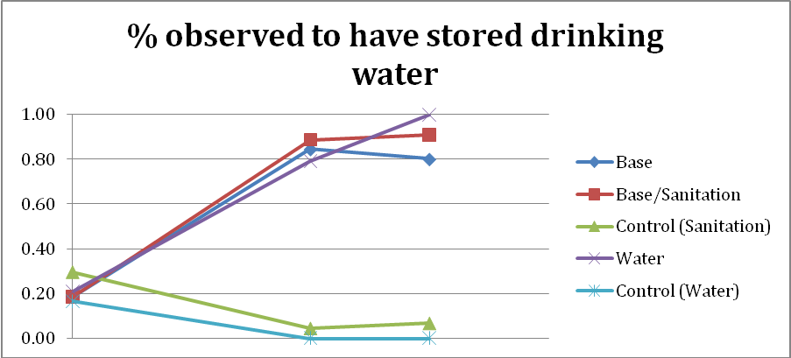
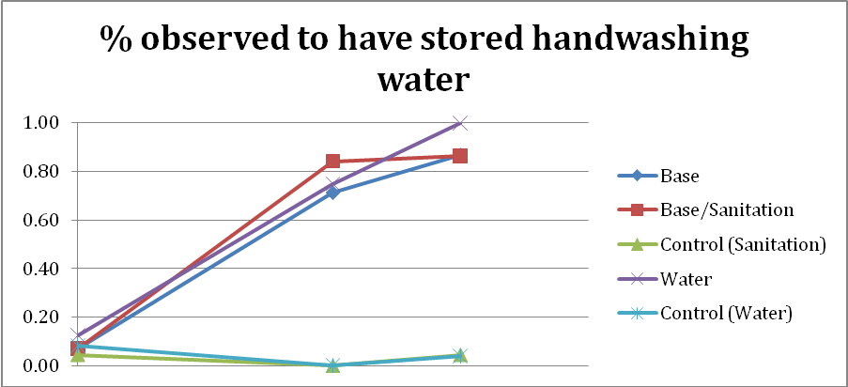

Are schools providing sustained treatment of water and soap?
Key findings
- Between 80% and 95% of schools in the intervention groups report using WaterGuard for treatment (reflecting a continued increase)
- However, the percent of Base and Sanitation schools with residual chlorine in their drinking water declined in the final evaluation.
- Similarly, the percent of Base and Sanitation schools with soap for handwashing on the day of the visit declined in the final evaluation
- Water package schools continued with high levels of residual chlorine and soap, in part because they have not run out of initial supplies
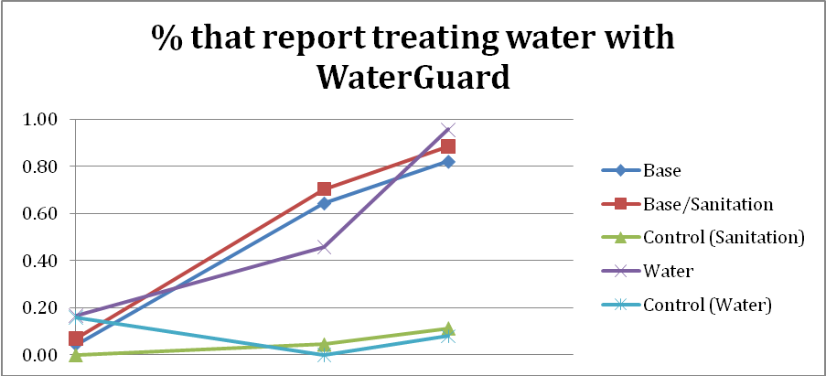
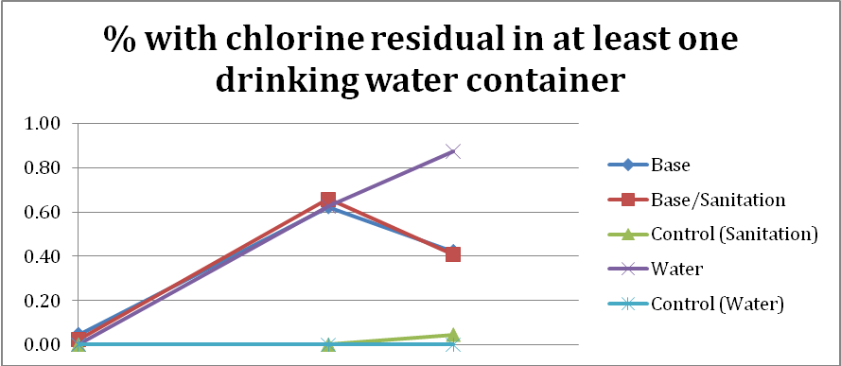
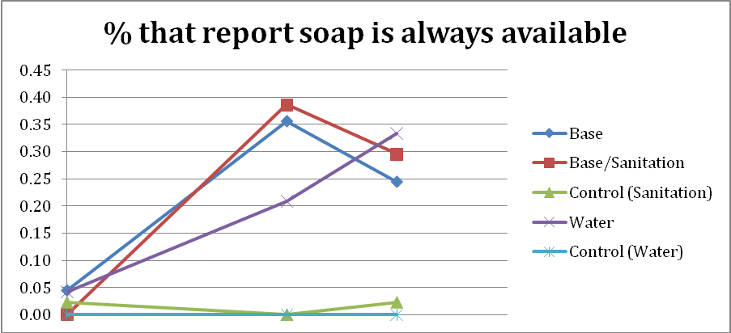

Are schools carrying out the necessary preconditions for sustaining, such as purchasing water treatment products and soap?
Key findings
- Base and Sanitation schools which have used up initial supplies of WaterGuard are repurchasing using school or community funds
- Combined with information on residual chlorine, schools may be rationing the use of WaterGuard to make it last longer
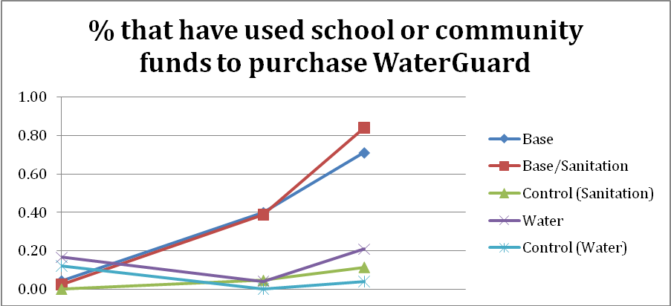

Are sanitation conditions continuing to improve in intervention schools?
Key findings
- The ratio of pupils per latrine significantly declined in Sanitation and Water Supply schools. Although the ratios do not reach those recommended by the government, it may be partially due to increasing student enrollments
- There may be a trend toward decreased ratio in the Base package schools, but much less marked
- When considering the ratio of pupils to acceptable latrine (defined as no major problems with smell, flies or feces outside the whole), the difference between Sanitation and Water Supply schools is less clear. Sanitation schools (and to an extent Water Supply schools) have some of the most favorable changes in latrine cleanliness, but there is a great deal of unexplained variability. In part this may be due to improvements in latrine conditions carried out by the schools themselves.
