ECHO Development Notes, issue 108, July 2010

Human Urine as a Fertilizer
By Dawn Berkelaar
Few would argue against the importance of fertilizer (be it natural or synthetic) for successful farming. Those farmers who cannot afford synthetic fertilizers, and who have no animals to provide fertilizer in the form of manure, are at a disadvantage.
One high quality and universally available source of all the major macronutrients (nitrogen, phosphorus and potassium) is human urine. Using human urine as fertilizer is not unprecedented, but for various reasons in most countries it is not commonly considered as an option, especially for growing vegetables.
However, urine is especially high in nitrogen, which is often a limiting nutrient for crops. The amount of nitrogen in urine will vary depending on the amount of protein in the diet. One estimate indicates that urine contains between 5.2 and 9.6 g N per person per day, 75 to 90% of it excreted as urea. Urine also contains 2.5 to 3.6 g of potassium (in plant-available ionic form); and 0.6 to 1.1 g of phosphate (95 to 100% as plant-available phosphate ions). (EcoSanRes)
Data from Ecosan indicate that the pH of fresh urine is approximately 6, with the pH increasing as urea hydrolyzes to ammonia. The pH of stored urine is often slightly alkaline.
Many helpful publications exist on the topic of ecological sanitation (i.e. using human waste in a way that positively impacts the environment). For example, EcoSanRes, an international network of ecological sanitation experts funded by Sida (the Swedish International Development Cooperation Agency), has published “Guidelines on the Use of Urine and Feces in Crop Production.” In various places in this article we include excerpts from the summary of those Guidelines.
Is Urine Safe to Use on Crops? And What about the Smell?
Health and olfactory concerns are usually the first issues people raise regarding the use of urine as a fertilizer. Careful treatment of urine can minimize both of these.
Except in rare instances, urine is sterile when it exits a person’s body. The key is to collect urine separately from feces. This can be done in a number of ways. If chamber pots are used at night (e.g. ECHO staff member Danny Blank says it is not uncommon for Haitians to use a chamber pot at night so that they do not to have to leave the house in the dark), the contents can be used to fertilize plants in a kitchen garden near the house. An alternative is to urinate directly into a bucket, but the bucket should be kept sealed when not in use, to minimize smell and loss of nitrogen due to volatilization of ammonia, which is a breakdown product of urea. A third option is to use a composting toilet, which can be designed to automatically separate the solid and liquid portions of human waste.
According to WHO Guidelines for the Safe Use of Wastewater and Human Excreta (p. 36), “It can be concluded that pathogens that may be transmitted through urine are rarely sufficiently common to constitute a significant public health problem and are not considered to constitute a health risk in the reuse of human urine in temperate climates. Schistosoma haematobium [the parasite that causes schistosomiasis, a disease also known as bilharzia] is an exception in tropical areas, however, with a low risk of transmission due to its life cycle.” This parasite must spend part of its life cycle inside a freshwater snail, so in areas where schistosomiasis is endemic, avoid using urine near bodies of freshwater.
It may not be feasible to completely exclude the possibility that urine will contain disease-causing organisms, though precautions can be taken. If urine is applied to the soil (not on the plant, to prevent leaves and fruit from contacting the urine), the use of urine as a fertilizer would be more sanitary than existing methods used in many places (e.g. open pit latrines, or lack of a system for containment of feces and urine, sometimes resulting in contamination of freshwater).
The strong smell associated with urine comes in part from ammonia that is volatilizing. In order to limit volatilization of ammonia and to reduce smell, urine should be stored in a non-corrosive container that will seal (e.g. plastic or clay). Do not dilute urine while in storage—only when ready to apply the urine to crops. This is because there are substances in urine that inhibit growth of bacteria. They are less effective when their concentration is reduced by adding water to the urine.
In a review paper on the use of human excreta as fertilizer, Heinonen-Tanski and van Wijk-Sijbesma (2005) explained, “Nitrogen occurs in fresh urine as urea, which is useful for plants and [is often an ingredient] in commercial fertilizers. Urea degrades easily by microorganisms to ammonium, which is also useful for plants. As urea degrades in stored urine, the urine becomes alkaline (pH 9.0). Though ammonium is useful to plants, in a slightly alkaline solution, part of the ammonium can volatilize easily as ammonia. This evaporation can be noted in the form of an unpleasant smell. If the urine solution were acidic, ammonia would not be formed as readily. Because the adjustment of pH is both difficult and costly [and may not be favorable for plant growth], this is not recommended for private households. Instead, the urine should be poured into a 1 to 4 cm deep. . . furrow with a watering can and covered with soil soon thereafter… .It is recommended further that urine is applied as a fertilizer just before irrigation or during the rains so that it spreads more perfectly. It can also be applied in the evening when the evaporation will be lower” (Heinonen-Tanski and van Wijk-Sijbesma, 2005). See Supplement for other ways to apply urine.
Heinonen-Tanski and van Wijk-Sijbesma also concluded, “Human urine is not totally sterile, but. . .the amounts of different enteric [intestinal] microorganisms can be so low that adding urine to the soil can readily be accepted. The urine may have a slight smell but this is not repulsive. There can also be some precipitation…of insoluble phosphate salts [from the urine]. The Swedish practice has sometimes been to store urine for some months before use in order to wait for the die-off of possible enteric microorganisms. Because the survival time of microorganisms is always shorter at higher temperatures, the storage time of urine up [to] the time when it is needed as fertilizer can be minimized in tropical climates.” Heinonen-Tanski and van Wijk-Sijbesma suggest that you try to avoid stirring the urine when it is being applied. Stirring will increase the volatilization of ammonia, and thus the smell. Also, any microorganisms that settle to the bottom would get mixed in again if the urine were stirred. Others recommend stirring.
Fertilization with human feces/manure, though possible, requires particular precautions and is not the focus of this article.
Does it Work?
According to the review paper on the use of human excreta as fertilizer, “If urine fertilization is done carefully at the correct time, the amount used is moderate, and the urine is incorporated into the soil, urine nitrogen has the same agricultural values as nitrogen of commercial mineral fertilizers” (Heinonen-Tanski and van Wijk-Sijbesma, 2005).
A paper in the Journal of Agricultural and Food Chemistry showed evidence that, compared to cabbages treated with industrial fertilizers, cabbages fertilized with human urine had less insect damage, similar microbiological quality [i.e. similar bacteria counts], and similar taste. (Industrial fertilized cabbages had faster initial growth, which may have attracted insects earlier.) The authors concluded that cabbage fertilized with human urine posed no significant health risks and did not affect the flavor of the cabbage (Pradhan et al, 2007).
How much Urine should I Use?
The EcoSanRes Guidelines include information that can help estimate the amount of urine to use on various crops. The amount will vary depending on the amount of nutrients in the urine, which will depend to some extent on the food the person ate—someone who eats less protein will have less nitrogen in their urine. The authors wrote, “Urine is used by the body as a balancing medium for liquids and salts and the amount of urine therefore varies with time, person and circumstances. For example, excessive sweating results in concentrated urine, while consumption of large amounts of liquid dilutes the urine. Thus, to determine the application rate of urine as a fertilizer, the calculation should preferably be based upon the number of persons and days that it has been collected from, as this gives a better indication of the nutrient content than the volume.”
The amount of urine needed will also depend on the availability (to the plant) of the nutrients and the treatment of the urine before it is applied to crops. Different crops will also require different amounts of fertilizer. If an application rate for commercial nitrogen fertilizers is available, that can be used as a starting point.
Undiluted urine can be analyzed for nitrogen concentration, but the EcoSanRes summary of the Guidelines also suggests it can be estimated at 3 to 7 g N per liter. Another way to approximate is to “apply the urine produced by one person during one day (24 hours) to one square meter of land per growing season. If all urine is collected, it will suffice to fertilize 300 to 400 m² of crop per person per year with N at a reasonable rate. For most crops, the maximum application rate, before risking toxic effects, is at least four times this dosage. [So there is little chance of adding too much by following these guidelines.] Urine also contains sufficient phosphorus to fertilize up to 600 m² of crop per person and growing season, if the application rate is chosen to replace the phosphorus removed.”
How and When to Apply Urine
Advice from the EcoSanRes summary of Guidelines: “Urine can be applied neat [undiluted] or diluted. However, its application rate should always be based on the desired nutrient application rate [for a specified area].”
“Any potential need for supplementary water should be met with plain water, not diluted urine. To avoid smells, loss of ammonia and foliar burns, urine should be applied close to the soil and incorporated as soon as possible.
“Urine is a quick-acting fertilizer….[The] nutrients are best utilized if the urine is applied from prior to sowing up until two-thirds of the period between sowing and the harvest.” After this time, the nitrogen will no longer help the crop, and much of it will likely be lost due to leaching or volatilization before the next crop is planted.
Urine Fertilizer Trial at ECHO
Frequency of application is also important to consider. The EcoSanRes summary says that under most circumstances, the total yield is the same whether the urine is applied in one large dose or in several smaller doses. Scott Britton and Andrew Kroeze tested this in a trial on ECHO’s farm in the summer of 2009, evaluating the use of human urine at different application frequencies on the growth of crops. They compared various application frequencies, while maintaining the same overall application rate of N for every treatment (each plant received 4 grams of nitrogen in total). The treatments included (for comparison) 1) no fertilizer (the control) and 2) soluble fertilizer (the standard for comparison).
The trial at ECHO included field and pot studies, comparing and measuring the effects of urine at three different application frequencies on growth of corn, okra and pak choi (Chinese cabbage, Brassica rapa chinensis). It consisted of five different treatments:
(1) Once a week at a 9:1 ratio of water and urine mix (~10% urine), for 0.5 L of liquid and 4 g N in total;
(2) Once every two weeks at a 3:1 ratio of water and urine (25% urine), for 0.5 L of liquid and 4 g N in total;
(3) Once every month at a 1:1 ratio of water and urine (50% urine), for 0.5 L of liquid and 4 g N in total;
(4) 0.5 L of only water (0% urine); and
(5) Once a week, 16-3-16 soluble synthetic fertilizer with micronutrients, at a rate that would total 4 g N.
In the pot study, plants were grown in 5 gallon pots with five replications of each treatment. Seeds were sown directly into pots filled with sand from the farm. Pots were watered as needed during the rainy season. Fertilizer mixes were applied to the soil (not the foliage) at the predetermined frequencies and dilutions for eight weeks (six weeks for pak choi, since it grows faster). The field study included the same treatments and amounts of urine. The age of the urine was not a factor.
Plant observations (health, coloring) were made weekly, and plant measurements (height, diameter of leaf spread, and diameter of main stem) were collected after eight weeks. Figure 1 shows some of the results.
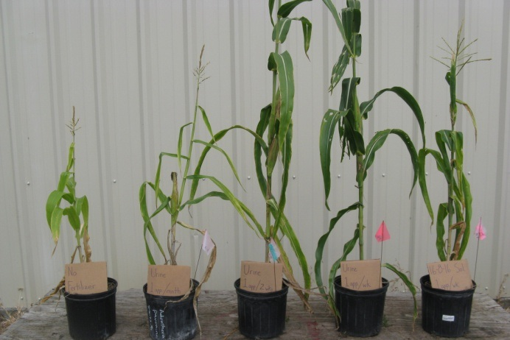
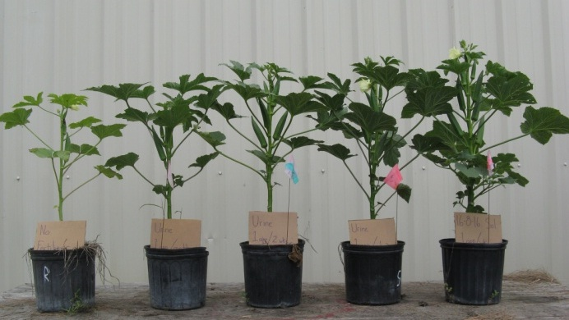
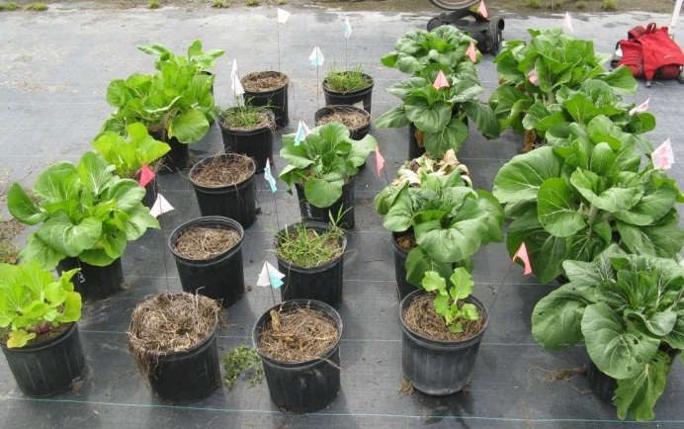
Figure 1: Plants used in a trial at ECHO. The top photo shows corn plants; middle photo shows okra plants; and bottom photo shows pak choi (pak choi grown in pots did not fare well with urine fertilizer, but pak choi grown in the field did as well as plants given soluble fertilizer). In each photo, the plant on the far left was unfertilized. The plant second from the left was given urine fertilizer (50% urine, 50% water) once a month. The plant in the middle was given urine fertilizer (25% urine, 75% water) twice a month. The plant second from the right was given urine fertilizer (10% urine, 90% water) once a week. Each of the middle three pots/rows received 1 liter of urine in total. (The ratios in parentheses are for corn and okra, not pak choi). The plant on the far right was given 16-3-16 soluble fertilizer once a week. Photos by Andrew Kroeze or Scott Britton.
Scott summarized the results as follows: “Urine is a…useful fertilizer. It is certainly better than nothing! The way that urine is applied matters. Peter Morgan [who has done many trials using urine as a fertilizer; see end of article for details] found that the more urine he applied, the higher the yields for corn (maize). However, he found that high application rates and concentrations also resulted in more leaching and therefore waste. So interestingly, for his growing conditions in southern Africa, a 5:1 mix of water and urine was more efficient, though lower yielding than a 3:1 mix.
”
Scott continued, “Our trial’s emphasis on application frequency is important because it determines how much time farmers will invest in fertilizer application. Though application three times a week worked great, that is a large demand on a farmer’s time. A good place to begin experimenting with urine would be to apply it once a week, at either a 3:1 or 5:1 ratio of water to urine. For our trial, corn seemed to grow better with an every-other-week application of diluted urine than with 16-3-16 soluble fertilizer.
“Okra did well with an application of diluted urine every week, and might benefit even further from a more dilute mixture applied three times per week. The okra did almost the same with urine once a week as with soluble fertilizer once a week. Also, in the field, the okra plants given urine once a week were amazing. They were a bit slow to put out pods, but that is because they started putting out side branches that ended up putting out pods. All of the other treatments (except maybe the every-other-week urine application) just put out pods on the main leader, but the plants given urine every week put energy into side shoots that then put out good-looking pods on both the main leader and the side shoots, resulting in more than 30 pods for some of the plants. We collected those data later than the others because we didn’t see what was going on until later.
“The pak choi in the pots did not respond well to the urine. In the field, however, the pak choi given urine fertilizer every week did about the same as the plants given soluble fertilizer.”
Experience with Urine Fertilizer in Haiti
Mark Hare working with MPP (Mouvement Paysan Papaye; Farmer’s Movement of Papaye) and the Road to Life Yard project in Haiti has experimented with the use of urine as a fertilizer. He heard about the idea from folks from the organization SOIL in Cape Haitian, who used urine to fertilize vegetables. Mark began applying urine to amaranth plants in tire gardens, keeping two as a control and using urine on three. All tires contained the “potting mix” they usually use, which contains approximately three parts soil; two parts dried, pulverized and sifted manure (cow, horse and burro); and one part sand. Some compost was also mixed in with the manure. Urine was the only additional fertilizer used, and the difference was so remarkable that he began talking with Road to Life Yard crew members about it.
Mark shared, “Another crew member, Wilner Exil, had already had an experience using urine. He had mulched two banana plants with bean chaff and poured urine on the mulch every morning. He was impressed by how fast the chaff turned into compost, and started using chaff mulch and urine on the [other seven]. He [had] noticed that the bananas with urine were much greener, while the other ones were yellowish.
“Since then, he has discovered that with application of urine, compost piles can also decompose more rapidly, taking a month and a half rather than three months (whether with or without urine, the compost was turned consistently).”
Mark has not done formal trials comparing urine to other fertilizer and/or to no fertilizer. But he repeated his amaranth demonstration a second time, including four tires fertilized with urine and three without (see Figure 2). He said, “After about two weeks, a friend who works with me told me to start using urine on all of them because it would be stupid to lose the production.”
Mark does not measure the exact dilution of urine that he uses. He puts an amount of urine anywhere from a pint to a quart (or sometimes more) into a watering can that holds two gallons of liquid, and then fills the remainder with water. His colleague Wilner says he can use a concentration as much as 1:1, filling the watering can half full with urine and half with water (for vegetables). Wilner notes that if you water with urine in the morning, it is good to water again, without urine, in the afternoon.
Urine fertilizer does not necessarily result in better plant growth. Mark added, “I also tried a comparison with green peppers and with tomatoes—one tire of peppers and one tire of tomatoes with urine, and one of each without. The result in that comparison tended to be negative. The peppers and tomatoes with urine produced less. I would need to repeat that, though. There may have been other factors involved. In contrast, we also have farmers who had very sad looking tomato plants and reportedly started using urine on them and ended up producing tomatoes ‘in abundance.’”
I asked Mark if he had any ideas about why his peppers and tomatoes did not fare well with urine fertilizer. He responded, “The other farmer's tomatoes were in tires, as were mine. I don't have an exact answer. All of my green peppers and tomatoes had vermicompost this year, so maybe there was already plenty of nitrogen and the urine pushed everything over the edge. We also forgot to mix in sand with the vermicompost, so the top layers of the tires were fairly waterlogged.”
I asked Mark whether or not others in his area have begun to use urine as a fertilizer, and if it has been a difficult thing to promote. Mark answered, “A number of the people who receive technical assistance from the Road to Life Yard crew members have started using the urine that they collect from chamber pots at night. Wilner and I think maybe around half. In some localities, it could be more.
“Those who have started using it have seen results, and so continue to use it. People who don't are turned off by the smell, don't try it and so don't see the positive results.”
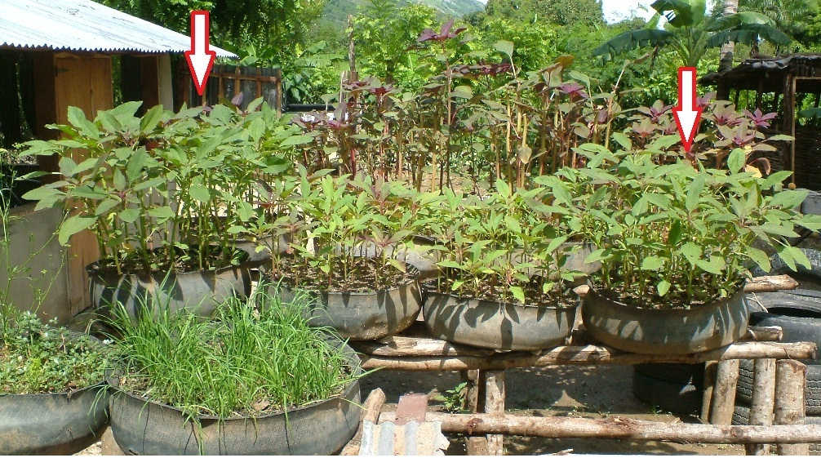
Figure 2: Amaranth growing in tire gardens (second row) in Haiti, June 2009. In the middle row of tires, the plants on the far left and right were fertilized for five of the previous seven days with a mix of water and urine in a 5:1 or 6:1 ratio. In the photograph, plants in all four tires are the same age. [Photo by Danny Blank during his visit to MMP (Mouvement Paysan Papaye) Road to Life Yard Project led by Mark Hare and his Haitian colleagues.]
Conclusion
Human urine seems to have significant potential as a source of essential plant nutrients. If you have experimented with the use of human urine as a fertilizer, or if you are inspired to do so by this article, we would love to know of your results.
For More Information
Guideline on the Use of Urine and Faeces in Crop Production. Hakan Jonsson et al.
www.ecosanres.org/
A helpful publication, as mentioned in the article
An Ecological Approach to Sanitation in Africa: A Compilation of Experiences
Dr. Peter Morgan, Aquamor, Harare, Zimbabwe
www.ecosanres.org/PM_Report.htm
and
Experiments Using Urine and Humus Derived from Ecological Toilets as a Source of Nutrients for Growing Crops
By Peter Morgan
http://aquamor.tripod.com/KYOTO.htm
Peter Morgan has done much research on the topic of recycling human waste. He aims to make ecological sanitation, or “eco-san,” “simple and cost-effective for use by low income communities in Africa. The ultimate aim is to form much stronger links between sanitation, agriculture and food production that actually work in practice, and can [provide benefits to having a toilet that go beyond sanitation.] It also aims to demonstrate that effective toilets for use in Africa can be built by a family with very little support from outside.” Included here are shallow pit composting eco-toilets, since “the pit latrine is the most commonly used toilet in Africa, and is likely to remain so for some time.” Simple urine diversion systems are also described.
Heinonen-Tanski, Helvi and Christine van Wijk-Sijbesma. 2005. Review paper: Human excreta for plant production. Bioresource Technology 96: 403-411.
This helpful paper summarizes a lot of information about using human urine and feces as fertilizer.
Pradhan, Surendra K. et al. 2007. Use of human urine fertilizer in cultivation of cabbage (Brassica oleracea)—Impacts on chemical, microbial and flavor quality. Journal of Agricultural and Food Chemistry 55: 8657-8663.

