Dhaka, Bangladesh, 31 January -2 February 2012

Asia Regional Sanitation and Hygiene

Practitioners Workshop

Reaching the poor and vulnerable community in Rural Afghanistan through CLTS

Adane Bekele, WASH Specialist, UNICEF-Afghanistan

In rural Afghanistan, sanitation coverage is low: half of rural Afghans use unimproved toilets and 20% have no toilets at all. Behind these national averages are stark disparities between rich and poor, but also between regions in the country. Four out of five people in the Central Highland region, four million people, defecate in the open or in sahrahis (area for defecation in the house compound, without a toilet pit), making this region one with the worst sanitation status in the country.

CLTS (community-led total sanitation) engages everyone in a community in problem diagnosis, problem analysis, and coming up with appropriate solutions. Its aim is to enthuse the entire community and build their resolve to end open defecation, using local resources. CLTS has shown success as a community mobilization strategy, resulting in improved sanitation behaviours and ending open defecation practices. Up to now, more than 150 villages have become open defecation free (ODF). The new Afghanistan National Rural Water, Sanitation, and Hygiene (WASH) Policy, also proposed CLTS as an approach and method to be used in the country. This paper describes a pilot intervention in the Central Highland region, with follow-up research among 23 communities that achieved ODF status. Elements of the pilot project included: pre-project baseline data collection, formation and activities of the voluntary hygiene committees in each village, triggering with participatory activities in each village, repeated follow-up household visits to each home by the NGO staff of SSDA, a post-project KAP survey of 41 households selected at random among the 23 target villages. The post-project sample survey showed a high coverage (96%) with latrines which were being used and a similarly high level of knowledge about sanitation behaviours.

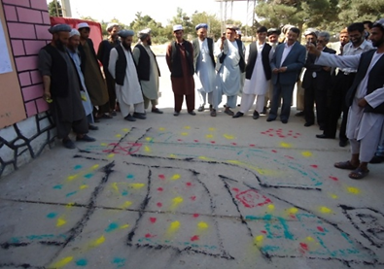

Background

The population of Afghanistan estimated on the basis of the National Risk and Vulnerability Assessment (2007-08) is close to 25 million people. The Afghan population is overwhelmingly rural: 74% (around 18.5 million people) lives in rural areas and only 20 % (5.0 million) in urban areas, while 6% (1.5 million) is classified as nomadic Kuchi. The total number of households in Afghanistan is estimated at around 3.4 million. This implies an average household size of 7.3 persons.

The sanitation indicator shows disparities: only 24% of household members in rural areas use an improved sanitation facility, while in urban areas 51% use an improved facility. Overall, 29% of household members use an improved sanitation facility.

In rural Afghanistan, sanitation coverage is low: half of rural Afghans use unimproved toilets and 20% have no toilets at all. Behind these national averages are stark disparities: between rich and poor, but also between regions in the country.

In the central Highland region, where this project took place, half of the residents have no choice but to defecate in open fields or sahrahis. Half million Afghans in this region live without access to an improved toilet, this makes the region experiencing the worst sanitation deficit in the country almost 15 times larger than the proportion in the North.

History of CLTS in Afghanistan

The concept of triggering a community into becoming open defecation free (ODF) by building or improving their own latrines was first introduced to Afghanistan at the Water and Sanitation Group meeting in May 2007. At that time the concept was not well received as the viewpoint of most participants was that this type of initiative would fail without subsidies and assistance. Later, the Society for Sustainable Development of Afghanistan (SSDA), an indigenous, non-political NGO, initiated the community-led total sanitation approach (CLTS) in October 2009. The SSDA also trained master trainers working in Provincial DDR (Disarmament, Demobilization, Reintegration), DoE (education), and DoPH (public health) in all Provinces of Afghanistan in 2010 under the financial support of UNICEF.

The National WASH Policy 2010 has proposed several options to make all villages 100% open defecation free and fully sanitized by 2020. Within this, the community-led total sanitation (CLTS) is considered as an option to target 20% of the population in those areas where open defecation is practiced. The CLTS approach has been implemented in many provinces by many national and international NGOs since 2010.

Agencies piloting CLTS in Afghanistan are mindful of the lessons learned elsewhere, which show that people in particularly vulnerable situations are often neglected and/or have difficulties participating in CLTS for a variety of reasons. The “naming and shaming” of people caught openly defecating during the CLTS process are often publicly identified and may be ridiculed, which may reinforce stigma and social exclusion of some groups. Communities may also coerce the poorest households to build toilets without giving adequate support, thus may create serious difficulties for such households.

CLTS as a tool to reach the poor and vulnerable community in central highland

The central highland of Afghanistan consists of Bamyan and Daikundi provinces with a total population of 794,400 of which only 20.4% have access to improved sanitation facilities as shown in Figure 1 below. Half the population practices open defecation. The two provinces are characterized by high poverty levels with low coverage of basic services and challenging road accessibility due to mountainous topography.

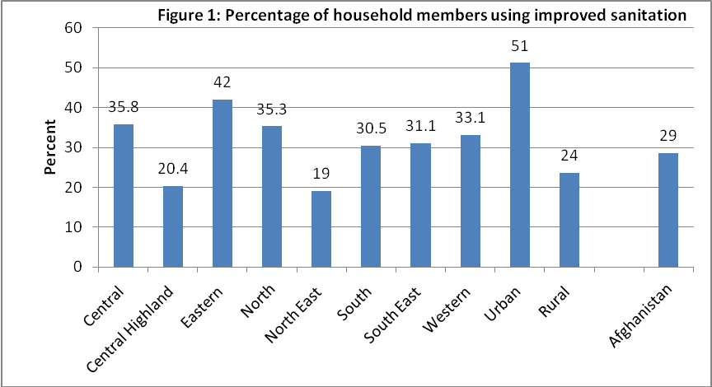

From the beginning of 2010, community-led total sanitation (CLTS) has been implemented in Daikundi province of the Central Highland. CLTS aims to stop all open defecation (OD) within a community, recognizing that individual hygiene behaviour can affect the health of other community members. The project was considered as a pilot to implement the WASH policy which endorsed CLTS as approach providing no subsidy for construction of household latrines, which are commonly provided in the country .

Objectives and steps of CLTS project

The overall steps in the CLTS project in Daikundi were:
- Assess the knowledge, attitude and practices of the communities living in 23 villages of two districts of Daikundy Province in the field of health, hygiene and sanitation through conducting a baseline survey.

- Implement, supervise and monitor the CLTS approach in the target communities of two districts
- Support and encourage the communities in changing their behaviour in health, hygiene and sanitation practices both at domestic and village level.
- Make the target communities open defecation free (ODF); declare and certify clean ODF villages at the end of the project.
- Re-assess the knowledge, attitudes and practices of the project communities in terms of health, hygiene and sanitation through conducting end-line survey.

Progress of CLTS in Daikundi Province: Experience to address the poor
To support the Government’s sanitation policy and improve the sanitation condition of the poor and marginalized communities, UNICEF launched the implementation of CLTS at provincial level. Daikundi is one of those provinces, where UNICEF has assisted the CLTS implementation through Society for Sustainable Development of Afghanistan (SSDA.) Daikundi province is home to 2.1% of the total population of Afghanistan, the population is distributed among the nine districts. The large majority of the population 99.5% lives in the rural area. SSDA was responsible for the implementation of CLTS in two districts (Khideer and Mairamoor) of Daikundi Province. For this, 23 villages with a total of 801 households were selected for the CLTS project in the two districts (14 villages from the four community development councils (CDCs) of Khedir district and nine villages from four CDCs of Miramoor district.).

Formation of hygiene committee at each village
SSDA offices at Khedir and Miramoor districts invited influential figures including male and female community development council (CDC) members from each target village; and then formed Hygiene Committees after a day-long discussion. Most Hygiene Committee members were self-selected, joining on a voluntary basis. Hygiene committees were responsible for several villages each and were assigned specific tasks at village level. Along with SSDA team, these hygiene committees intensified their efforts in each village.

Triggering villagers for sanitation
The triggering was done by a team of male and female facilitators who are NGO or government staff members trained on CLTS methods and facilitating community discussion. The team visited the village at a scheduled time. Upon arrival in the village, the female team went to a pre-selected house, where the village women were already gathered to welcome the female team. The male team went to the pre-selected Hujra, a common place for guests, where the village men were already gathered. During the meeting, facilitators triggered the villagers through applying Participatory Rural Appraisal (PRA) tools, in general:

- Introduction, strengthening rapport, and launching the triggering session
- Social Mapping / Defecation Mapping
- Facilitating mapping to be focused, fast and fun
- Transect Walk or “Walk of Shame”
- Some important question to be asked during this walk
- Calculation of Faeces
- Flow Diagram
- Triggering Stage / Ignition Point
- Calculation of Medical Expenses
- Glass Exercise
- Water Quality Test

To facilitate the communities to identify the following issues by themselves, the following was done:
- Introduction to personal hygiene and its main constraints and obstacles (facilitation of the communities to introduce personal hygiene to the crowd gathered by the SSDA workers in the village).
- Current situation of personal hygiene, based on one person/boy/girl who volunteers as example in the gathered crowd (part of triggering for personal hygiene in PRA).
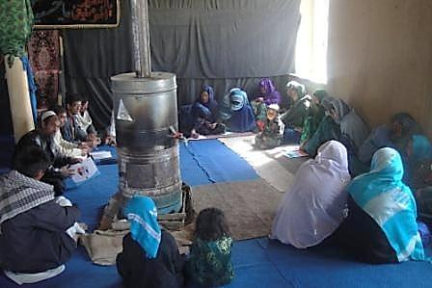
- Introduction to food hygiene and its main constraints and obstacles (issues such as having clean, covered containers for left-over food and the need to warm left over food before eating) (facilitation of the communities to introduce personal hygiene to the gathered crowd, see photo 1).
photo: 1 Facilitation of the communities to introduce personal hygiene to the gathered crowd
- Current situation of food hygiene, taking one over-left food as example in the gathered crowd (part of triggering for personal hygiene in PRA). This exercise was done by female staff within the houses.
- Introduction to domestic hygiene and its main constraints and obstacles such as the problems of finding sufficient land for construction of latrines, particularly in compounds where five or more families live.
- Current situation of domestic hygiene, taking one dirty part of the house as example in the gathered crowd (part of triggering for personal hygiene in PRA). This exercise was done by female staff within the houses.
- Introduction to environmental hygiene and its main constraints and obstacles
- Current situation of environmental hygiene, taking one person/boy/girl as example in the gathered crowd (part of triggering for personal hygiene in PRA). This exercise was done by male staff outside the houses.
The newly developed hygiene committees played a vital role in terms of cleaning their own houses as well as their surroundings. In this way, most of them became the natural examples for safe sanitation and hygiene.

Continuous follow up by SSAD staff
During 12-month project period SSDA staff knocked on the door of each household many times to stimulate and observe the changes made by the householders after this specific triggering. Significant changes were observed in the personal, domestic and environmental hygiene during these follow ups, for example, soap along with water were found in many latrines; some children were observed with cleaner nails and hair; covered water pots were also seen in some of the houses.

Regular Supportive supervision
SSDA team visited each household many times to monitor the construction activities, specifically, the construction of new latrines, the transformation of un-safe latrines into safe latrines. In these visits, SSDA staffs observed that the villagers had been working collectively for the cleanliness of their respective village in terms of JOINT ASHAR in many villages, construction of new latrines and converting un-safe latrines into safe latrines. Upon observing the zeal, interest and physical work in the construction of new latrines, the SSDA team distributed five pairs of soap (one bar for laundry, one bar of body soap) to each family as an award for constructing a new latrine. Based on the following observations made by the SSDA team and UNICEF, all these 23 villages of four CDCs were ODF by June, 2011.

Good news for the ODF of a village

Toap is a village of Khoshkab CDC in Khideer district with 21 households. At the beginning of the project, this village had only eight latrines, all of which were unsafe. Human excreta/faeces could be seen everywhere in the village. Now the village has become open defecation free. All households have constructed latrines. However, only one family has not constructed the latrine due the lack of land. However, this family has been utilizing the latrines of the neighboring families.

Project results: Knowledge, Attitude and Practice (KAP) survey

A KAP survey was conducted to collect end-line information about the CLTS implementation, community perceptions and reported practices related to safe drinking water supply, sanitation and hygiene. The KAP survey was conducted in the 23 target villages. Each 20th household was selected in each village for an interview and for observation. Thus, out of a total 801 households, 41 were randomly selected and interviewed.

One of the most common water borne diseases is the diarrhoea, which is widespread among the children under five years of age in Afghanistan. The survey data also depicts a similar picture. Out of the total 41 households surveyed, 3 households were those where at least one of the family members got sick with diarrhoea during the last two weeks.

The project advocated storing water in a narrow neck container to reduce the chances of water being polluted by flies and other insects. Almost 85% of the households stored their water in a narrow neck container in comparison to remaining 15% had their water stored in a broad neck container. With regard to cleanliness of the water container, it was observed that 90% households had water containers that appeared to be clean and only 10% had visually unclean water containers.

With respect to latrines, of the 40 households surveyed, 42 % (17 HH) did not have a latrine and were defecating in the open. The remaining 23 households (58%) had latrines. Out of 23 households which had latrine, twenty 20 households had vault latrines, 2 households had pit latrines and one household had another form of latrine.

For hygiene, the data illustrated personal hygiene awareness among the households and mothers in particular. In response to the question about hand washing habits, Over 99% mothers stated that they wash their hands while 1% said that they do not wash their hands at all. Nine (48%) respondent mothers said that they wash hands in more than one activity of either before eating; praying and preparing food or after defecating, handling child faeces and touching animals. Two (5%) respondent mothers said that she washes only after defecating, 8 (20%) respondent mothers said they wash their hands only before preparing food; 3(8%) respondents said they wash only before eating; 1(3%) mother said they wash hands only after touching animals and only 2(%) mothers said that they wash their hand only before praying while 5(13%) respondents said that they wash their hands before or after doing other things.

While research shows that asking respondents to comment on their own handwashing behaviour gives responses that are 2 to 3 times more positive than data from actual observations, at least these responses indicate a high level of knowledge about handwashing. In addition, over 95% mother expressed the view that washing hands actually removes dirt from their hands and nearly 5% mother said that it helps to prevents diarrhoea.

In the area of personal hygiene, data illustrated considerable level of personal hygiene awareness among the households and mothers in particular. When the mothers were asked about with what they wash their hands, over 35 % mother replied that they wash their hands with water and soap and above 65 percent mother wash their hands with water only.

Over 50 % mothers expressed their view that washing hands actually removes dirt from their hands and nearly 10% mothers gave their point of view that it helps to prevents diarrhoea and 10 % mothers gave their opinion that it prevents dust/dirt to get into mouth where as 15% mother said they don’t know and 15 % mothers said that there are other reasons for washing hands.

Conclusion

With so many alternative approaches to sanitation and hygiene promotion it may be difficult to select the most appropriate approach. The decision about an approach to be used should be based on the local context and situation. . In rural Afghanistan, sanitation coverage is low: half of rural Afghans use unimproved toilets and 20% have no toilets at all. Behind these national averages are stark disparities: between rich and poor, but also between regions in the country.

Half of residents of the central Highland region have no choice but to defecate in open fields or sahrahis. Half million Afghans in this region live without access to an improved toilet. The Highland region has among the lowest coverage in the country, and has about 40% fewer improved latrines than the north, for example.

The implementation of CLTS at 23 villages of Daikundi province, engaged everyone in a community in problem diagnosis, and in developing appropriate solutions for the problems they identified. This led to strong community mobilization and in improved sanitation behavior which ended open defecation practices without any hardware subsidy. The poor people in 23 villages who had not used sanitation facilities previously have now constructed and started to use their own household latrines. This indicates the effectiveness of the CLTS approach to address sanitation problems among poor and vulnerable rural communities of Afghanistan. Up to now, more than 150 villages have become ODF in different parts of Afghanistan. A national review workshop on the progress of CLTS in Afghanistan conducted on July 23, 2011 also confirmed the application CLTS as one of the approach to address poor and vulnerable communities in rural Afghanistan

Key words: CLTS, Open Defecation, Open Defecation Free (ODF)

Keywords
CTLS, Open Defecation, Open Defecation Free (ODF)

Contact details
Name of Principal Author: Adane Bekele
Address UNCIEF-Afghanistan
Email: adbekele@unicef.org
www.unicef.org/infobycountry/afghanistan.html

with support from Tetra Tech ARD Inc., under the USAID-supported Sustainable Water Supply and Sanitation (SWSS) Project
Danquah, Lisa. Measuring hand washing behaviour: methodological and validity issues. South Asia Hygiene Practitioners' Workshop. Dhaka, Bangladesh, February 2010. See: http://www.irc.nl/page/51626

