Accra, Ghana, 10-12 November 2009

West Africa Regional Sanitation and Hygiene Symposium

Community Led Total Sanitation - a low-cost approach to improved health and hygiene for rural communities

A. Abie Joy ,B. Immanuel & C. James [Sierra Leone]

Various development partners and donors in Sierra Leone have expended huge sums of money to provide sanitation facilities in the rural communities. Unfortunately, these projects have failed to improve the sanitary conditions and habits of the rural populace, because of lack of ownership and sustainability issues. The introduction of Community Led Total Sanitation (CLTS) approach in Sierra Leone has created amazing practical results by ensuring a low cost-high impact community based approach to deliver improved hygiene behaviours and practice using Participatory Rural Appraisal (PRA) process as modified in the CLTS context. Chibuzor Human Resource Development Organization (CHIDO) is a National NGO in Sierra Leone working with UNICEF to implement CLTS activities in 25 communities in Kenema District. Major objective of project was to ensure that by the end of nine months residents of 25 communities in Kenema District will adopt a minimum of two healthy practices of always using the latrine and washing of hands at critical times. Also, to ensure that by end of nine months, 3 Physical Health Units (PHUs) have sustainable access to safe water and sanitation facilities. CHIDO is here to share our experience.

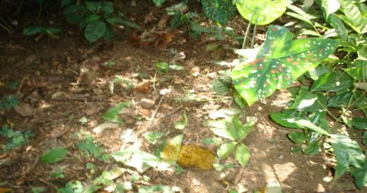
Photograph1: Freshly Deposited Faeces: OPEN DEFECATION: This faeces was discovered in a bush just behind Sembehun village in Dama Chiefdom, Kenema District by a team of CLTS facilitators from CHIDO, Ministry of Health, UNICEF Staff, and community people during the walk of shame. This was just one of many faeces scattered all over the community bush. This is a CLTS approach after which the Facilitators and community sit down and calculate the amount or quantity of faeces deposited in the community.
Source: CHIDO – Immanuel Walters

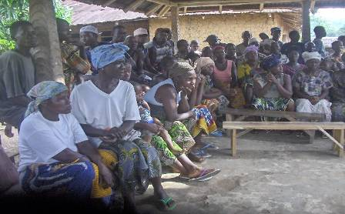
Photograph 2: Triggering of Communities on CLTS Approach & Methodology
Source: CHIDO – Immanuel Walters
Triggering is a process of community mobilization and sensitization on CLTS aim, objectives, and approaches. During this process, CLTS Facilitators organise community meetings involving community leaders, women, men, youths and children. The picture above shows a cross section of the community listening to CLTS facilitators on the overview of CLTS. This is followed by a practical mapping or drawing of community map and water and sanitation facilities, using charcoal, saw dust, blue, vanguard, etc.

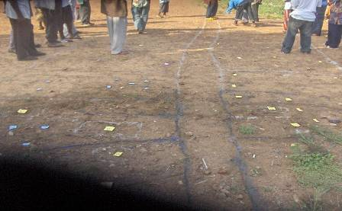
Photograph 3: Social/Resource Mapping (House Holds, Latrines, Wells)
Source: CHIDO – Immanuel Walters
Here the community people are drawing their community and mapping out the entire social and sanitation facilities such as schools, roads, churches, mosques, water wells, latrines, etc. The legs above are those of members of community who draw the community map and of those who stood by to observe and make contributions. They follow the person who does the actual drawing on the ground.

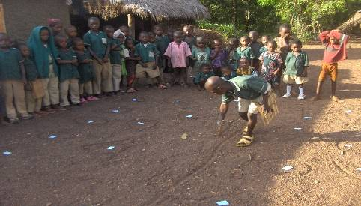
Photograph 3: Children as agents of change conducting Community Mapping
Source: CHIDO – Immanuel Walters
During the triggering process, children are given equal opportunity of participating and contributing by drawing the community and mapping out social and sanitation facilities just like the adults. The picture above shows child facilitator who volunteers himself to lead the children’s section. Here, Brima is leading the children in mapping out community resources in Kpandebu village Dama Chiefdom, Kenema District Sierra Leone.

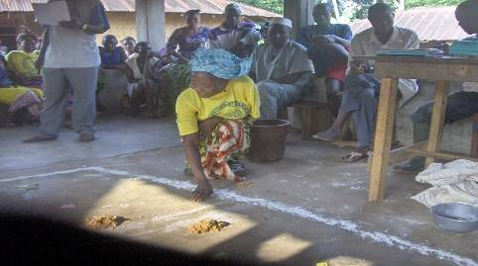
Photograph 4: Gender Participation on Sanitation Mapping
Source: CHIDO – Immanuel Walters
Few years ago, women hardly participate in any community activity including community meetings. They always sit or stay behind the men. But recent development in Sierra Leone has created awareness on gender equality and equal participation. Here Mrs. Mansaray is mapping out places of defecation using saw dust to locate where faeces are deposited in the bush. During Sanitation Mapping, water wells, latrines and health centres are located on the map drawn on the ground.

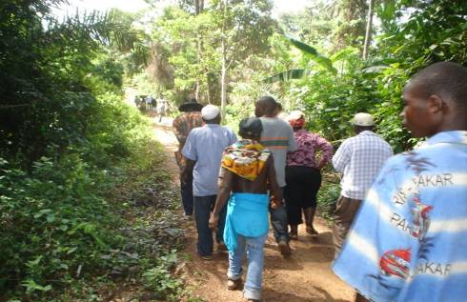
Photograph 6. CHIDO CLTS-Transient Walk (Walk of Shame) to identify Open Defecation Sites and to shame those who defecate in the open bush
Source: CHIDO – Immanuel Walters
In this village called Teiwo in Dama Kenema District, CLTS facilitators from CHIDO, Ministry of Health and Sanitation, UNICEF Representatives, Community Leaders, and the entire community walk through the community and surrounding bushes to check for any site of open defecation. During this process the community is asked to show where individuals such as town chiefs, mammy queen, teachers, Imam, and everyone else in the village defecate. The entire village joins in the walk of shame.

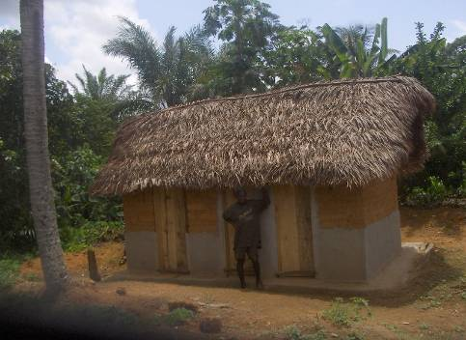
Photograph 7. CHIDO CLTS-Newly Constructed 3-Cell CLTS Latrine
Source: CHIDO – Immanuel Walters
The latrine above is one of the CLTS latrines constructed in Tunkia Chiefdom after CHIDO’s intervention. It is a House Hold Latrine constructed by Morie Kallon (standing in front of the building). It is a 3-seater latrine for his house hold comprising three different family heads. Each family uses one of the compartments. It was a joint effort by the three families. There was no subsidy from CHIDO or UNICEF for the construction of the latrine. There are more than 25 new latrines of different shape sand sizes constructed in this village as a result of the CLTS approach.

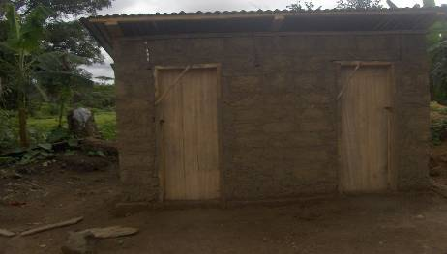
Photograph 8. CHIDO-CLTS-Newly Constructed Zinc Roofed CLTS Latrine
Source: CHIDO – Immanuel Walters
This latrine is a more solid and well designed latrine with corrugated iron zinc as roofing. It was a matter of choice and the financial ability of individuals or families to construct their own latrine. Mr Lahia Vandi decided to construct this latrine after accepting the CLTS approach and methodloly. He decided to make it a more durable and sustainable latrine.

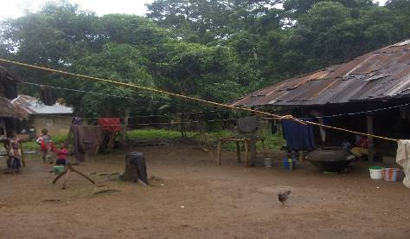
Photograph 9. CHIDO CLTS-Clothe Lines are constructed by each House Hold after triggering
Source: CHIDO – James E. Ebube
Prior to triggering of this community on CLTS approach, most community member used to spread or dry their clothes or laundry on the grass or sand. Having been adequayely informed about the medical implications of spreading clthes on ground and grass, the communities immediately decided to construct clothe lines on hpouse-hold basis. Each house-hold constructed its own clothe line where every member hang his/her clothes after laundry. This means that skin disease such as rahes, insect bites associated with spreading of clothes on the ground has been eliminated.

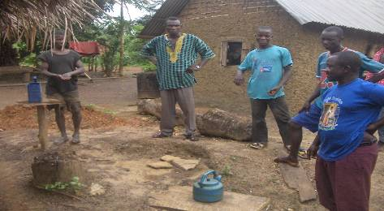

Photograph10. CHIDO CLTS-Hand Washing with Soap at Critical Times is one of the main objectives of CLTS
Source: CHIDO – James E. Ebube
Hand washing at critical times (After using the latrine and before eating) is an integral part of CLTS approach. Communities are sensitized on the merits of hand washing using soap and water. In the absence of soap, ashes can also be used because of its chemical composition. The households provide soap for the use of each member after using the latrine. There different kinds or types of soap which can be placed in a secured place near the latrine. These include Black soap, bath soap, and even ashes. These local soaps are easily available and affordable in the communities.

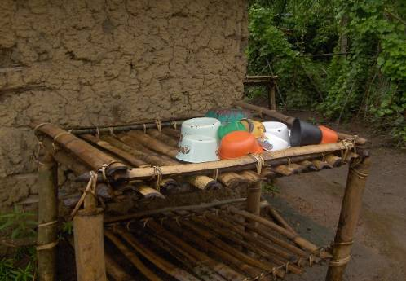
Photograph11. CHIDO CLTS-Plate Racks are used to dry pots, plates & other Utensils
Source: CHIDO – James E. Ebube
Plate racks are constructed by each house hold near the main house or close to the kitchen. There are more than 50 of this plate rack of different designs and sizes. The above is a double deck plate rack built by Salia Koroma for his wife at Ngelehun village in Dama Chiefdom, Kenema District.

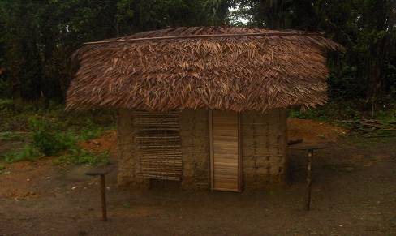
Photograph12. CHIDO CLTS-Beautiful 2-hole CLTS Latrines constructed after Triggering
Source: CHIDO – Immanuel Walters
The above latrine was built by Mustapher Swarrey at Gorahun village Dama chiefdom. He decided the design and number of holes for this latrine. The materials used in the construction of CLTS latrines varies from one house hold to another and from one village to another. The individual decides which material to use and how many drop holes to be constructed. No money is paid to individuals for constructing CLTS latrines.
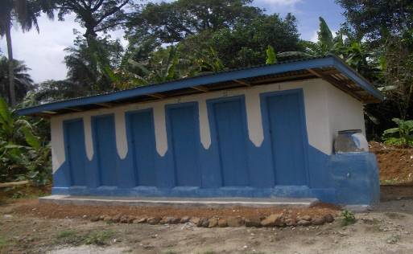
Photograph13. CHIDO CLTS- UNICEF funded 3 X 6-hole Pit Latrine for PHUs in CLTS community
Source: CHIDO – Immanuel Walters
The latrine above is a 6-hole pit latrine constructed by CHIDO and funded by UNICEF as part of the CLTS project in Dama and Tunkia Chiefdoms in Kenema District. There are three of this type constructed in three Peripheral Health Units to improve access to water and sanitation facilities in the three PHUS .The water pot seen is a hand washing facility to be used for hand washing after using the latrine. It was the idea of UNICEF to construct a hand washing facility in any latrine constructed through UNICEF funding.

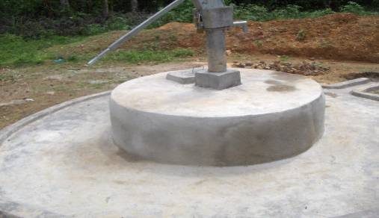
Photograph14. CHIDO CLTS-UNICEF funded 3 X 1 Hand Dug Well at PHUS in CLTS Communities
Source: CHIDO – Immanuel Walters
The water wells are installed in the peripheral health units (PHUs) to increase access to safe drinking water by patients and clinic staff. These are health centres that do not have safe source of drinking water. One of the objectives of the CLTS project is to increase access to safe and sustainable drinking water at the 3 PHUS covered by the project. UNICEF provided funding for the construction of the well which was implemented by CHIDO. It was part of UNICEF Annual Work Plan to increase access by PHUS to safe and sustainable drinking water.

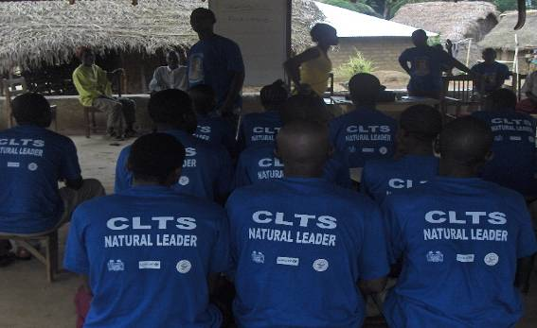
Photograph 15: CHIDO CLTS-25 Natural Leaders were trained as Ambassadors of CLTS in their communities to ensure sustainability and replication of CLTS activities in nearby communities
Source: CHIDO – James E. Ebube
A CLTS Natural Leader is a volunteer who is willing to nominate himself/herself to be a CLTS Leader. During the triggering process in each community, a Natural Leader is identified and selected through self nomination and acceptance to be involved in the CLTS project. The natural leader works in collaboration with community health committee and community leaders to ensure that the hygiene and sanitation status achieved through CLTS is maintained through monitoring and inspection of hygiene conditions in the community. The natural leader also helps to spread the CLTS approach to neighbouring communities who want to improve the sanitary and hygiene conditions of their community. The visit such communities and trigger them to construct new latrines, clothe lines and plate racks. The health committees comprised 5 women and 5 men and the natural leader is part of the committee. He does not find it challenging to reach out to women since there are female members of the committee who can be assigned to reach out to any woman.

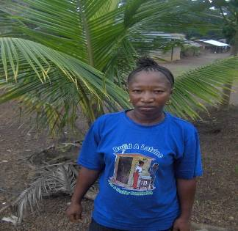
Photograph 16: CHIDO CLTS- Natural Leader Mamie Gibba is the only woman among 25 Natural Leaders in the 25 CLTS communities in Dama and Tunkia Chiefdoms Kenema District. She was bold enough to volunteer herself as a Natural Leader
Source: CHIDO – James Ebube
Mamie Gibba is accepted by other natural leaders and her community. Since she became a Natural Leader she has received tremendous support from her husband and this has encouraged her to participate fully in the CLTS activities. Mamie has no specific challenge or benefit as a natural leader except she has to convince her husband to allow her to travel to other communities or to the city to attend CLTS trainings and exchange visit. Acknowledgements
The author/s would like to extend thanks to UNICEF Sierra Leone and Ministry of Health and Sanitation for all the technical, financial and capacity building support they have provided for CHIDO during the past two years

References

Note/s
CLTS is a Low-cost high Impact Approach towards improving Sanitation and Hygiene in Rural Communities.

Keywords
clts, low-cost, high-impact, odf, improved, health

Contact details

Name of Principal Author: James E. Ebube  Address: 11 Boima Street, Off IDA Section  Kenema, Sierra Leone  Tel: +23276699447  Fax: N/A  Email: chiddo3000@yahoo.com  www: NA | Name of Second Author: Immanuel Walters  Address: 7 Buleh Street  Kenema, Sierra Leone  Tel: +232783223256  Fax:  Email: cevicus@yahoo.com  www: NA

